**Supplemental Materials**

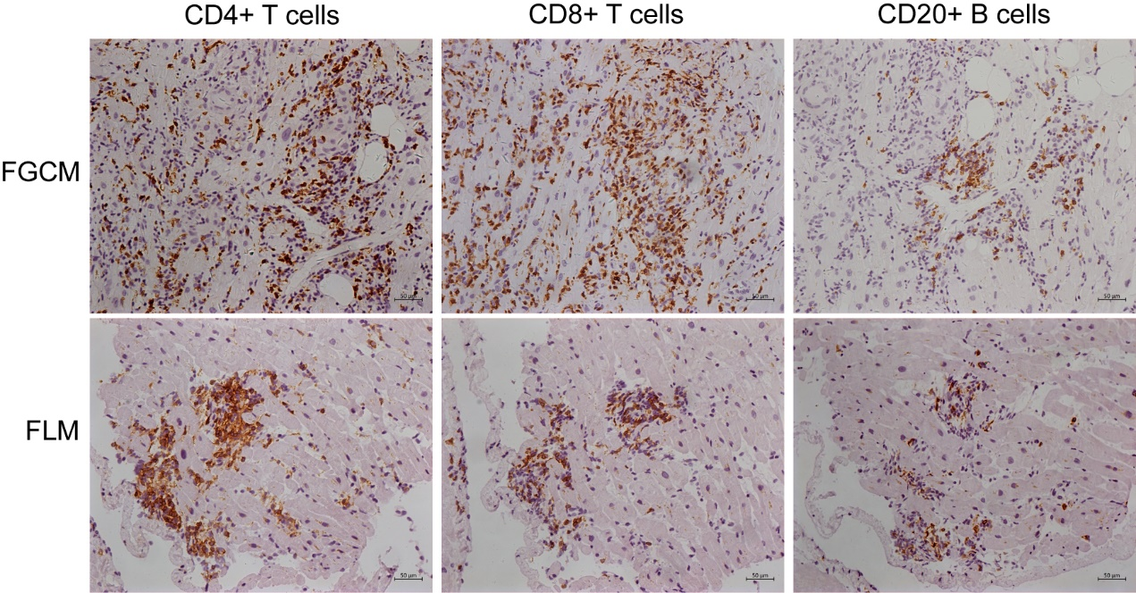

**Supplemental Figure 1** Representative immunopathology of patients with FGCM (upper line) and FLM (lower line). left column = staining with anti-CD4 antibody; middle column = staining with anti-CD8 antibody; right column = staining with anti-CD20 antibody.



**Supplemental Figure 2** Pearson correlation analysis revealed the significant correlation of levels of hs-CRP and fT3 (r = 0.7453, P ≤ 0.001).