Supplementary Material
SUPPLEMENTARY METHODS
Association of PBK expression and cellular proliferation marker labelling indices
Labelling indices for CCNA, GMNN, and Ki-67 were determined by counting > 500 tumor cells per case in a high-power field (HPF, ×400) in our previous study [8]. Spearman’s rank correlation coefficient was performed to analyze the significance.

Survival analyses in Kaplan–Meier Plotter
Survival analyses were performed using the Kaplan–Meier Plotter program Pan-cancer RNA-sec data according to PBK expression (https://kmplot.com/analysis/). The best cut-off values were automatically set by the program in each tumor type.

SUPPLEMENTARY TABLES
Supplementary Table S1. Characteristics of Colorectal Cancer Patients
 |  | Total No.
 |  | 269 | (100%)
Sex
 | Male | 143 | [53%]
 | Female | 126 | [47%]
Age, years (mean±S.D.) |  | 68.6±12.6
Size, cm (mean±S.D.) |  | 5.0±2.6
Tumour location
 | Right-sided colon | 124 | [46%]
 | Left-sided colon | 86 | [32%]
 | Rectum | 59 | [22%]
pT stage
 | pT2 | 36 | [13%]
 | pT3 | 189 | [70%]
 | pT4 | 44 | [16%]
Histological differentiation
 | Well to moderately | 242 | [90%]
 | Poorly | 27 | [10%]
Mucus production
 | Positive | 14 | [5%]
 | Negative | 255 | [95%]
Lymph node metastasis
 | Positive | 124 | [49%]
 | Negative | 129 | [51%]
Peritoneal metastasis
 | Positive | 50 | [19%]
 | Negative | 219 | [81%]
Distant organ metastasis
 | Positive | 44 | [16%]
 | Negative | 225 | [84%]
Operation status
 | Complete resection | 237 | [88%]
 | Incomplete resection | 32 | [12%]
MMR system status
 | Deficient | 31 | [12%]
 | Preserved | 238 | [88%]
Characteristics of the 269 CRC patients are summarized.

Supplementary Table S2. Antibodies and Conditions for Immunohistochemistry and Immunoblotting
 |  | IHC |  | IB
Genes |  | Reagent | Dilution | Dilution |  |  | Antibodies
ACTB |  | - | - | 5,000 |  |  | AC-74, SIGMA (Rocklin, CA)
Bax |  | - | - | 1,000 |  |  | Clone D2E11, Cell Signaling Technology, Inc. (Danvers, MA)
BCL2 |  | - | - | 1,000 |  |  | Clone D55G8, Cell Signaling Technology, Inc. (Danvers, MA)
Caspase 3 |  | - | - | 1,000 |  |  | #9662, Cell Signaling Technology, Inc. (Danvers, MA)
C-Caspase 3 |  | - | - | 1,000 |  |  | Clone 5A1E, Cell Signaling Technology, Inc. (Danvers, MA)
CCNA |  | IV | 100 | - |  |  | sc-751, Santa Cruz Biothechnology, Inc. (Dallas, TX)
CDH1 |  | - | - | 1,000 |  |  | Clone 24E10, Cell Signaling Technology, Inc. (Danvers, MA)
CK AE1/3 |  | IV | 1 | - |  |  | Clone AE1/3 NICHIREI BIOSCIENCES INC. (Tokyo, Japan)
ERK |  | - | - | 1,000 |  |  | #9102, Cell Signaling Technology, Inc. (Danvers, MA)
P-ERK |  | - | - | 1,000 |  |  | #9101, Cell Signaling Technology, Inc. (Danvers, MA)
FLAG |  | - | - | 1,000 |  |  | M2 HRP-conjugated, Invitrogen/Thermo Fisher Scientific (Tokyo, Japan)
Geminin |  | OV | 100 | - |  |  | EPR14637, Abcam (Cambridge, UK)
GST |  | - | - | 1,000 |  |  | Kindly provided by Dr. Toshinori Hyodo*
Ki-67 |  | OV | 100 | - |  |  | Clone MIB-1, Dako/Agilent (Santa Clara, CA)
Luciferase |  | - | - | 10,000 |  |  | PM016, MBL CO., LTD. (Tokyo, Japan)
MLH1 |  | OV | 200 | - |  |  | Clone G168-728, BD Biosciences (Franklin Lakes, NJ)
MSH2 |  | OV | 200 | - |  |  | Clone G219-1129, BD Biosciences (Franklin Lakes, NJ)
MSH6 |  | OV | 400 | - |  |  | Clone 44/MSH6, BD Biosciences (Franklin Lakes, NJ)
C-PARP |  | - | - | 1,000 |  |  | Clone D64E10, Cell Signaling Technology, Inc. (Danvers, MA)
PMS2 |  | OV+Linker | 50 | - |  |  | Clone A16-4, BD Biosciences (Franklin Lakes, NJ)
PBK |  | IV | 100 | - |  |  | sc-293028, Santa Cruz Biothechnology, INC (Dallas, TX)
PBK |  | - | - | 5,000 |  |  | EPR21983, Abcam (Cambridge, UK)
PHH3 |  | OV | 500 | - |  |  | Cell MarqueTM, Millipore SIGMA (Rocklin, CA)
PHH3 Ser10 |  | - | - | 1,000 |  |  | ab136810, Abcam (Cambridge, UK)
VIM |  | - | - | 1,000 |  |  | Clone D21H3, Cell Signaling Technology, Inc. (Danvers, MA)
IV, iView reagent. OV, OptiView reagent. Antigen retrieval was performed with heat activation in high pH buffer.
*; Hyodo et. al., The Journal of Biological Chemistry, 287（30）, 2012. DOI: 10.1074/jbc.M112.372342

Supplementary Table S3. Survival analyses in Kaplan-Meier Plotter according to PBK expression
 |  |  |  | Patient | Hazard |  | 95% CI |  |  |  | Log-rank
 |  |  |  | No. | Ratio |  | min |  | max |  | P-value
Thymoma |  |  |  | 118 | 0.10 |  | 0.02 |  | 0.49 |  | 0.00065
Oesophageal squamous cell carcinoma |  |  |  | 81 | 0.25 |  | 0.11 |  | 0.61 |  | 0.00088
Cervical squamous cell carcinoma |  |  |  | 304 | 0.52 |  | 0.32 |  | 0.85 |  | 0.0072
Lung squamous cell carcinoma |  |  |  | 495 | 0.66 |  | 0.50 |  | 0.87 |  | 0.0033
Ovarian cancer |  |  |  | 373 | 0.66 |  | 0.50 |  | 0.87 |  | 0.0027
Stomach adenocarcinoma |  |  |  | 371 | 0.75 |  | 0.54 |  | 1.03 |  | 0.078
Lung adenocarcinoma |  |  |  | 504 | 1.74 |  | 1.28 |  | 2.35 |  | 0.00029
Clear cell renal cell carcinoma |  |  |  | 530 | 1.91 |  | 1.40 |  | 2.60 |  | <0.0001
Pancreatic ductal adenocarcinoma |  |  |  | 177 | 2.03 |  | 1.30 |  | 3.13 |  | 0.001
Hepatocellular carcinoma |  |  |  | 370 | 2.05 |  | 1.42 |  | 2.95 |  | <0.0001
Oesophageal adenocarcinoma |  |  |  | 80 | 2.40 |  | 1.26 |  | 4.58 |  | 0.0061
Papillary renal cell carcinoma |  |  |  | 287 | 4.62 |  | 2.53 |  | 8.44 |  | <0.0001
RNA-seq data were analyzed using the Kaplan–Meier Plotter program on the web site.

Supplementary Figure S1. Associations between cellular proliferation marker expressions and PBK expression.
CCNA, GMNN, and Ki-67 labelling indices showed significant association to PBK expression.

Supplementary Figure S2. Co-expression of PBK and PHH3 in CRC cells in M phase.
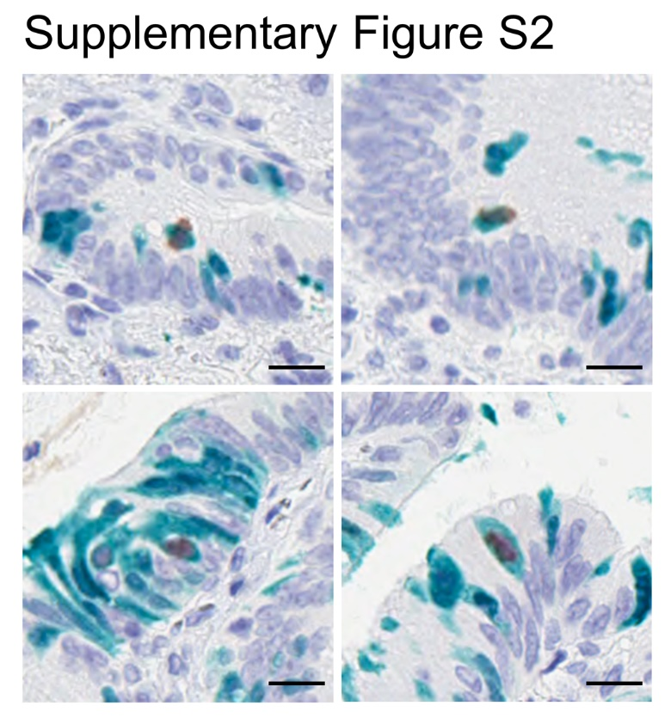
In sequential immunostaining, co-expression of PBK and PHH3 was observed. Bar = 20 µm.

Supplementary Figure S3. SDS-PAGE and immunoblot analyses of FLAG- or GST-tagged CDH1^{cyt} with or without mutations.
a, immunoblot analyses showing specific band shifts of FLAG-CDH1^{cyt/S840,846,847A} and FLAG-CDH1^{cyt/S840,846,847D} mutants. MG132, a proteosome inhibitor, did not affect CDH1^{cyt} expressions. In contrast, Luc2CP was accumulated in the MG132-treated group. b, coomassie Brilliant Blue staining of GST-tagged proteins synthetized in E. coli. 500ng of each protein was separated by SDS-page. c, in vitro kinase assay revealed that rPBK direct phosphorylated rHH3.1, while it failed to phosphorylate CDH1^{cyt/WILD}. NS, non-specific.

