**Supplementary**

**S1 Additional details on materials and methods**

**S1.1 Recalculation of Salinities**

In order to recalculate salinities measured as electrical conductivity (EC) the equation provided by Holzbecher (1998) was used:

$$S(mg/L) = -3.83 + 0.699 * EC(µS/cm)$$

**S1.2 Slug test results**

Each well was slug tested three times unless field conditions due to slow recovery were not allowing three replicates. The data was imported and analyzed with the software Aqtesolv (HydroSolve, Inc.) using Hvorslev solution (Hvorslev 1954). Summarized results are found in Table S1

**S1.3 Calculation of Rayleigh Number based on Wooding et al. (1997)**

The macroscopic Rayleigh Number is calculated by:

$R\text{s}=\frac{γgkH}{μD\text{M}}$,

with g= gravitational acceleration (9.81 m/s), µ= dynamic viscosity (1.3E-6 kg/m*s), DM = molecular diffusivity (1.2E-9 m2/s), γ=density difference between max. density and background liquid (0.2 at Ringkøbing Fjord), H= porous layer thickness (~20 m at Ringkøbing Fjord), k=permeability (m2).

*k*= ,

where K= average hydraulic conductivity (2.03E-4 m/s),ρf= density of freshwater (997 kg/m3),µ1=dynamic viscosity.

The Boundary Rayleigh number is calculated by:

$$R\text{δ}=\frac{u\text{c}}{ε}$$

With ε being the Evaporation rate approximated at Ringkøbing fjord to be 157mm/yr.

$u\text{c}=\frac{γ*g*k}{μ}$,

$k\text{min}=\frac{\text{µ}\text{*}R\text{δ}\text{*}ε}{g*γ}$,

**S1.4 EC of seepage flux**

The EC of seepage meter samples was measured for each replicate with HACH IntelliCAL CDC401 Standard conductivity probe connected to a HACH HQ40d instrument. From those measurements the EC of the measured flux was derived by a mass balance approach presented in Duque et al. 2019 as follows:

$$EC flux=\frac{\left[\left(W\text{off}-W\text{bag}\right)*EC\text{off}\right]-[\left(W\text{on}-W\text{bag}\right)*EC\text{on}]}{W\text{off}-W\text{on}}$$

Where Woff= weight of seepage bag after measurement,Wbag=Empty weight of seepage bag and attachement accessories, ECoff= EC of water in seepage bag after measurement, Won=Weight of seepage bag before measurement, ECon=EC of water in seepage bag before measurement.

**S1.5 References**

Duque, Jessen, Tirado-Conde, Karan, Engesgaard. Application of Stable Isotopes of Water to Study Coupled Submarine Groundwater Discharge and Nutrient Delivery. Water. 2019 Sep 4;11(9):1842.

Holzbecher, E. O. (1998). *Modeling Density-Driven Flow in Porous Media: Principles, Numerics, Software*. Springer-Verlag. <https://doi.org/10.1007/978-3-642-58767-2>

Hvorslev,Juul. (1951). *Time lag and soil permeability in ground-water observations* (Bulletin No. 36; Corps of Engineers, p. 57). U.S.Army. <http://luk.staff.ugm.ac.id/jurnal/freepdf/Hvorslev1951-USACEBulletin36.pdf>

Wooding, R.A., Tyler, S.W. and White, I. (1997) Convection in groundwater below an evaporating Salt Lake: 1. Onset of instability. Water Resources Research 33(6), 1199-1217.

**S2. Supplementary Tables**

Table S1. Hydraulic conductivities obtained for each piezometer using slug test with the falling head method. Location of each piezometer is shown in Figure 1. For each piezometer, three slug test replicates were obtained. Piezometers for which only one replicate was measured are marked by *. High standard deviations (SD) ocured for piezometers where at least one slug test deviated substantially form the two others.

|  |  |  |  |  |  |
| --- | --- | --- | --- | --- | --- |
| **piezometer** | **x-utm [m]** | **y-utm [m]** | **z [m a.s.l.]** | **avg. K [m/d]** | ***SD***  ***K [m/d]*** |
| **J1S** | 6205633 | 457302 | -0.3 | 13.19 | *0.3* |
| **J1D** | 6205633 | 457301 | -6 | 0.51 | *0.1* |
| **J2\*** | 6205623 | 457284 | -5 | 0.14 | *-* |
| **J3** | 6205619 | 457272 | -3 | 5.17 | *2.7* |
| **J4** | 6205615 | 457261 | -1 | 15.93 | *6.9* |
| **J6\*** | 6205611 | 457244 | -3 | 0.04 | *-* |
| **J7S** | 6205609 | 457231 | -1 | 15.68 | *1.5* |
| **J7D** | 6205609 | 457231 | -5 | 0.51 | *0.2* |
| **J8** | 6205610 | 457229 | -4 | 25.26 | *0.2* |
| **J9** | 6205610 | 457228 | -4 | 27.70 | *1.0* |
| **J10** | 6205610 | 457227 | -4 | 38.23 | *0.2* |
| **J11\*** | 6205609 | 457224 | -6 | 14.99 | *-* |
| **J5-1** | 6205610 | 457247 | -1 | 6.52 | *0.2* |
| **J5-2** | 6205610 | 457247 | -2 | 11.07 | *0.8* |
| **J5-3** | 6205610 | 457247 | -3 | 17.05 | *1.7* |
| **J5-4** | 6205610 | 457247 | -4 | 19.02 | *3.9* |
| **J5-5** | 6205610 | 457247 | -5 | 22.12 | *1.7* |
| **J5-6** | 6205610 | 457247 | -6 | 18.51 | *3.3* |
| **J5-7** | 6205610 | 457247 | -7 | 19.92 | *0.5* |
| **J5-8** | 6205610 | 457247 | -8 | 30.32 | *0.2* |
| **J5-9** | 6205610 | 457247 | -9 | 25.40 | *1.5* |
| **J5-10** | 6205610 | 457247 | -10 | 32.80 | *3.2* |
| **J5-11** | 6205610 | 457247 | -11 | 41.32 | *0.8* |
| **J5-12** | 6205610 | 457247 | -12 | 67.68 | *12.1* |
| **J4D-4** | 6205615 | 457262 | -4 | 9.64 | *5.3* |
| **J4D-8** | 6205615 | 457262 | -8 | 7.63 | *2.6* |
| **J4D-10** | 6205615 | 457262 | -10 | 3.57 | *0.3* |
| J4D-12 | 6205615 | 457262 | -12 | 1.10 | *0.2* |

Table S2. Flux q is used to deﬁne the range of qeast. Water levels in regional piezometer were measured at diﬀerent times, therefore an average from all contributing piezometer (listed in Table S2) was considered. Its value was compared to the average stage at Ringkøbing Fjord (∆h). These piezometer were also in diﬀerent distance to the lagoon shore, hence maximum and minimum distances were used to calculate the hydraulic gradient. Darcy law with an average K of 17.54 m/d was then used to compute ﬁnal ﬂuxes according to their distance. Similar approach was used for the outermost piezometer J1d also, where the average water level between October 2014 and July 2015 was used.

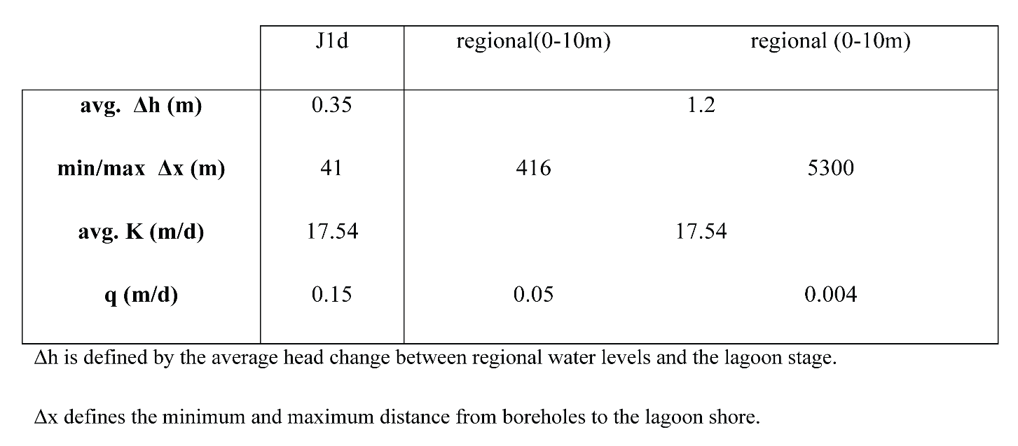

***S*3. Supplementary Figures**

Figure S1. Borehole information in the vicinity of the study site. Data were extracted from the Jupiter database (geus.dk). Depths are in meter below surface (mbs). The horizontal line indicate sea level according to the Danish normal null (DNN) reference elevation.

