**Supplementary Figures: Central aortic waveform-derived parameters obtained using Mobil-O-Graph device: Body height-related percentiles**

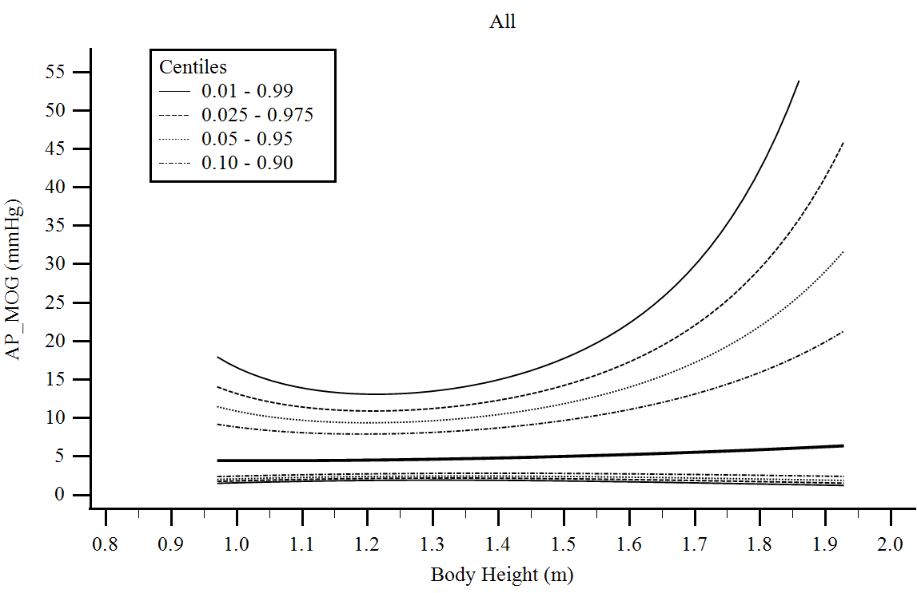

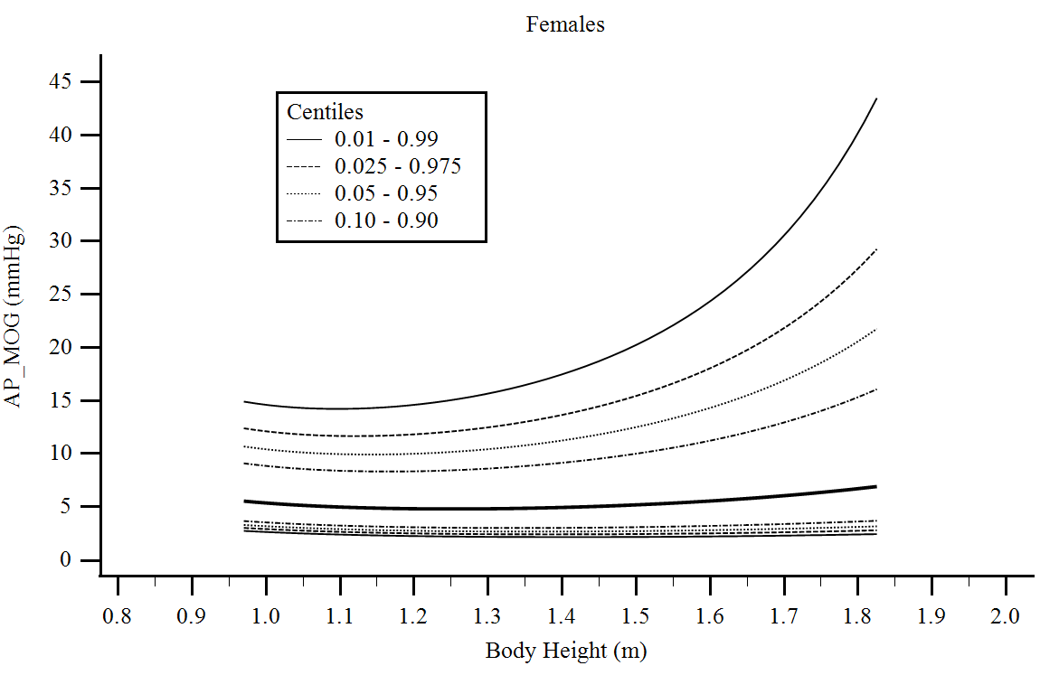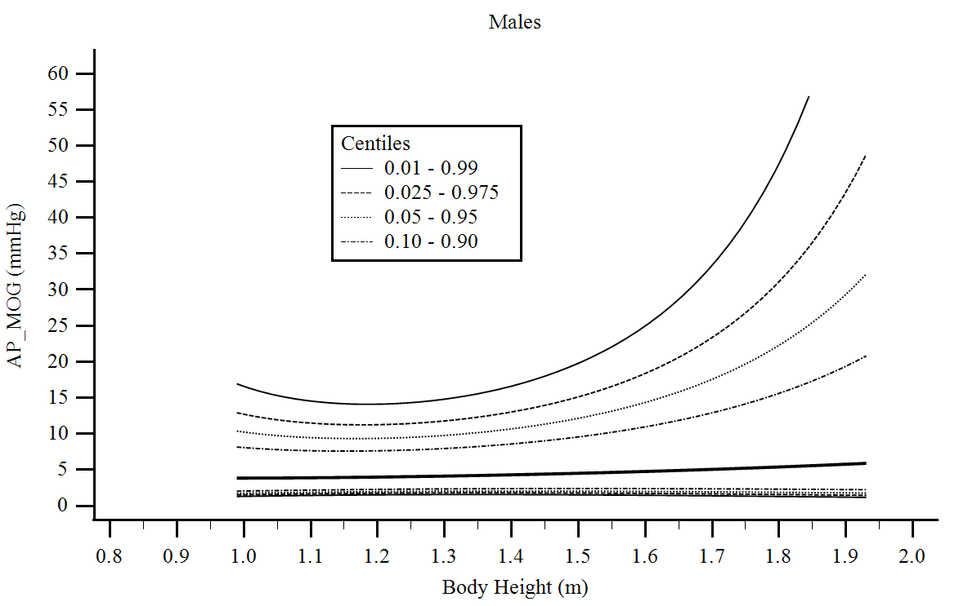

Supplementary Figure 22. Central aortic waveform-derived parameters obtained using Mobil-O-Graph device (MOG): Augmentation Pressure (AP) body height-related percentiles.

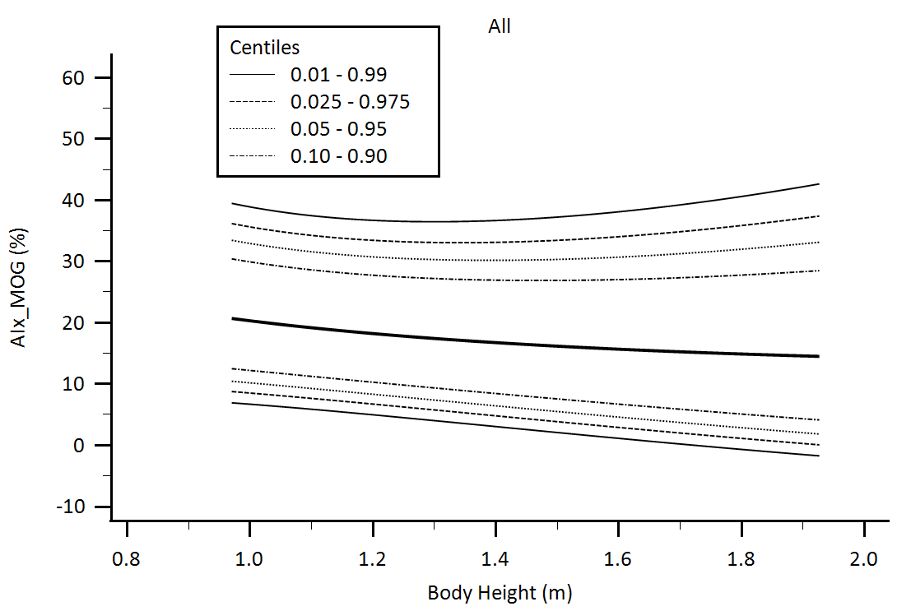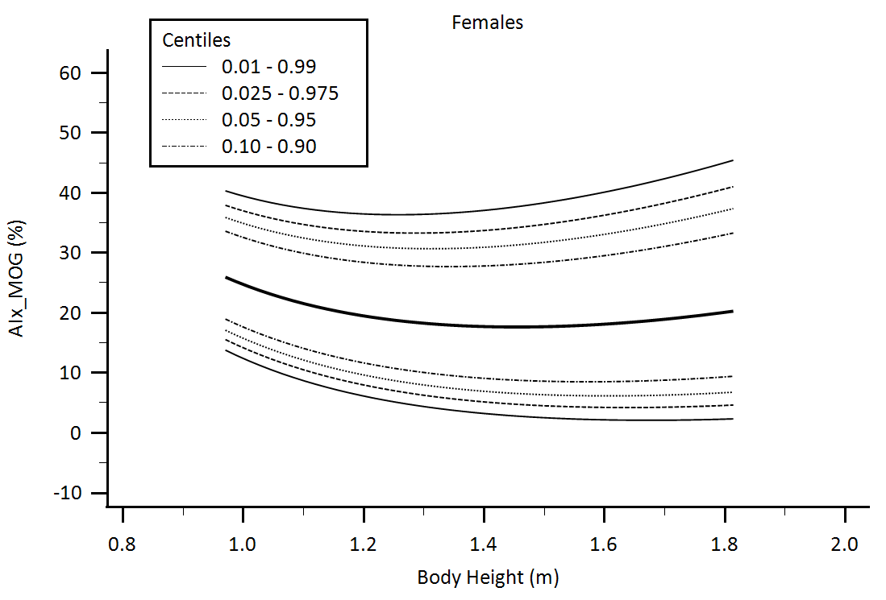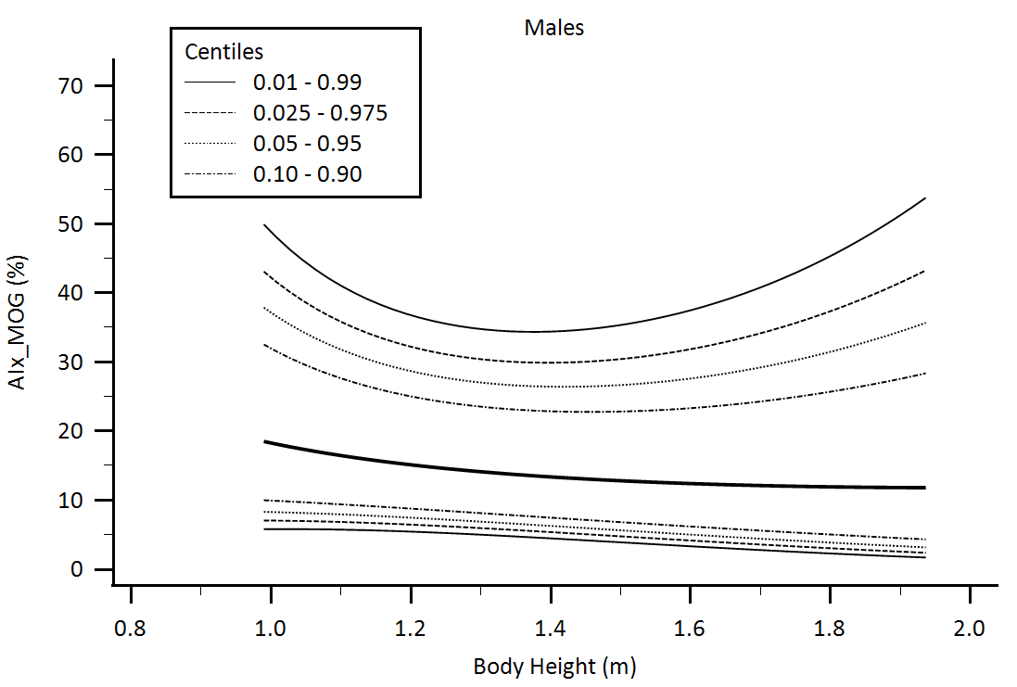

Supplementary Figure 23. Central aortic waveform-derived parameters obtained using Mobil-O-Graph device (MOG): Augmentation Index (AIx) body height-related percentiles.

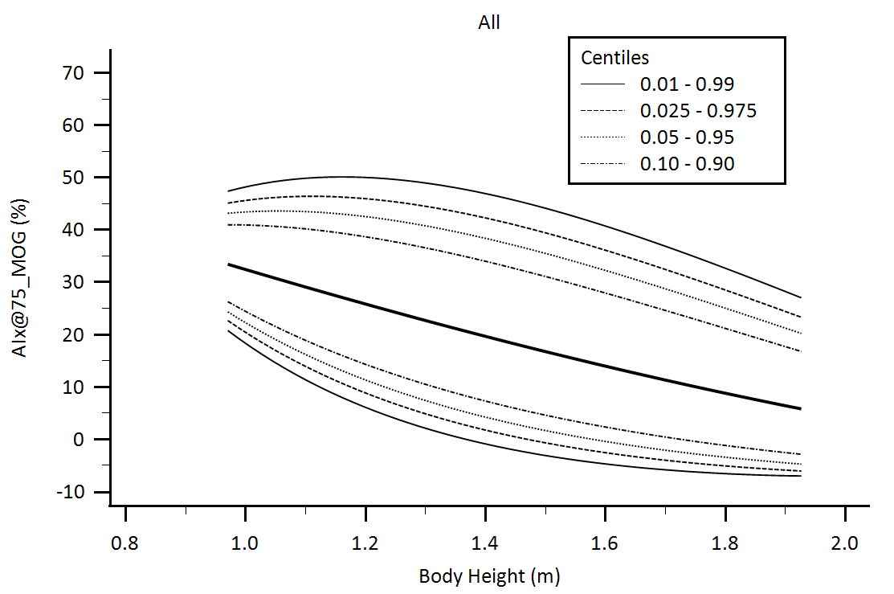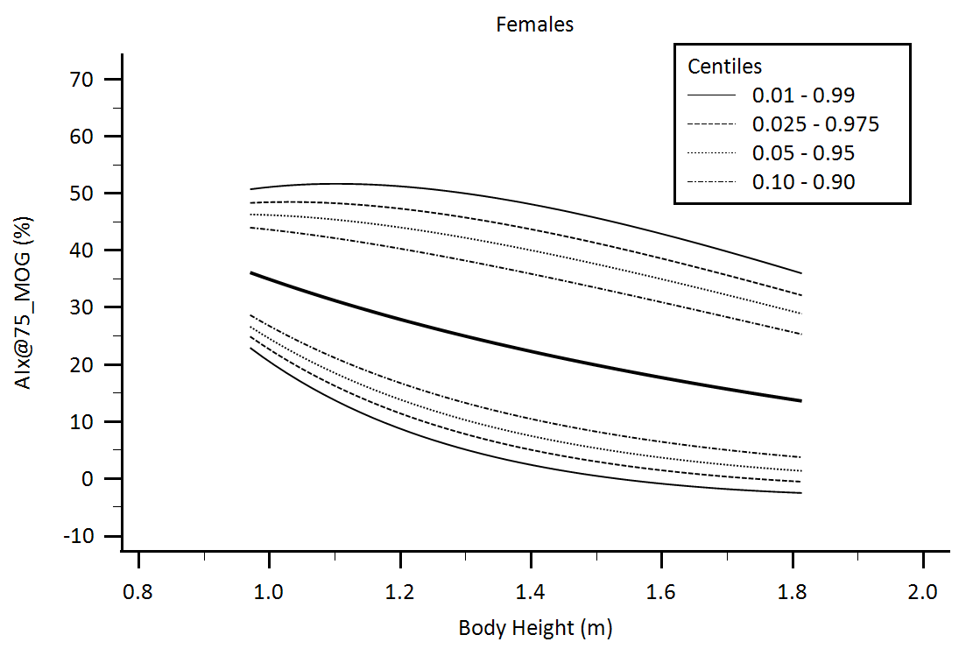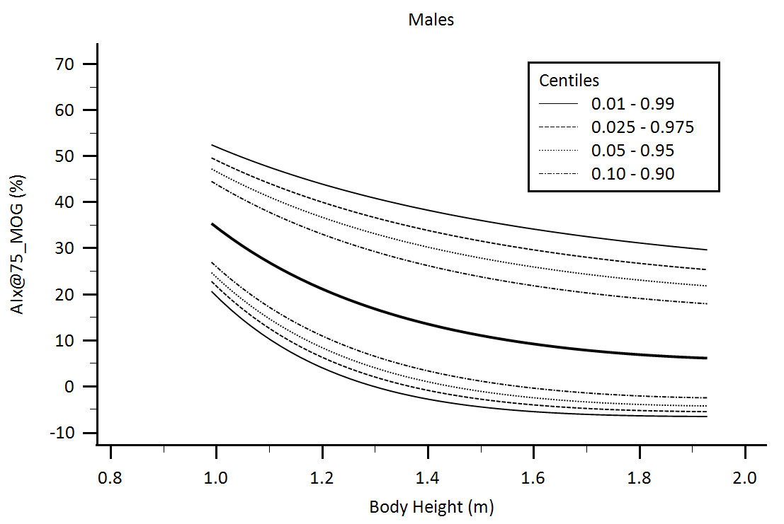

Supplementary Figure 24. Central aortic waveform-derived parameters obtained using Mobil-O-Graph device (MOG): Augmentation Index adjusted for heart rate equal 75 beats/minute (AIx@75) body height-related percentiles.

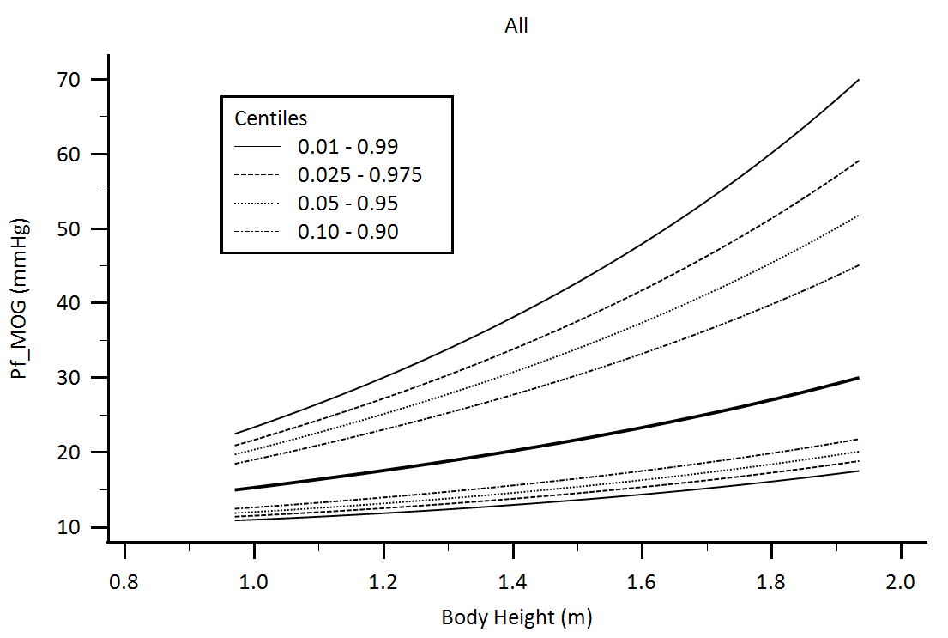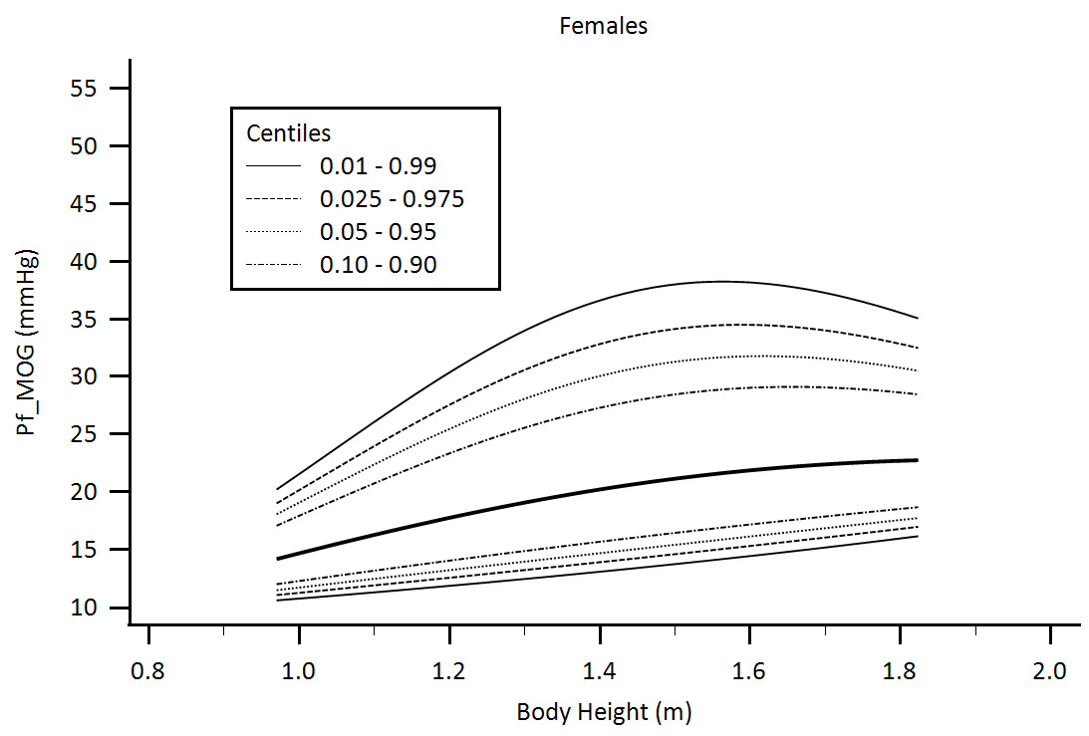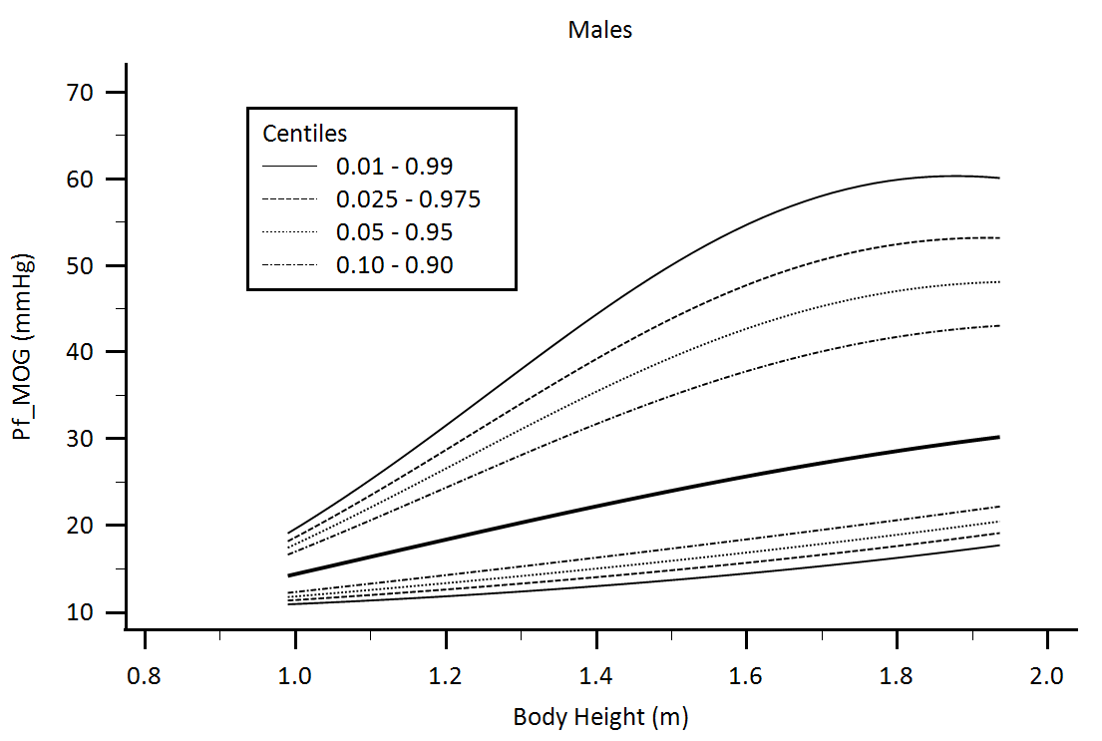

Supplementary Figure 25. Central aortic waveform-derived parameters obtained using Mobil-O-Graph device (MOG): Forward pressure (Pf) body height-related percentiles.

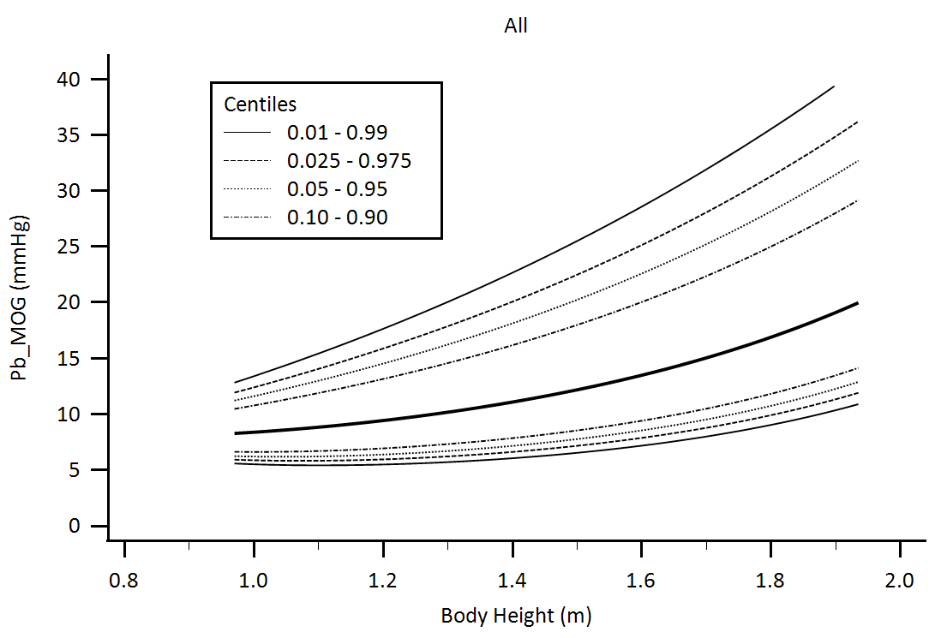

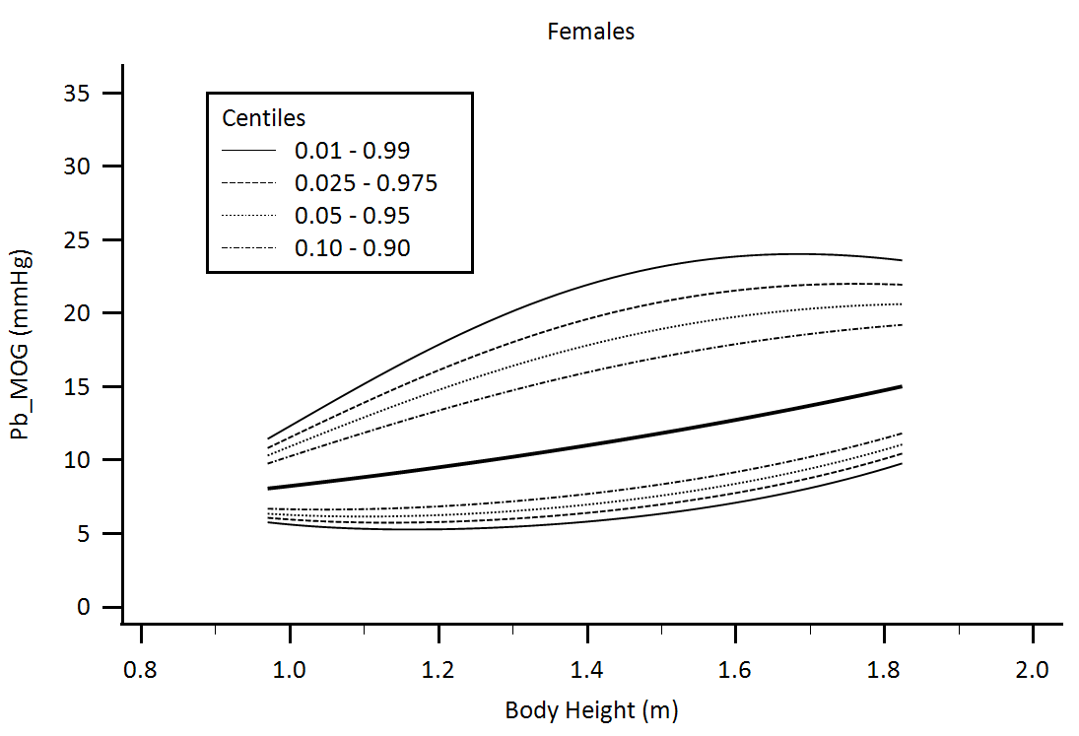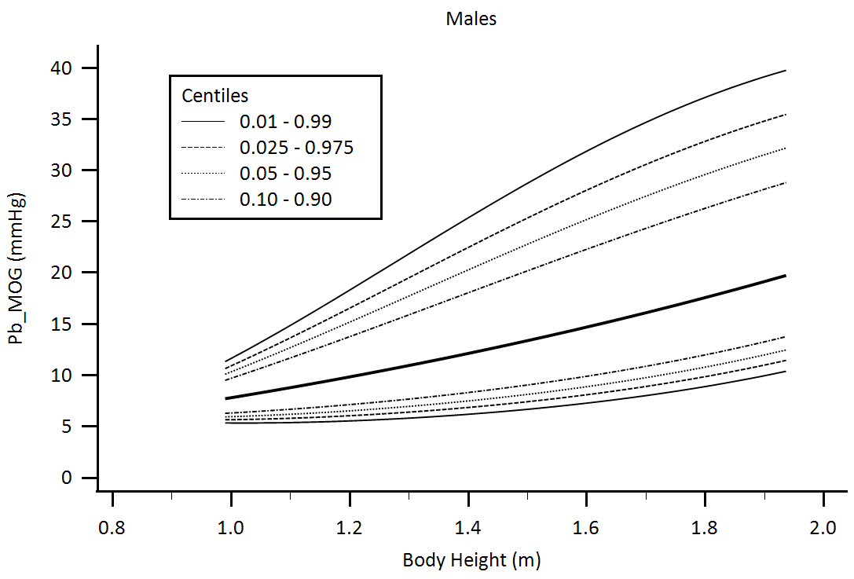

Supplementary Figure 26. Central aortic waveform-derived parameters obtained using Mobil-O-Graph device (MOG): Backward pressure (Pb) body height-related percentiles.

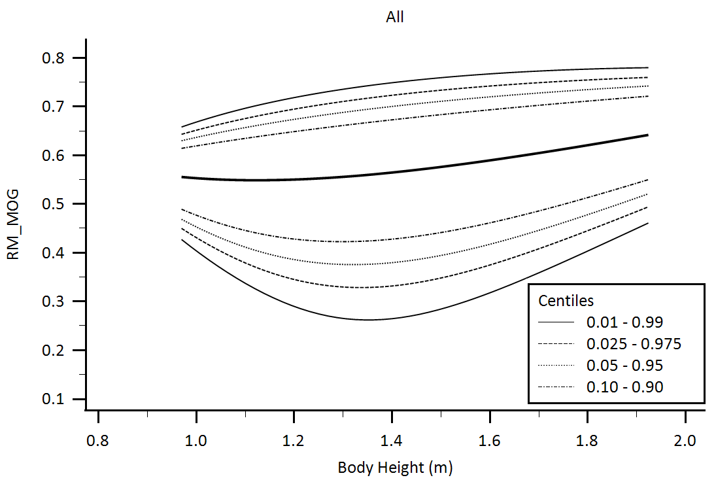

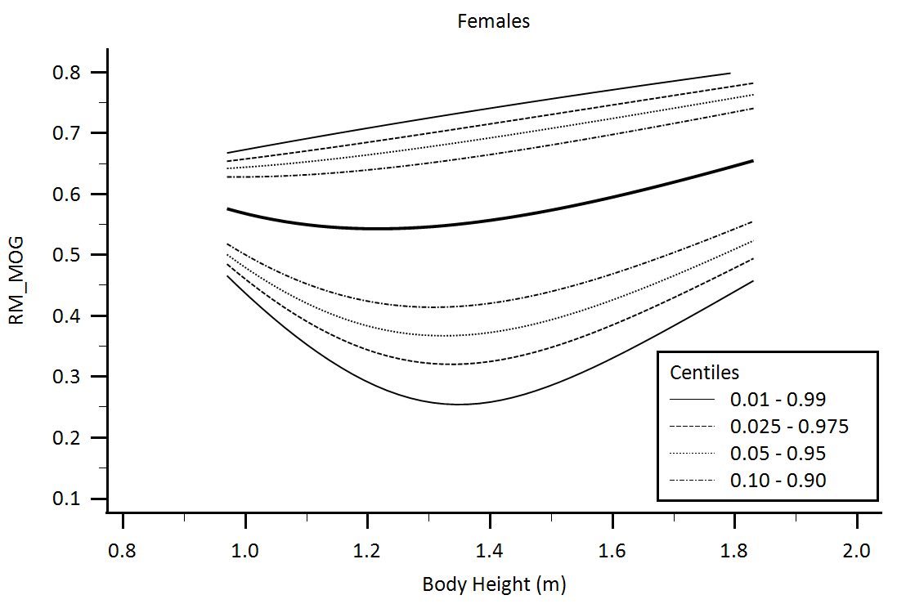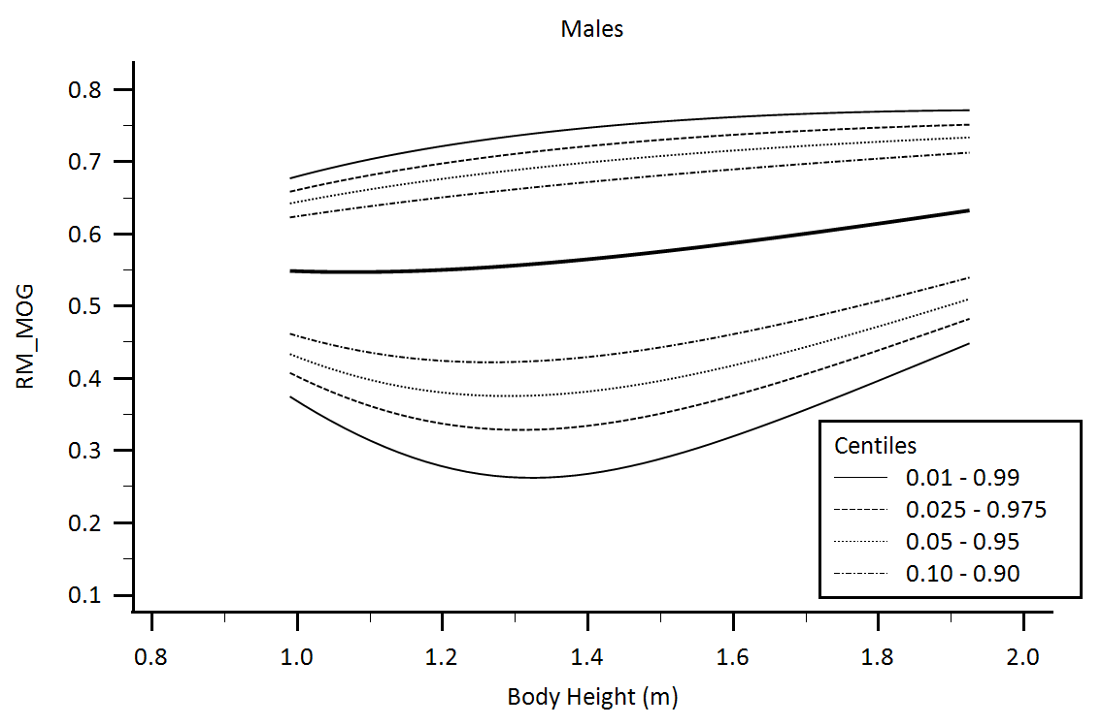

Supplementary Figure 27. Central aortic waveform-derived parameters obtained using Mobil-O-Graph device (MOG): Reflection Magnitude (RM) body height-related percentiles.

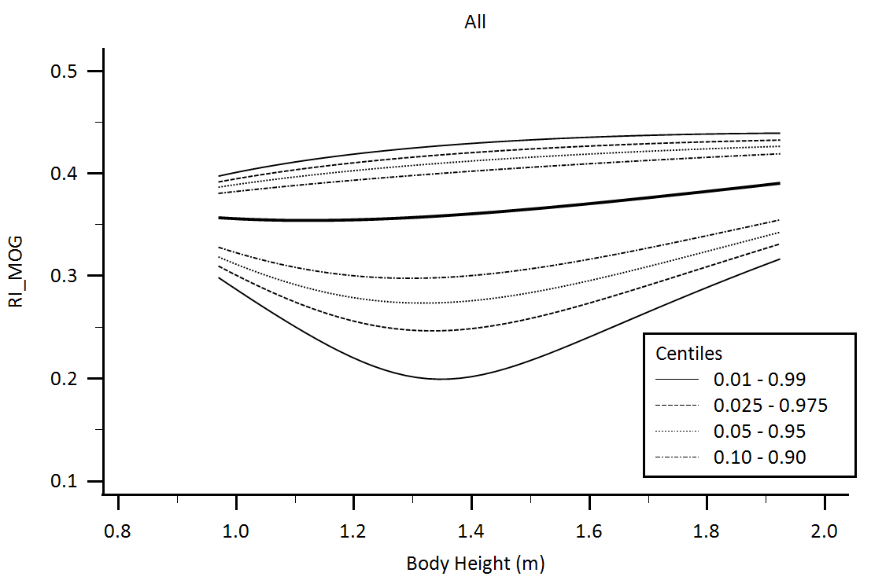

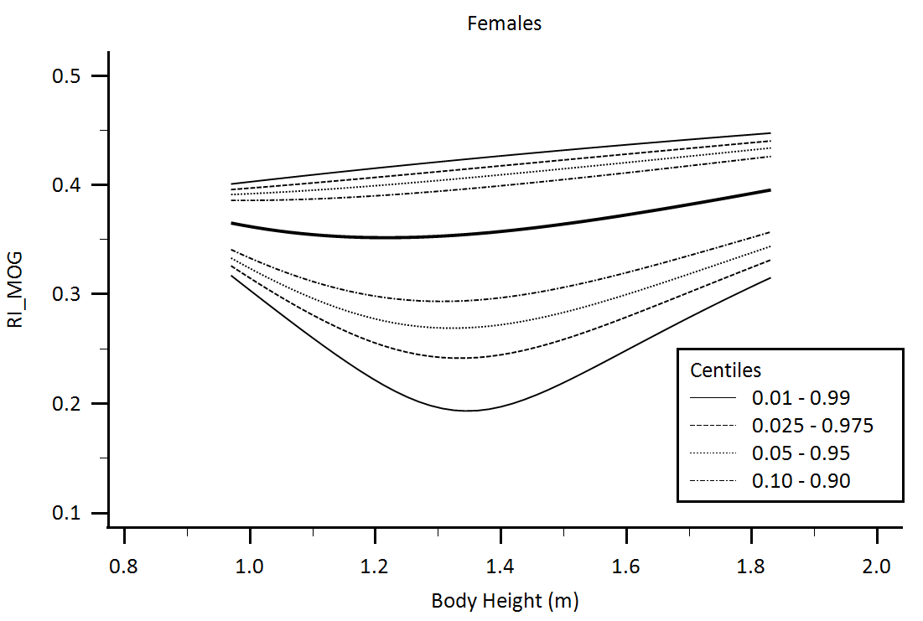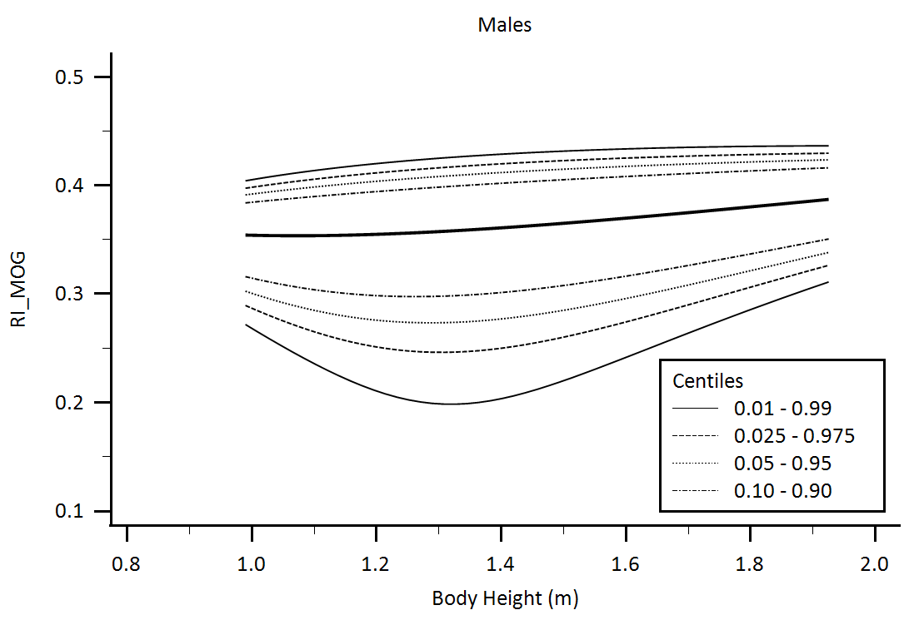

Supplementary Figure 28. Central aortic waveform-derived parameters obtained using Mobil-O-Graph device (MOG): Reflection Index (RI) body height-related percentiles.

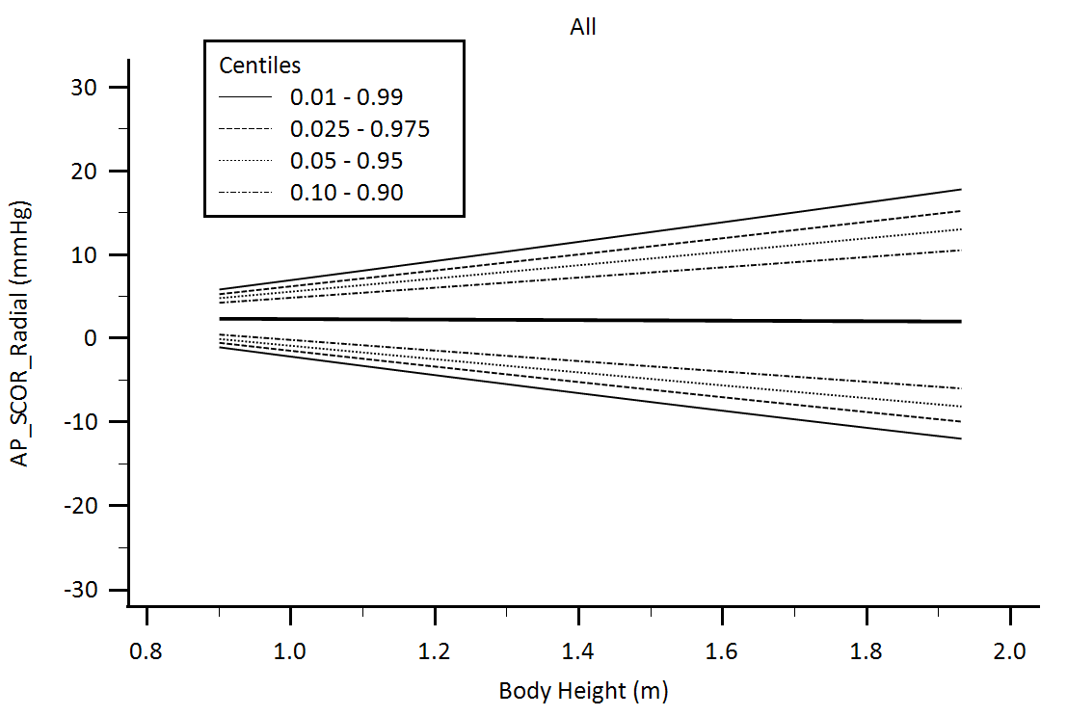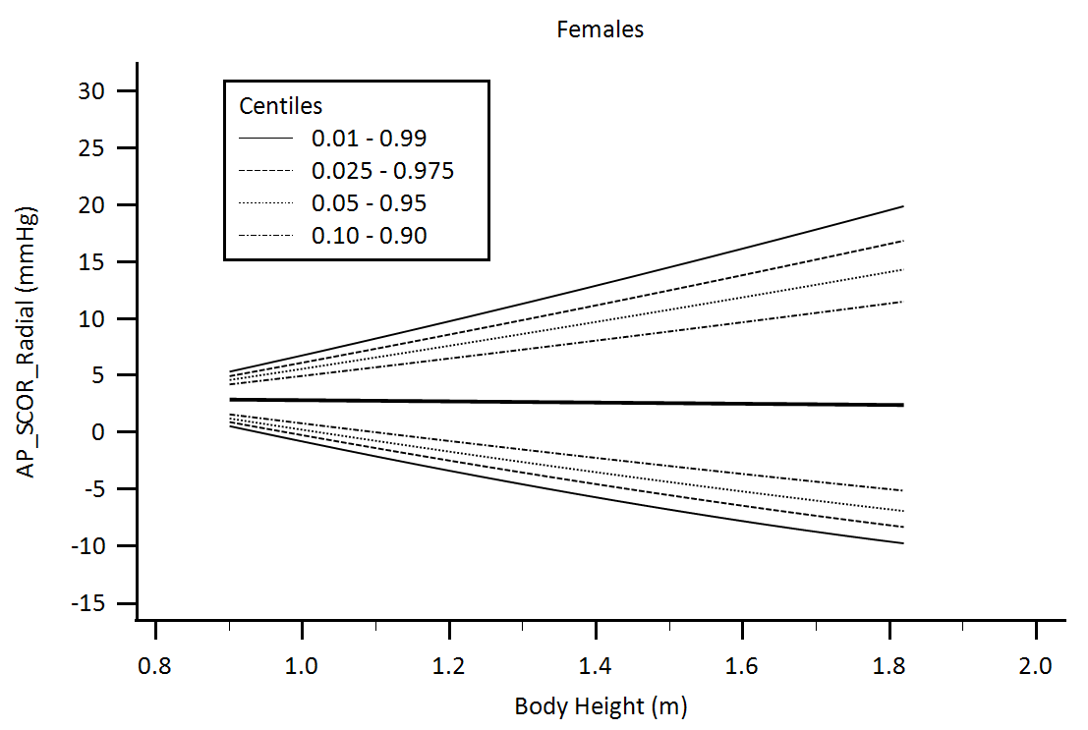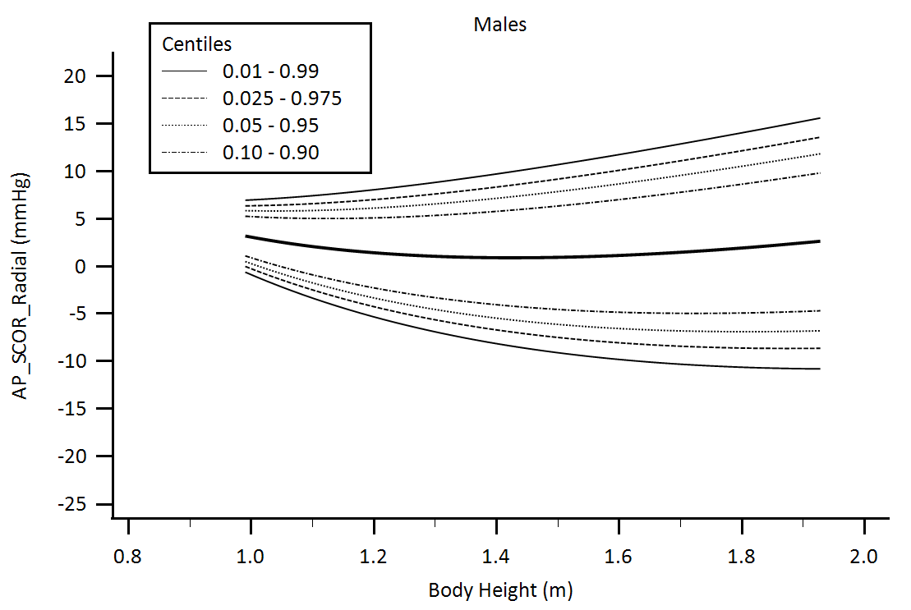

Supplementary Figure 29. Central aortic waveform-derived parameters obtained using radial artery applanation tonometry (SphygmoCor device, SCOR): Augmentation pressure (AP) body height-related percentiles.

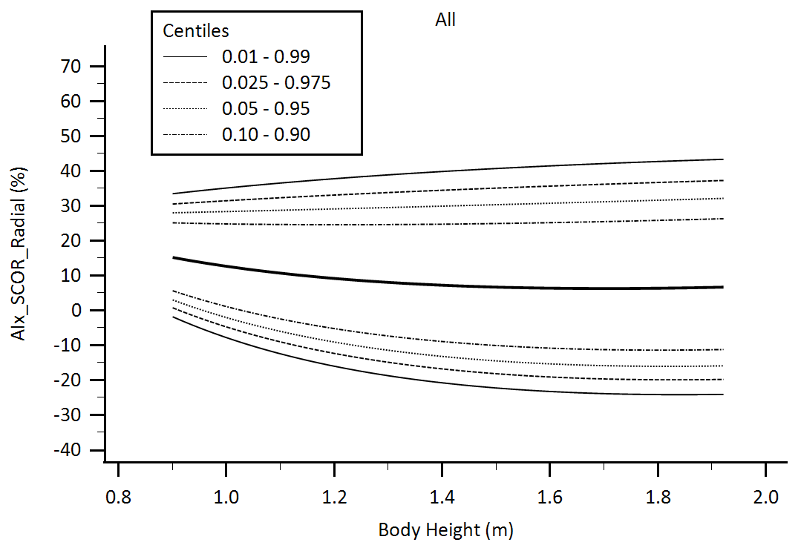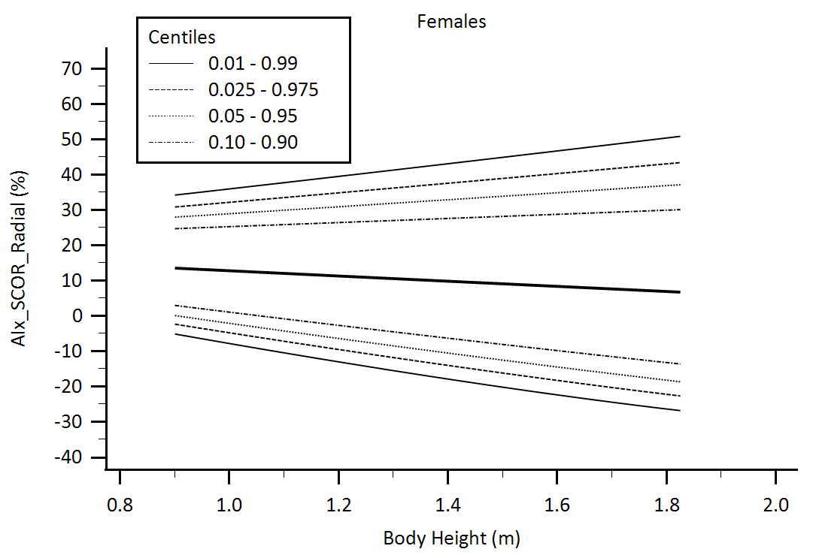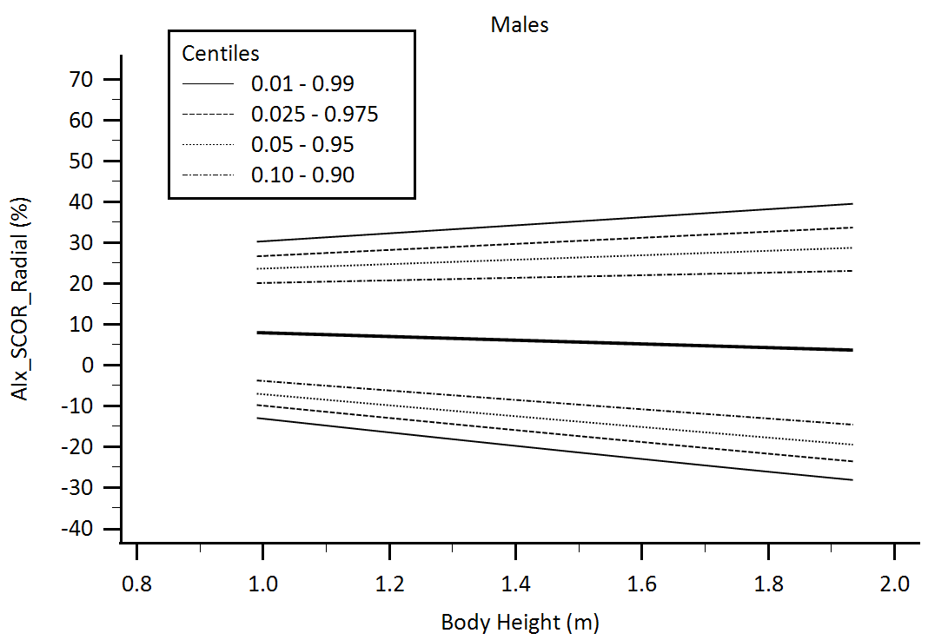

Supplementary Figure 30. Central aortic waveform-derived parameters obtained using radial artery applanation tonometry (SphygmoCor device, SCOR): Augmentation Index (AIx) body height-related percentiles.

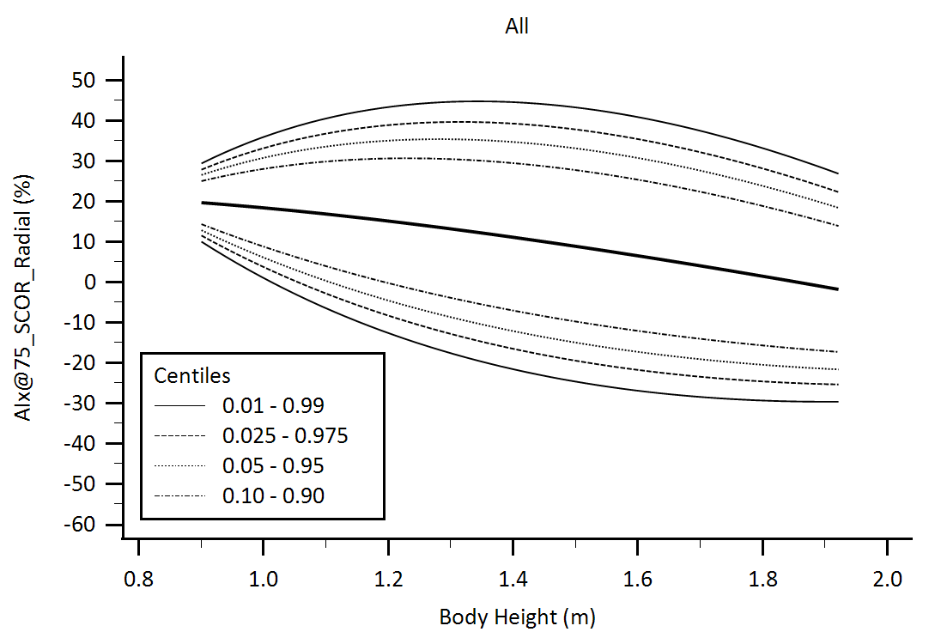

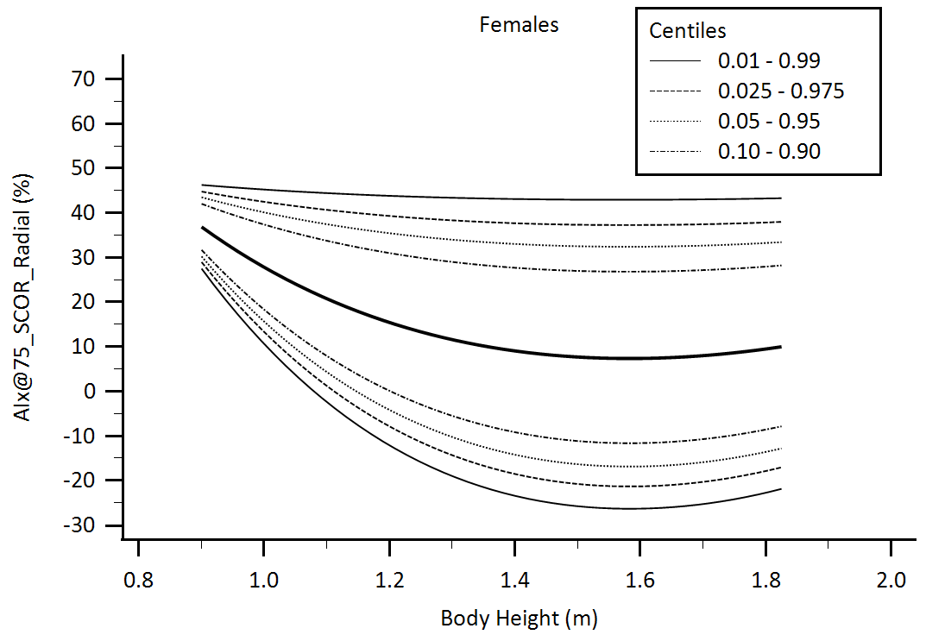

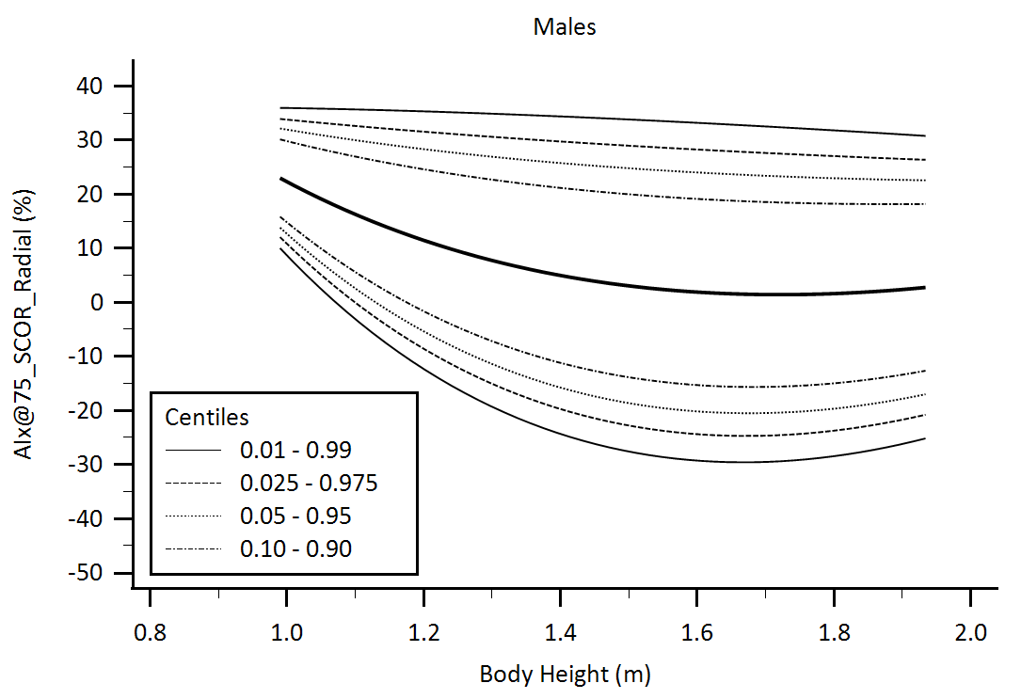

Supplementary Figure 31. Central aortic waveform-derived parameters obtained using radial artery applanation tonometry (SphygmoCor device, SCOR): Augmentation Index adjusted for heart rate equal 75 beats/minute (AIx@75) body height-related percentiles.

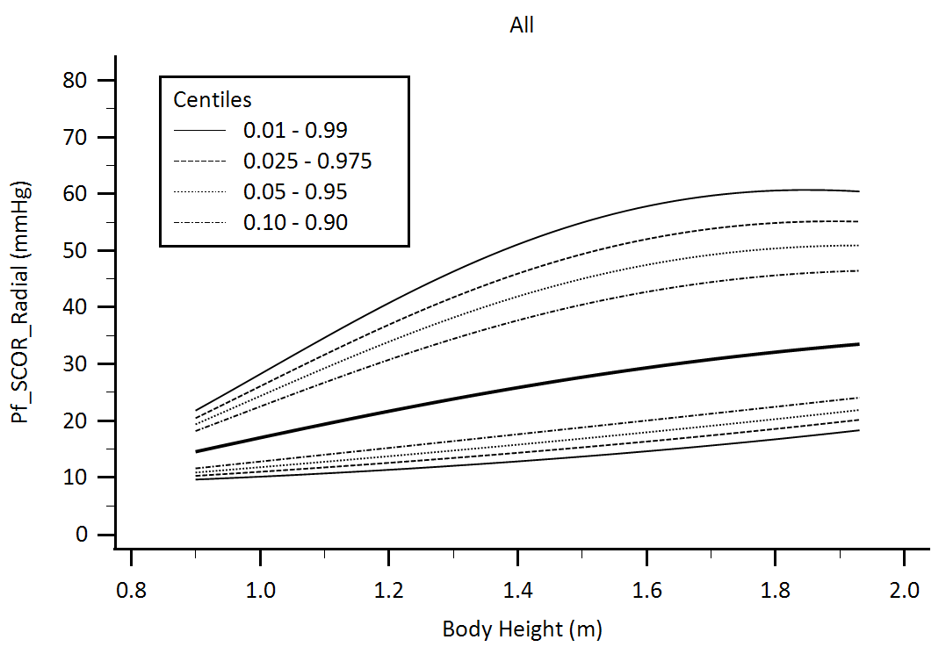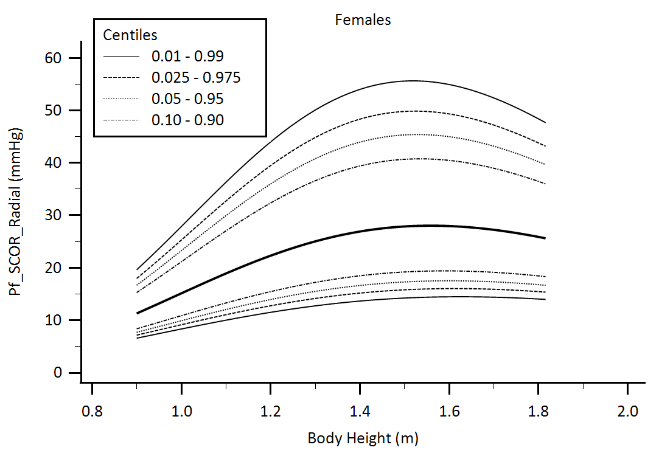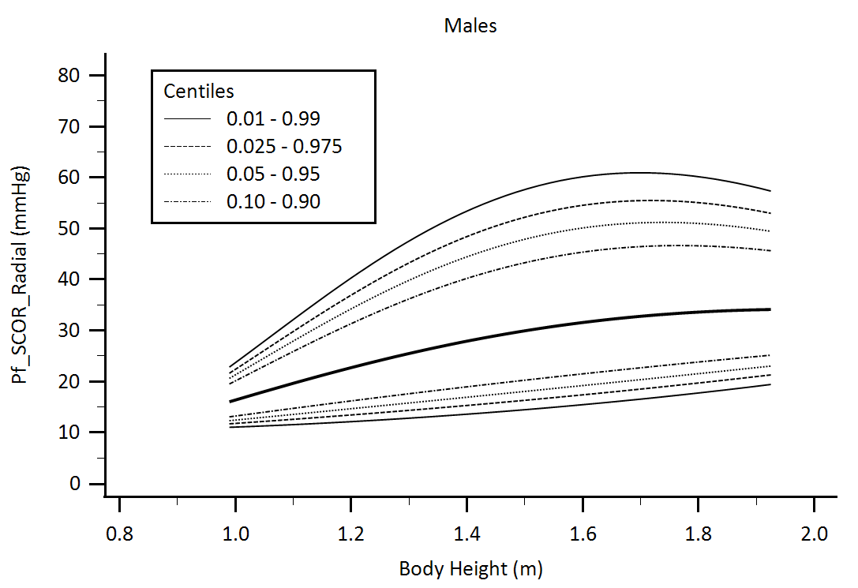

Supplementary Figure 32. Central aortic waveform-derived parameters obtained using radial artery applanation tonometry (SphygmoCor device, SCOR): Forward Pressure (Pf) body height-related percentiles.

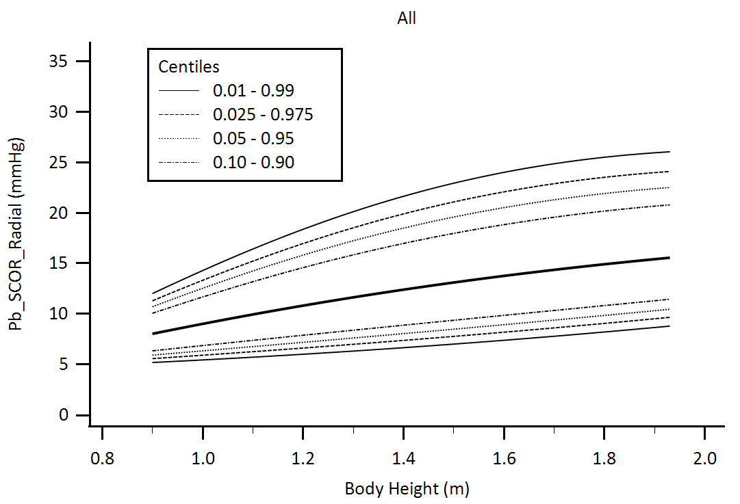

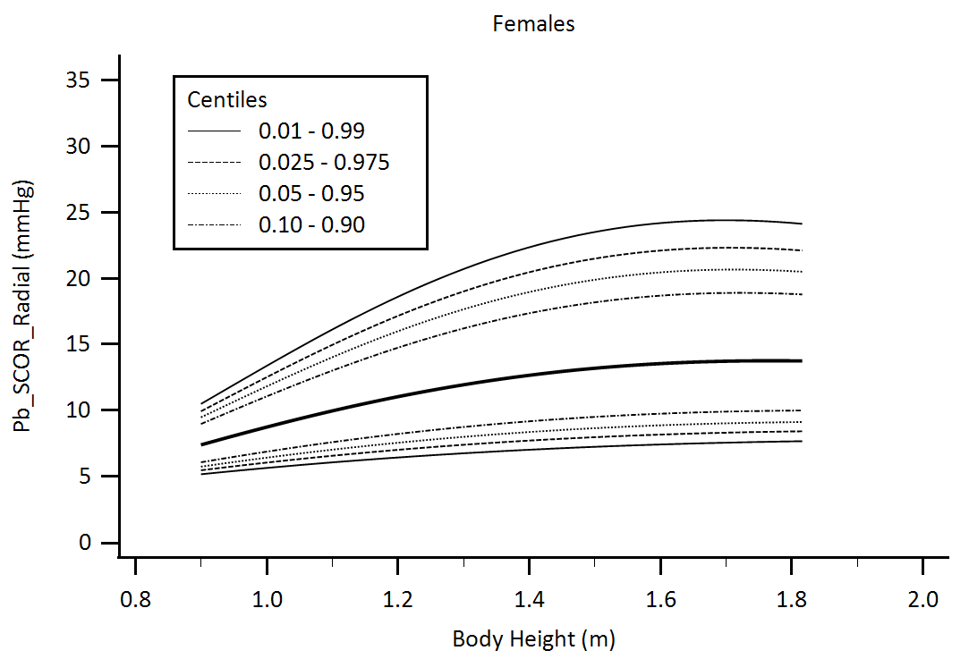

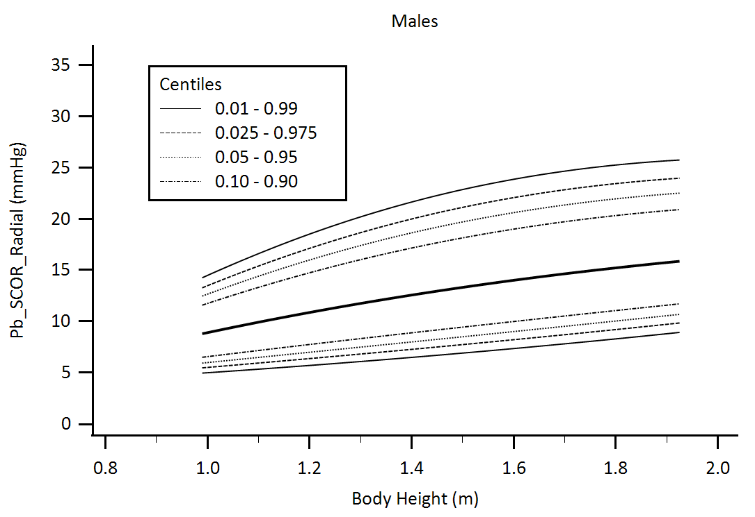

Supplementary Figure 33. Central aortic waveform-derived parameters obtained using radial artery applanation tonometry (SphygmoCor device, SCOR): Backward Pressure (Pb) body height-related percentiles.

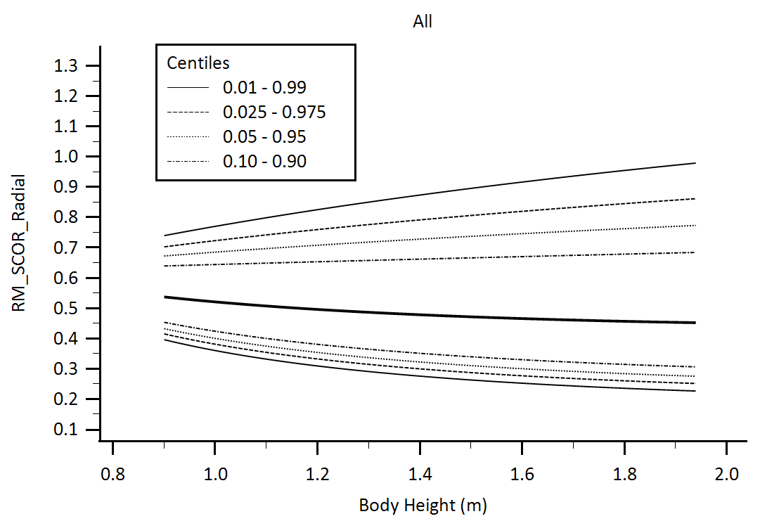

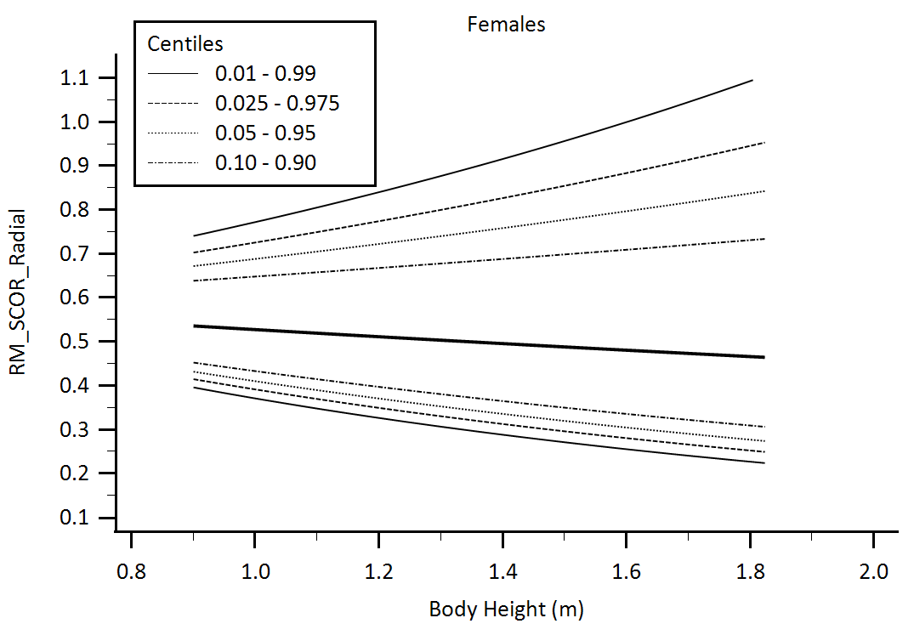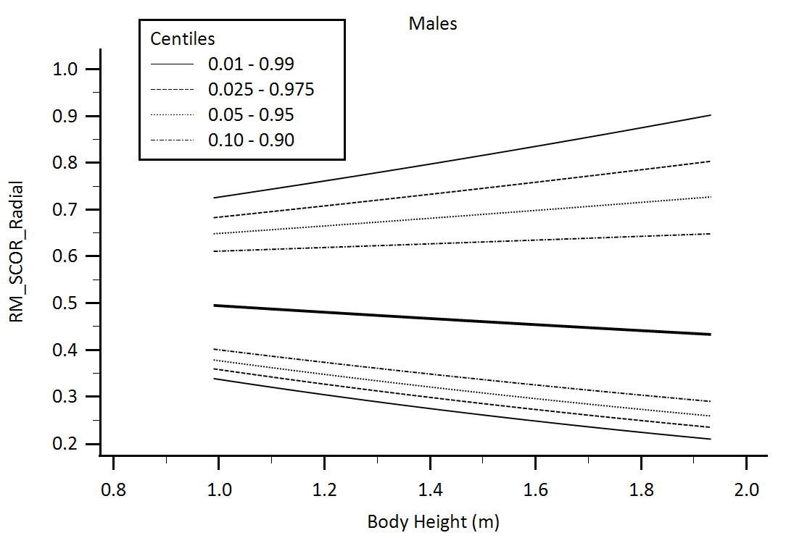

Supplementary Figure 34. Central aortic waveform-derived parameters obtained using radial artery applanation tonometry (SphygmoCor device, SCOR): Reflection Magnitude (RM) body height-related percentiles.

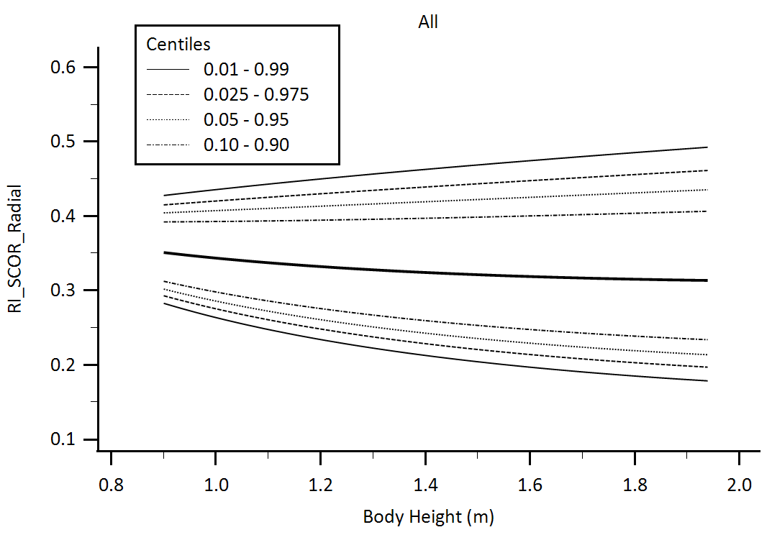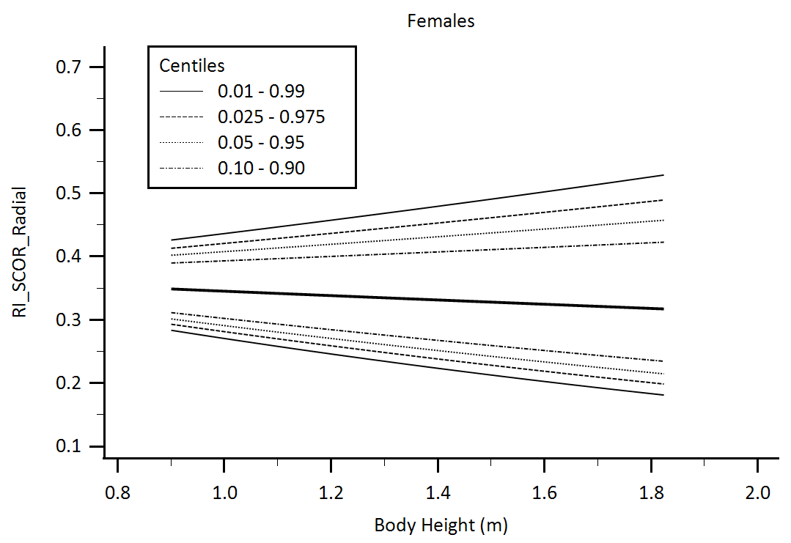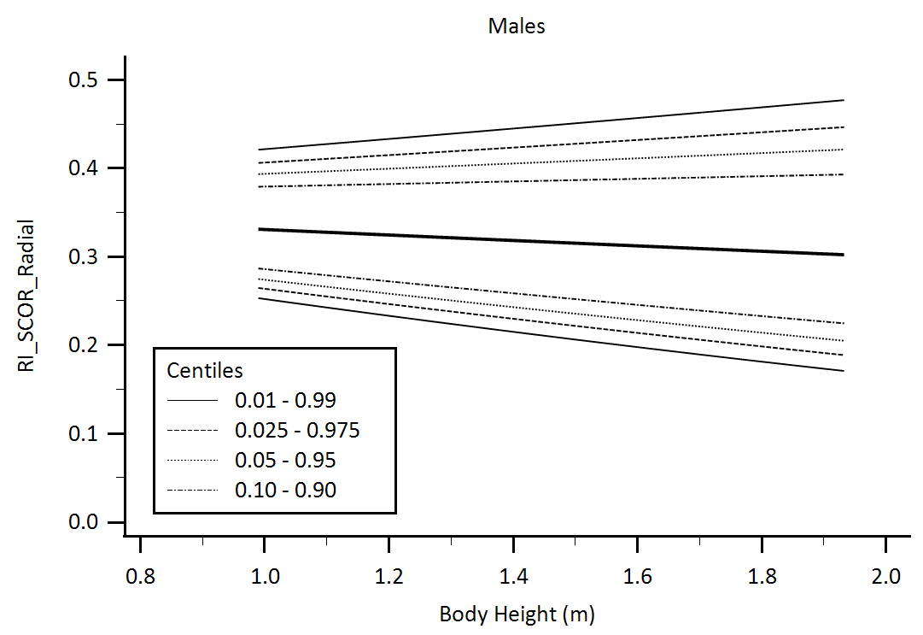

Supplementary Figure 35. Central aortic waveform-derived parameters obtained using radial artery applanation tonometry (SphygmoCor device, SCOR): Reflection Index (RI) body height-related percentiles.

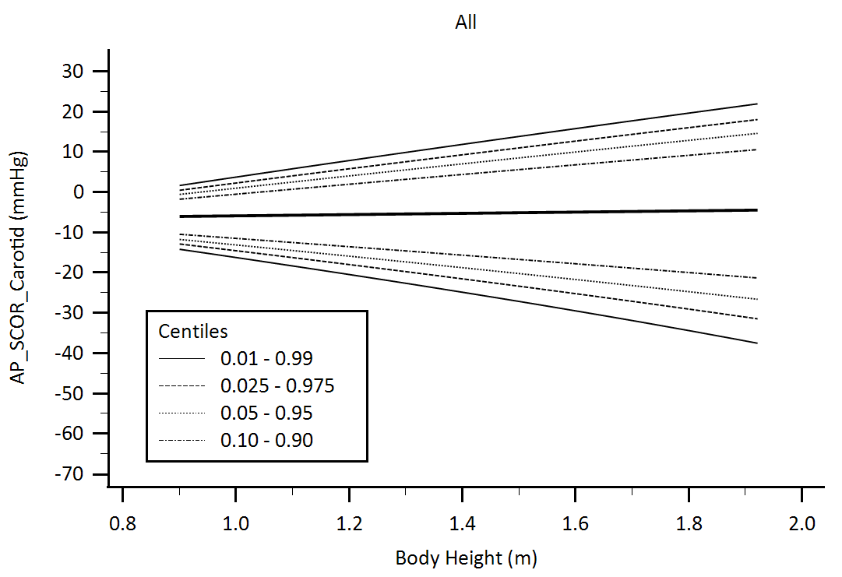

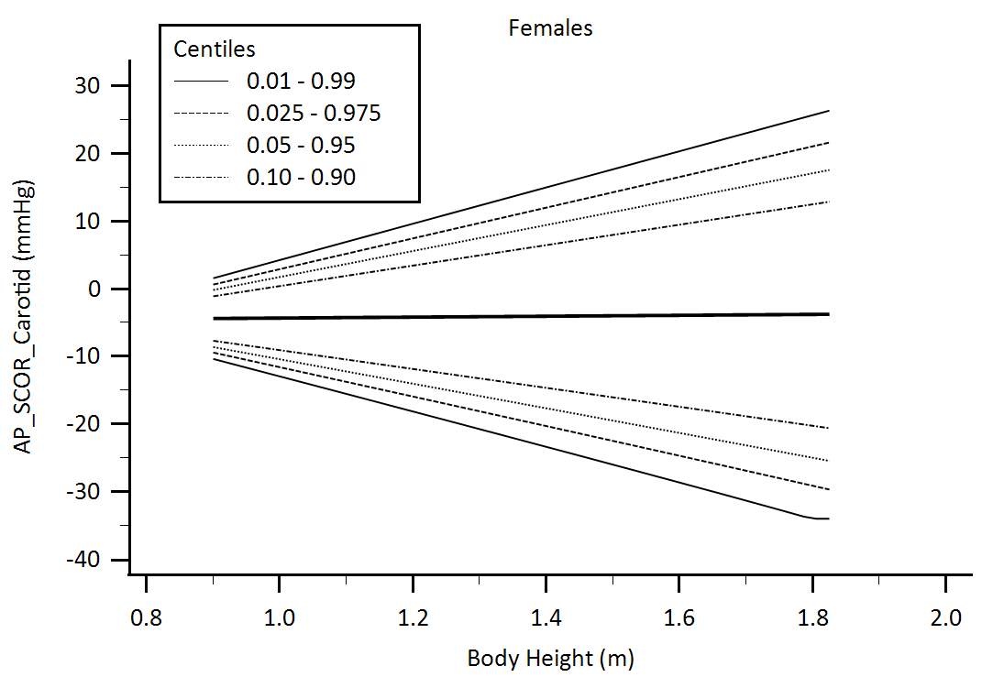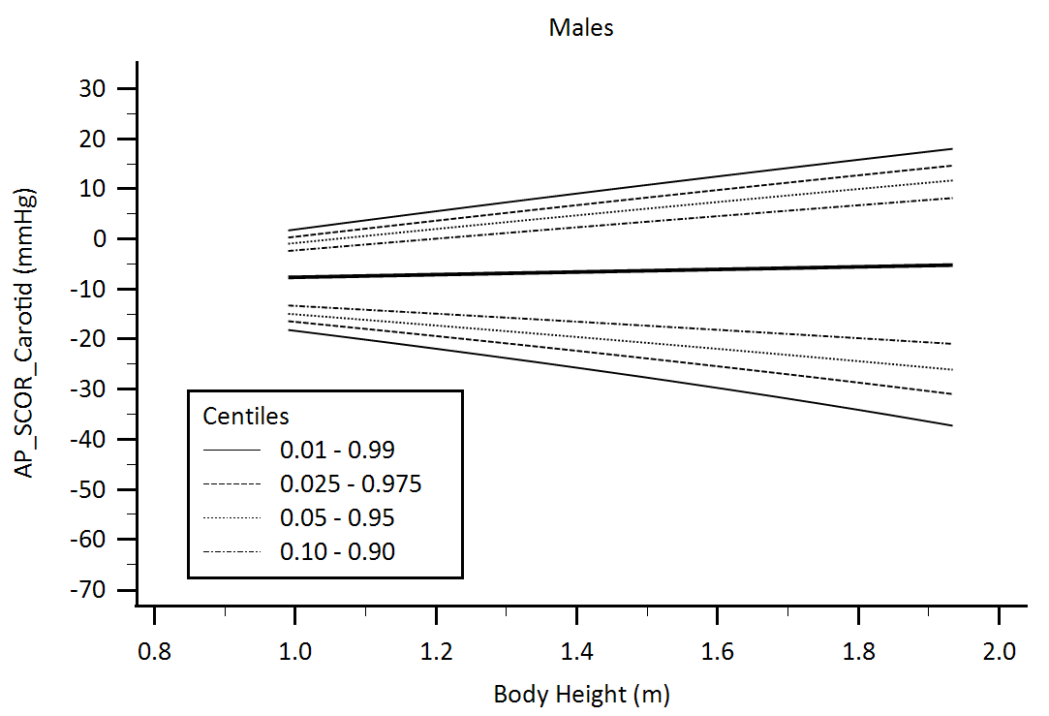

Supplementary Figure 36. Central aortic waveform-derived parameters obtained using carotid artery applanation tonometry (SphygmoCor device, SCOR): Augmentation Pressure (AP) body height-related percentiles.

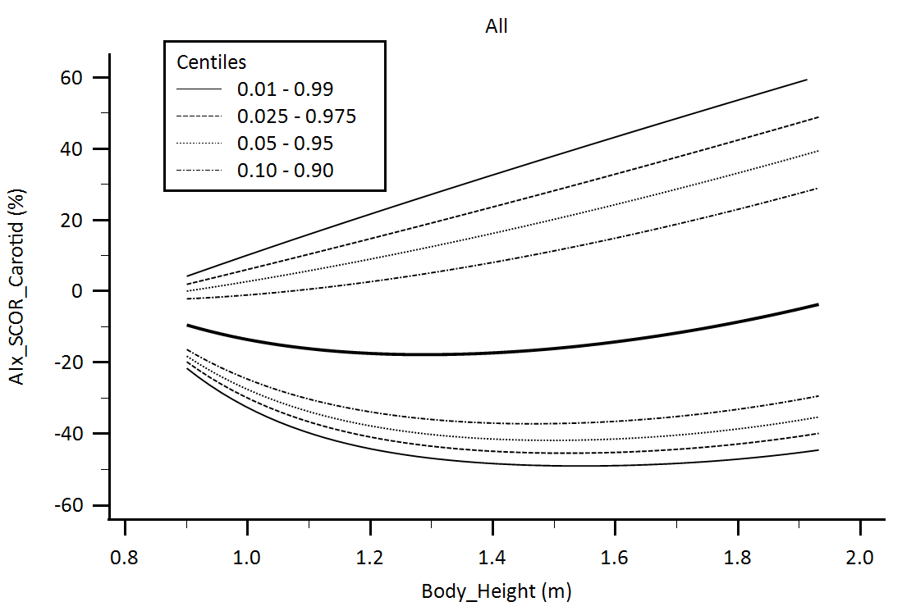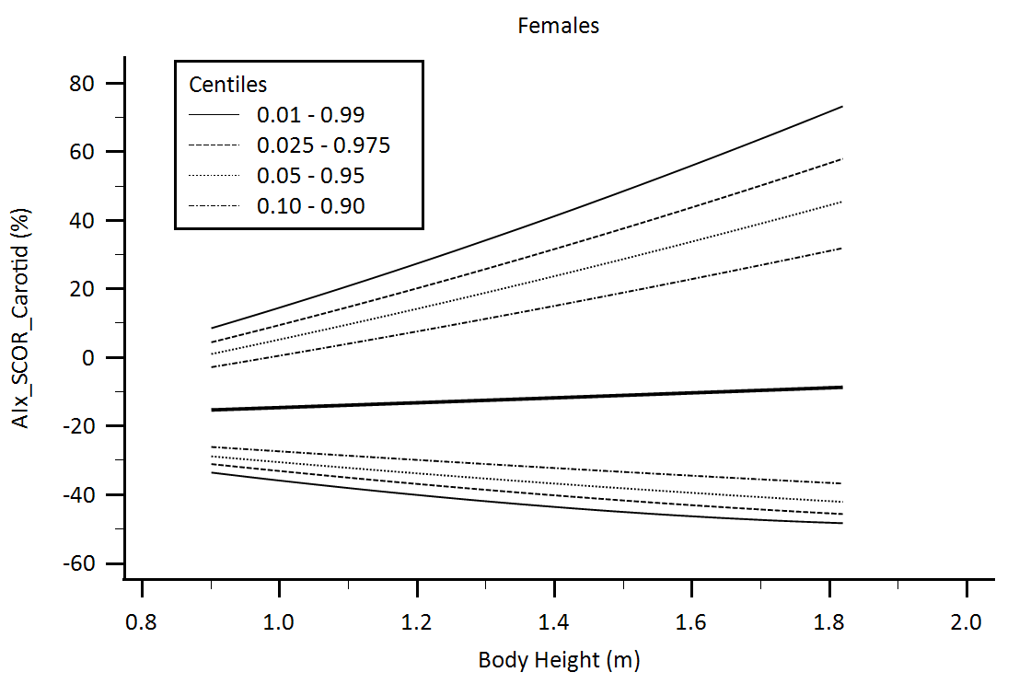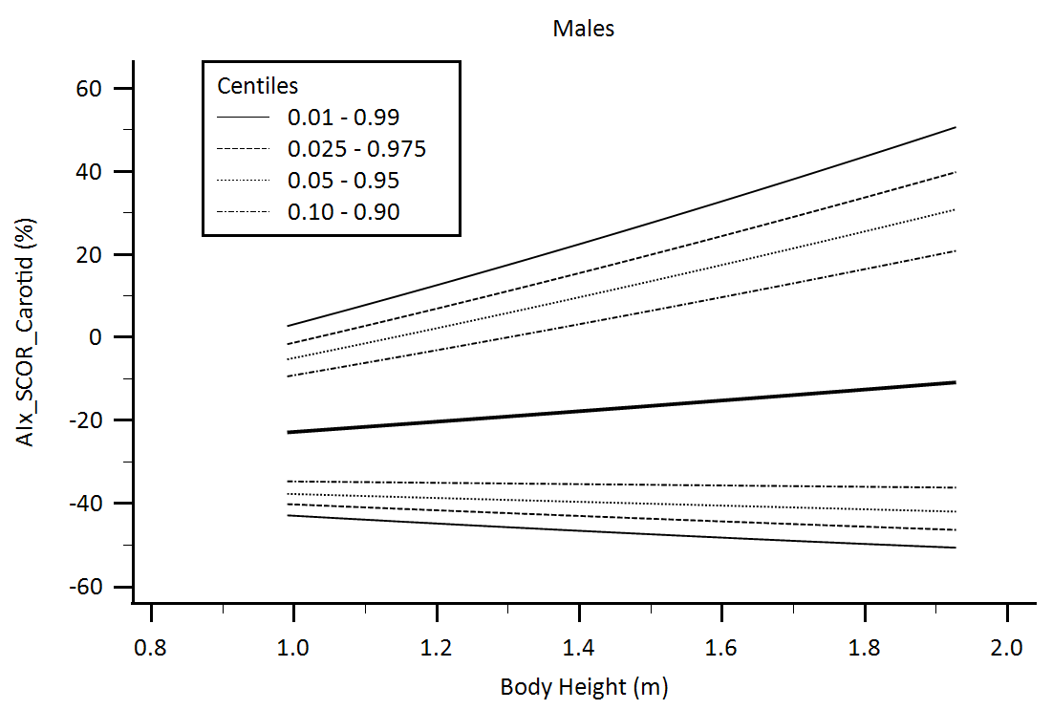

Supplementary Figure 37. Central aortic waveform-derived parameters obtained using carotid artery applanation tonometry (SphygmoCor device, SCOR): Augmentation Index (AIx) body height-related percentiles.

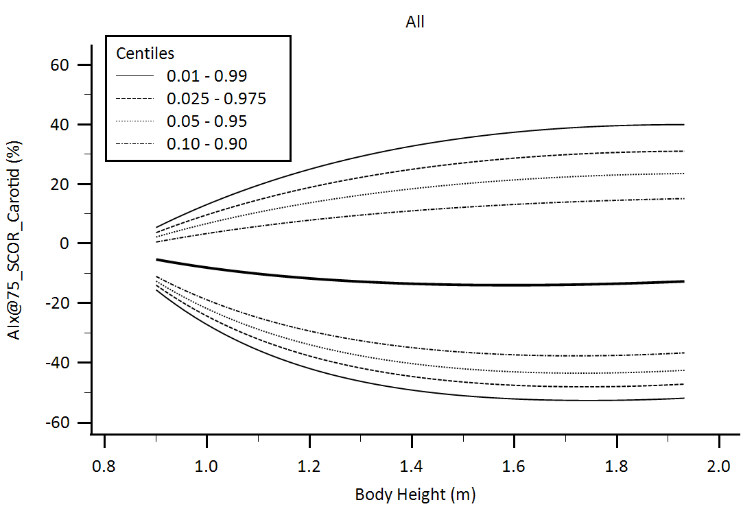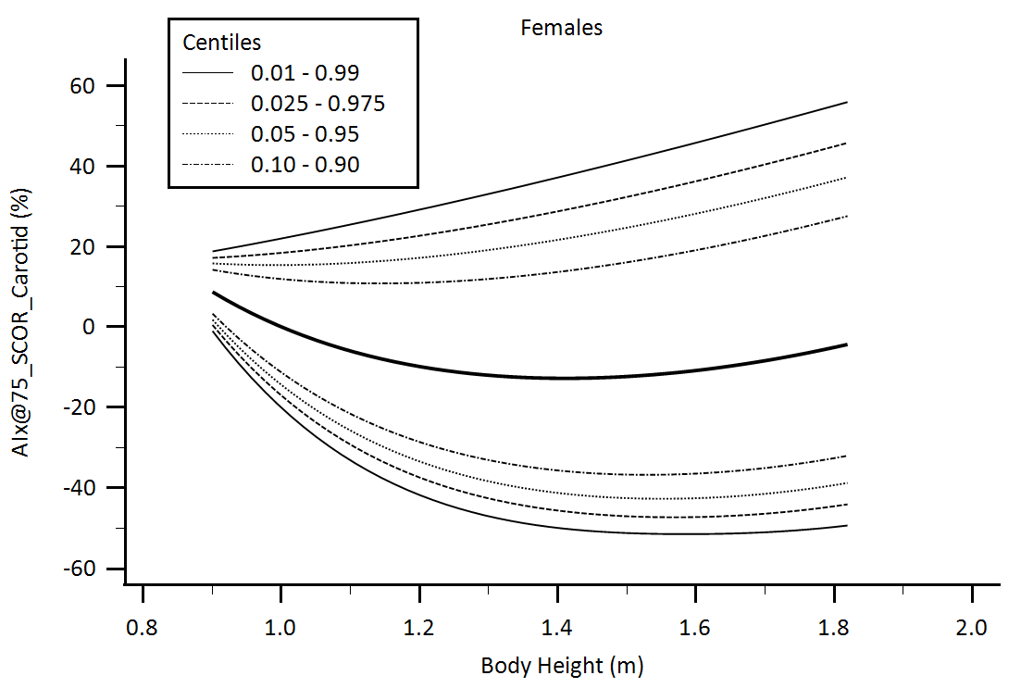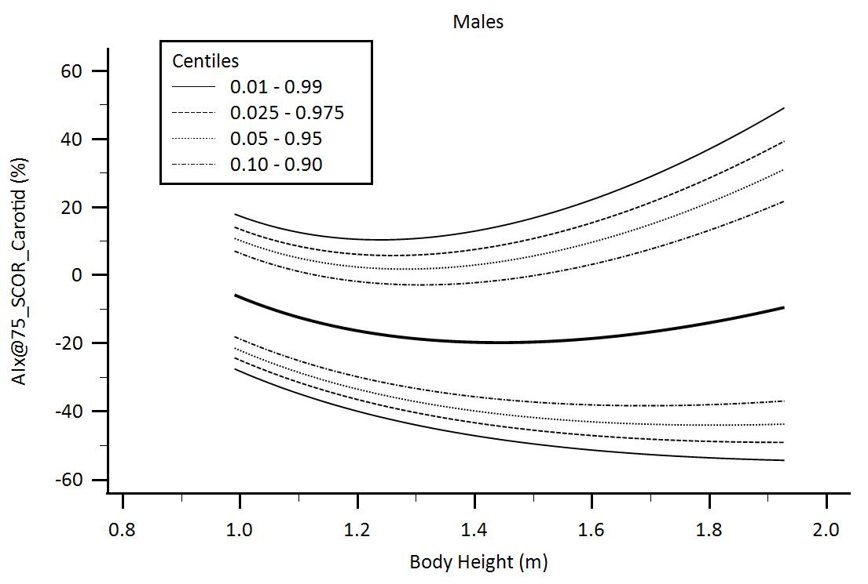

Supplementary Figure 38. Central aortic waveform-derived parameters obtained using carotid artery applanation tonometry (SphygmoCor device, SCOR): Augmentation Index adjusted for heart rate equal 75 beats/minute (AIx@75) body height-related percentiles.

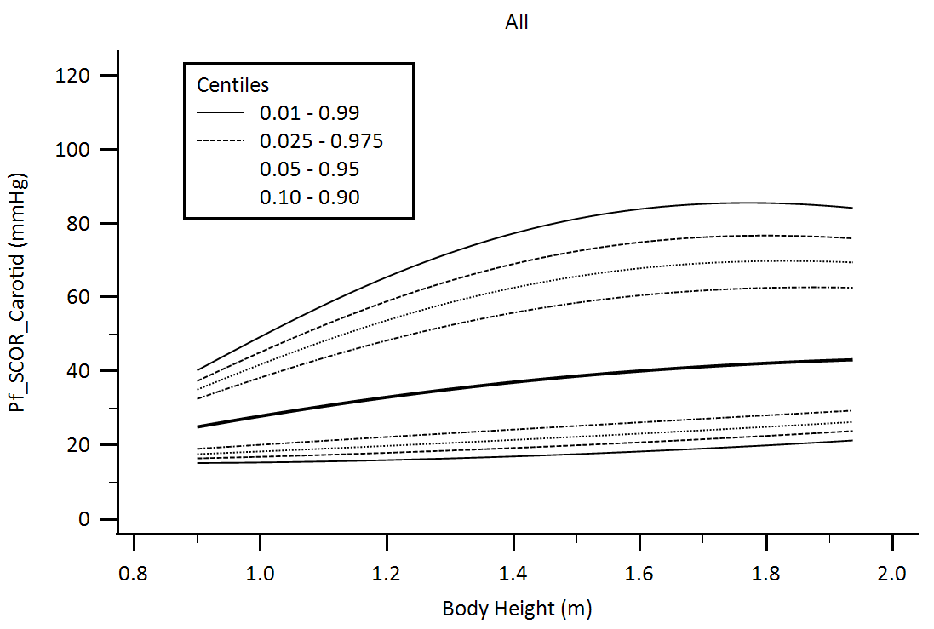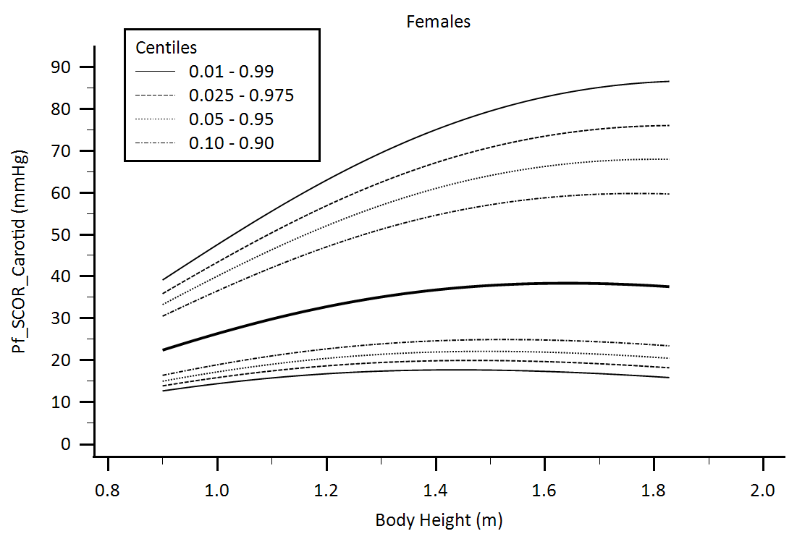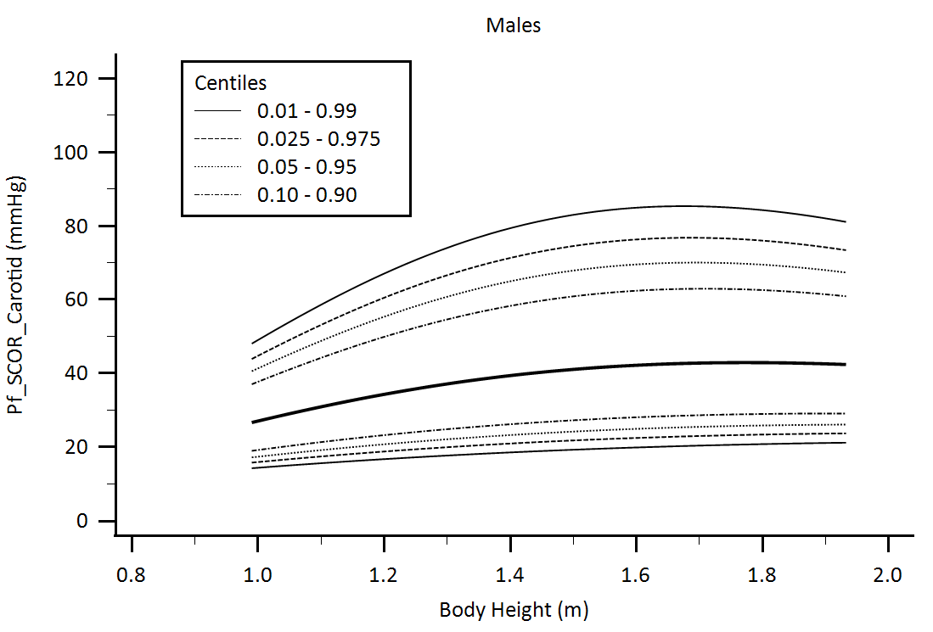

Supplementary Figure 39. Central aortic waveform-derived parameters obtained using carotid artery applanation tonometry (SphygmoCor device, SCOR): Forward Pressure (Pf) body height-related percentiles.

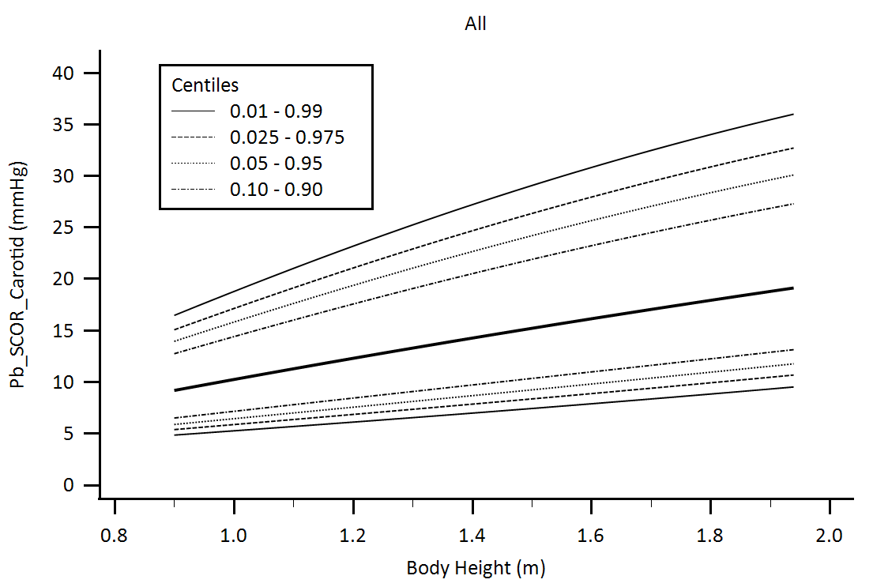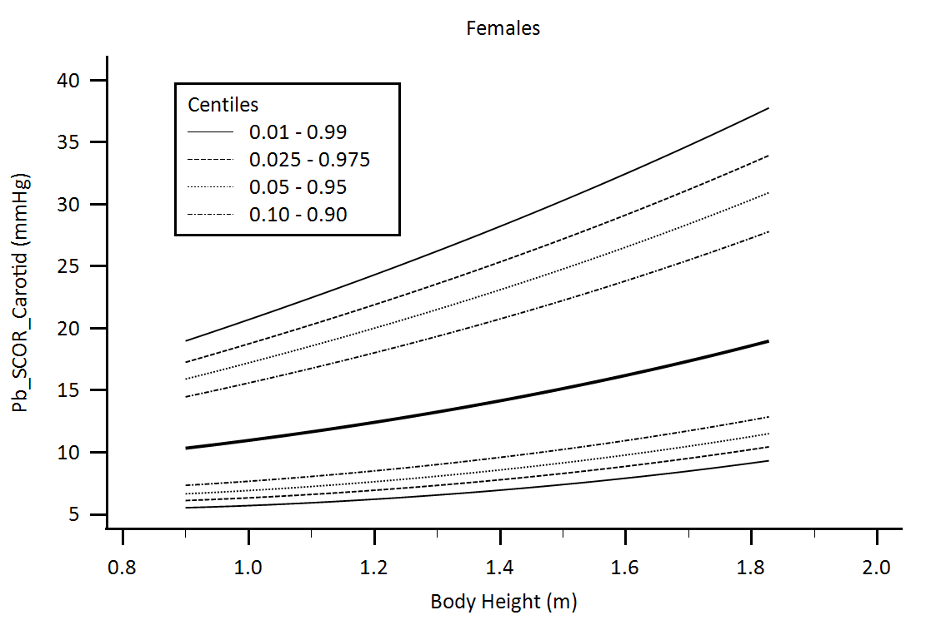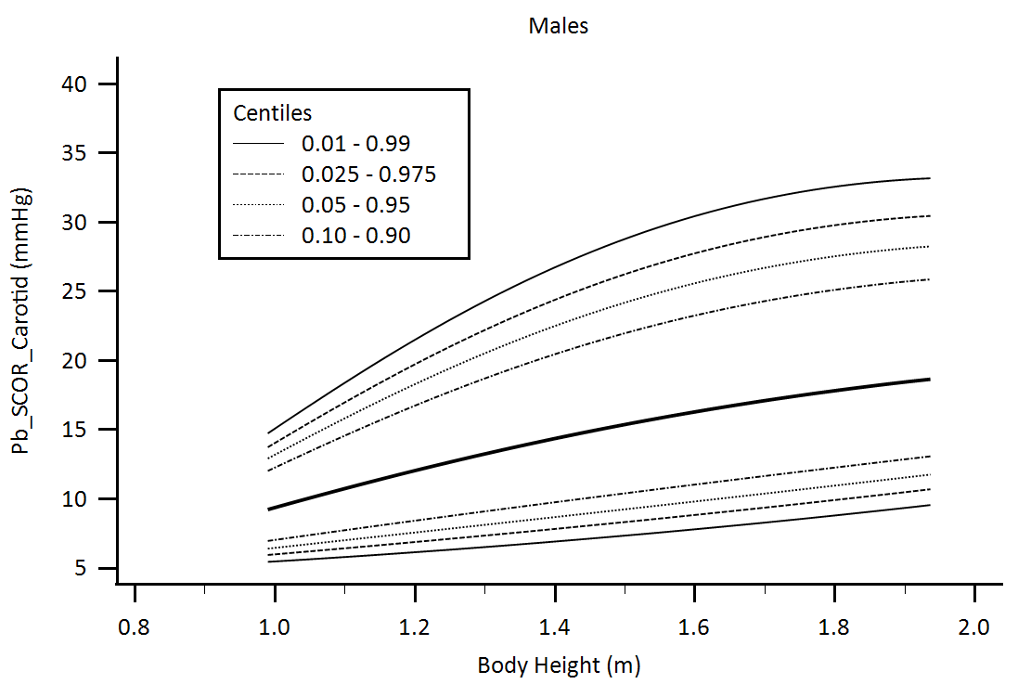

Supplementary Figure 40. Central aortic waveform-derived parameters obtained using carotid artery applanation tonometry (SphygmoCor device, SCOR): Backward Pressure (Pb) body height-related percentiles.

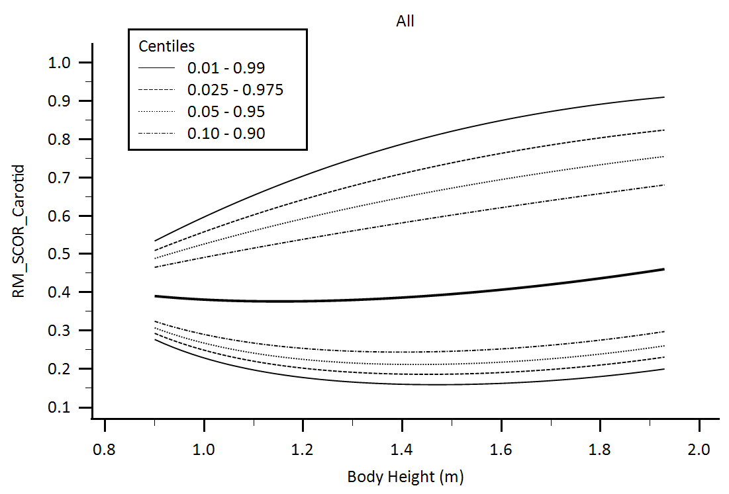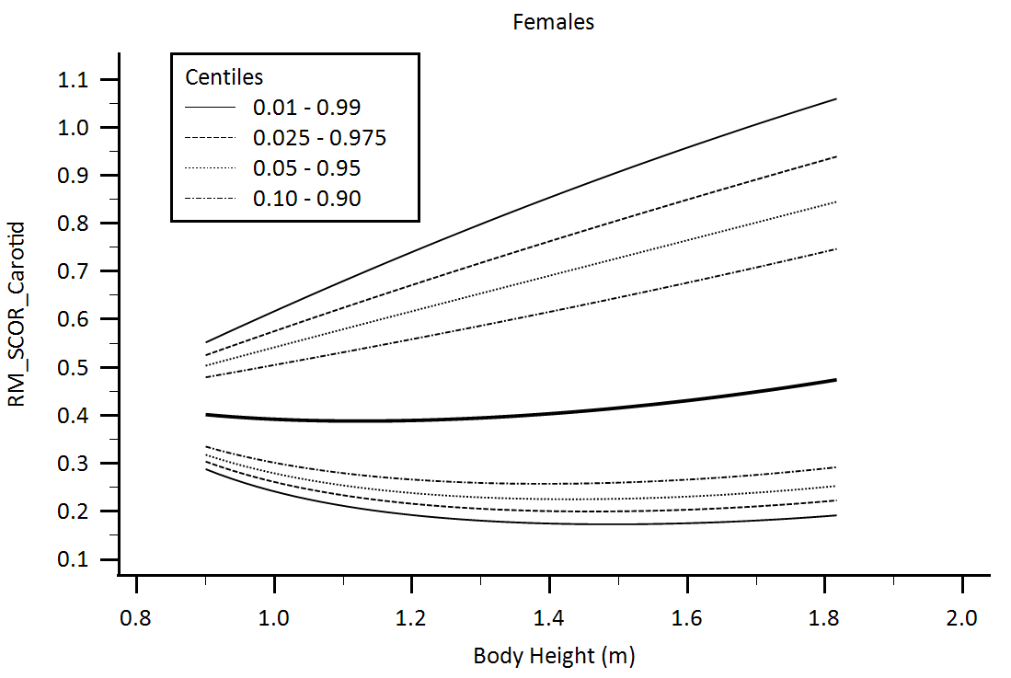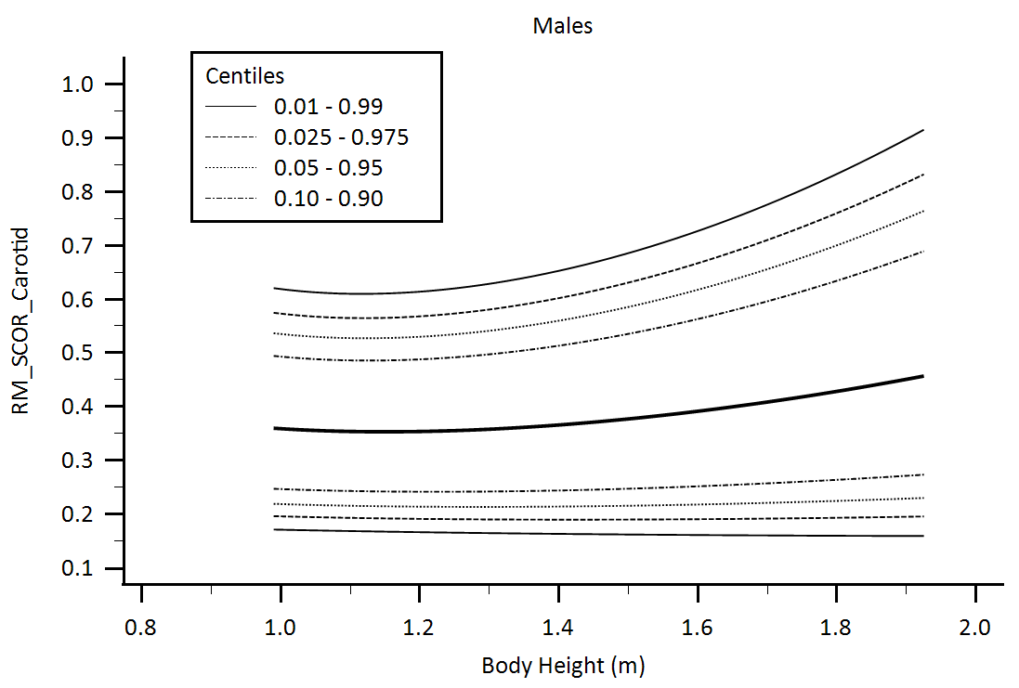

Supplementary Figure 41. Central aortic waveform-derived parameters obtained using carotid artery applanation tonometry (SphygmoCor device, SCOR): Reflection Magnitude (RM) body height-related percentiles.

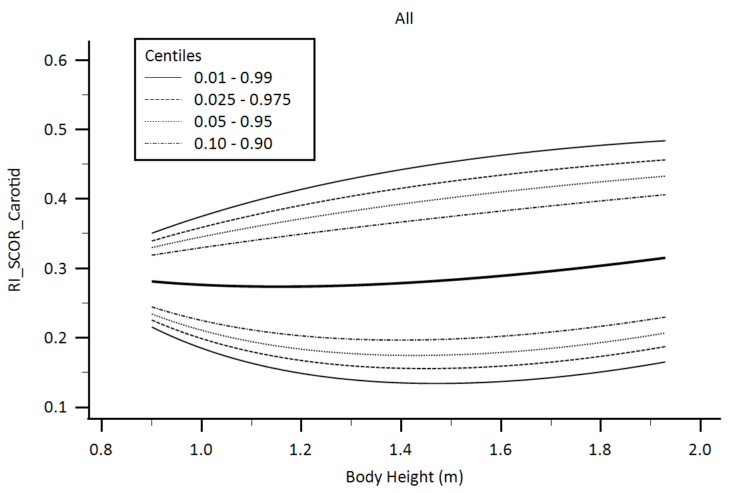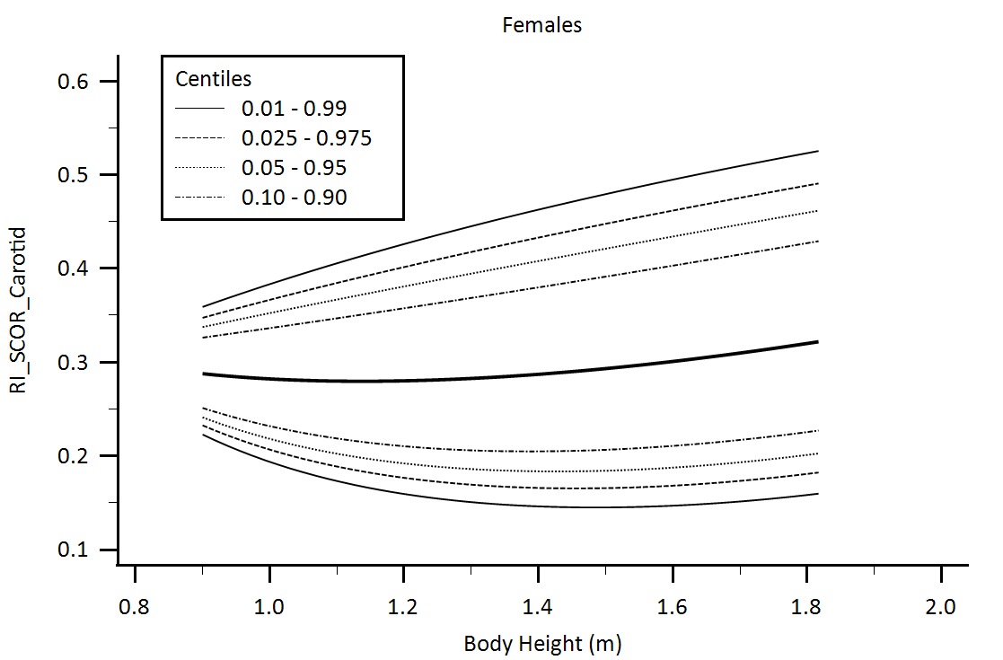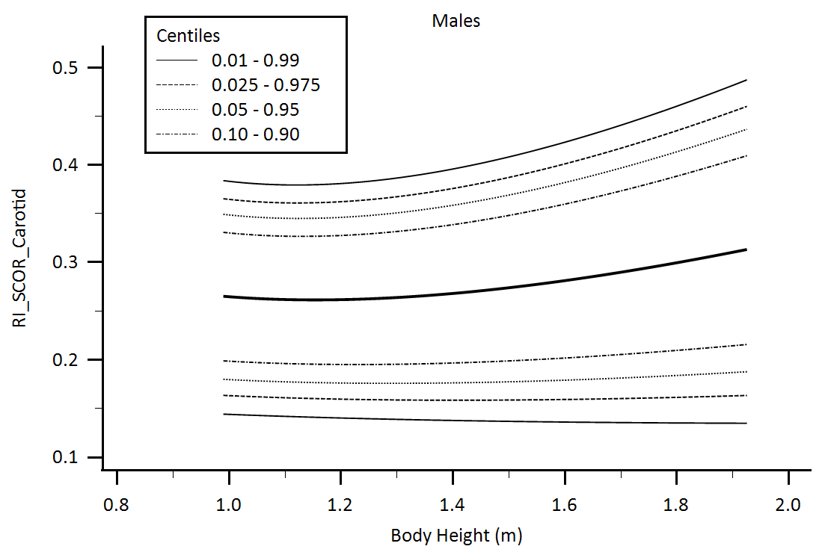

Supplementary Figure 42. Central aortic waveform-derived parameters obtained using carotid artery applanation tonometry (SphygmoCor device, SCOR): Reflection Index (RI) body height-related percentiles.