Mol | Molecule Name | OB | DL | HL | Structure | Number of targets
M1 | Platycoside A | 5.81 | 0.01 | Long | 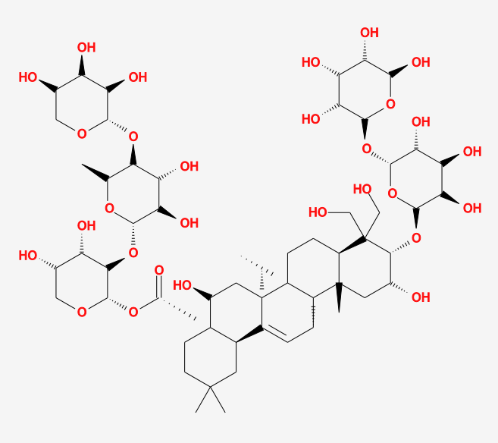 | 19
M2 | Platycoside B | 2.20 | 0.02 | Long | 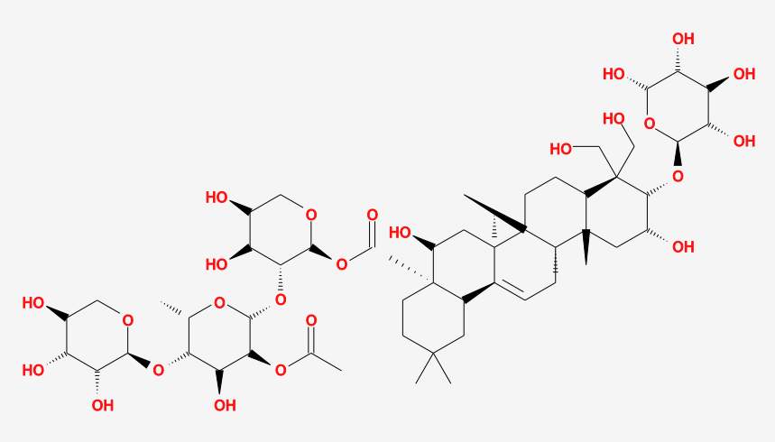 | 44
M3 | Platycoside C | 3.39 | 0.02 | Long | 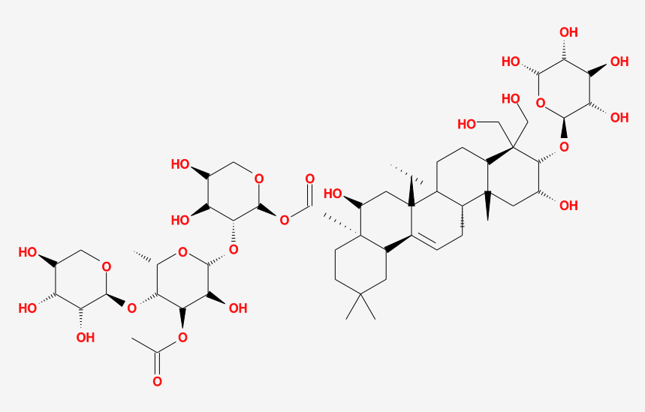 | 21
M8 | Platycoside G2 | 6.84 | 0.01 | Long | 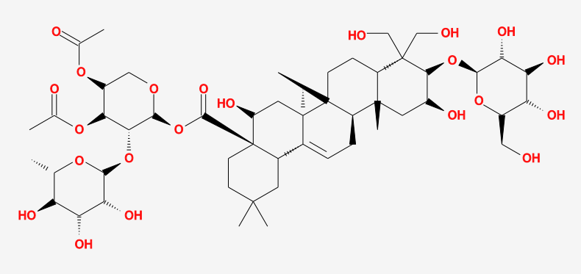 | 21
M11 | Platycoside I | 7.44 | 0.00 | Long | 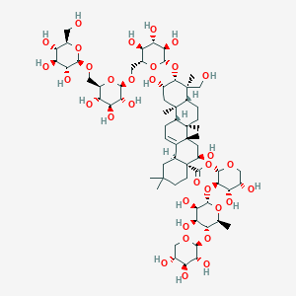 | 17
M12 | Platycoside J | 3.10 | 0.03 | Long | 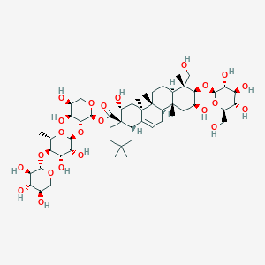 | 22
M14 | Platycoside L | 2.11 | 0.11 | Long | 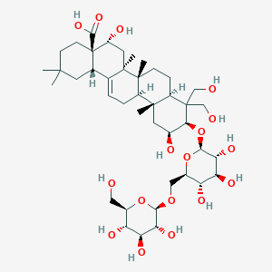 | 22
M20 | Platycodin A | 7.71 | 0.01 | Long | 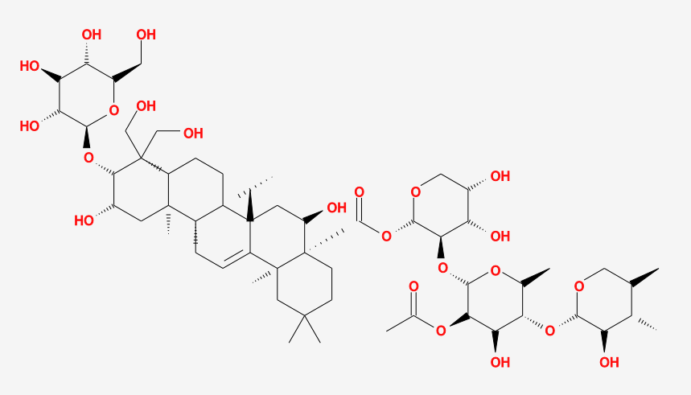 | 27
M21 | Platycodin C | 7.61 | 0.01 | Long | 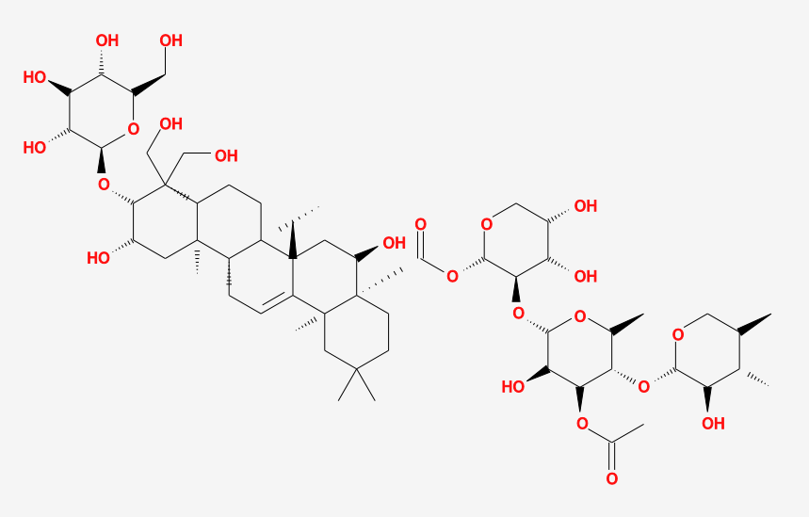 | 18
M22 | Platycodin D | 7.58 | 0.01 | Long | 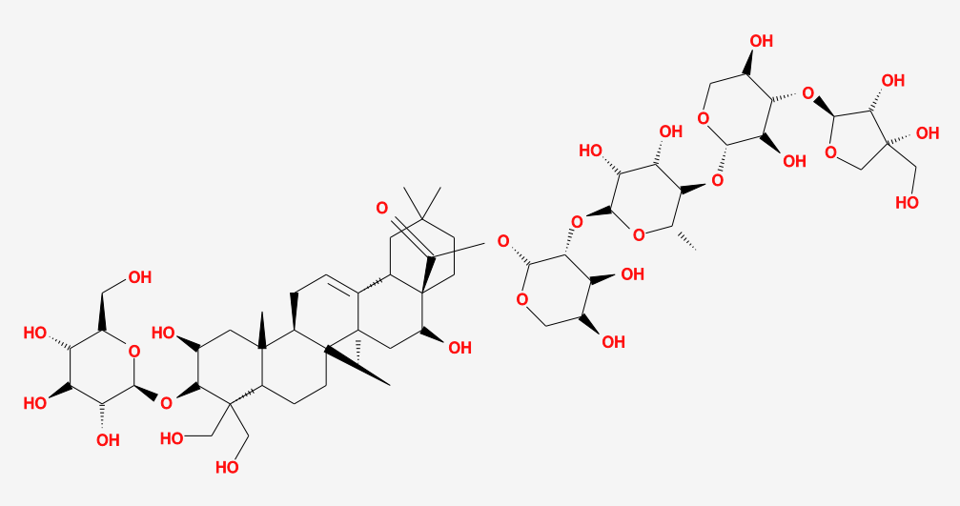 | 22
M23 | Platycodin D2 | 7.57 | 0.00 | Long | 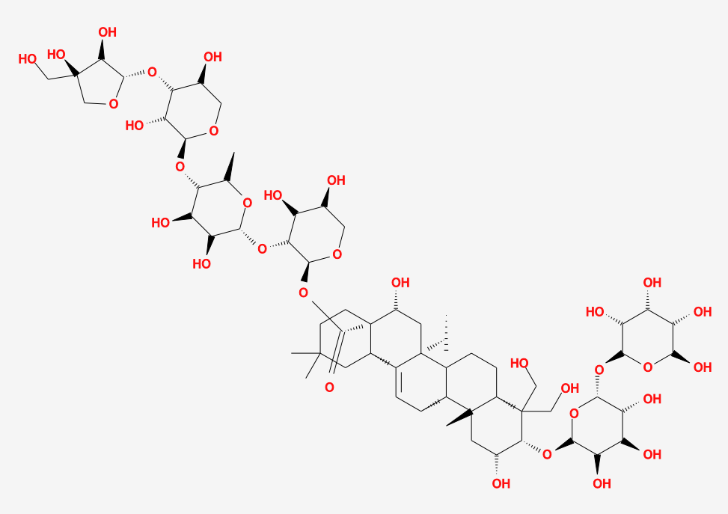 | 14
M24 | Platycodin D3 | 7.57 | 0.00 | Long | 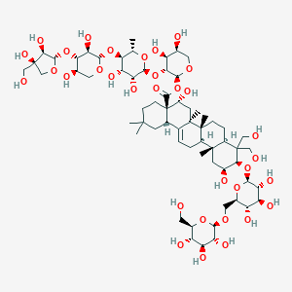 | 19
M31 | 3'-O-acetylPlatycodin D2 | 7.57 | 0.00 | Short | 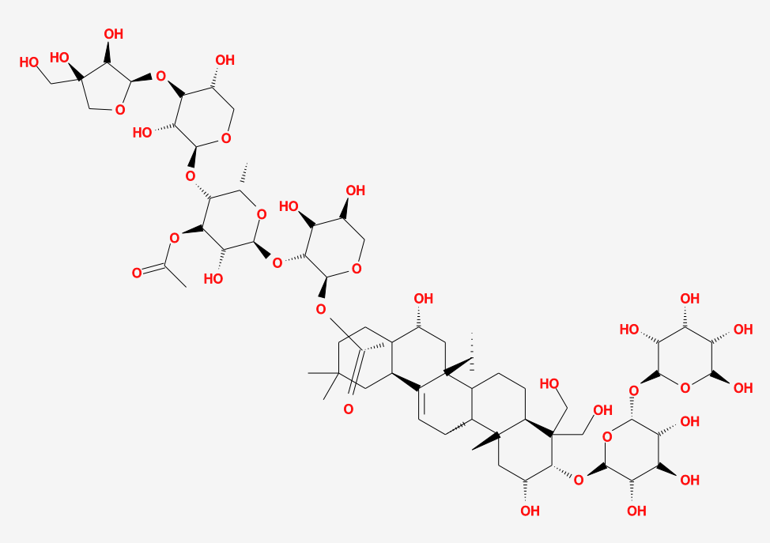 | 8
M33 | 3-O-β-D-glucopyranosyl platycodigenin methyl ester | 13.77 | 0.29 | Long | 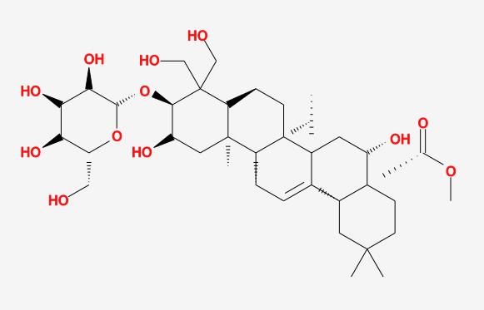 | 22
M34 | 3-O-β-D-laminaribiosyl platycodigenin methyl ester | 2.80 | 0.11 | Long | 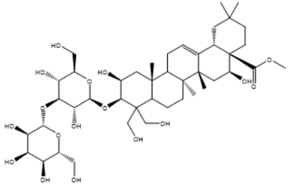 | 20
M35 | 3-O-β-D-gentiobiosyl platycodigenin methyl ester | 4.88 | 0.11 | Long | 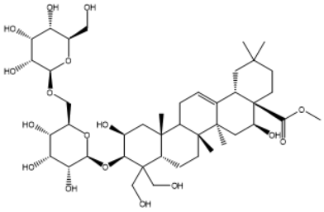 | 30
M39 | platycodon B | 17.61 | 0.16 | Long | 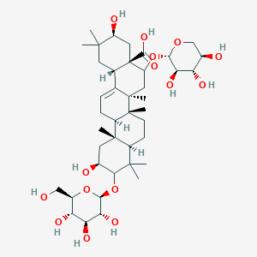 | 24
M40 | Platycogenic acid A | 21.29 | 0.65 | Short | 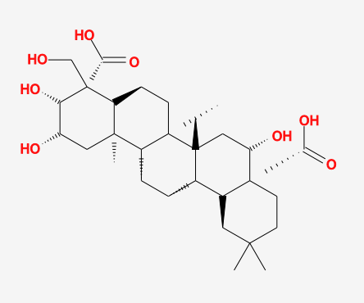 | 19
M41 | Platycogenic acid B | 17.83 | 0.64 | Short | 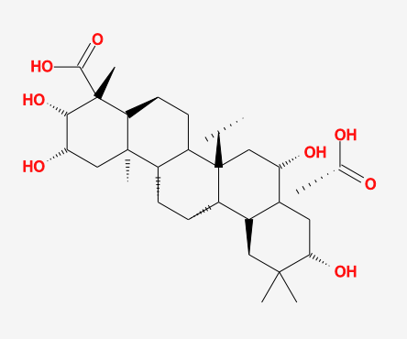 | 22
M42 | Platycogenic acid C | 13.06 | 0.69 | Short | 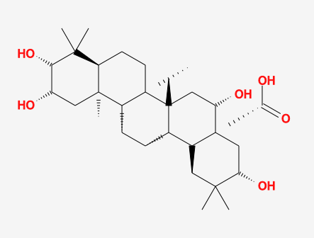 | 20
M48 | Polygalacic acid | 11.06 | 0.70 | Short | 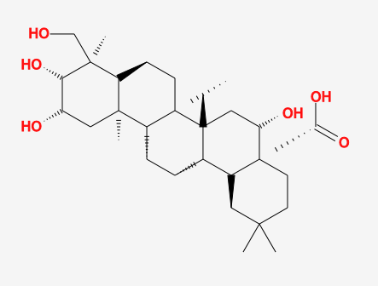 | 19
M49 | platicodigenin | 6.36 | 0.67 | Short | 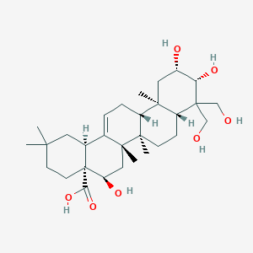 | 19
M50 | 3''-O-Acetyl platyconic acid A | 7.73 | 0.01 | Long | 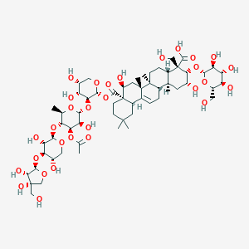 | 22
M56 | beta-Sitosterol | 36.91 | 0.75 | Short | 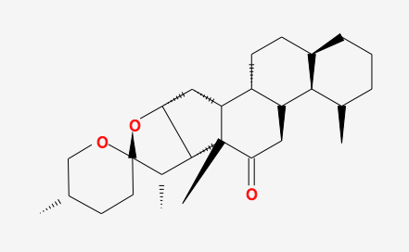 | 19
M57 | Betulin | 16.22 | 0.78 | Long | 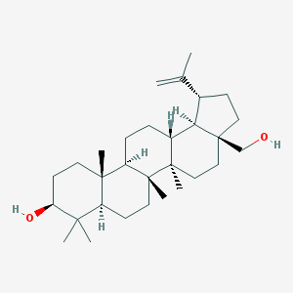 | 25
M74 | 3-O-laminaribiosylplatycodigenin methyl ester | 5.97 | 0.65 | Short | 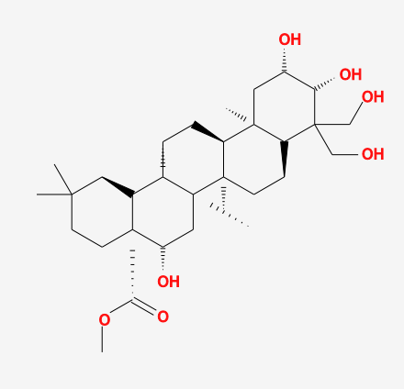 | 14
M77 | 3-O-β-gentiobiosyl platycodigenin methylester | 13.50 | 0.11 | Long | 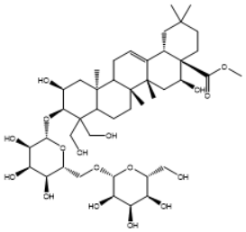 | 21
M87 | dimethyl 2-O-methyl-3-O-a-D-glucopyranosyl platycogenate A | 39.21 | 0.25 | Long | 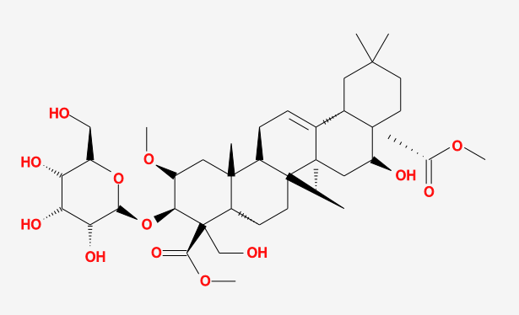 | 14
M109 | nicotinic acid | 47.65 | 0.02 | Long | 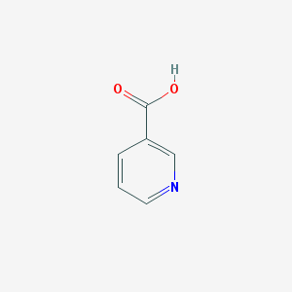 | 37
M111 | Platycodigenin | 21.19 | 0.67 | Short | 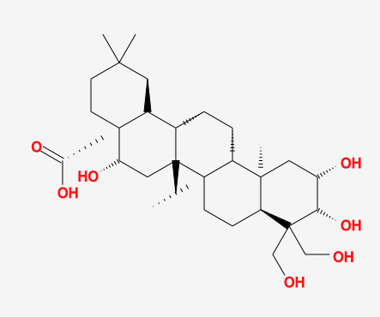 | 26

