Supplementary Material

Supplementary Figure 1
A
B

Supplementary Figure 1. Virologic and immunologic characteristics of Patient 15 who experienced a HCV-superinfection. (A) Serum and B cells, examined in the present study, have been taken in 2006 and 2009 and are shown as P15_2006 and P15_2009 (shaded areas). HCV-genotyping of human sera was performed using a Line Probe Assay (LiPA) developed by Innogenetics (Versant® HCV genotype Assay) and by genotype specific PCR-amplification of the E1E2 region (in house). The patient reported intravenous drug use at the time of superinfection. (B) Evolution of E1E2-specific immunological responses since time of initial viremia. Anti-E1E2_{H77} IgG and anti-E1E2_{S52} IgG levels are expressed as reciprocal EIA-titer. Neutralizing responses of autologous serum to HCV-pseudoviral particles expressing envelope proteins of gt1a (HCVpp_H77) or gt3a (HCVpp_S52) are expressed as IC₅₀ (reciprocal titer).

Supplementary Figure 2
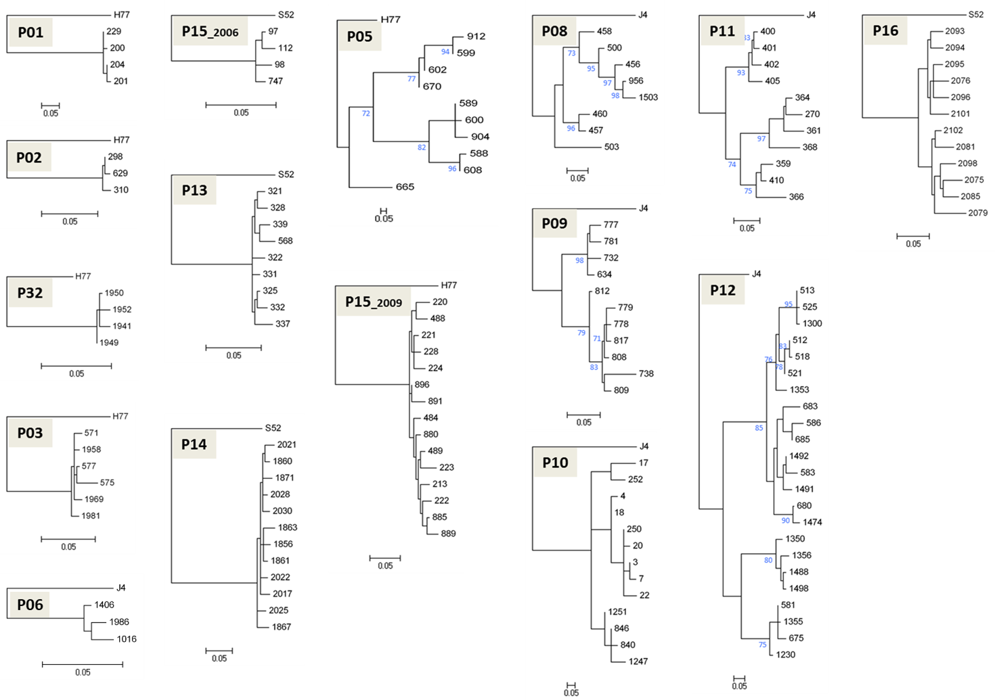

Supplementary Figure 2. Phylogenetic analyses of HCV-infected patients. Maximum-Likelihood phylogenetic trees showing the relationship between E1E2₁₉₂₋₇₄₅ sequences of the major viral variants were inferred under the LG model of AA substitution with estimated γ- distribution parameter, using PhyML software (v3.0; South of France bioinformatics platform; ATGC). The tree topology (starting with a Neighbor-Joining tree) was optimized using the Nearest Neighbor Interchange (NNI) approach. Bootstrapping with 1000 replicates tested the statistical robustness of the phylogenetic trees. Only branching with a bootstrap value of ≥70% was defined as robust clustering (depicted in blue). Phylogenetic trees are rooted on the consensus sequence for each genotype (HCV-H77 for gt1a, HCV-J4 for gt1b and HCV-S52 for gt3a). For each tree, the black numbers (tree-leaves) are clone-codes, each corresponding to a unique E1E2-AA sequence. An estimate of the genetic distance is presented as a bar at the bottom of each tree.

Supplementary Figure 3.

Supplementary Figure 3. HVR1-diversity in human serum and in uPA-SCID mice plasma following inoculation with serum from patients with low QS-diversity. Schematic representation of the E1E2-HVR1 viral quasispecies (QS) distribution in human serum and mouse plasma for four gt1a-patients (P01, P02, P32 and P03), one gt1b-patient (P06) and one gt3a-patient (P15_2006) with QS-score <0.2 (Figure 1, Supplementary Figure 2). The number of clones analysed per compartment is shown beneath each pie chart that represents the fraction of each clone/compartment based on diversity in HVR1. Based on individual AA-similarity and clustering in phylogenetic analysis, all HVR1-sequences shown are closely related within each patient.

Supplementary Figure 4.
Supplementary Figure 4. Amino acid sequences and corresponding colour codes of viral variants (HVR1) depicted in Figure 3. Schematic representation of the E1E2-HVR1 viral quasispecies (QS) distribution in human serum and B cells at the time of injection and in uPA-SCID plasma for three gt1b-patients (P09, P10 and P12) and one gt3a-patient (P16) is shown in Figure 3. Viral HVR1-isolates are indicated by different colours and are unique for each patient. The AA sequences of the HVR1 region (AA₃₈₄₋₄₁₀) and their corresponding colour codes are shown. The consensus sequences HCV-J4 (gt1b) and HCV-S52 (gt3a) are used for HVR1-alignments and shown on top. Closely related HVR1-variants (based on individual AA-similarity and clustering in phylogenetic analysis) are depicted in different intensities of the same colour.

Supplementary Figure 5
A
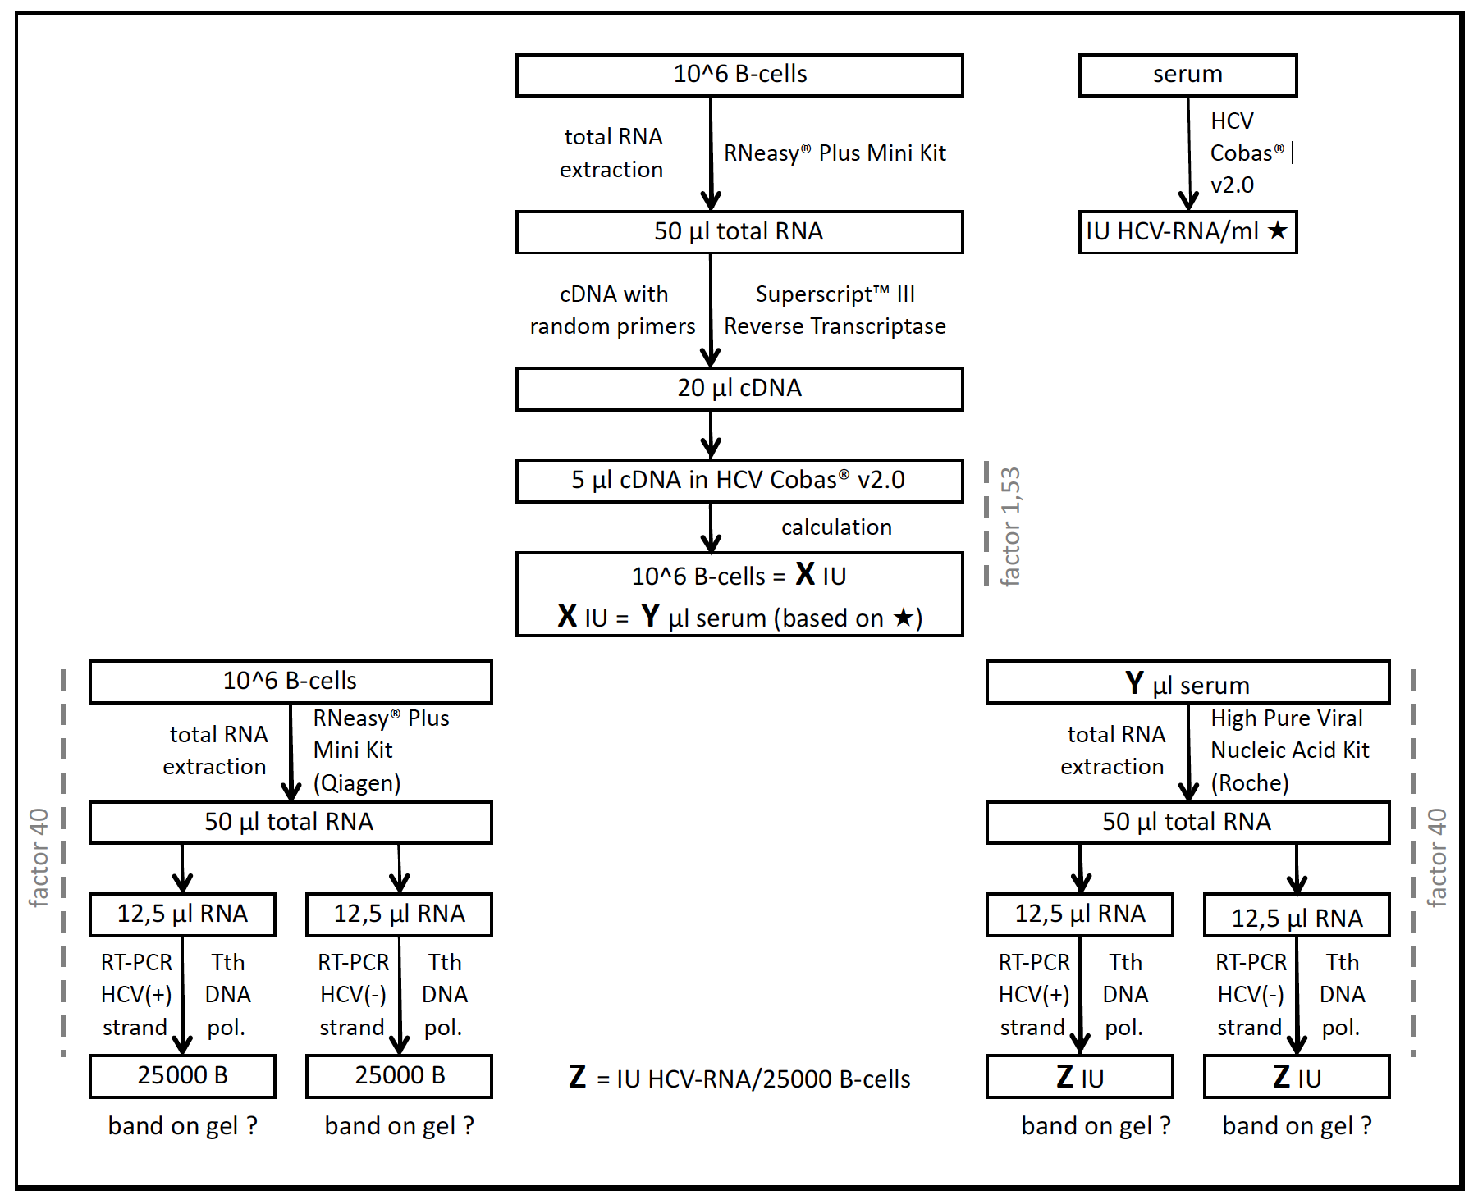
B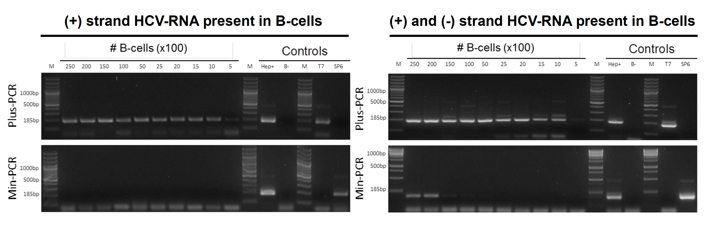

Supplementary Figure 5. Presence of (+) and (-) single strand HCV-RNA in infectious and non-infectious B cells. (A) Flow chart illustrates the sequence of basic steps in (i) the quantification of HCV-RNA in B cells using the COBAS® TaqMan® HCV Test v2.0 (Roche) and (ii) the detection of (+)ssRNA and (-)ssRNA in B cells and serum using a strand-specific RT-PCR based on Tth DNA polymerase (detailed in methods). (B) Representative example of an agarose gel electrophoresis showing the semi-quantitative detection of (+)ssRNA (Plus-PCR, upper part of both left and right panels) and (-)ssRNA (Min-PCR, lower part of both left and right panels) in non-infectious B cells (P05, HCV-gt1a) and infectious B cells (P08, HCV-gt1b). After total RNA extraction from B cells, (-) and (+) strand-specific cDNA was generated and amplified using a Tth-based RT-PCR-protocol. The presence of ssRNA was monitored on a dilution series representing absolute amounts of B cells (normalized for total RNA content after extraction). HCV_JC1-infected Huh7.5 hepatoma-cells (referred as Hep+) and B cells from non-infected individuals (referred as B-) were used as HCV-positive and -negative control cells, respectively. Synthesized appropriate positive- (T7) and negative-strand (SP6) HCV-RNA control fragments were added in each run (kindly provided by Harvey Alter, NIH). M, 100 bp DNA ladder

Supplementary Table 1.
ªIDU, injecting drug use. ^{b}Time elapsed between initial HCV-infection/diagnosis and biological sampling for the present study (y, year; m, month). ^{c}Anti-E1E2_{H77} IgG levels are expressed as reciprocal endpoint dilution titer of autologous serum in EIA; <10, IgG was not detected at serum-dilution 1/10. ^{d}Neutralizing activities of autologous serum to HCV-pseudoviral particles expressing envelope proteins of gt1a (HCVpp_H77) are expressed as IC₅₀ (reciprocal titer); <50%, neutralization did not reach 50%.

Supplementary Table 2.
 |  | serum injection |  |  | B cell injection |  |  | % CD19+ cells
 | Patient ID | mouse ID | hu-Alb (mg/ml) |  | mouse ID | hu-Alb (mg/ml) |  | PBMC | after purification (=injected)
Figure 1 | P01 | K753 | 5.6 |  | K750L | 5.8 |  | 6 | 96
 | P02 | K874 | 8.7 |  | B133L | 5.1 |  | 12 | 98
 | P32 | B582 | 3.3 |  | K874R | 4.0 |  | 19 | 99
 | P03 | B629L | 4.1 |  | K813R | 3.9 |  | 12 | 98
 |  |  |  |  | B147L | 6.2 |  | 13 | 99
 | P06 | K594 | 2.9 |  | K628 | 2.7 |  | 14 | 98
 | P15_2006 | B78R | 4.4 |  | K874RL | 2.4 |  | 22 | 99
 | P13 | B160 | 4.8 |  | K884 | 6.9 |  | 8 | 98
 | P14 | K993 | 10.2 |  | B673RL | 4.8 |  | 13 | 99
 | P05 | B295R | 3.8 |  | K687R | 4.3 |  | 22 | 98
 |  | B682 | 3.7 |  | K1030 | 9.0 |  | 18 | 99
 |  | B507 | 4.9 |  | K1290 | 5.0 |  | 20 | 98
 | P15_2009 | B85L | 4.0 |  | K811 | 9.6 |  | 18 | 98
 |  | B828L | 4.7
 | P08 | K738 | 2.0 |  | K693R | 2.1 |  | 15 | 99
 |  | B259L | 4.8 |  | B186R | 4.4 |  | 13 | 99
 |  | K1197L | 6.3 |  | K1196R | 6.1 |  | 14 | 99
 | P09 | K1045R | 6.8 |  | K1019 | 3.6 |  | 29 | 98
 |  | B528 | 8.5 |  | B720RL | 6.9 |  | 27 | 99
 |  |  |  |  | K1461R | 8.2 |  | 30 | 99
 | P10 | K579 | 3.4 |  | K628R | 2.0 |  | 6 | 98
 |  | B505RL | 4.9
 |  | B528R | 6.5
 | P11 | K829L | 2.1 |  | K797 | 3.3 |  | 26 | 98
 |  | K1190R | 4.0
 | P12 | K1106L | 4.5 |  | K983 | 3.6 |  | 16 | 98
 |  |  |  |  | K1772R | 5.2 |  | 17 | 99
 | P16 | B584R | 3.1 |  | B582R | 4.8 |  | 12 | 98
Figure 2A | mP09_K1019 |  | 3.4
 | mP09_K1461R |  | 3.9
 | mP10_K628R |  | 5.4
 | mP12_K983 |  | 5.0
Figure 2B | B_healthy + mK983 |  |  |  |  | 4.5
 | B_healthy + mK983 + IgG_P12 |  |  |  |  | 4.0

