**B. Photoluminescence properties of carbon dots**

***B.1. Amine-coated carbon cots (NH2-FCDs)***

The photoluminescence spectrum of amine coated carbon dots (NH2-FCDs) showed an absorbance profile maximum of 280 nm and the fluorescence emission profile showed large emission band at 455 nm when excited at 335 nm (Figure S1)

***B.2. Carboxylate carbon dots (COOH-FCD)***

The photoluminescence spectrum of carboxylate carbon dots (COOH-FCDs) showed an absorbance profile maximum of 285 nm and the fluorescence emission profile showed large emission band at 470 nm when excited at 335 nm (Figure S2)

***B.3. L-Arginine and glucose***

The photoluminescence spectrum of carbon dots synthesized from L-arginine and glucose (N-CDs) showed an absorbance profile maximum of 280 nm and the fluorescence emission profile showed large emission band at 460 nm when excited at 335 nm (Figure S3)

***B.4. Citric acid and polyethyleneimine***

The photoluminescence spectrum of carbon dots synthesized from citric acid and PEI showed an absorbance profile maximum of 280 nm and the fluorescence emission profile showed large emission band at 450 nm when excited at 335 nm (Figure S4)

**C. Zeta potential of synthesized CDs**

***C.1. Amine-coated carbon cots (NH2-FCDs)***

The zeta potential value of NH2-FCDs was found to be (10.50± 0.3) mV. The positive charge is the result of primary amines derived from TTDA linker [36]. There was no particle coagulation observed which suggests the stabilization of NH2-FCDs by linker steric effects [36] (Figure S1)

***C.2 Carboxylate carbon dots (COOH-FCD)***

The zeta potential value of COOH-FCDs was found to be (-14.1±5.63) mV. The obtained negative values could be attributed to the increased number of carboxylic acids on the surface. (Figure S2)

***C.3 L-Arginine and glucose***

The zeta potential value of N-CDs was found to be (-11.2±2.6) mV. The obtained negative values could be attributed to the deprotonation of -COOH groups of the reaction mixture [41]. (Figure S3)

***C.4. Citric acid and polyethyleneimine***

The zeta potential value of CDs derived from citric acid and PEI was found to be (7.54±7.8) mV. The obtained positive values could be attributed to the functional polycationic polymer with various amine groups. (Figure S4)

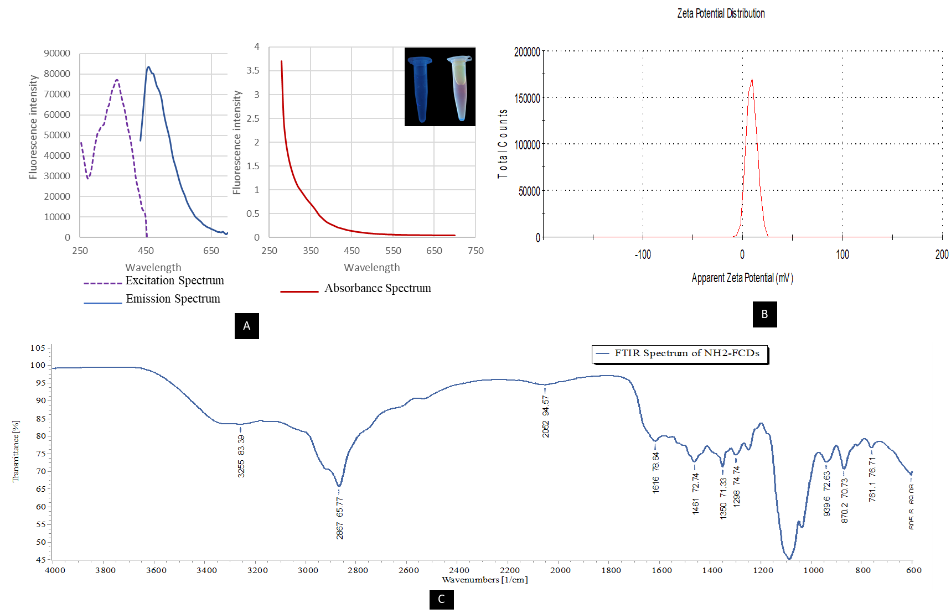

Figure S1. Photoluminescence properties of NH2-FCDs. A) Graphs representing excitation, emission, and absorbance wavelength for the NH2-FCDs. B) Zeta potential of NH2-FCDs using a Malvern Instruments Zetasizer Nano ZS. CDs were diluted with pH-4 distilled water. C) FTIR spectrum of NH2-FCDs.

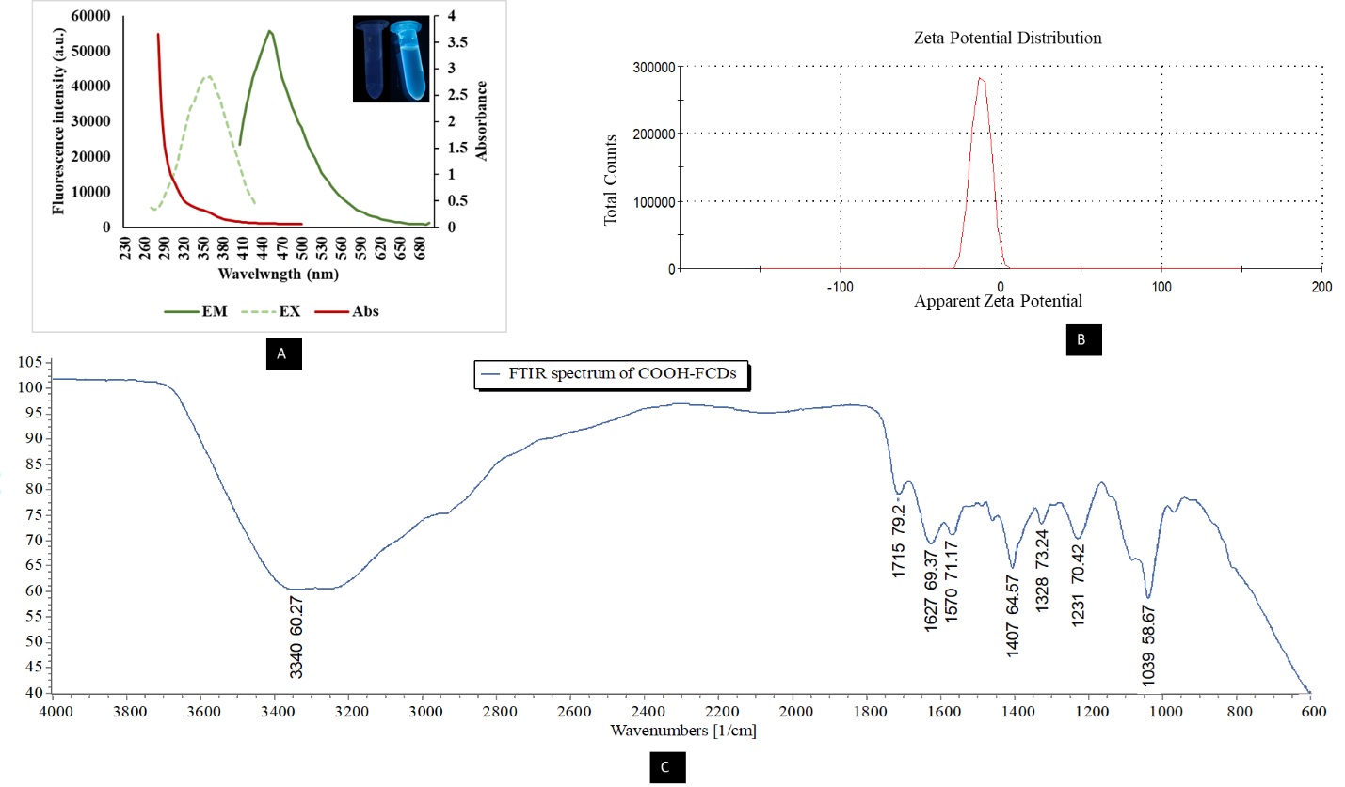

Figure S2. Photoluminescence properties of COOH-FCDs. A) Graphs representing excitation, emission, and absorbance wavelength for the COOH-FCDs. B) Zeta potential of COOH-FCDs using a Malvern Instruments Zetasizer Nano ZS. CDs were diluted with pH-4 distilled water. C) FTIR spectrum of COOH-FCDs.

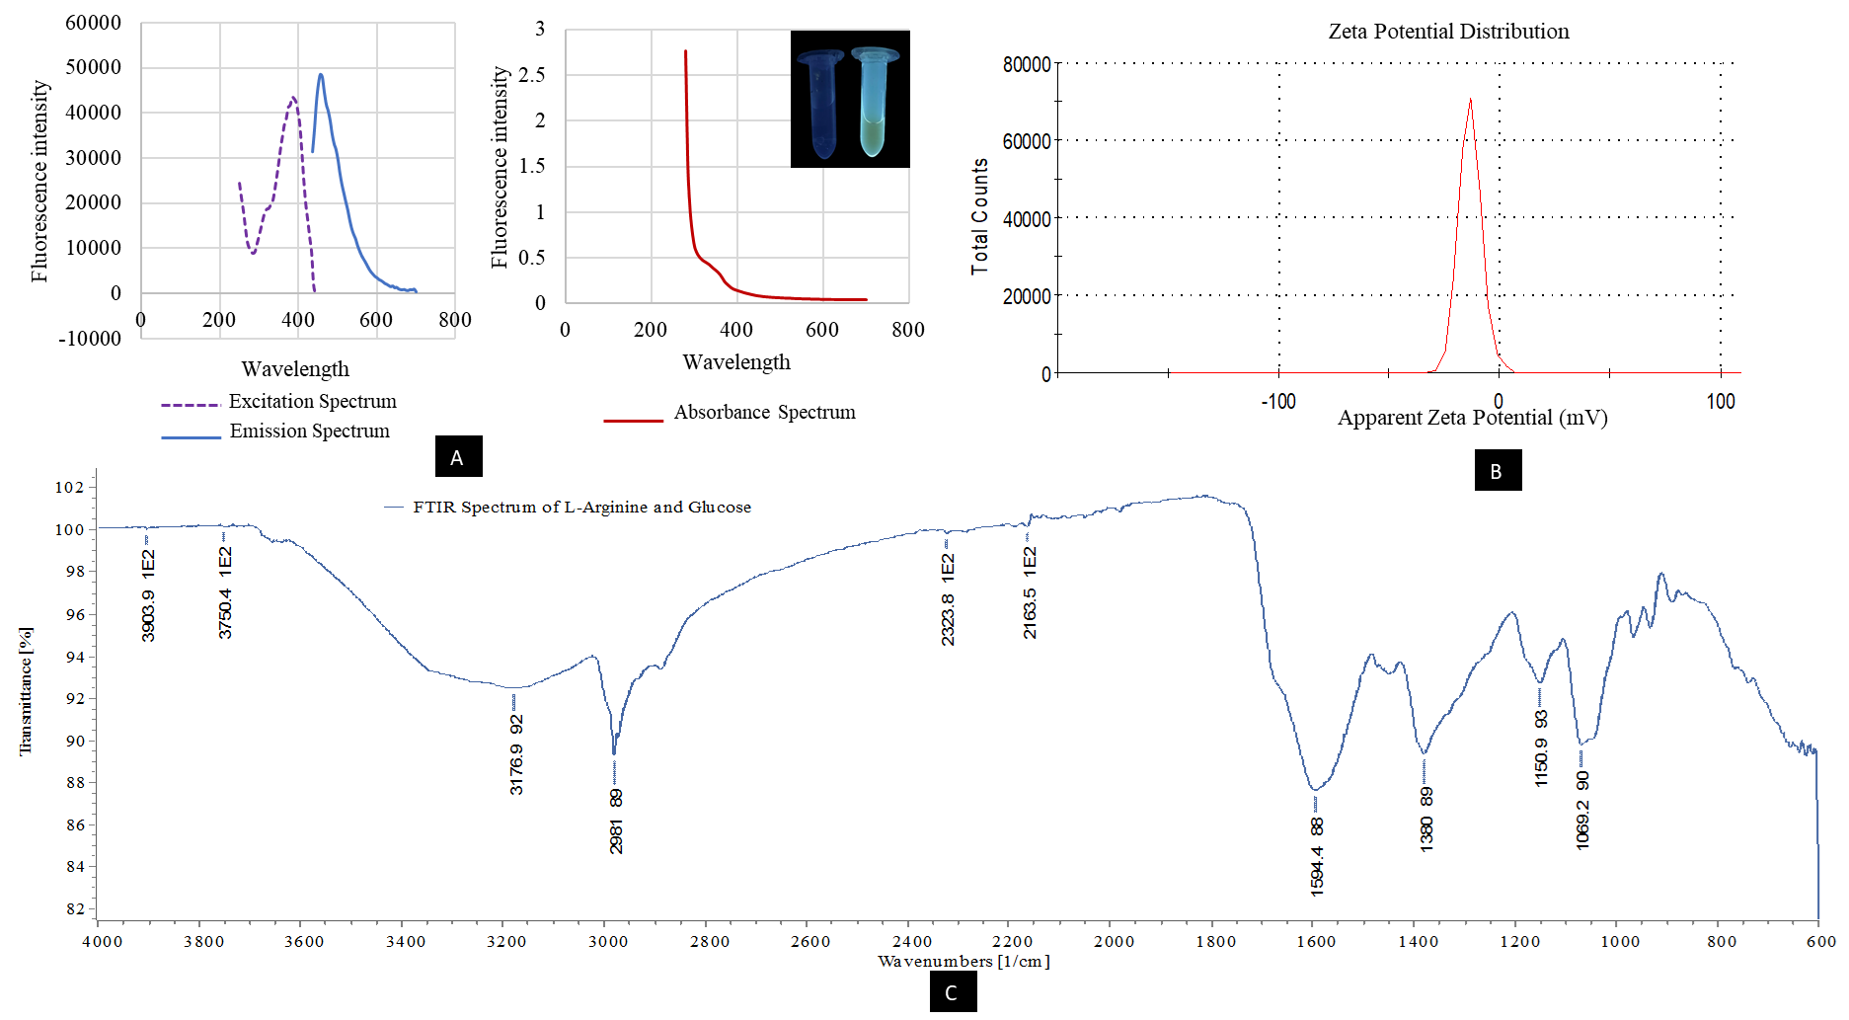

Figure S3. Photoluminescence properties of N-CDs. A) Graphs representing excitation, emission, and absorbance wavelength for the N-CDs. B) Zeta potential of N-CDs using a Malvern Instruments Zetasizer Nano ZS. CDs were diluted with pH-4 distilled water. C) FTIR spectrum of N-CDs.

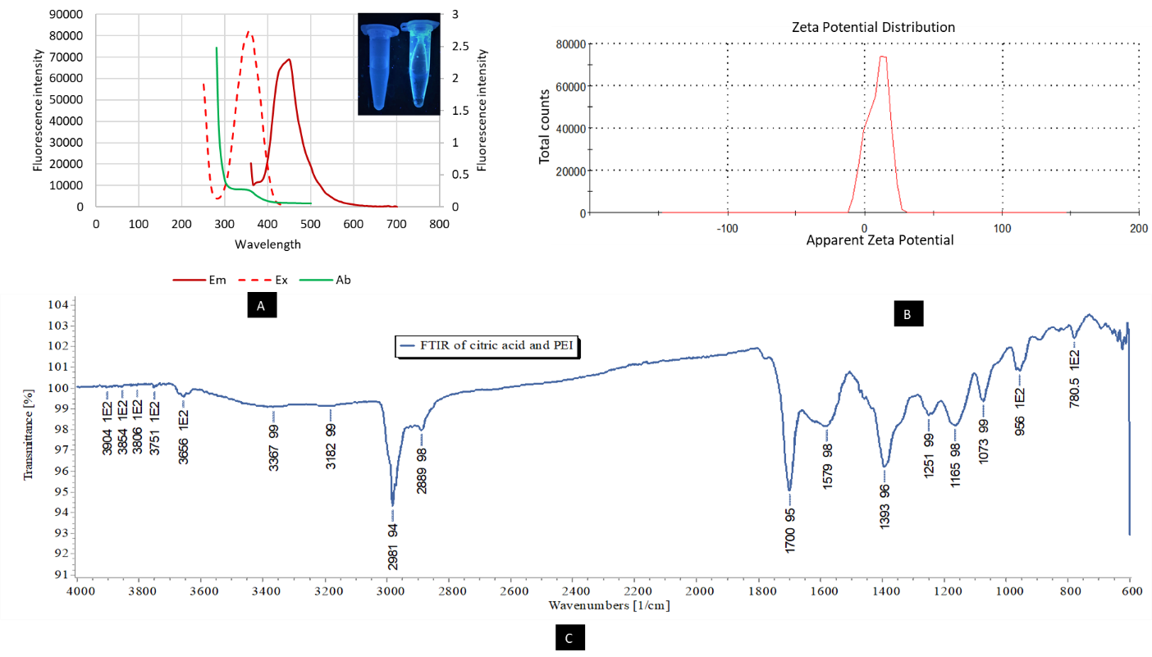

Figure S4. Photoluminescence properties of citric acid and PEI CDs. A) Graphs representing excitation, emission, and absorbance wavelength for the PEI CDs. B) Zeta potential of citric acid and PEI CDs using a Malvern Instruments Zetasizer Nano ZS. CDs were diluted with pH-4 distilled water. C) FTIR spectrum of citric acid and PEI-CDs.

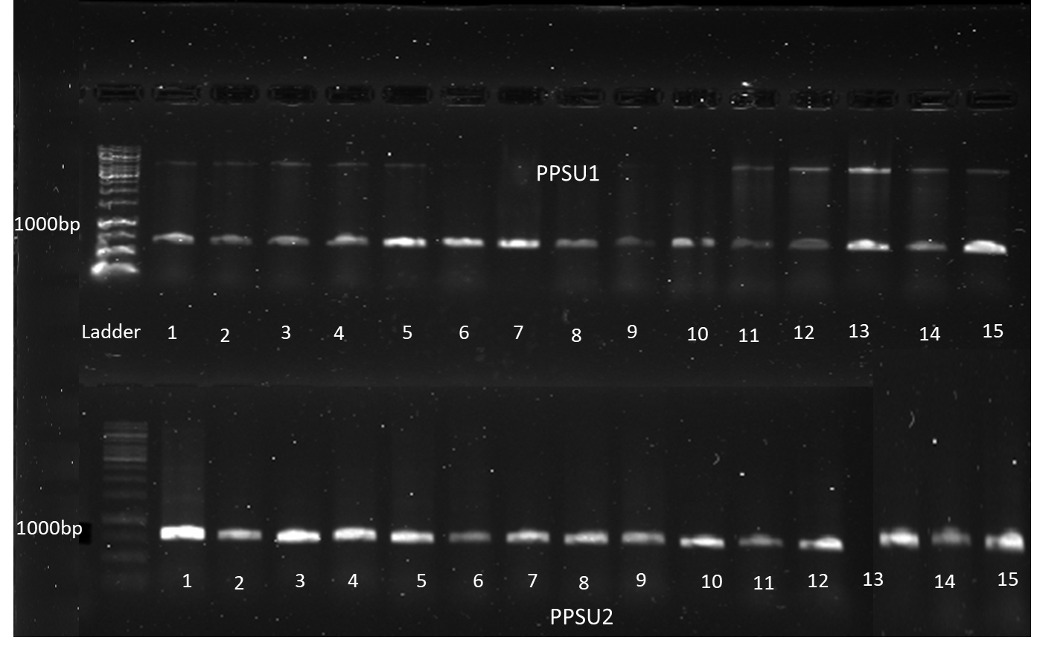

Figure S5. Colony PCR confirmation of the transformed colonies of pPSU1 and pPSU2.