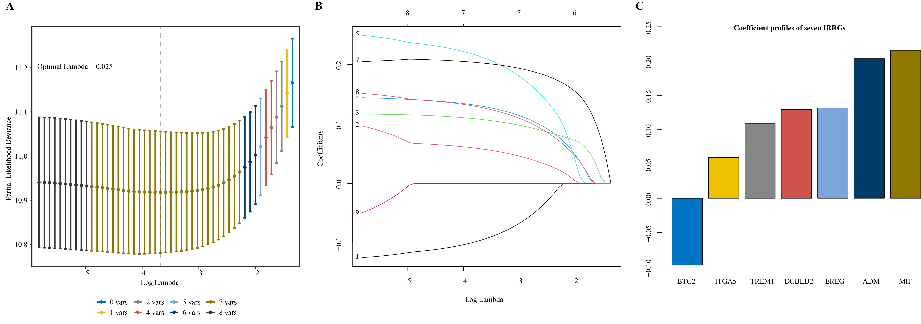
FIGURE S1 Establishment of an IRRGs prognostic signature. (A) Cross-validated partial likelihood deviance. (B) Coefficient profiles of eight IRRGs at varying levels of λ. (C) Bar plot show coefficient profile of each gene.
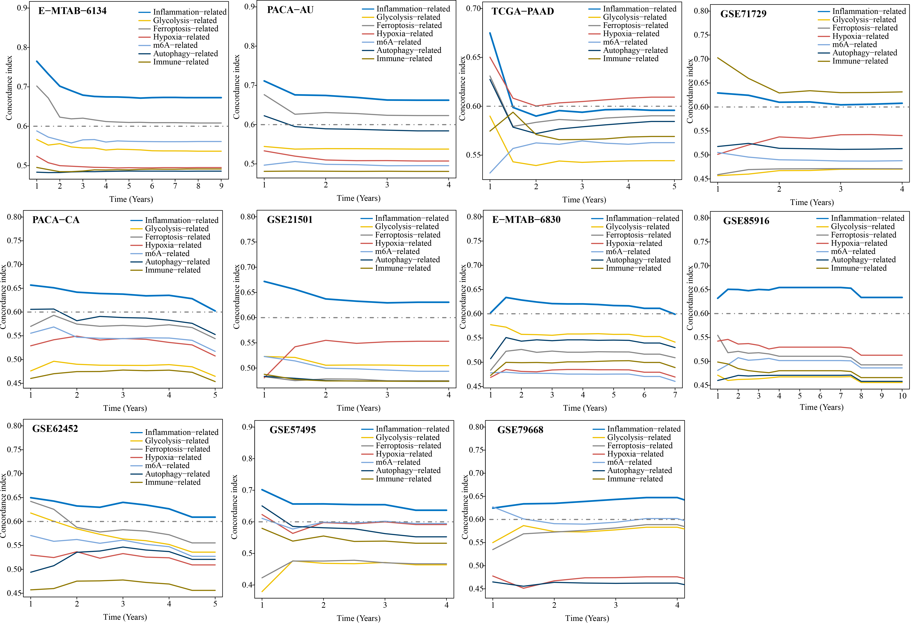
FIGURE S2 Time-varying concordance index of our IRRGs signature and six previous published signatures.
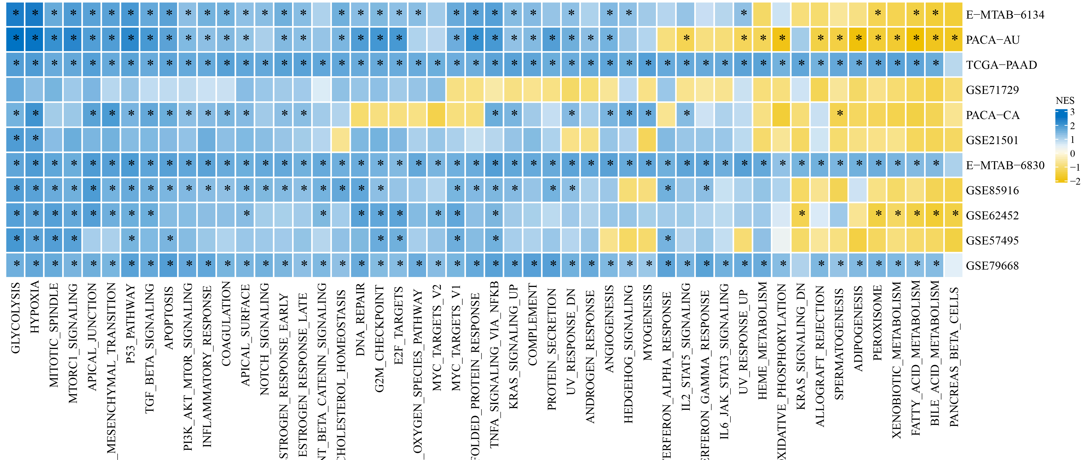
FIGURE S3 The differences in 50 hallmark gene sets between high- and low-risk groups were compared by GSEA analysis. Blue represents upregulated in high-risk group, while yellow represents downregulated in high-risk group. * FDR<0.25

