**Figure S1.** The iter of patients enrolled in the trial

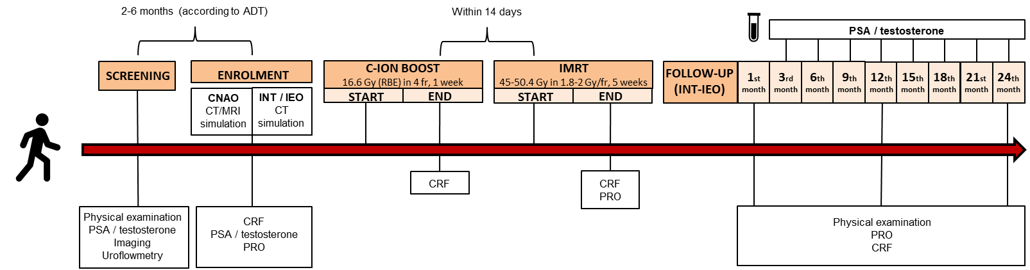

**Abbreviations –** **ADT:** Androgen Deprivation Therapy; **C-ION:** Carbon Ions; **CNAO:** Centro Nazionale di Adroterapia Oncologica (National Centre of Oncological Hadrontherapy); **CRF:** Case Report Form; **CT:** Computed Tomography; **fr:** fraction; **Gy:** Gray; **IEO:** Istituto Europeo di Oncologia (European Institute of Oncology); **IMRT:** Intensity-Modulated Radiotherapy; **INT:** Istituto Nazionale dei Tumori (National Cancer Institute); **MRI:** Magnetic Resonance Imaging; **PRO:** Patient- and Physician- Reported Outcome; **PSA:** Prostate-Specific Antigen; **RBE:** Relative Biological Effectiveness;