**Supplementary materials**

**Intracellular Water Lifetime as a Tumour Biomarker to monitor Doxorubicin treatment *via* FFC-Relaxometry in a Breast Cancer Model**

Maria Rosaria Ruggiero1, Simona Baroni1, Valeria Bitonto1, Roberto Ruiu1, Smeralda Rapisarda1, Silvio Aime2, Simonetta Geninatti Crich1

1Department of Molecular Biotechnology and Health Sciences, University of Turin, Turin, Italy

2IRCCS SDN, Naples, Italy

**Western Blot**

Frozen cells, not previously treated with trypsin for detachment, were incubated in RIPA lysis buffer (150 mM NaCl; 50 mM Tris-HCl, pH 8.0; Sodium dodecyl sulphate (SDS) 0,1%; Sodium deoxycholate 0,5%; Nonidet P-40 1%) supplemented with 1 mM PMSF, 1 mM NaVO4, 1 mM NaF and protease inhibitors cocktail (Sigma-Aldrich) for 40 min on ice. Cell lysates were centrifuged for 10 min at 14.000 *g* and supernatant harvested for quantification. Total protein concentration was quantified using the Pierce™ BCA Protein Assay Kit (Thermo-Fisher Scientific). Following 30 min incubation at room temperature (when not otherwise specified) in β-mercaptoethanol-containing Laemmli Sample Buffer (Bio-Rad), equal amounts of protein lysates (ranging between 30 and 70 μg) were separated through electrophoresis in a 4-15% Mini-Protean TGX precast gel (Bio-Rad) and then transferred onto an Immobilion-P PVDF membrane (0.45 μm pore size, Merck Millipore). Following blocking with 5% non-fat dry milk (Santa Cruz Biotechnology) or 5% BSA (Sigma-Aldrich) in wash buffer (Tris Buffered Saline supplemented with 0.1% Tween-20 - T-TBS - from Sigma-Aldrich), membranes were incubated overnight at 4°C with rabbit anti-MDR1 (Cat#sc-9313, clone H-241 Santa Cruz Biotechnology, 1:250 in PBS, 1% BSA) or mouse anti-β-actin (Cat#sc-69879, Clone AC-15, Santa Cruz Biotechnology, 1:200 in T-TBS, 5% Milk) antibodies in blocking buffer. Membranes were then rinsed 3 times in T-TBS and then incubated for 1 hour at room temperature with HRP-conjugated anti-rabbit (Cat#A0545, Sigma-Aldrich, 1:2000 in T-TBS, 5% Milk) or anti-mouse (Cat#A4416, Sigma-Aldrich, 1:2000 in T-TBS, 5% Milk). β-actin was used as loading control. Membranes were incubated with Pierce® ECL Western Blotting Substrate (Thermo-Fisher Scientific) and images were acquired using a ChemiDocTM Touch Imaging System (Bio-Rad).

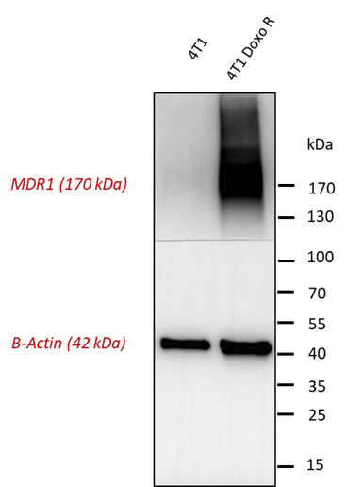

**Figure S1:** The western blot analysis of MDR1/P-glycoprotein, using both cytoplasmic and nuclear extracts of 4T1 and 4T1-R cells confirmed the overexpression in resistant cell lines.

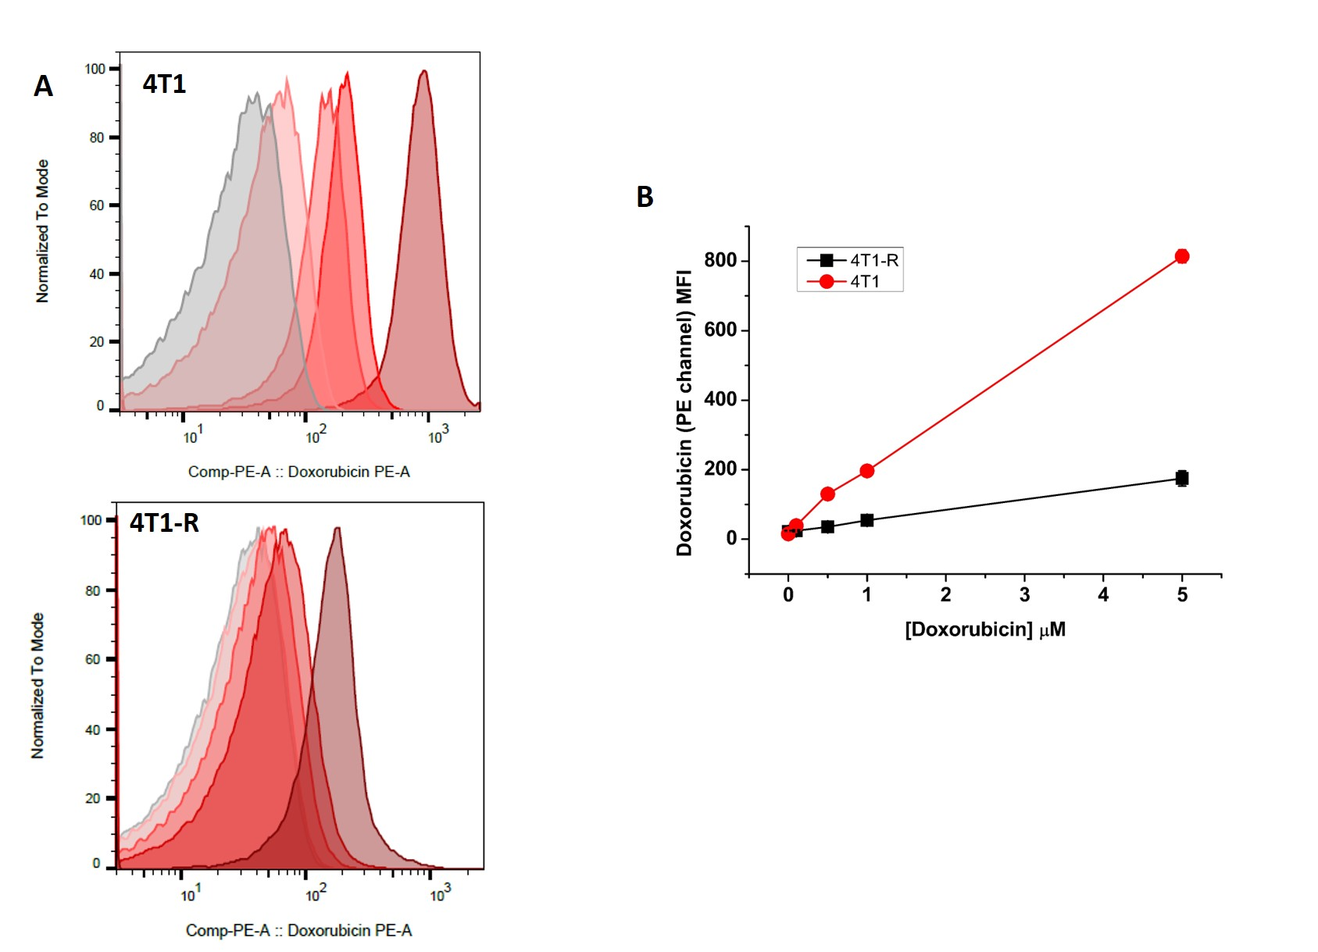

**Figure S2: A)** The phosphoethanolamine (PE) signal, due to doxorubicin fluorescence, is a good index of intracellular incorporation of doxorubicin showing that this signal changes as a function of drug concentration in 4T1-R than 4T1 only at high concentration of the drug. **B)** Further confirmation of their resistance comes from the graphs in which the mean fluorescence intensity (MFI) was plotted as a function of doxorubicin concentration. The results confirmed uptake increased of doxorubicin in wild type 4T1 than resistant ones.

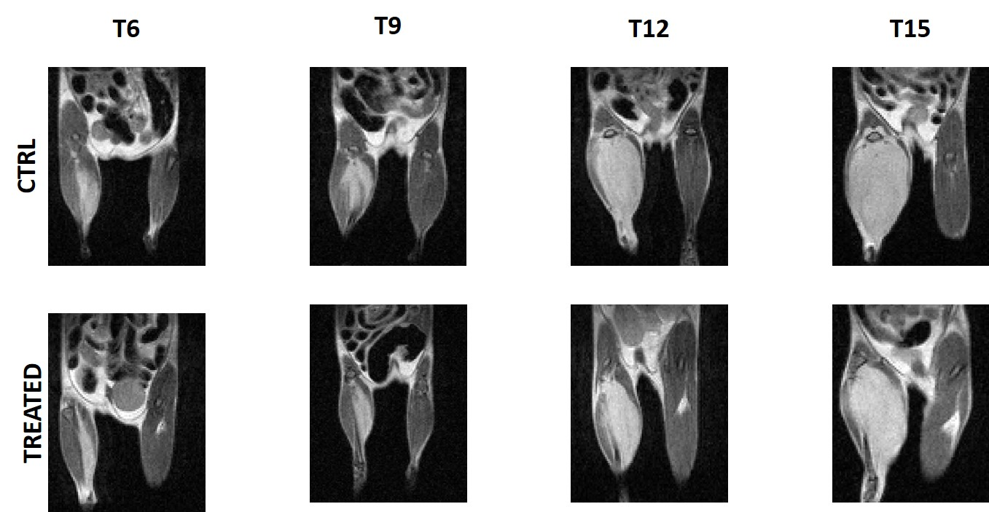

**Figure S3:** The T1-weighted images were acquired at 1 T on Aspect M2-High Performance MRI System (Aspect Magnet Technologies Ltd., Netanya, Israel) every three days as described in figure 3 of the main text to assess the doxorubicin treatment (5 mg/kg) in 4T1 animal models compared to control animals (0.9% saline solution). Tumor volume was determined using the ITK-SNAP software and the results are shown in figure 5 A