Supplementary Material
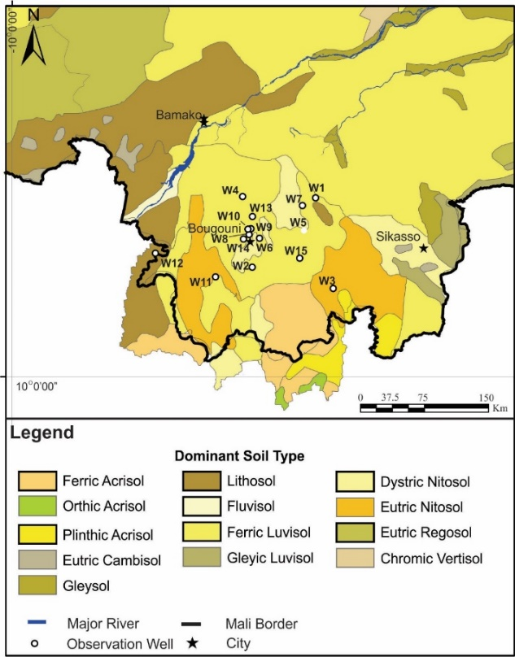
Supplementary Figure 1. Dominant soil types in southern Mali. Representative soil types used for recharge modeling are outlined in bold in the legend. The observation wells are shown (see Supplementary Table 1 for well lithology). Soil data were obtained from the Food and Agricultural Organization (2003).
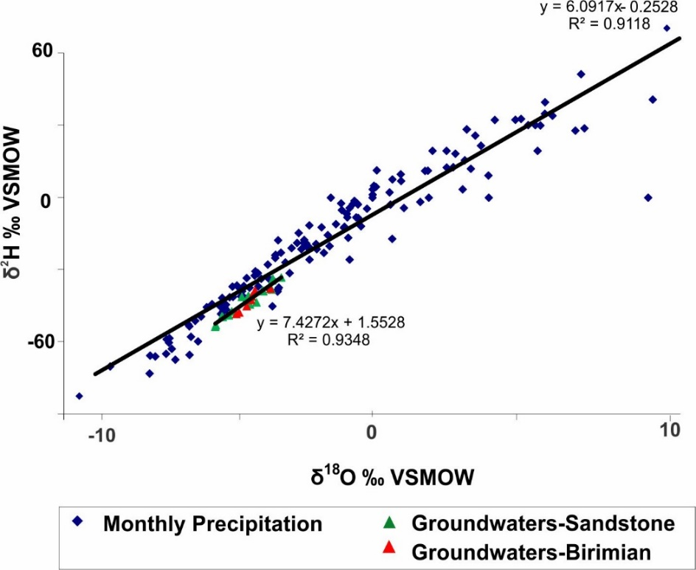
Supplementary Figure 2. Monthly δ¹⁸O and δ²H of Bamako precipitation (from GNIP) and groundwaters sampled in May 2008 in the Sandstone and Birimian.

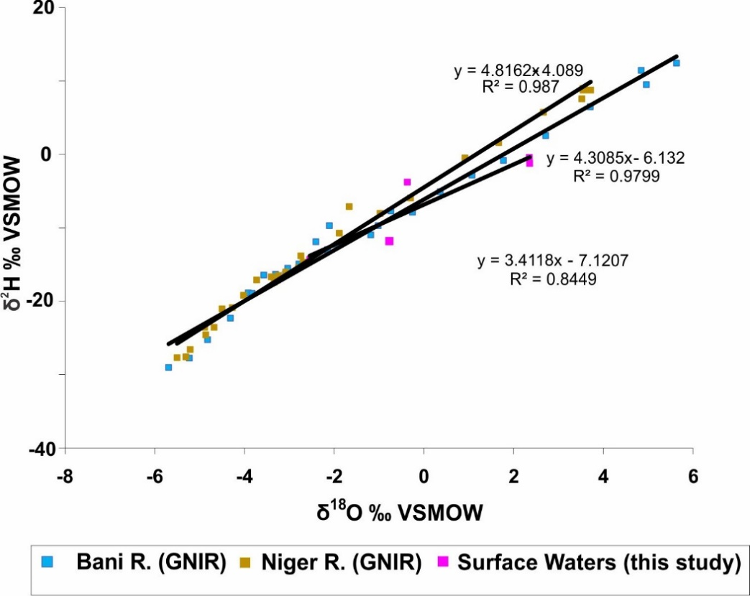
Supplementary Figure 3. δ¹⁸O and δ²H for the Bani and Niger rivers (from GNIR) and the surface waters sampled in May of 2008.

