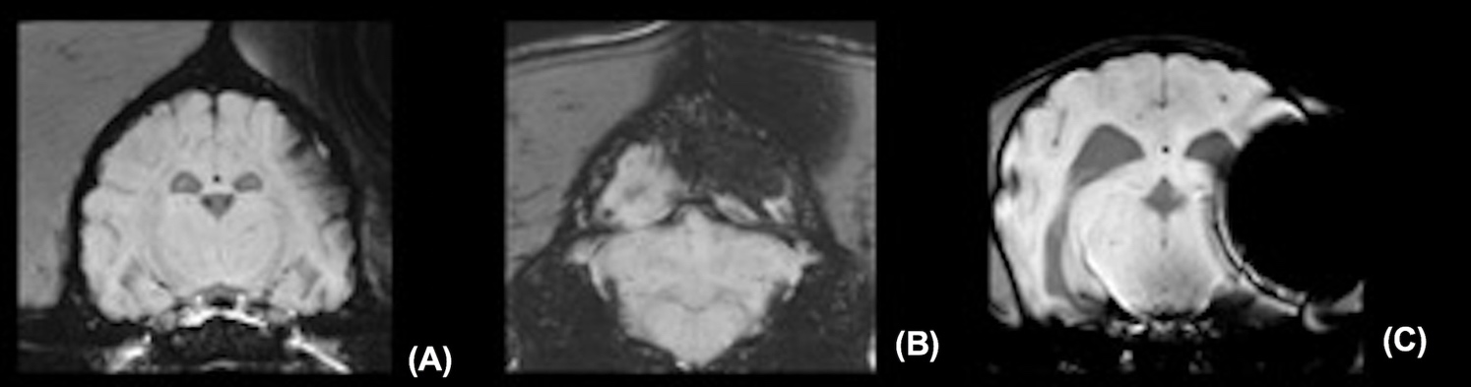

**Supplementary Figure 1.** Different degrees of impairment to image evaluation due to artifacts originating from the microchip in susceptibility-weighted images (SWI) (A mild, B moderate, C severe).