**Trimetallic NiVCe-LDH as multifunctional nanomaterials for supercapacitor, oxygen evolution reaction, and sensor applications**

Josué M. Gonçalves1*,Irlan S. Lima1, Nathália F. B. Azeredo1, Diego P. Rocha1, Abner de Siervo2 and Lúcio Angnes1*

*1Instituto de Química, Universidade de São Paulo, Av. Prof. Lineu Prestes 748, 05508-000, São Paulo-SP, Brazil.*

*2Institute of Physics “Gleb Wataghin”, Applied Physics Department, State University of Campinas, 13083-859, Campinas-SP, Brazil.*

***Corresponding authors:*** *josuemartins@usp.br* *(JMG) and* *luangnes@iq.usp.br* *(LA)*

**Figure S1**. X-ray diffractograms of (A) Ni0.9V0.1-LDH and (B) Ni0.8V0.1Ce0.1-LDH NPs deposited on a glass slip substrate.

**Figure S2**. XPS survey spectrum showing the characteristic elements presented for the synthesis of LDH NPs.

**Figure S3**. High-resolution XPS from samples synthesized with a single element. (A) Ni 2p from Ni(OH)2 nanoparticles. (B) V 2p, consistent with nanoparticles in the V2O5 phase. (C) Ce 3d consistent with Ce(OH)2 NPs of pure Ce3+ phase.

**Figure S4**. TEM images of Ce(OH)3 deposited on graphene oxide (GO) sheets.

**Figure S5**. High-resolution XPS for Ce 3d and Ni 2p core levels from samples Ni0.8V0.1Ce0.1-LDH. The attempt to fit the peak structure, especially in the Ce 3d region demonstrates that extra structures are present, suggesting the LDH formation.

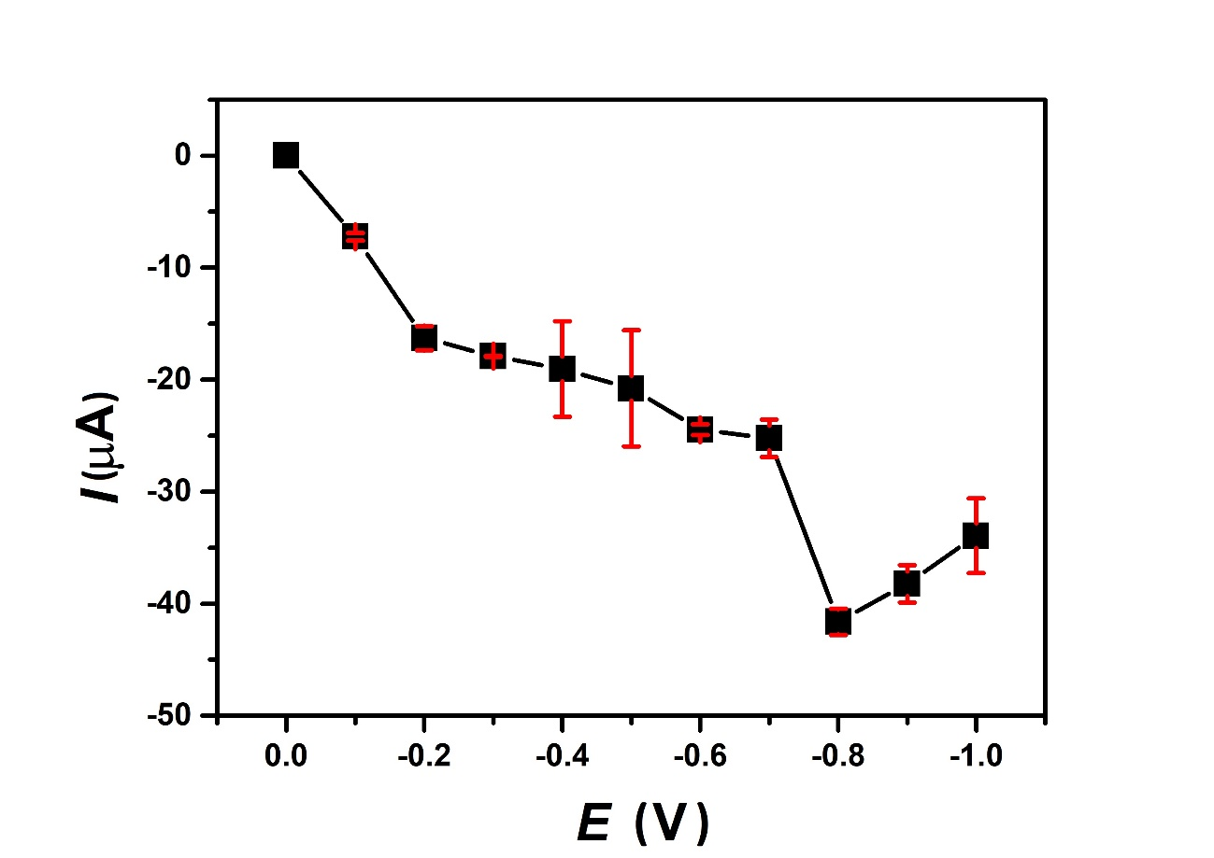

**Figure S6.** Hydrodynamic voltammetric recordings acquired in the optimization of the working potential in the presence of 10 mmol L-1 H2O2 on the Ni0.9V0.05Ce0.05-LDH SPE after electrochemical activation with NaOH 0.5 mol L-1. Background electrolyte:KCl 0.1 mol L-1.

**Figure S7**. Optimization of the volume (**red**) and dispensing speed (**black**) in BIA technique in the presence of 10 mmol L-1 H2O2 on the Ni0.9V0.05Ce0.05-LDH SPE after electrochemical activation with NaOH 0.5 mol L-1. Background electrolyte:KCl 0.1 mol L-1.