Supplementary figure 1 Timeline of surgery, treatment and behavioral test in rats. ICV: Intracerebroventricular

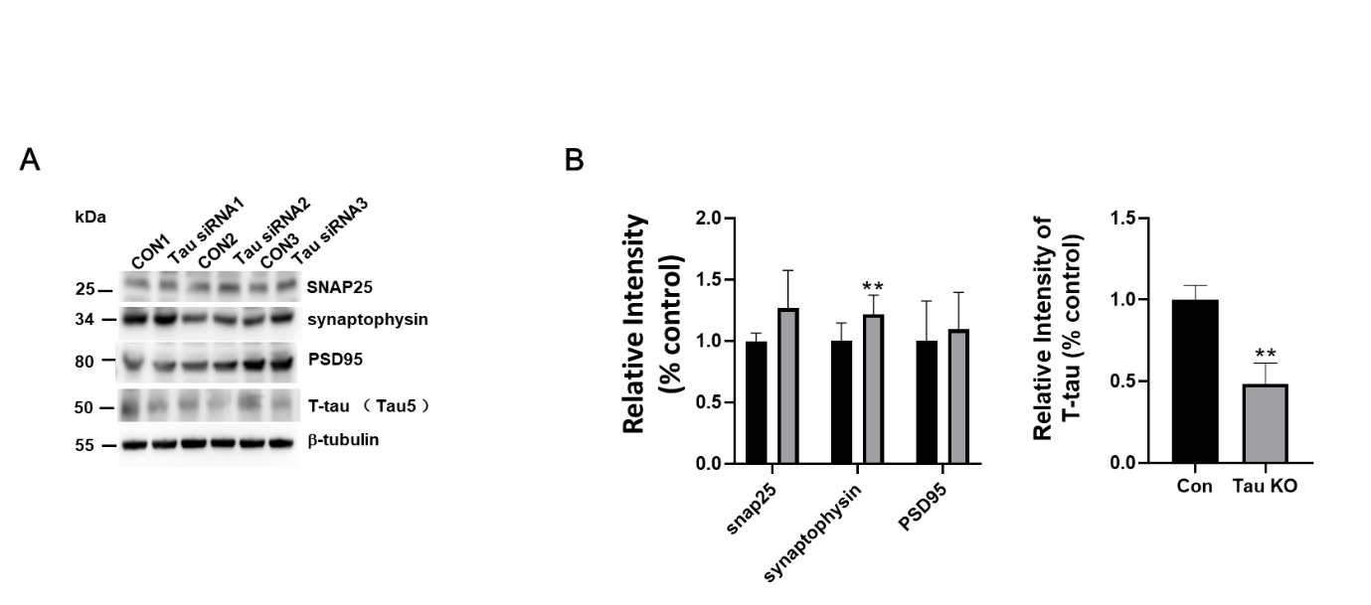
Supplementary figure 2: Effects of tau deletion on the levels of synaptic proteins. (A-B) Representative blots and quantification of the protein expression levels of SNAP25, synaptophysin, PSD95 and Total-tau in SH-SY5Y cells in the control and Tau siRNA groups. n = 3 cell experiments per group; **p < 0.01, ***p <0.001 vs. control group; Quantifications of the blots were normalized to β-tubulin.

