Supplementary Material

Fast changes in the bioenergetic balance of krill in response to environmental stress

Paulo F. Lagos¹, Alva Curtsdotter², Antonio Agüera³, Amandine J.M Sabadel⁴, David Burrit⁵ and Miles Lamare¹

Supplementary material A: Supplementary details of experimental set-up and UVR doses and intensities, including additional Figures (Figure A.1 and Figure A.2)

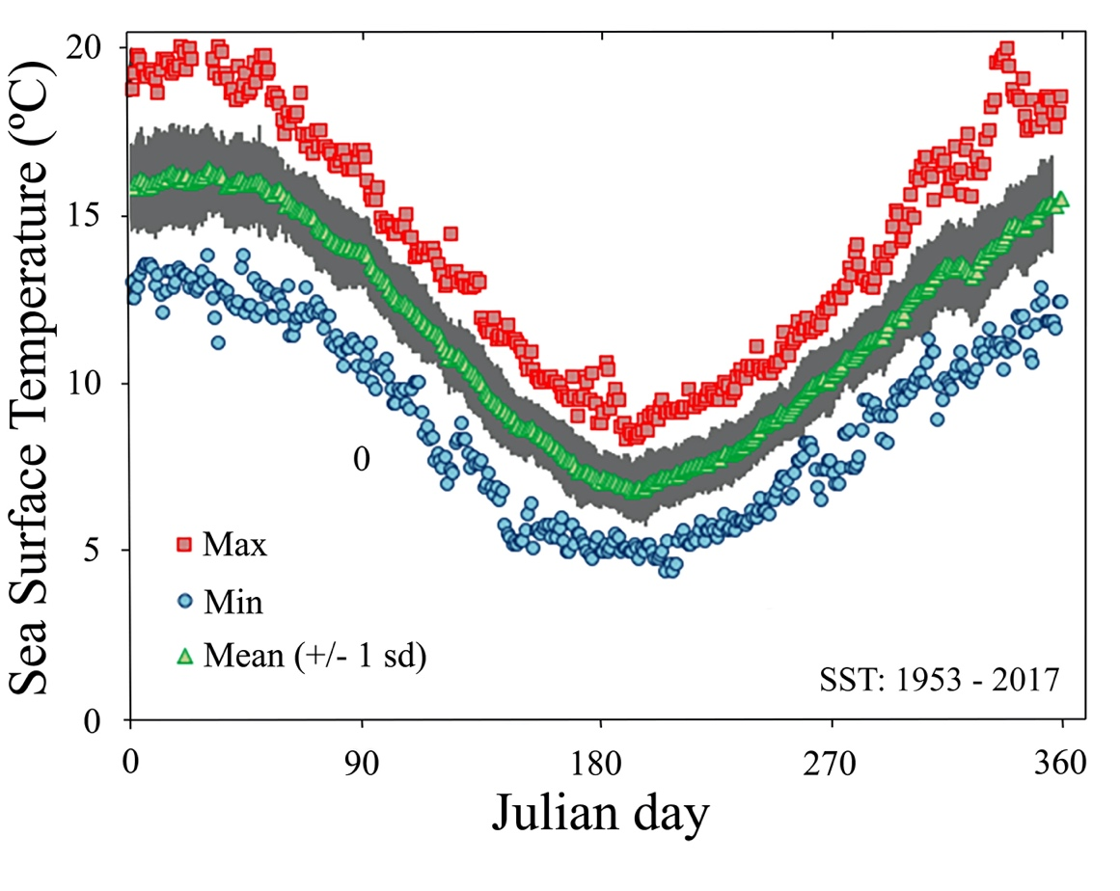
Figure A.1. Minimum, maximum and average sea surface temperatures (SST) for the Otago Harbour area were krill was sampled. Measurements of one year period from 1533 to 2017 obtained from the University of Otago portobello marine laboratory (PML). Dunedin, New Zealand.

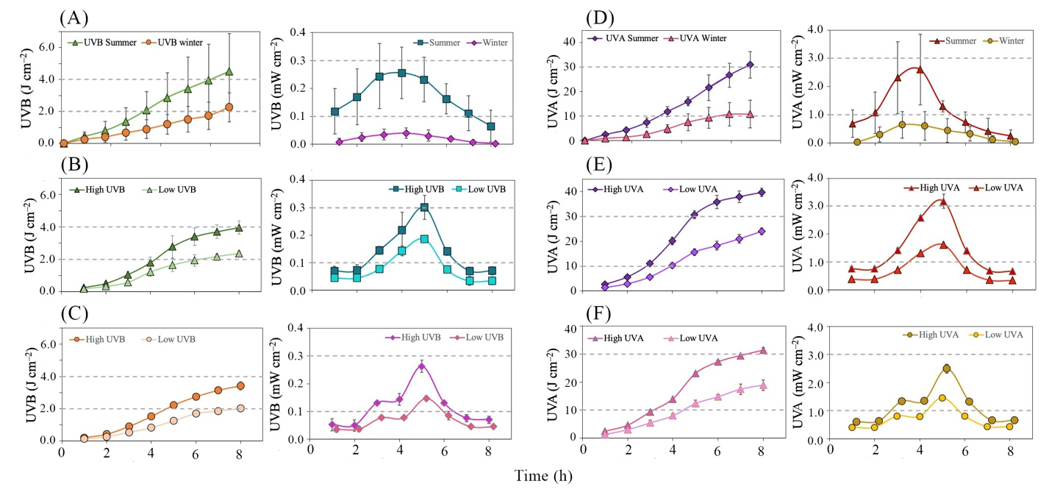
Figure A.2. Differences between natural UVR measured during the months of summer and winter from 9:00 am to 5:00 pm (A) and artificial doses of UVR obtained from the fluorescent tubes used during the temperature and light exposition experiments carried out over a period of 8 hours during the months of summer (B) and winter (C). Gray dashed lines are for comparison purposes between doses.

The experimental set-up used for temperature and light exposition experiments consisted of nine small 6L plastic tanks entirely cover with aluminium foil to avoid unwanted light entering the system. The 6L plastic tanks were placed inside two thermoregulated baths to keep the temperature stable. On top of this system, a set of 6 fluorescent UV light tubes (Cosmolux VHR-XT 160-200W) was placed at a distance of 51 cm of the plastic tanks. The fluorescent tubes emitted UV radiation between the wavelengths of 280 – 400 nm and visible light between the wavelength of 400 – 420 with a peak UV intensity between 350 – 370 nm. This set-up was used for simultaneous temperature and UVR exposure treatments. For this, a total of two UV light treatments (High UV, Low UV), one positive control treatment (WL) consisting of visible light achieved by blocking all wavelengths below 390 nm using clear PET coated polyester UV filters (ROSCO e-Colour+ #226 UV filter), which have a light transmission of 91% and one negative control treatments (DARK) consisting in krill not exposed to light, were used in combination with five temperature treatments (8ºC; 12ºC, 13ºC, 16ºC, 19ºC) with three replicates per light treatment placed inside the thermoregulated baths. To ensure krill were exposed to the same temperatures in each tank, this set-up was left to run with krill inside until the selected temperature was achieved, usually around one to two hours depending on the temperature treatment. The temperature inside the tanks was measured by placing a small temperature logger. Similarly, to ensure the correct doses and intensities of UVR were applied, a handheld radiometer was used to measure UVR doses and intensities throughout the experiments.
Each set of treatments was continued for a total of nine hours, and samples of krill (~200 individuals) were taken from the small 6 L tanks after 4 hours and 8 hours of exposure to the experimental conditions. Sampling times and expositions treatment were based on previous studies on the response of crustaceans to UVR (Souza et al., 2012; Moresino & Helbling, 2010; Lagos et al., 2015; Kazerouni et al., 2016).
Prior to the beginning of the light and temperature exposure experiments, adult krill (size 10 - 20 mm) were kept for ~24 hours under dark conditions without any input of food. The krill were then selected individually from the 250 L holding tank and only individuals that showed the best possible physiological condition, based on activity levels and amount of ectoparasitic algae, were selected and placed inside each 6 L tanks. Each small 6 L tank was filled with filtered and sterilized seawater and ~300 individuals were placed in a volume of 1.5 L (1/4 of each 6 L tanks). The animals were then left to acclimate to the new conditions in their respective tanks with the UV lights off for one hour previous to the start of the experiments.
In a separate set of experiment, adults were subjected to the same experimental temperature and UVR doses previously describe. However, during the respirometry experiments, krill individuals starved for 24 h were sampled from the 250 L fibreglass holding tank and placed inside a custom made 40 ml cylindrical glass static respirometry chamber (10 cm length x 3.5 cm diameter). Each chamber (n = 9) was separated internally into two sections using a small plastic mesh. Inside the bottom half of the glass chamber, a small magnetic mixer was placed to ensure good mixing of water, while in the top half section, an optical self-adhesive Oxygen sensor spot (PreSesns® sensor spot SP-PSt3-SA) was attached to the chamber glass wall.
Oxygen consumption mas measured on each chamber by placing the chambers on top of a magnetic stirrer set at low speed for 30 seconds to ensure good mixing of the water inside the chambers (although most likely regular swimming activity of krill is enough to break any barrier effect) while the oxygen consumption was measured. Previously to the beginning of the experiments, respirometry chambers were filled with filtered and sterilized seawater previously aerated for 12h to ensure 100% oxygen saturation and placed in the experimental set-up for an hour to bring the chambers to the desire experimental temperature before placing krill individuals inside. After this time, a total of three active krill adults were carefully placed inside each of the nine chamber (Total amount of chamber: UV x 3, White light x 3, Dark x 3), and oxygen consumption rates (𝜇mol/h) were measured using a fibre optic oxygen meter (PreSens®, Fibox 3 oxygen meter). For each light treatment we control for background respiration by placing three extra blank chambers per light treatment.
In total, the respirometry experiments used three replicates per treatments, and dark treatments were achieved by wrapping entirely the dark treatments respirometry chambers with black rubber to stop any light.
The chambers were incubated for a total of 2 h to ensure that oxygen concentration inside the chambers stayed above 60% to avoid unwanted sources of stress to the animals. Measurements of oxygen consumption were taken every 30 minutes for each chamber, and ash-free dry weights (AFDW) were then used to correct oxygen consumption rates for the total biological mass inside the chambers to obtain oxygen consumption rates per dry weight of krill individual.

Supplementary Material B: Supplementary details on the kril-DEB model design, with additional tables (Tables A.1, A.2, A.3 and A.4) and Figures (Figure A.1).

The DEB model is a mechanistic model that outlines the intake of energy and its subsequent allocation to metabolic processes such as maintenance, growth, and reproduction and describes the dynamics of three state variables: E, the energy stored in reserves, V, the volume of structure, and $E_{R}$, the energy allocated to reproduction. Briefly, the model dynamics (Figure 1, Main text) can be explained as follows: the reserve mobilization rate ${\dot{p}}_{C}$ is divided in two parts. A first constant fraction, 𝛋, is allocated to structural growth ${\dot{p}}_{G}$, and maintenance ${\dot{p}}_{S}$, and the remainder, 1-𝛋, is allocated to reproduction ${\dot{p}}_{R}$, and maturity maintenance ${\dot{p}}_{J}$. The equations describing the dynamics of the state variables and the energy fluxes of the model are given in Table B.1. and the full list of parameters of the DEB model are given in Table B.2.

Table B.1. Fluxes and state variables of the Dynamic Energy Budget model applied to Nyctiphanes australis. Core equations of the standard DEB model and changes in the state variables of the model.

DEB model fluxes | Formulation | Equation #
Assimilation | $${\dot{p}}_{C}=E \frac{\left[E_{G}\right] \dot{v} L^{2}+ {\dot{p}}_{S}}{κ E+ \left[E_{G}\right]{ L}^{3}}$$  $${\dot{p}}_{A}=\left\{{\dot{p}}_{Am}\right\} f L^{2} if \left(E_{H}≥E_{H}^{b}\right)$$ | eq.4
Mobilization |  | eq.5
Somatic Maintenance | $${\dot{p}}_{S}=\left[{\dot{p}}_{M}\right] { L}^{3}+\left\{{\dot{p}}_{T}\right\} L^{2}$$ | eq.6
Maturity Maintenance | $${\dot{p}}_{J}={\dot{k}}_{J} { E}_{H}$$ | eq.7
Growth | $${\dot{p}}_{G}={κ\dot{ p}}_{C}-{\dot{p}}_{S}$$ | eq.8
Reproduction | ${\dot{p}}_{R}=\left(1-κ\right) {\dot{p}}_{C}-{\dot{p}}_{J}$ | eq.9
Change in the state variables
Structural volume | $$\frac{d}{dt}V=\frac{{\dot{p}}_{G}}{\left[E_{G}\right]}$$ | eq.10
Reserves | $$\frac{d}{dt}E={\dot{p}}_{A}-{\dot{p}}_{C}$$ | eq.11
Maturity | $$\frac{d}{dt}E_{H}={\dot{p}}_{R} if \left(E_{H}=E_{H}^{P}\right)$$ | eq.12
Reproduction | $$\frac{d}{dt}E_{R}=k_{R}{\dot{p}}_{R} with \left(E_{H}≥E_{H}^{p}\right)$$ | eq.13

Table B.2. Parameters of the DEB model. Parameters obtained in the calibration of the model using only the control data of N.australis not exposed to light treatments. In the table (1) represent free parameters and (0) represent fix parameters. All the parameters presented in the table were later fixed to obtain the light parameters of the model during the second model step.
Standard DEB parameters
Symbol | Units | Value | Free | Description
z | - | 0.3732 | 1 | Zoom factor
𝜅_{x} | - | 0.8 | 0 | Digestion efficiency of food to reserve
𝜅_{P} | - | 0.1 | 0 | Faecation efficiency of food to faeces
$$\dot{v}$$ | cm d^{–1} | 0.02546 | 1 | Energy conductance
𝜅 | - | 0.7764 | 1 | Allocation fraction to soma
𝜅_{R} | - | 0.95 | 1 | Reproduction efficiency
$$\left[{\dot{p}}_{M}\right]$$ | J d^{–1}cm^{–3} | 119.5 | 1 | Volume-specific somatic maintenance rate
$${\dot{p}}_{T}$$ | J d^{–1}cm^{–2} | 0.002165 | 1 | Surface-specific somatic maintenance rate
$${\dot{k}}_{J}$$ | 1 d^{–1} | 0.002 | 1 | maturity maintenance rate coefficient
$$\left[E_{G}\right]$$ | J cm^{–3} | 4424 | 1 | Specific cost for structure
$$E_{H}^{b}$$ | J | 0.03147 | 1 | Maturity at birth
$$E_{H}^{P}$$ | J | 9.49 | 1 | Maturity at puberty
$${\dot{h}}_{a}$$ | 1 d^{–2} | 7.249E-07 | 1 | Weibull aging acceleration
$$s_{G}$$ | - | 0.001 | 0 | Gompertz stress coefficient
f | - | 1 | 0 | Functional response for 0-var data
f₁ | - | 1.179 | 1 | Functional response for Heterocaspa sp.
f₂ | - | 0.797 | 1 | Functional response for Phaeocystis sp.
f₃ | - | 0.6846 | 1 | Functional response for Thalassiosira sp.
Temperature parameters

T_{ref} | K | 293.1 | 0 | Reference temperature
T_{A} | K | 7273 | 0 | Arrhenius temperature
T_{L} | K | 280 | 0 | lower boundary tolerance range
T_{H} | K | 294 | 0 | upper boundary tolerance range
T_{AL} | K | 625.9 | 0 | Arrhenius for lower boundary
T_{AH} | K | 4765 | 0 | Arrhenius for upper boundary
Conversion parameters
del_{M} | - | 0.1577 | 1 | Shape coefficient
$${\overline{u}}_{E}$$ | 550000 | J/mol | F | Chemical potential of reserves

Table B.3. Equations within the DEB model for predictions of N. australis
Predictions | Formulation | Units | Equation #
Length-time |  | cm | eq.14
Time–dry weight | $$Lt=\frac{L_{i}-\left(L_{i}-L_{b} \right)e^{\left(-t {\dot{r}}_{b}^{T}\right)}}{δ_{M}}$$  tW = $\left(L_{i}-(L_{i}-L_{b} δ_{M}\right){ e^{-t {\dot{r}}_{b}^{T}})}^{3}{ d}_{V} \left(1+f w\right)$ | d | eq.15
Length–dry weight | $${LW=d_{V} \left(L δ_{M}\right)}^{3}\left(1+f w\right)$$ | cm | eq.16
Length–wet weight | LW $={\left(L δ_{M}\right)}^{3}\left(1+f w\right)$ | cm | eq.17
Growth rate | $${ {\dot{r}}_{b}^{T}=a}_{b}^{T} \frac{{\dot{k}}_{M}}{3} \frac{1}{\left(1+f/g\right)}$$ | cm/d | eq.22
Reproduction rate | $$\dot{R}= κ_{R}\frac{{\dot{p}}_{R}}{E_{0}}$$ | #egg/ d | eq.23
Compounds (No-Light) | $${ M}_{C}=M_{CV}+\left(\frac{M_{CE}}{M_{E}}\right) t {\dot{J}}_{EM}$$ | C-mol | eq.24

Table B.4. Comparison of model predictions from this study (Pred. A) with observed data for N. australis, with the relative error (RE) for each prediction and results of model prediction of previous DEB model of N.australis (Pred. B) (Lagos et al., 2012)
Symbol  $$a_{b}$$ | Unit | Description | Observation | Pred.(A) | RE | Pred.(B) | References
 | d | Age at birth | 5 | 6.129 | 0.225 | 8.01 | This study
$$t_{p}$$  $$a_{m}$$ | d | Time at puberty | 115 | 110.8 | 0.003 | 112.3 | Hosie (1982)
$$L_{b}$$ | d | Mean life-span | 365 | 445.5 | 0.221 | 595 | Hosie (1982)
$$L_{p}$$ | cm | Total length at birth | 0.045 | 0.182 | 3.05 | 0.188 | Hosie (1982)
 | cm | Total length at puberty | 1.163 | 1.053 | 0.009 | 1.213 | Haywood & Burns (2003)
$$L_{i}$$ | cm | Ultimate total length | 2.21 | 2.36 | 0.071 | 2.25 | Lagos et al., (2021)
$${Ww}_{i}$$ | g | Ultimate wet-weight | 0.06 | 0.061 | 0.003 | 0.07 | Lagos et al., (2021)
$$R_{i}$$  $${Wd}_{14}$$ | g | Dry-weight at 1.45 cm | 0.00305 | 0.00310 | 0.018 | – | This study
$$N_{i}$$ |  | Max. reproduction rate | 4.75 | 6.12 | 0.286 |  | Lagos et al., (2021)
 |  | Life-time reproductive output | 1100 | 1000 | 0.09 | 1074 | Hosie (1982)

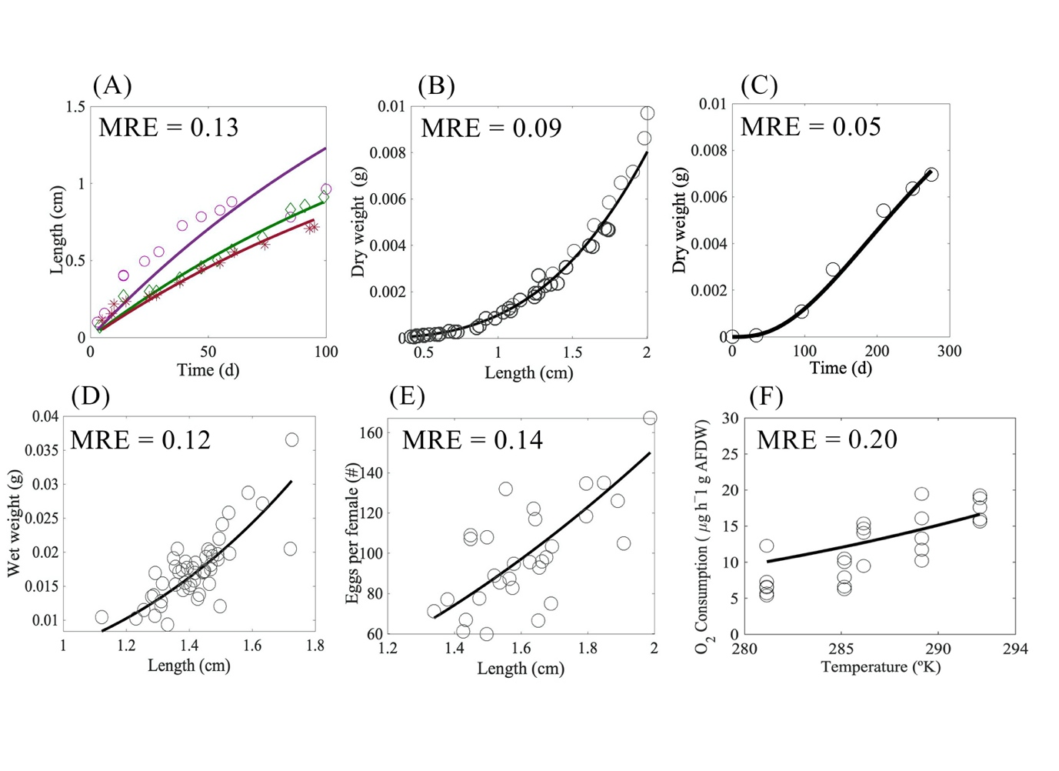Figure B.1. Control model predictions (continuous lines) of N. australis data (Circles) of body length at different diets (A), length dry weight (B). Predicted dry-weight from birth to adult stages compared against observation of dry weight in time obtained from literature (C). DEB model prediction versus observations of wet weight and length (D) and the total number of eggs per female at length (E) and prediction of the increase in respiration rates with temperature (F). With parameter values for predictions obtained from (Table 1)

Supplementary Material C: Detailed description of the part of the DEB model that deal with the effect of light and additional figure (Figure B.1).

The DEB model presented in the main text considers any potential effects of white light (WH) and ultraviolet light (UVR), using light specific coefficients and light-compounds specific parameter for accounting for direct (photo-oxidation) and indirect (metabolic usage) effects of light and temperature on compounds. The introduction of WH light coefficients rests on the assumption that WH light mainly affect krill behaviour. Therefore, any effects on metabolism are exclusively a response to increased activity (e.g. Increased swimming activity) and not a product of the breakage of compounds or enhanced metabolism due to stressful conditions. Its effect is considered smaller than the effect produced by UVR, which must have a much higher effect on metabolisms, that is, the product of the combination of two independent but interactive processes, a biological one (i.e. increased metabolisms) and a physicochemical (e.g. Oxidation of molecules)
In the model, the light parameters for WH and UV light are approached from respiration rates of krill exposed simultaneously to several temperatures and light experiments, following the reasoning that respiration and metabolic rates escalate with temperature (Hirche, 1984; Yaikin et al., 2000; Tremblay et al., 2014) minus any physicochemical effects on compounds produced by UVR. Therefore, assuming that the effect of light is multiplicative both in time and with temperature, both parameters are used to predict respiration rates and track the utilization of compounds in time. Additionally, because fatty acids and amino acids dynamics can be highly variable with light and temperature (Goes et al., 1994; Werbrouck et al., 2016; Abol-Munafi et al., 2020; Jin et al., 2020; ), the model test if assuming a non-linear reduction of compounds during starvation conditions due to light and temperature improves model predictions of compounds dynamics over time compared to predictions that use a linear decreases of compounds as proposed by Kooijma, (2010).
Assuming an exponential decay rate instead of a lineal reduction in time implies that the decrease of compounds in the reserve compartment due to temperature and light is compound specific. Therefore, it disrupt the assumption of strong homeostasis, which states the relative proportion/composition of molecules in the reserves and structure is constant and what it can change is the amount of compounds (Kooijman. 2010).
The advantage of this assumption is that it allows accounting for compound-specific rates of change and light specific rates of change. The effect of light then can be divided into two components, a first component that accounts for the metabolism and a second component that account for the oxidative stress-related breakage of compounds due to highly energetic light wavelengths.

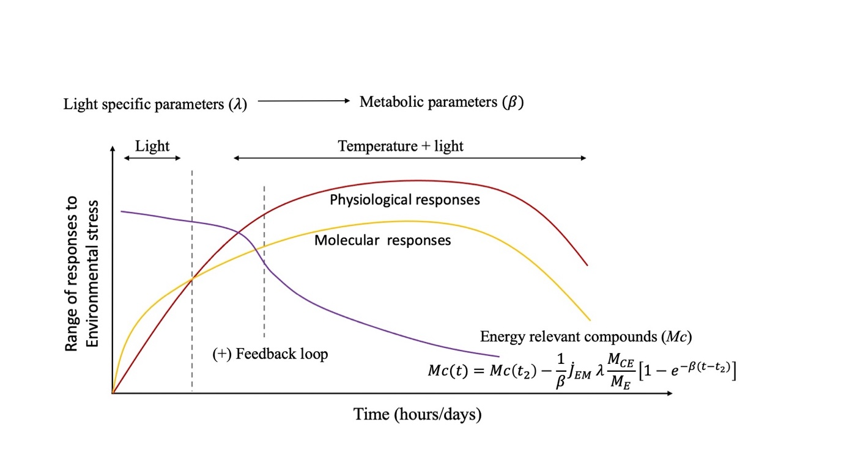
Figure C.2. Conceptual representation of the progression in the responses to the effects of light and temperature at the molecular and physiological level. The figure illustrate how light first produce a response that quickly trigger molecular responses that could be associated to defence mechanisms against stress followed by a generalize increase in physiological responses. During the first hours reduction of energy relevant compounds are trigger by a quick increment of molecular responses which later produce an increment of the physiological responses, which create a positive feedback loop that further reduced the amount of energy relevant compounds.

Supplementary material D: Supplementary details on predictions of respiration rates.
In DEB theory, a single chemical reaction in which food and oxygen are turn into reserves, waste products and heat, following rules of conservation of mass and energy can be splitted in three small reaction that conform the assimilation, dissipation and growth fluxes of the DEB model.

$$assimilation = food +02 \underset{→}{yields} reserves + feces + H_{2}0+heat$$ | (Eq.1)

$$dissipation = reserve + O_{2}\underset{→}{yields} H_{2}O+{CO}_{2}+{NH}_{3}+heat$$ | (Eq.2)

$$growth = reserve +O_{2}\underset{→}{yields} structure + H_{2}O+{C0}_{2}+{NH}_{2}+ heat$$ | (Eq.3)
The organic fluxes (${\dot{J}}_{O}$) of the DEB model, which include: ${\dot{J}}_{X}$ flux of food (C-mol X day^{–1}), ${\dot{J}}_{V}$flux of reserves (C-mol V day^{–1}), ${\dot{J}}_{E}$ reserve flux (C-mol E day^{–1}) and ${\dot{J}}_{P}$ flux of feces (C-mol P day^{–1}) are stipulated as a weighted sum of the powers of: ${\dot{P}}_{A}$ assimilation , ${\dot{P}}_{D}$ dissipation and ${\dot{P}}_{G}$growth.

$${\dot{J}}_{O}= η_{O} \dot{p}$$
Where:
$${\dot{J}}_{O} = \left(\begin{matrix}{\dot{J}}_{X} \\ {\dot{J}}_{V} \\ {\dot{J}}_{E} \\ {\dot{J}}_{P}\end{matrix}\right) η_{O} = \left(\begin{matrix}–y_{XE}{\overline{ μ}}_{E}^{–1} & 0 & 0 \\ 0 & 0 & \left[M_{V}\right]{\left[E_{G}\right]}^{–1} \\ {\overline{ μ}}_{E}^{1} & {\overline{ μ}}_{E}^{–1} & –{\overline{ μ}}_{E}^{–1} \\ y_{PX }y_{XE}{\overline{ μ}}_{E}^{–1} & 0 & 0\end{matrix}\right) \dot{\dot{p}=\left(\begin{matrix}{\dot{p}}_{A} \\ {\dot{p}}_{D} \\ {\dot{p}}_{G}\end{matrix}\right)}$$

where $y_{XE}$ is the yield of reserve on food, $y_{PX }$is the yield of feces on food and ${\overline{μ}}_{E}$ is the chemical potential of reserves. Most of the compound parameters of the DEB model described in this section, are values from a generalize animal, while $\left[M_{V}\right]$ the volume-specific structural mass and $\left[E_{G}\right]$ the volume-specific cost of structure, are DEB model parameters obtained using the co-variation method for model parametrization.
The mineral fluxes of the model (${\dot{J}}_{M}$), which include: ${\dot{J}}_{C}$ carbon flux (mol CO₂ day^{–1}), ${\dot{J}}_{H}$ hydrogen flux (mol H₂O day^{–1}), ${\dot{J}}_{O}$ oxygen flux (mol O₂ day^{–1}) and the ${\dot{J}}_{N}$ nitrogen flux (mol NH₃ day^{–1}) are also stipulated as a weighted sum of the organic fluxes following:

${\dot{J}}_{M}= η_{M}\dot{ p}$ & $η_{M}= –n_{M}^{–1} n_{O} n_{O}$

where:
$${\dot{J}}_{M} = \left(\begin{matrix}{\dot{J}}_{C} \\ {\dot{J}}_{H} \\ {\dot{J}}_{O} \\ {\dot{J}}_{N}\end{matrix}\right) and η_{M} = \left(\begin{matrix}η_{CA} & η_{CD} & η_{CG} \\ η_{HA} & η_{HD} & η_{HG} \\ η_{OA} & η_{OD} & η_{OG} \\ η_{NA} & η_{ND} & η_{NG}\end{matrix}\right)$$

The computation for the prediction of the oxygen consumption (Eq. 25) is then a sum of the organic fluxes multiplied by the fluxes of assimilation, dissipation and growth.

$${\dot{J}}_{O}= η_{OA}{\dot{p}}_{A}+ η_{OD}{\dot{p}}_{D}+ η_{OG}{\dot{p}}_{G}$$ | (Eq. 4)

The three basic powers ($\dot{p}$) in the equation are cubic polynomials in length (Kooijman, 2010) from which it follows that mass fluxes are also cubic polynomials in length. This property is used for computing model prediction for data sets of temperature-respiration rates (T–JO).

Supplementary Material E: Effect of temperature on models predictions and Figure (Figure. E.1)

DEB uses the Arrhenius concept of activation energy (Kooijman, 2010) to include the effect of temperature on the metabolism of krill, assuming that all rates of the model are temperature dependent. We relate the metabolic rates, $k$, to temperatures, $T$, by multiplying the rate at the reference temperature by the temperature correction factor $C_{T},$ defined by equation Eq.5 (Kooijman, 2020).

$C_{T} = S_{A} \frac{S(T)}{S(T_{ref})}$ (Eq.5)
$S_{A} = exp\left(\frac{T_{A}}{T_{1}}–\frac{T_{A}}{T}\right)$ (Eq.6)
${S(T) = \left(1 + exp \left(\frac{T_{AL}}{T}–\frac{T_{AL}}{T_{L}}\right)+ exp\left(\frac{T_{AH}}{T_{H}}–\frac{T_{AH}}{T}\right)\right)}^{–1}$ (Eq.7)

The temperature parameters of the model were fixed to values empirically calculated using Eq.6 and Eq.7 based on laboratory obtained measurements of respirometry at temperatures between 8ºC to 19ºC (281.15 and 292.15 ºK, respectively) according to (Agüera et al., 2015).

$$C_{T} = S_{A} \left(1+exp\left(\frac{T_{AL}}{T}–\frac{T_{AL}}{T_{L}}\right)+exp{\left(\frac{T_{AH}}{T_{H}}–\frac{T_{AH}}{T}\right)}^{–1}\right)$$ | (Eq. 8)

$$S_{A} = exp\left(\frac{T_{A}}{T_{1}}–\frac{T_{A}}{T}\right)$$ | (Eq. 9)

We calculate the Arrhenius temperature for N. australis based on respirometry data collected from respirometry experiments performed by the authors at temperatures between 8 – 19ºC (Figure E1) using the software R v3.6 (R the core team, 2019) and the function "nlsLM" of the package "minpak.lm" to fit a Non-linear least squares regression to respiration data of krill at several temperatures. First, we calculate an initial value of $T_{A}$ based on the slope of a lineal model between 1/T and the logged respiration rate (k). This value of $T_{A}$= 8306 was fixed and used as an estimate during the parametrization of the parameter T_AL using the Arrhenius equation Eq.6 to estimate the parameter using the R function "nlsLM".
Secondly, respirometry experiments also provided the range of sensitivity to temperature at which mortality of N. australis is below 5% for a period of exposure to temperature treatments of 10 hours, and help set the lower temperature boundary at temperature value of $T_{L }=280.15$ ºK (7 ºC) (Figure E1).

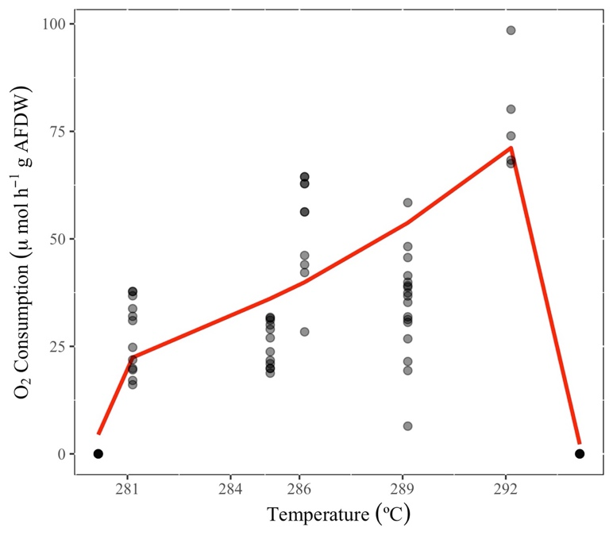
Temperature (ºK)
Figure E.1. Arrhenius plot. Data of respiration rate of N. australis with increasing temperature (Black dots), and fitted Arrhenius equation (eq.1 Main text)(Black line) used to find the parameters T_A, T_L, T_H, T_AH and T_AL. To fit the Arrhenius equation, when temperature is at both extremes 280 K (7ºC) and 294 K (21ºC) respiration is assumed to be zero due to high mortality of the animals following (Monaco et al., 2016). With obtained parameters values T_H = 293.5, T_L = 54.75, T_AL = 625.9, T_AH= 4.765e+05 and T_A = 7273.

Supplementary Material F: Mathematical derivation of main equations for predictions of the reduction of energy-relevant compounds in time and Figure (Figure F1)

The mathematical derivation of Eq.2 and Eq.5 (main text) needed solving for the effects of light and temperature in different time-steps. A first time step that solves for the modelling effects of temperature in krill not exposed to light for an initial starvation period of 24 hours and a second time step that include the effects of light for the next 8 hours. The steps to derive the equation Eq.2 and Eq.5 as follow:

$$M_{C}\left(t\right)=E_{m}\left(t_{2}\right)–\int_{0}^{t}{{\dot{J}}_{EM}{ T}_{C }λ }\frac{M_{CE}}{M_{E}} e^{–β\left(t – t_{2}\right)}dt$$
$$=E_{M}\left(t_{2}\right)+\frac{1}{β} {\dot{J}}_{EM}{ T}_{C} λ \frac{M_{CE}}{M_{E}} \left[e^{–β\left(t – t_{2}\right)} –1\right]$$
$$=E_{M}\left(t_{2}\right) – \frac{1}{β}{ \dot{J}}_{EM} T_{C} λ\frac{{ M}_{CE}}{M_{E}} \left[{1 –e}^{–β\left(t – t_{1}\right)}\right]$$

For simplification of the notation the term, 𝛽, represent the compound specific light parameters $L_{β}$, responsible to capture the non-metabolic reduction of compounds in time and, 𝜆, represent the metabolic light amplification factors $L_{α}$ associated to the increase in respiration rates. The overall prediction of the reduction of compounds follows from Eq.2 and Eq.5 as:
The approach taken to predict decreases in compounds concentrations in the control or base model follow for the DEB assumption that each compounds decrease linearly in time (t ) during starvation. The decrease is then a direct function of the amount of compounds in the organisms, $M_{c}$ (in C-mol) and the rate of decrease of the compounds. Before starvation, is understood that krill individuals have a known amount of structure, $M_{V}$, and reserves, $M_{E}$. However, during starvation DEB theory states that if reserves mobilization are enough to cover somatic maintenance cost, the amount of structure, $M_{V}$, remains constant and what change is the amount of individual compounds in time. The change in compounds in time can then be calculated following Eq. 26:

$M_{C}\left(t*\right)=M_{CV}+\left(\frac{M_{CE}}{M_{E}}\right) t {\dot{J}}_{EM}$ with: ${\dot{J}}_{EM}= \left(\frac{{\dot{p}}_{M}}{μ_{E}}\right)$ | (Eq. 10)

Where $M_{c}\left(t*\right)$ is the amount of each (*) compound in time. $M_{CV},$ is the (constant) amount of compounds in structure. $M_{CE}/M_{E}$, is the ratio of the compound in the reserve and, ${\dot{J}}_{EM}$, is the rate of use of reserves for somatic maintenance purposes, which is a product of the DEB specific parameter, volume-specific somatic maintenance cost, ${\dot{p}}_{M}$, and the fixed conversion parameter, chemical potential of the reserve, $μ_{E}$, (Table 5, main text).
If the initial amount of compounds are known then Eq. 26 can also be used to predict the initial amount of compounds, $M_{C0}$, by substituting, $t,$ by $t=\left(t_{o }– t\right)$ and substituting the term $M_{CV}$ by $M_{C0}$ which in turn gives equations Eq.27 and Eq.28 as follow:

$$M_{C0}= M_{CV}+ {\dot{J}}_{CM} t_{0}$$ | (Eq. 11)

$M_{C}\left(t\right)=M_{C0}–t{ \dot{J}}_{CM}$ with: ${\dot{J}}_{CM}= \left(\frac{M_{CE}}{ME}\right) {\dot{J}}_{EM}{ T}_{C}$ | (Eq. 12)

Where, ${\dot{J}}_{CM}$, is the rate of decrease of compounds in the reserve, $t_{0}$, the initial time before compounds are depleted and, $T_{C}$, is the temperature correction factor.
Because information of the initial amount of compounds was experimentally measured, the values of $M_{C0}$ for each compounds were set as a fix parameter and Eq.28 was in turn used to calculate the final amount of compounds after 36 hours of starvation.

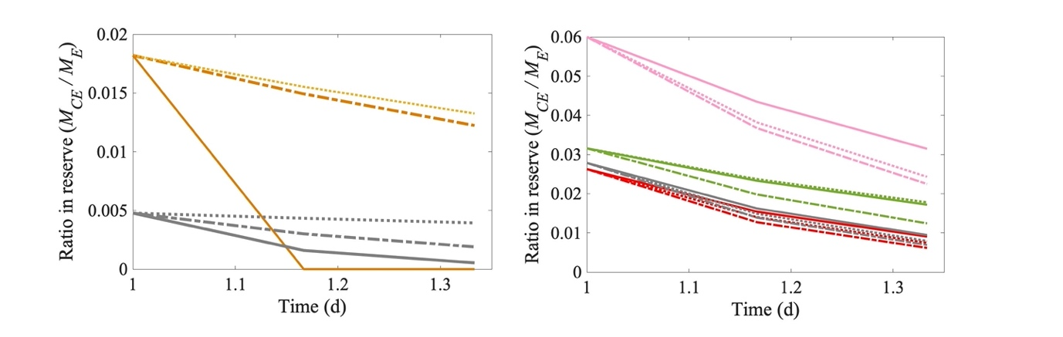
Figure F1. Figure shown compositional changes in time inside the reserve compartment of the DEB mode. When krill face different light conditions. Continuous lines (___) represent UV light, dotted lines (…) represent WH light and (-.-.) represent DARK conditions.

