Supplementary Information
Novel pyrazine-bridged D-A-D type charge neutral probe for membrane permeable long-term live cell imaging
Pei Liu^{e}, Suna Chenª, Wenxuan Zhao^{f}, Qiutang Wang^{g}, Shuqi Wu^{h}, Liang Xu^{i}, Dan Bai*^{abcd}
a. Frontiers Science Center for Flexible Electronics (FSCFE), Institute of Flexible Electronics (IFE), MIIT Key Laboratory of Flexible Electronics (KLoFE), Northwestern Polytechnical University, Xi'an, CN 710072
b. Research and Development Institute of Northwestern Polytechnical University in Shenzhen, Northwestern Polytechnical University, Xi'an, CN 518057
c. Xi'an Key Laboratory of Special Medicine and Health Engineering, Northwestern Polytechnical University, Xi'an, CN 710129
d. Research Institute of Xi'an Jiaotong University (Zhejiang), Hangzhou, CN 311215
e. Department of Chemistry and Chemical Engineering, School of Natural Sciences, Northwestern Polytechnical University, Xi'an 710072, PR China
f. School of Material Science and Engineering, Northwestern Polytechnical University, Xi'an, CN 710072
g. School of Medicine, Xi’an Jiaotong University, CN 710061 h. School of Life Sciences, Northwestern Polytechnical University, CN 710072 i. School of Chemistry and Chemical Engineering, Key Laboratory for Green Processing of Chemical Engineering of Xinjiang Bingtuan, Shihezi University, CN 832003
Correspondence: iamdbai@nwpu.edu.cn
Materials and characterization instrumentation
The materials used for synthesis were all purchased from Innochem (Beijing, China). Cell viability assay (CCK-8) was purchased from Sigma-Aldrich Co. LLC (Shanghai, China). Lysotraker Red and RedDotTM 1 were purchased from Invitrogen (China). ¹H and ¹³CNMR spectra in CDCl₃ were determined by a BrukerAVANCE 400 MHz Spectrometer, and mass spectrometry was determined by Waters QTof. UV-Vis absorption spectra were recorded on Thermo Evolution 220 spectrometre. Photoluminescence spectra were recorded on Hitachi F7500 spectrometre. Fluorescence lifetime spectrum and quantum yield were recorded on Holiba F-7000 FL spectrophotometer with Quanta-φSpectralon® integrating sphere with center-mounted cuvette sample holder, Ludox® TMA colloidal silica was used as reference. CCK-8 assay was performed on a platereader (Synergy HT, BioTek).

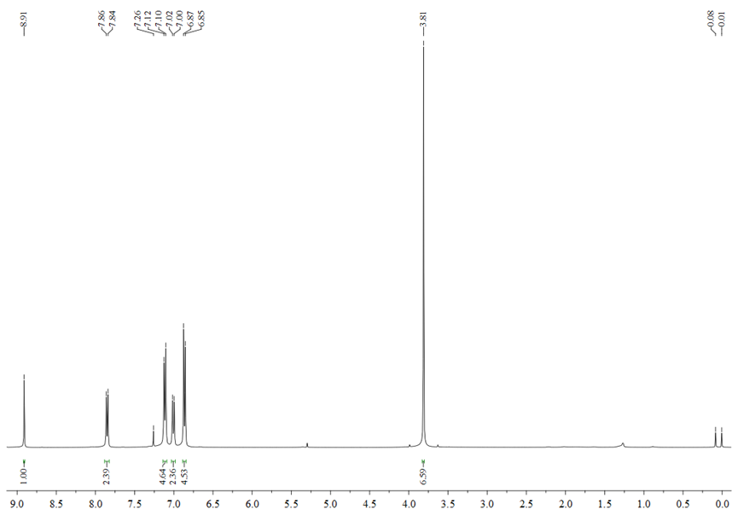
Fig. S1 ¹H NMR spectrum of (OMeTPA)₂-Pyr in CDCl₃.
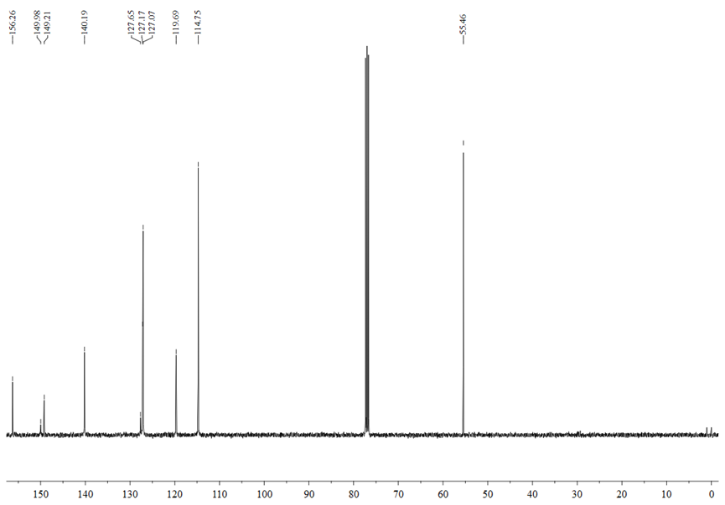
Fig. S2 ¹³C NMR spectrum of (OMeTPA)₂-Pyr in CDCl₃.

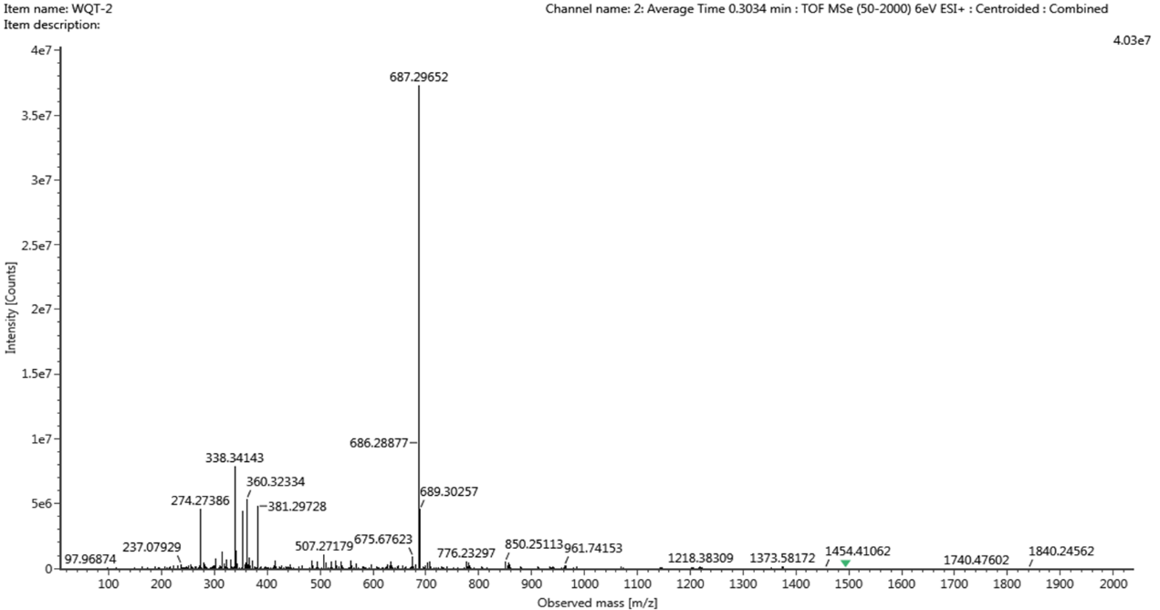
Fig. S3 HRMS spectrum of (OMeTPA)₂-Pyr in acetonitrile.
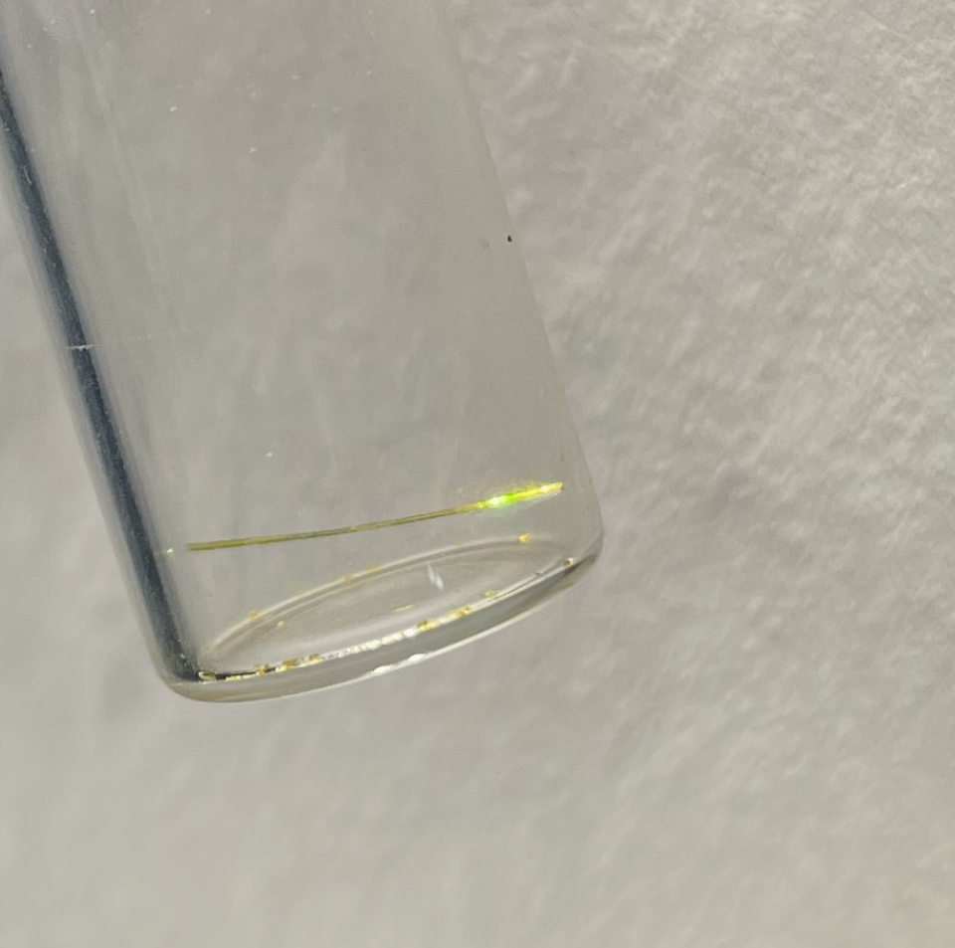
Fig. S4 Single crystal of (OMeTPA)₂-Pyr isolated by slow vapor diffusion (CHCl₃:Hexane).
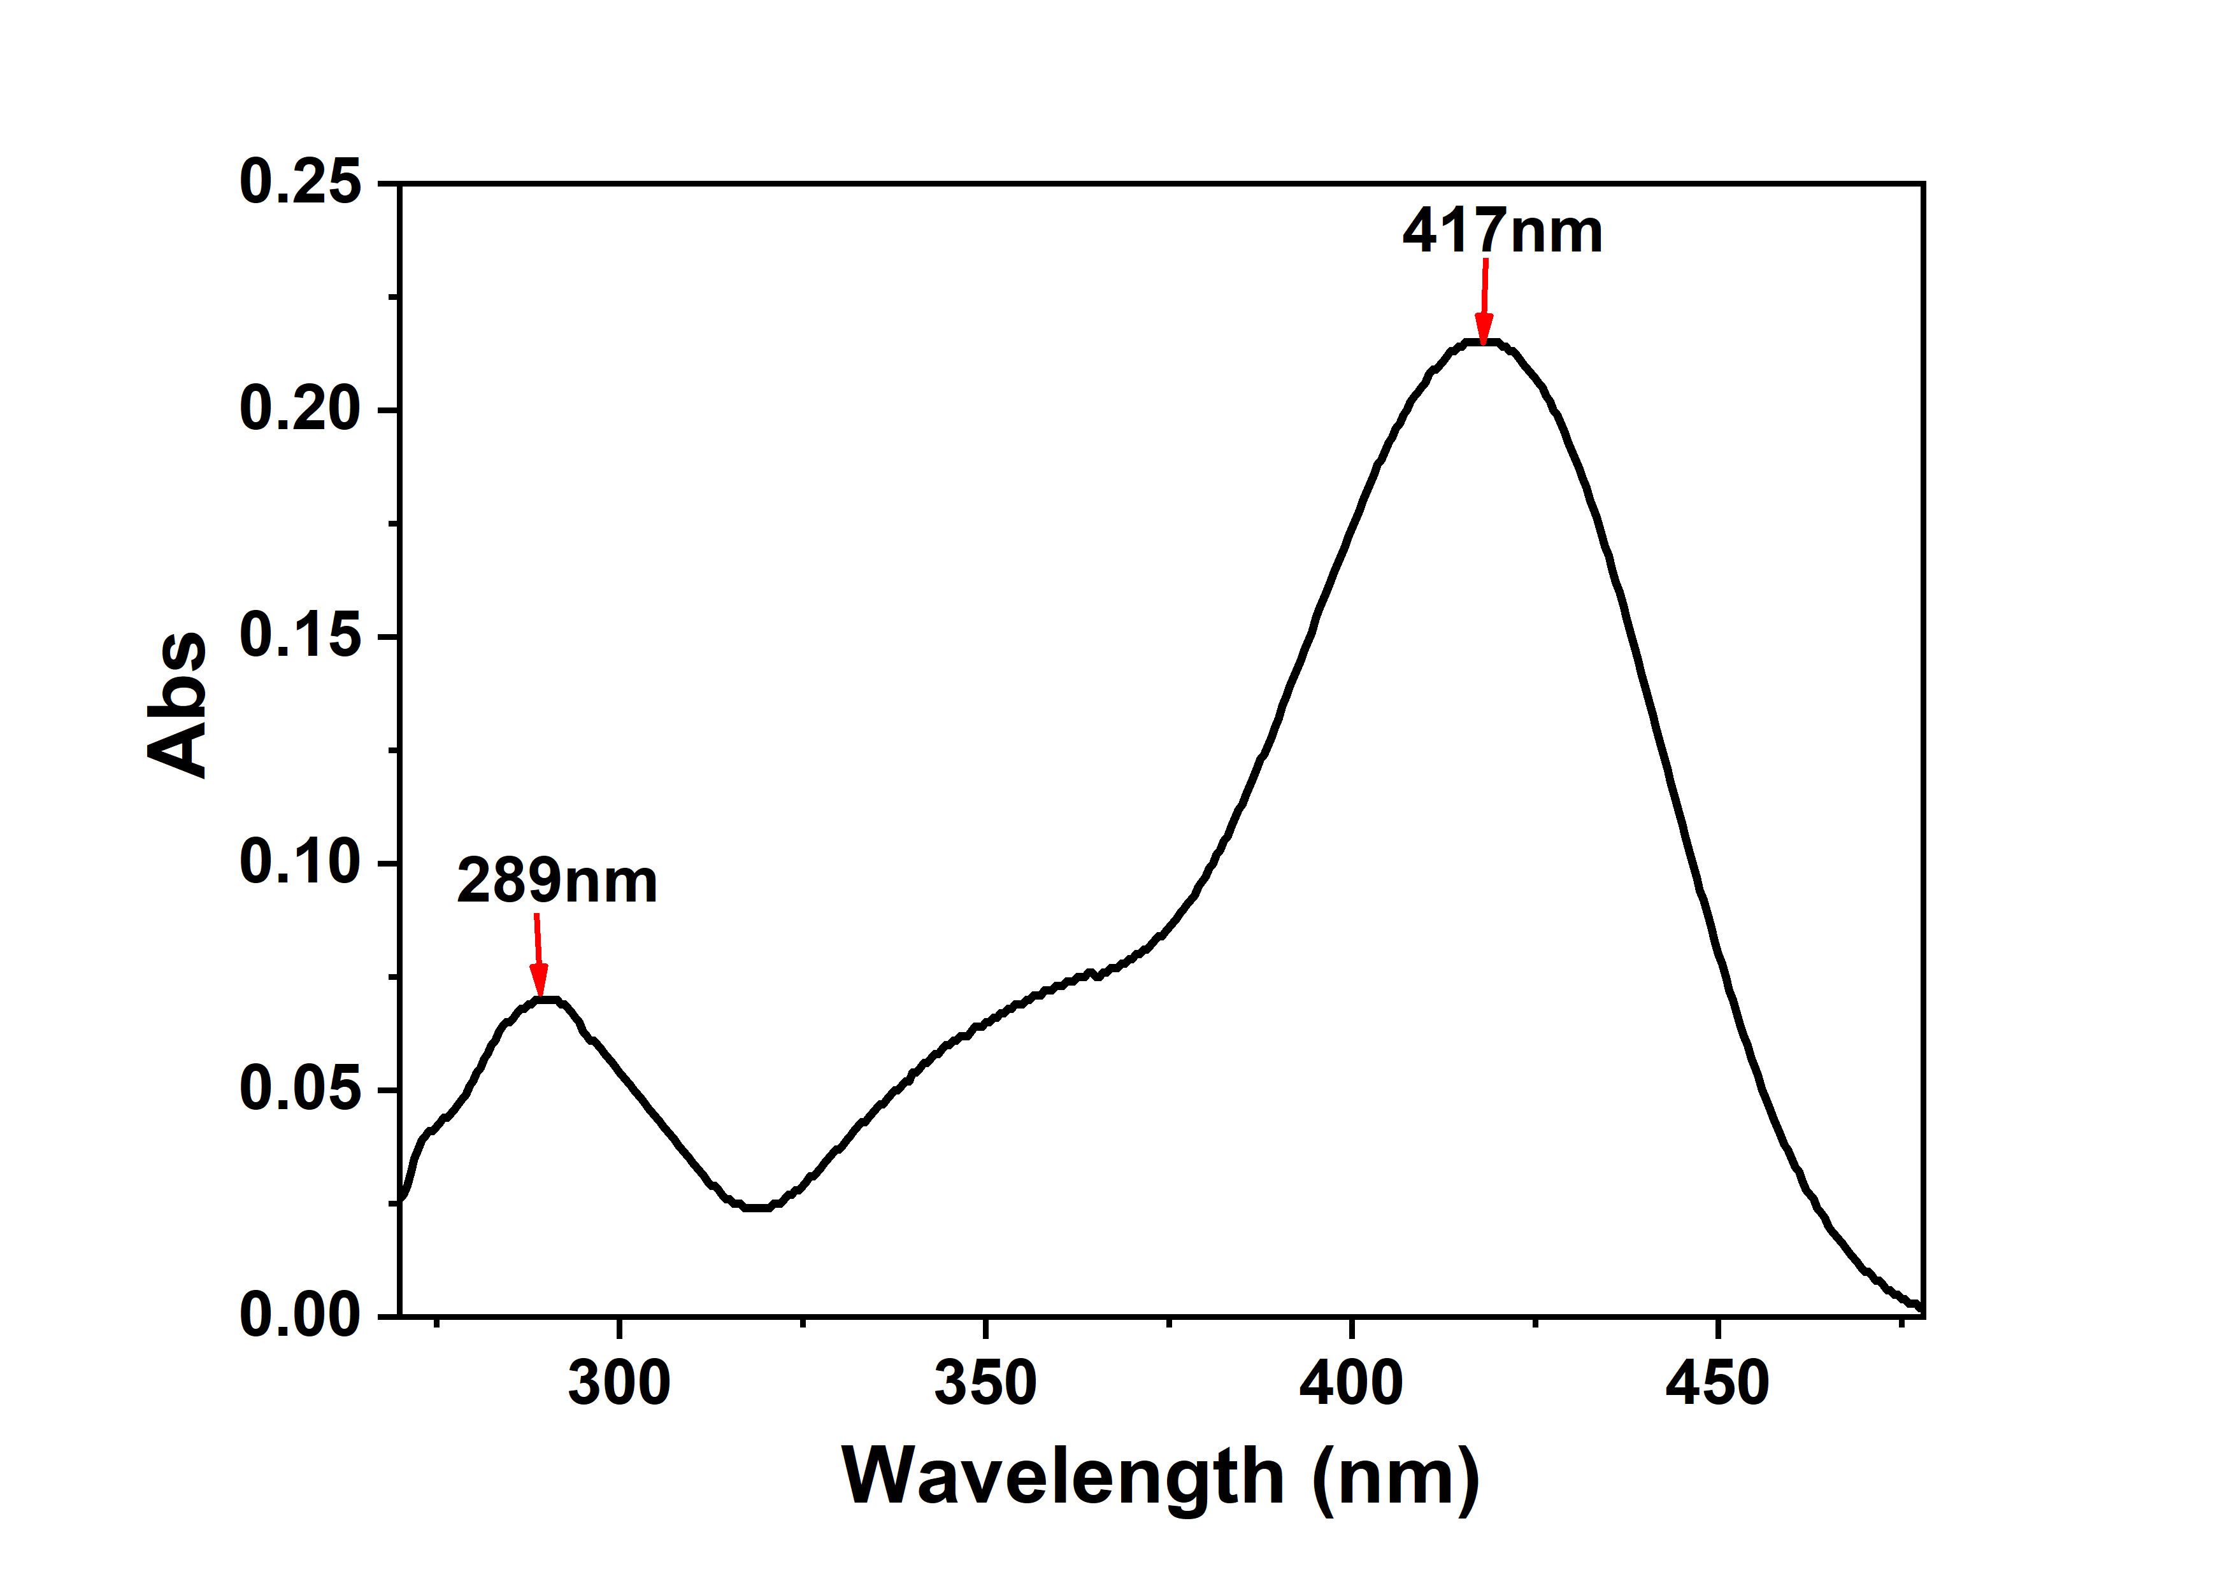
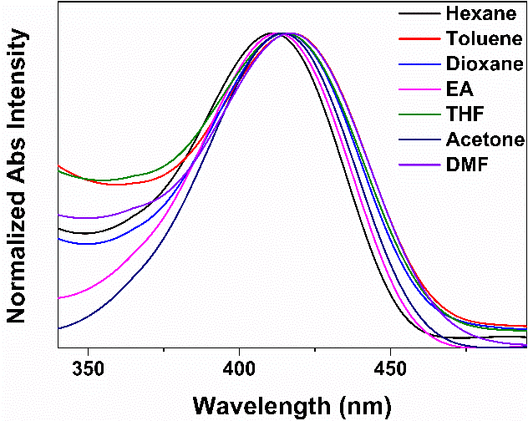
Fig. S5 Upper: Absorption spectra of (OMeTPA)₂-Pyr in DMF; lower: in variant solvents.
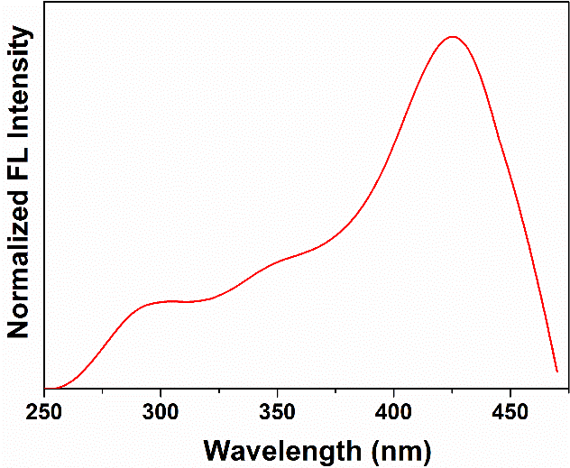
Fig. S6 Normalized excited fluorescence of (OMeTPA)₂-Pyr (2×10⁻⁶M) in DMF.
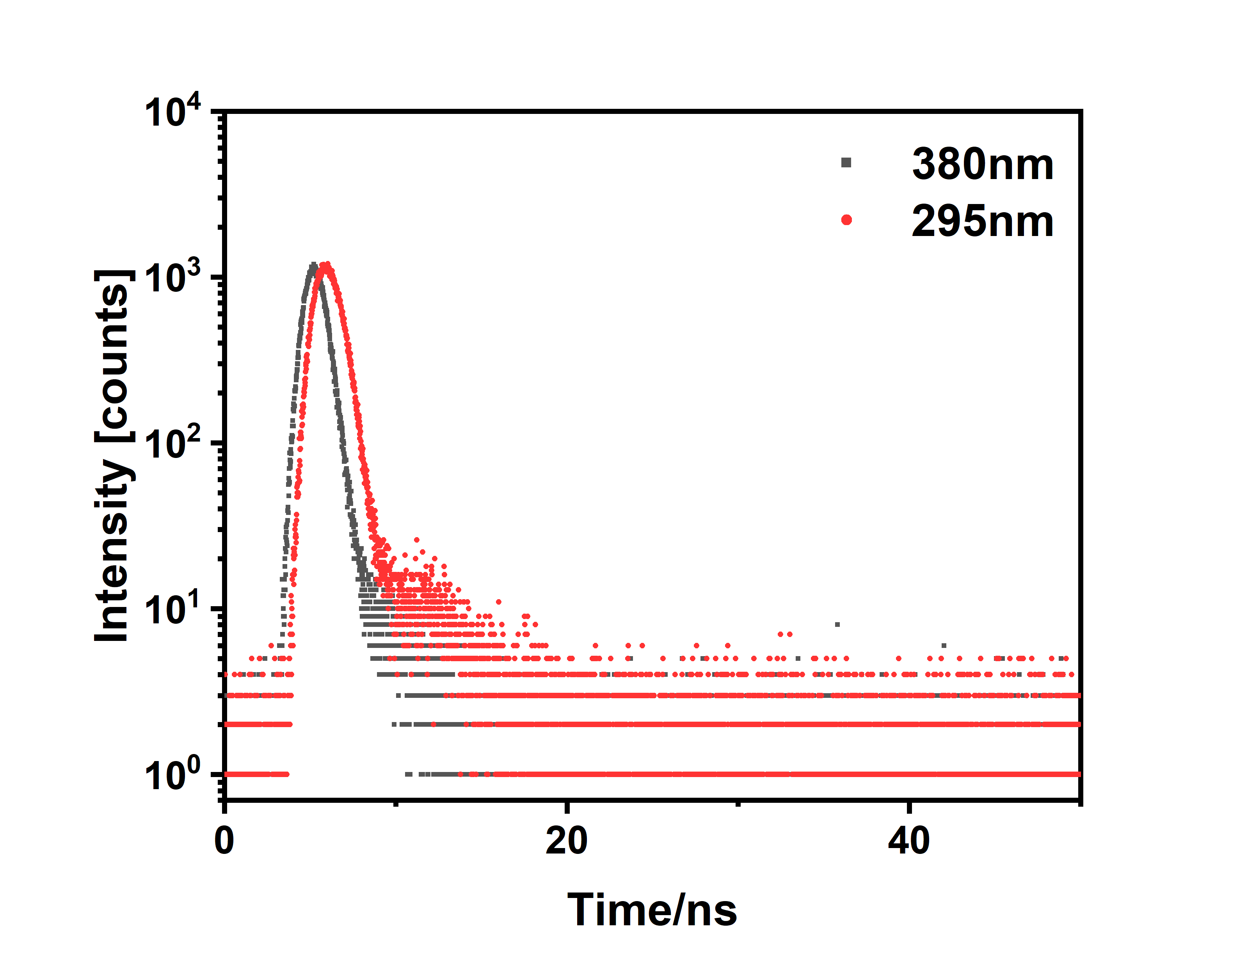
Fig. S7 Time-resolved fluorescence decay profile of (OMeTPA)₂-Pyr (2×10⁻⁶M) in DMF with excitation wavelengths at 295nm and 380nm respectively.

Solvent | E_{T}(30) Δf |  |  |  | λ_{abs}  (nm) | λ_{em}  (nm) | Stokes shift  nm/(cm⁻¹)
Hexane | 31.0 | 0 |  | 411 |  | 489 | 64/(3080)
Toluene | 33.9 | 0.014 |  | 417 |  | 497 | 72/(3409)
1,4-Dioxane | 36.0 | 0.027 |  | 415 |  | 499 | 74/(3489)
EA | 37.4 | 0.201 |  | 413 |  | 513 | 88/(4036)
THF | 38.6 | 0.210 |  | 415 |  | 515 | 90/(4112)
Acetone | 42.2 | 0.284 |  | 414 |  | 544 | 119/(5147)
DMF | 43.2 | 0.275 |  | 417 |  | 549 | 124/(5314)

Table. S1 Detailed photophysical data of (OMeTPA)₂-Pyr in variant solvents. Abbreviations: λ_{abs}=absorption maximum, λ_{em}=emission maximum, Δf = orientation polarizability, E_{T}(30) = solvent polarity parameters.

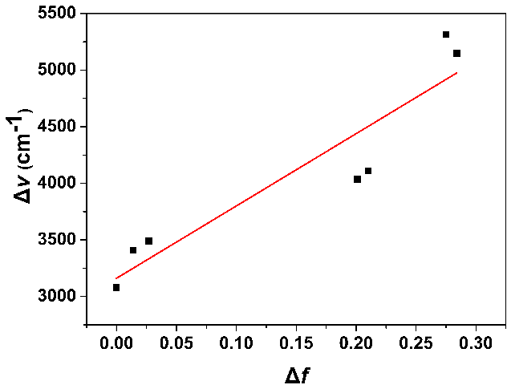
Fig. S8 Lippert-Mataga plot of Stokes shift (Δν) versus the orientation polarization (Δf) of solvent media for (OMeTPA)₂-Pyr.

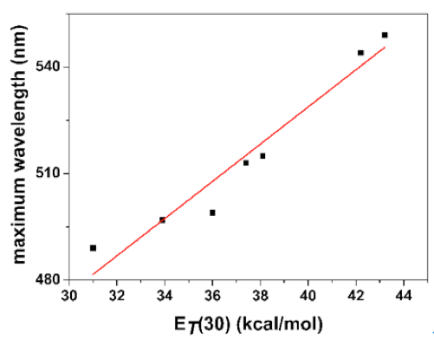

Fig. S9 Plot of the emission maximum of (OMeTPA)₂-Pyr in different solvents versus E_{T}(30), where E_{T}(30) was the empirical parameter for solvent polarity.

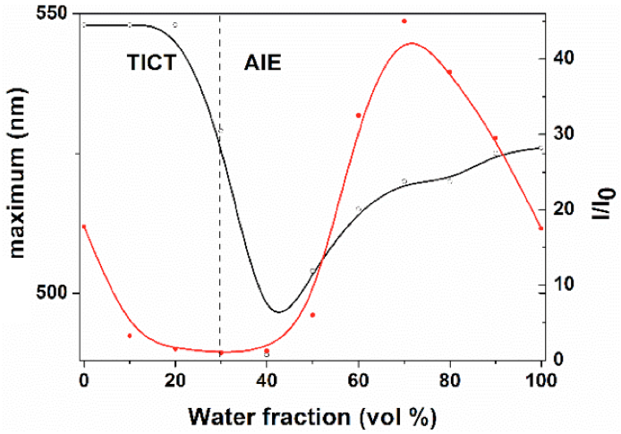
Fig. S10 Plots of fluorescence maximum and relative intensity (I/I₀) versus the composition of the DMF/water mixture of (OMeTPA)₂-Pyr, where I₀ was the intensity at 30% f_{w}. Concentration = 2×10⁻⁶M, λex = 427 nm.

Table. S2 Average diameter and PDI of the (OMeTPA)2-Pyr in DMF/water mixtures with different water fractiona
f_{w} (%) | d (nm) | PDI
70 | 213 | 0.608
100 | 19 | 0.305
ªAbbreviations: d = average diameter, PDI = polydispersity index
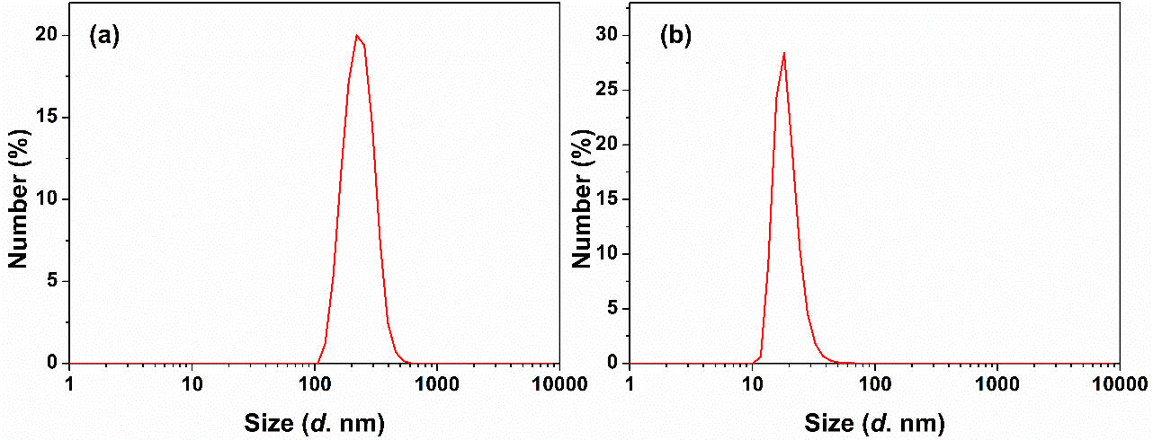
Fig. S11 Particle size distributions of (OMeTPA)₂-Pyr in DMF/water mixtures with (a) f_{w} = 70% and (b) f_{w} = 100%

Cell Culture
4T1 and HeLa cells (Procell, Wuhan, China) were cultured in Dulbecco’s modified Eagle’s media (DMEM) supplemented with 10% fetal bovine serum and100 U mL⁻¹ of penicillin–streptomycin at 37 °C in 5% CO₂.
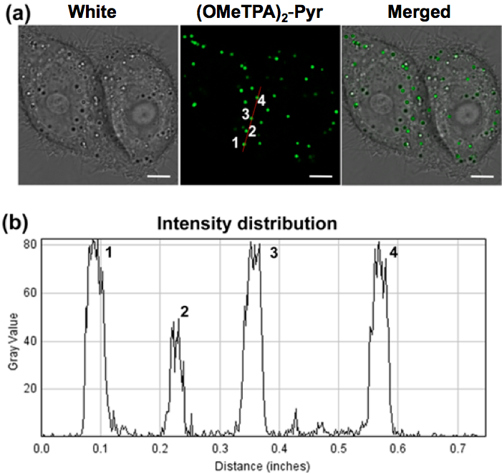
Fig. S12 Fluorescence images of Hela cells stained with (OMeTPA)₂-Pyr (1.5 µg/mL) after 24 hrs incubation and wash. Scale bar, 10 μm. (a) (b) The intensity distribution of (OMeTPA)₂-Pyr in Hela cells. Scale bar, 5μm.
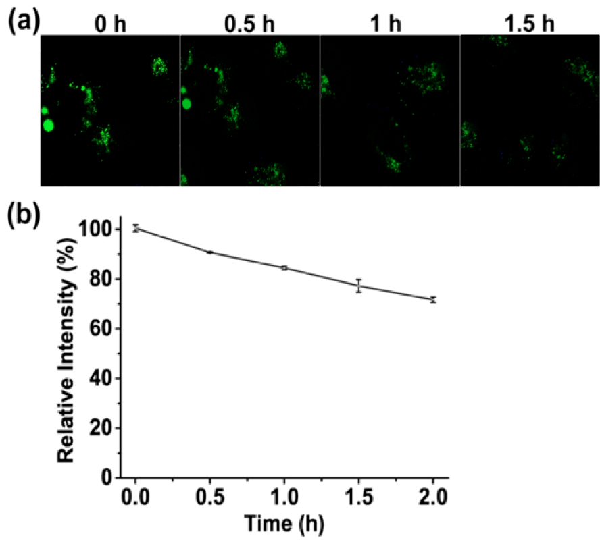
Fig. S13 (a) Fluorescence imaging of (OMeTPA)₂-Pyr (1.5 μg/mL) irradiated by continuous 405 nm laser for 0, 0.5, 1, 1.5 h respectively in live Hela cells. (b) Plots of relative intensity versus irradiation time, where fluorescence intensity was relative to the fluorescence intensity at 0 hours of irradiation.

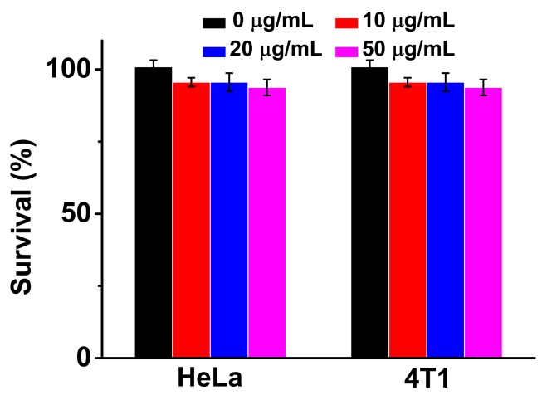
Fig. S14 In vitro cell viability of Hela and 4T1 cells incubated with (OMeTPA)₂-Pyr at different concentrations for 24 hrs.

