



**Fig. S1** Morphological characteristics change in *S. davidii* under different drought treatment conditions. Effects of drought stress on **a** growth rate of plant height, **b** dry weight of the aerial part, **c** dry weight of the roots, **d** leaf length, **e** leaf width, and **f** leaf area. The different lowercase letters indicate significant differences (*p* < 0.05) for each index among the different drought treatments.

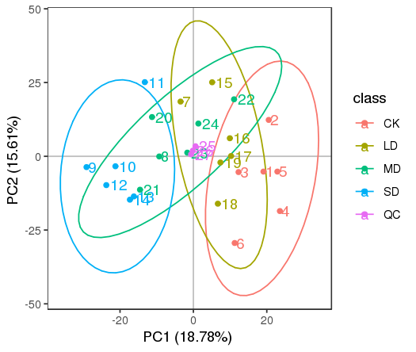

**Fig. S2** PCA of metabolites

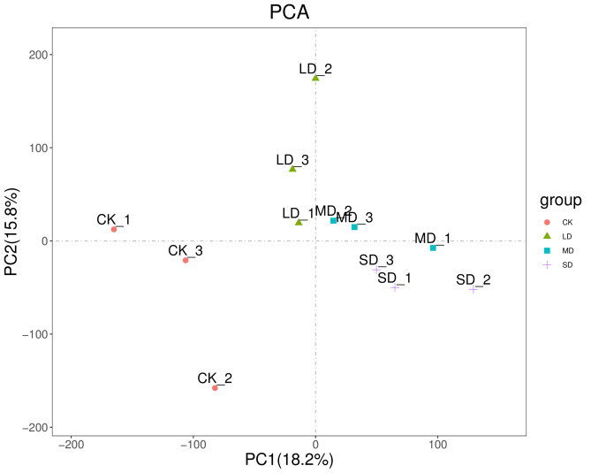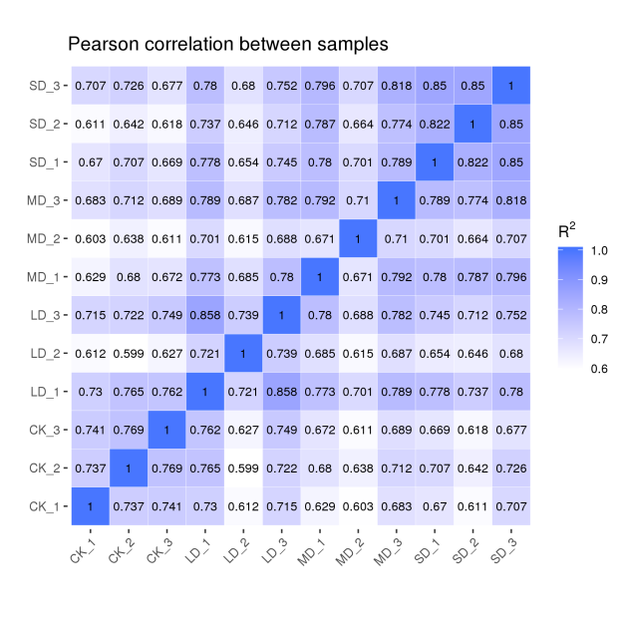

**a**

**b**

**Fig. S3** Transcription profiling. **a** PCCs analysis of the expression patterns of encoding genes under drought stress. **b** PCA analysis of expression genes.