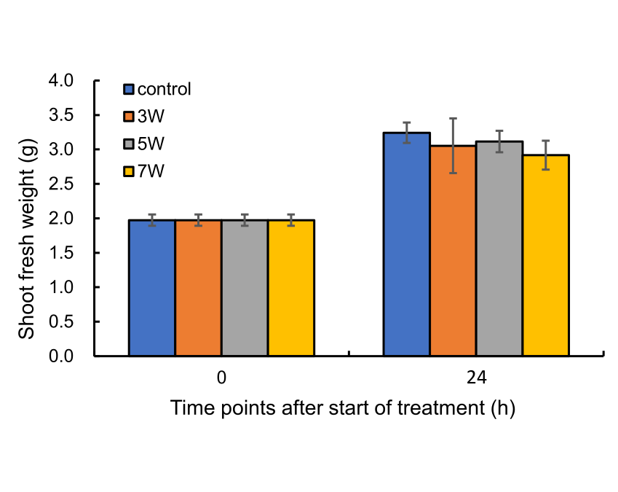

**Supplementary Figure S1.** **Shoot fresh weight before and 24 h after UV-B treatment onset**. UV-B irradiation intensities at top of cultivation panel were set to 3, 5, and 7 W m-2.