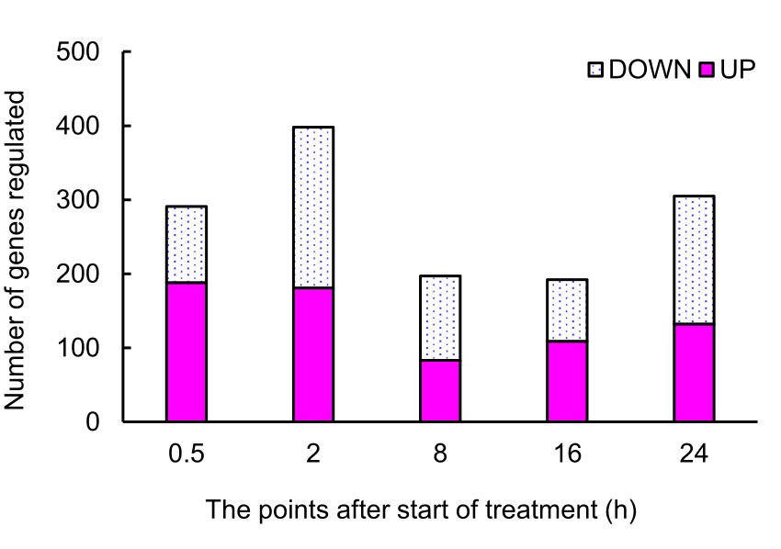

**Supplementary Figure S2.** **Total numbers of differentially upregulated and downregulated genes in canola irradiated with UV-B.** The UV-B irradiation intensity at the top of the cultivation panel was set to 5 W m−2. The numbers of upregulated (Log2 fold change ≥ 1) and downregulated-genes (Log2 fold change ≤ -1) are presented.