Supplementary Material

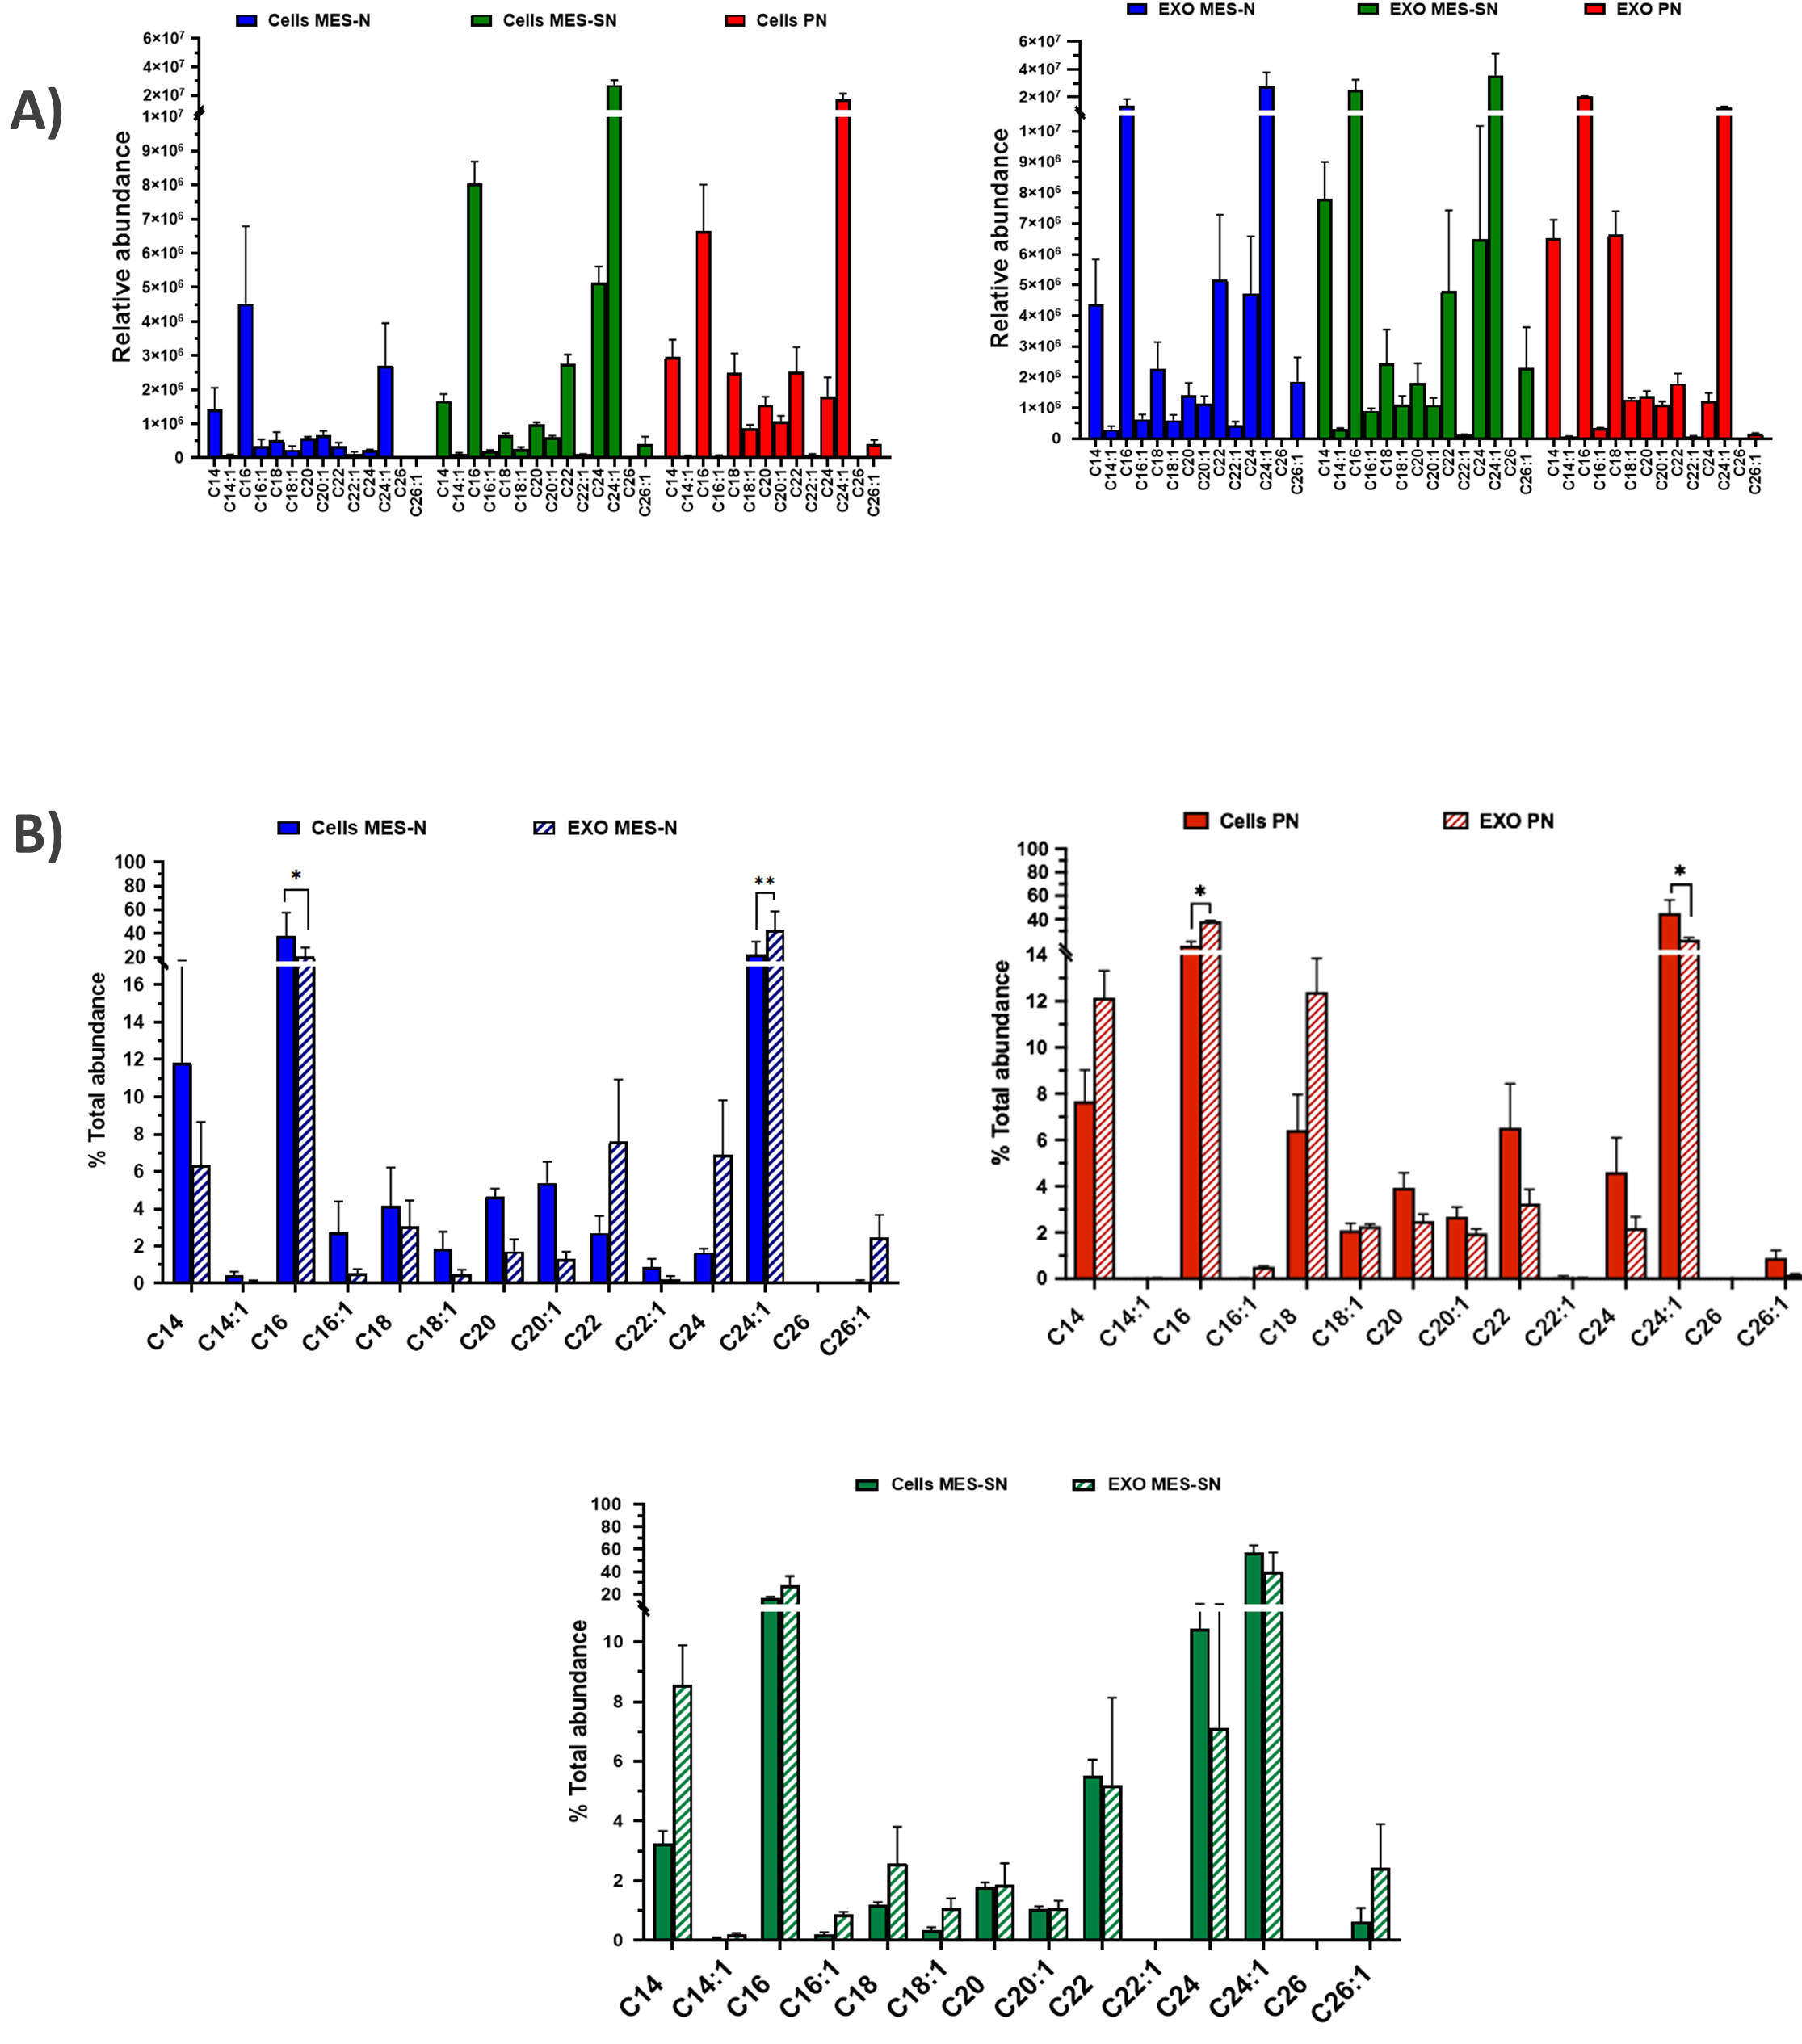

**Supplementary Figure 1.** **Zoomed graphs of the ceramide profiles abundance.** A) Ceramide profile for the three phenotypes for cells and EXO. B) Ceramide distribution between EXO and their parent cells for each phenotype independently. In blue: MES-N phenotype; in green: MES-SN phenotype and in red PN phenotype.

|  |  |  |  |
| --- | --- | --- | --- |
|  | **MES-SN** | **MES-N** | **PN** |
| **CSCs** N**EUROSPHERES** | crop_18p28_02.tif | crop_38p20_07.tif | crop_27p21_07.tif |

**Supplementary Figure 2: Characterization of GSCs.** The GSCs cultures were generated and maintained as neurosphere cultures in a serum-free selective for CSCs described in methods. Light microscopy images of neurospheres (GSCs) obtained from primary cultures.

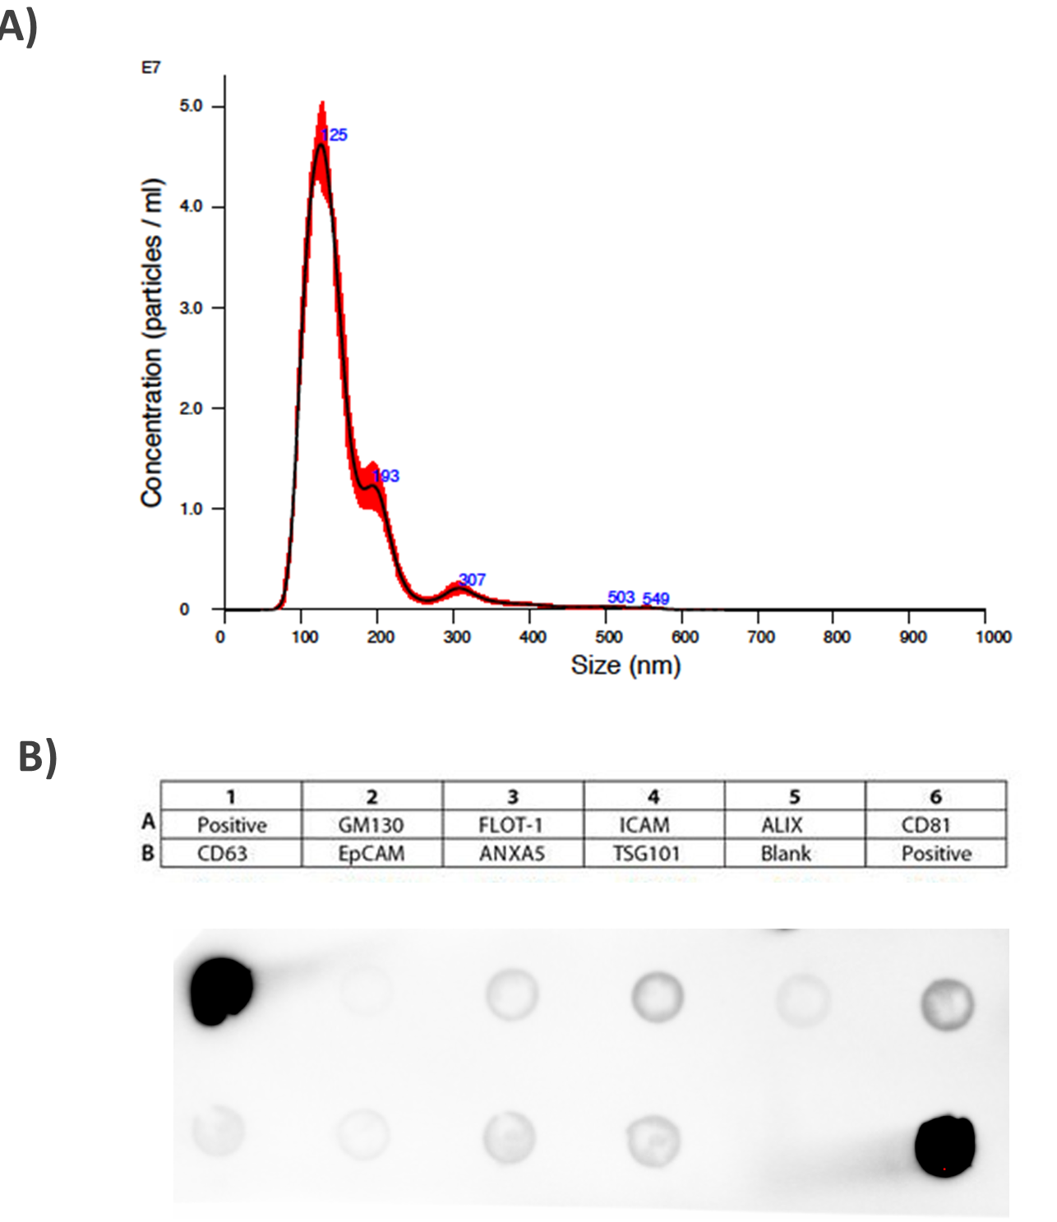

**Supplementary Figure 3**. **Exosome characterization using Nanoparticle tracking analysis (NTA) and Exo-Check Exosome antibody Array**. A) All the exosome samples were quantify using NTA by triplicate. One representative experiment is shown. B) Representative image of one Exosome Array assay out of 3 replicates. A1 and B6: positive control for HRP detection, A2: GM130 Cis-golgi matrix protein, A3: FLOT1, Flotillin-1, A4: ICAM1 Intercellular adhesion molecule 1, A5: ALIX, Programmed cell death 6 interacting protein (PDCD6IP), A6: CD81, Tetraspanin, B1: CD63 Tetraspanin, B2: EpCam Epithelial cell adhesion molecule, B3: ANXA5 Annexin A5, B4: TSG101 Tumor susceptibility gene 101, B5: Blank Background control.

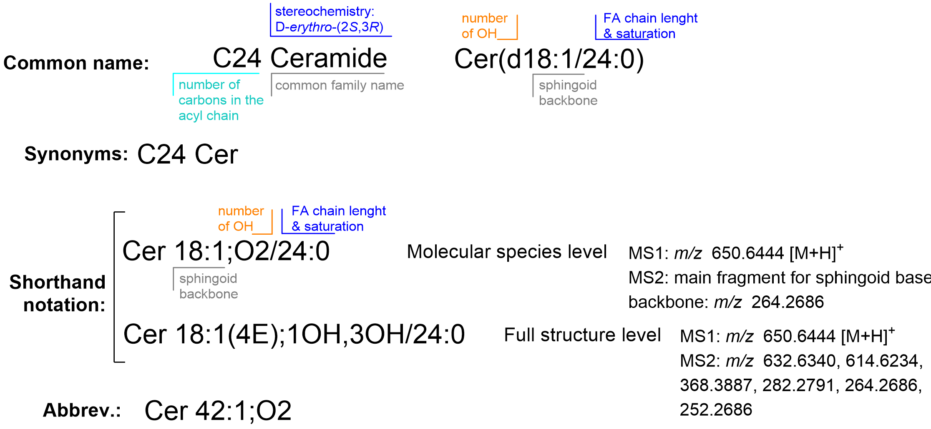

**Supplementary Figure 4. Ceramide designations and abbreviations used for annotation.**