Supplementary Material

# Supplementary Figures

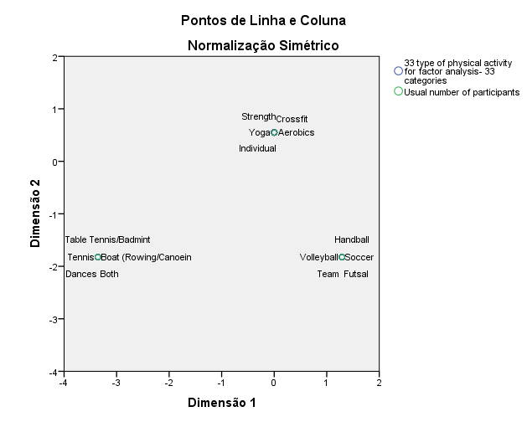

Supplementary Figure 1- Grouping of physical activities according to usual Number of Participants.

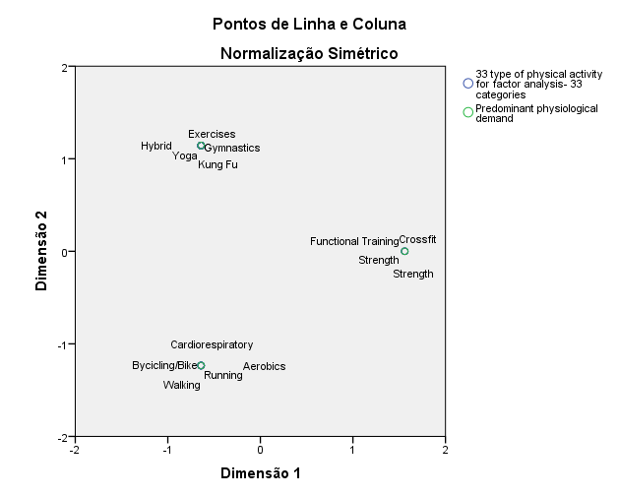

Supplementary Figure 2- Grouping of physical activities according to predominant physiological demand.

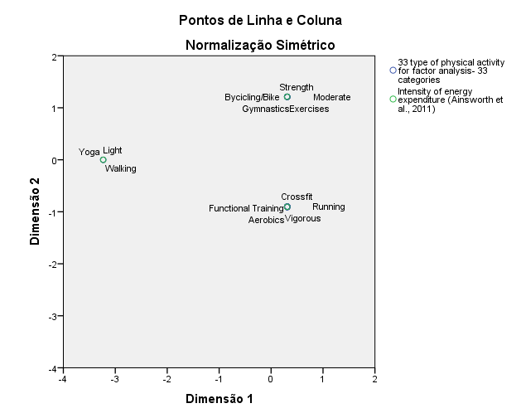

Supplementary Figure 3- Grouping of physical activities according to Intensity of Energy Expenditure.

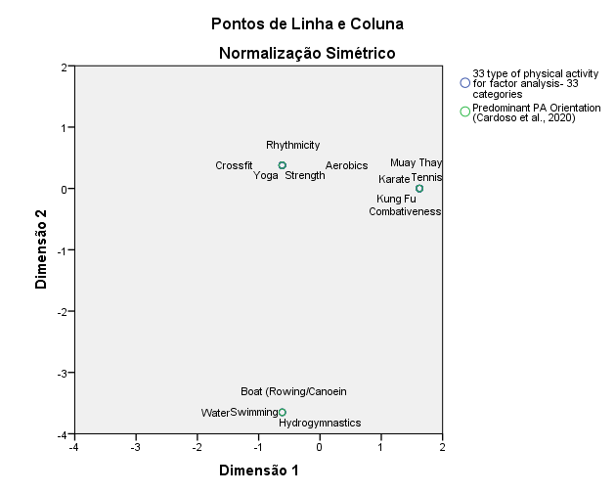

Supplementary Figure 4- Grouping of physical activities according to predominant Motor Orientation.