**Supplementary Material**

**Microplastics Reduce the Negative Effects of Litter-derived Plant Secondary Metabolites on Nematodes in Soil**

Shin Woong Kim*, Yun Liang, Yudi M. Lozano, Matthias C. Rillig

Institute of Biology, Freie Universität Berlin, 14195 Berlin, Germany

Berlin-Brandenburg Institute of Advanced Biodiversity Research. 14195 Berlin, Germany

* Corresponding author: swkim@zedat.fu-berlin.de

6 pages

2 figures

1 table

Reference list

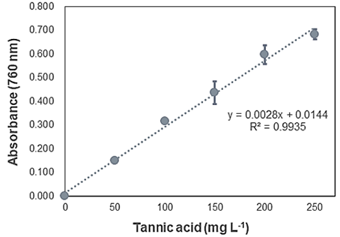

**Figure S1.** Calibration curve of tannic acid (50 to 250 mg L-1) and the regression equation (y=0.0028x+0.0144, R2=0.9935)

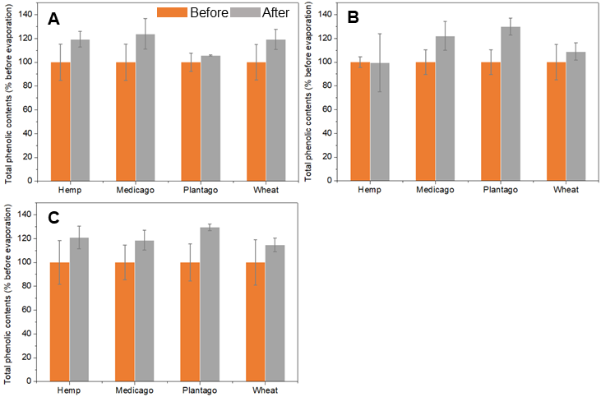

**Figure S2**. Total phenolic concentrations in each solvent extract before and after the evaporation process. Each solvent extract was prepared using (A) 80% acetone, (B) 80% ethanol, and (C) 80% methanol.

**Table S1**. Phenolic profiles of each plant (hemp, Medicago, Plantago, and wheat) in previous studies (Beara et al., 2012; Chiriac et al., 2020; Kaur et al., 2021; Izzo et al., 2020)

|  |  |  |  |  |
| --- | --- | --- | --- | --- |
| **Author (year)** | Izzo et al. (2020) | Chiriac et al. (2020) | Beara et al. (2012) | Kaur et al. (2021) |
| **Target plant** | Hemp (Cannabis sativa L.) | Medicago sativa | Plantago lanceolata L. | Wheat (Triticum aestivum I., C306) |
| **Target organ part** | Female inflorescences (200 um) | Entire sprouts (120 h) | Aeial parts (herbal) | Wheatgrass (juice powder) |
| **Extraction solution** | Methanol | 70% ethanol (1:10 g DW/g) | Methanol/water (4:1) | 80% ethanol |
| **Coumarins** | | | |  |
| Aesculetin | - | - | O | - |
| Scopoletin | - | - | O | - |
| Umbelliferone | - | - | ND | - |
| **Flavones** | | | |  |
| Isovitexin | - | - | - | O |
| **Flavonoids** | | | |  |
| Amentoflavone | - | - | O | - |
| Apigenin | O | O | O | - |
| Apigenin-7-O-glucoside | O | - | O | - |
| Apiin | - | - | O | - |
| Baicalein | - | - | O | - |
| Baicalin | - | - | O | - |
| Cannflavin A | O | - | - | - |
| Cannflavin B | O | - | - | - |
| Catechin | O | ND | ND | O |
| Chrysoeriol | - | - | O | - |
| Crysin | - | O | - | - |
| Daidzein | - | O | ND | - |
| Daidzin | - | ND | - | - |
| Epicatechin | O | - | ND | O |
| Epigallocatechin gallate | - | - | ND | - |
| Formononetin | - | O | - | - |
| Genistein | - | O | ND | - |
| Glycitein | - | O | - | - |
| Hesperetin | - | O | - | - |
| Hyperoside | - | ND | O | - |
| Isorhamnetin | - | O | ND | - |
| Kaempferol | O | O | ND | O |
| Kaempferol-3-O-glucoside | O | - | O | - |
| Luteolin | O | - | O | - |
| Luteolin-7-O-glucoside | O | - | O | - |
| Myricetin | - | O | ND | - |
| Naringein | O | O | O | - |
| Pinocembrin | - | O | - | - |
| Pinstrobin | - | O | - | - |
| Quercetin | - | O | O | O |
| Quercetin-3-glucoside | O | - | - | - |
| Quercetin-3-O-glucoside | - | - | O | - |
| Quercitrin | - | O | O | - |
| Rutin | O | O | O | O |
| Vitexin | - | - | O | O |
| Lignans |  |  |  |  |
| Matairesinol | - | - | O | - |
| Secoisolariciresinol | - | - | O | - |
| **Non-flavonoid** |  |  |  |  |
| Resveratol | - | - | - | O |
| **Phenolic acids** | | | | |
| 2,5-Dihydroxybenzoic acid | - | - | O | - |
| 3,4-Dimethoxycinnamic acid (ND) | - | - | O | - |
| Abiscisic acid | - | ND | - | - |
| Caffeic acid | O | ND | O | O |
| Cannabisin A | O | - | - | - |
| Cannabisin B | O | - | - | - |
| Cannabisin C | O | - | - | - |
| Chlorogenic acid | O | O | O | O |
| Cinnamic acid | - | - | O | O |
| Ellagic acid | - | O | - | - |
| Ferulic acid | O | O | O | O |
| Gallic acid | - | ND | O | O |
| o-Coumaric acid | - | - | ND | - |
| p-Coumaric acid | O | O | O | O |
| p-Hydroxybenzoic acid | - | - | O | - |
| Protocatechuic acid | - | - | O | O |
| Sinapic acid | - | - | O | O |
| Syringic acid | - | O | O | O |
| Vanillic acid | - | - | O | - |
| **Phenolic amide** | | | | |
| N-trans-Caffeoyltyramine | O | - | - | - |

**Reference list**

Beara, I. N., Lesjak, M. M., Orčić, D. Z., Simin, N. Đ., Četojević-Simin, D. D., Božin, B. N., and Mimica-Dukić, N. M. (2012). Comparative analysis of phenolic profile, antioxidant, anti-inflammatory and cytotoxic activity of two closely-related Plantain species: *Plantago altissima* L. and *Plantago lanceolata* L. *Food Sci. Technol.* *47*, 64–70.

Chiriac, E. R., Chiţescu, C. L., Borda, D., Lupoae, M., Gird, C. E., Geană, E. I., et al. (2020). Comparison of the polyphenolic profile of *Medicago sativa* L. and *Trifolium pratense* L. sprouts in different germination stages using the UHPLC-Q exactive hybrid quadrupole orbitrap high-resolution mass spectrometry. *Molecules* *25*, 2321.

Kaur, N., Singh, B., Kaur, A., Yadav, M. P., Singh, N., Ahlawat, A. K., and Singh, A. M. (2021). Effect of growing conditions on proximate, mineral, amino acid, phenolic composition and antioxidant properties of wheatgrass from different wheat (*Triticum aestivum* L.) varieties. *Food Chem.* *341*, 128201.

Izzo, L., Castaldo, L., Narváez, A., Graziani, G., Gaspari, A., Rodríguez-Carrasco, Y., and Ritieni, A. (2020). Analysis of phenolic compounds in commercial *Cannabis sativa* L. Inflorescences using UHPLC-Q-Orbitrap HRMS. *Molecules* *25*, 631.