Supplementary Material

# Supplementary Figures and Tables

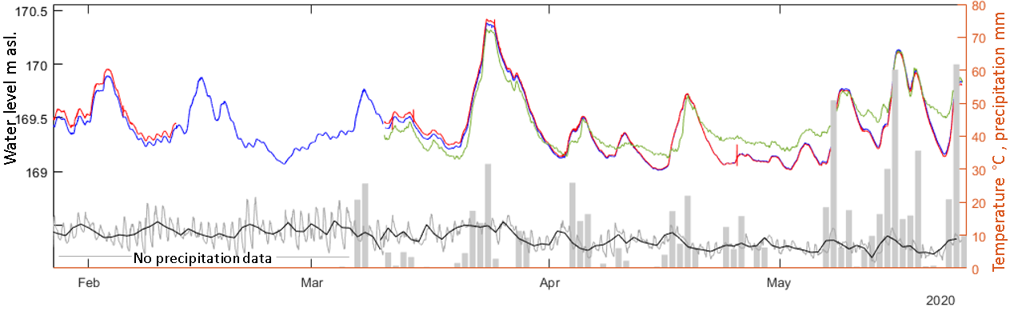

Figure S1 Lake water elevation connectivity. Terminal lake (blue), east marginal lake (red), green supraglacial pond (green). Location is shown in Figure 2. Daily precipitation (grey bars), air temperature at 15 minutes (grey line) and daily mean temperature (black line) are plotted in the right-hand side axis (same scale).

Table S1. Calibrated UAV camera parameters.

|  |  |  |  |  |  |  |  |  |  |
| --- | --- | --- | --- | --- | --- | --- | --- | --- | --- |
|  | Initial values | calibrated internal parameters | | | | | | | |
|  | all surveys | 2019.03.07 | 2019.03.21 | 2019.11.24 | 2019.12.16 | 2020.01.21 | 2020.02.20 | 2020.03.09 | 2020.05.28 |
| F | 10.633 | 10.554 | 10.523 | 10.524 | 10.540 | 10.549 | 10.500 | 10.485 | 10.537 |
| Px | 6.540 | 6.349 | 6.344 | 6.342 | 6.346 | 6.342 | 6.341 | 6.344 | 6.346 |
| Py | 4.348 | 4.204 | 4.217 | 4.221 | 4.211 | 4.210 | 4.219 | 4.223 | 4.206 |
| R1 | 0.033 | 0.028 | 0.030 | 0.029 | 0.027 | 0.029 | 0.031 | 0.030 | 0.026 |
| R2 | -0.209 | -0.169 | -0.177 | -0.173 | -0.165 | -0.168 | -0.176 | -0.176 | -0.163 |
| R3 | 0.315 | 0.248 | 0.255 | 0.250 | 0.241 | 0.244 | 0.251 | 0.251 | 0.239 |
| T1 | 0.000 | -0.006 | -0.006 | -0.006 | -0.006 | -0.006 | -0.006 | -0.006 | -0.006 |
| T2 | 0.000 | -0.006 | -0.006 | -0.006 | -0.006 | -0.006 | -0.006 | -0.006 | -0.006 |

Table S2. Satellite images used in this study.

|  |  |  |  |
| --- | --- | --- | --- |
| Satellite | Acquisition date yyyy.mm.dd | | Spatial resolution (m) |
| Landsat ETM+ | | 2001.12.15 | 30 |
| Landsat ETM+ | | 2004.03.11 | 30 |
| Landsat ETM+ | | 2004.12.08 | 30 |
| Landsat ETM+ | | 2006.02.04 | 30 |
| Landsat ETM+ | | 2011.07.29 | 30 |
| Rapid Eye | | 2010.03.04 | 5 |
| Rapid Eye | | 2011.12.01 | 5 |
| Rapid Eye | | 2013.07.07 | 5 |
| Rapid Eye | | 2014.02.26 | 5 |
| Rapid Eye | | 2015.02.27 | 5 |
| Rapid Eye | | 2015.11.03 | 5 |
| Rapid Eye | | 2016.02.29 | 5 |
| Rapid Eye | | 2017.04.17 | 5 |
| Rapid Eye | | 2018.08.31 | 5 |
| Rapid Eye | | 2019.04.24 | 5 |

Table S3. Ablation rates derived from ablation stakes

|  |  |  |  |  |  |  |  |
| --- | --- | --- | --- | --- | --- | --- | --- |
|  |  | mm we d-1 | | | dGNSS ice elevation m asl. | | |
| date | days | S1 | S2 | S3 | S1 | S2 | S3 |
| 27/11/2019 | - | - | - | - | - | - | - |
| 06/12/2019 | 9 | 64.00 | 69.00 | 70.50 | - | - | - |
| 16/12/2019 | 10 | 122.40 | 112.05 | 79.20 | - | - | - |
| 22/01/2020 | - | - | - | - | 178.00 | 185.10 | 177.27 |
| 20/02/2020 | 29 | 102.41 | 92.61 | 81.62 | 177.36 | 184.30 | - |
| 09/03/2020 | 18 | 78.50 | 65.00 | 40.00 | 177.68 | 184.50 | 177.13 |
| 29/05/2020 | 81 | 75.11a | 47.56 | 38.89 | - | - | - |

a supraglacial stream incised the ice near the stake

Ablation stakes reading were converted to mm w.e. d-1 considering an ice density of 900 kg m-3.

References

Dussaillant, I., Berthier, E., Brun, F., Masiokas, M., Hugonnet, R., Favier, V., and others. (2019a). *South American Andes elevation changes from 2000 to 2018, links to GeoTIFFs*. Retrieved from: <https://doi.org/10.1594/PANGAEA.903618>

Dussaillant, I., Berthier, E., Brun, F., Masiokas, M., Hugonnet, R., Favier, V., and others. (2019b). Two decades of glacier mass loss along the Andes. *Nature Geoscience, 12*(10), 802-808. doi:10.1038/s41561-019-0432-5

Farinotti, D., Huss, M., Fürst, J. J., Landmann, J., Machguth, H., Maussion, F., & Pandit, A. (2019). A consensus estimate for the ice thickness distribution of all glaciers on Earth. *Nature Geoscience, 12*(3), 168-173. doi:10.1038/s41561-019-0300-3

Gardner, A. S., Fahnestock, M. A., & Scambos, T. A. (2019). [accessed March 2021]: ITS_LIVE Regional Glacier and Ice Sheet Surface Velocities. Data archived at National Snow and Ice Data Center. doi:10.5067/6II6VW8LLWJ7