**Legends to Figures**

**FIGURE s1 2D diagram of protein-ligand interaction.**

Receptors: OPG, RANKL, RANK, BMP-2, BMP-4, and RUNX-2; Ligands: BHG-I, ICA, IT

**FIGURE s2 Effect of ICA, IT and BHG-I on behavioral analysis-hot plot (n = 15).**

CK, blank E3 medium; DMSO, 0.5% DMSO; MX, 25 μM PNSL; YTLSN, 15 μM disodium ethydronate + 25 μM PNSL; ICA, 0.1, 1.0 or 10.0 μM ICA + 25 μM PNSL; BHG-I, 0.1, 1.0 or 10.0 μM BHG-I + 25 μM PNSL; IT, 0.1, 1.0 or 10.0 μM IT + 25 μM PNSL.

**FIGURE s3 Effect of ICA, IT and BHG-I on the mineral contents in zebrafish larvae (n = 15).**

CK, blank E3 medium; DMSO, 0.5% DMSO; MX, 25 μM PNSL; YTLSN, 15 μM disodium ethydronate + 25 μM PNSL; ICA, 0.1, 1.0 or 10.0 + 25 μM PNSL; BHG-I, 0.1, 1.0 or 10.0 μM BHG-I + 25 μM PNSL; IT, 0.1, 1.0 or 10.0 μM IT + 25 μM PNSL. ## p< 0.01 compared with DMSO. ### p< 0.001 compared with DMSO. * p< 0.05compared with MX. *** p< 0.001 compared with MX.

Fig. s1

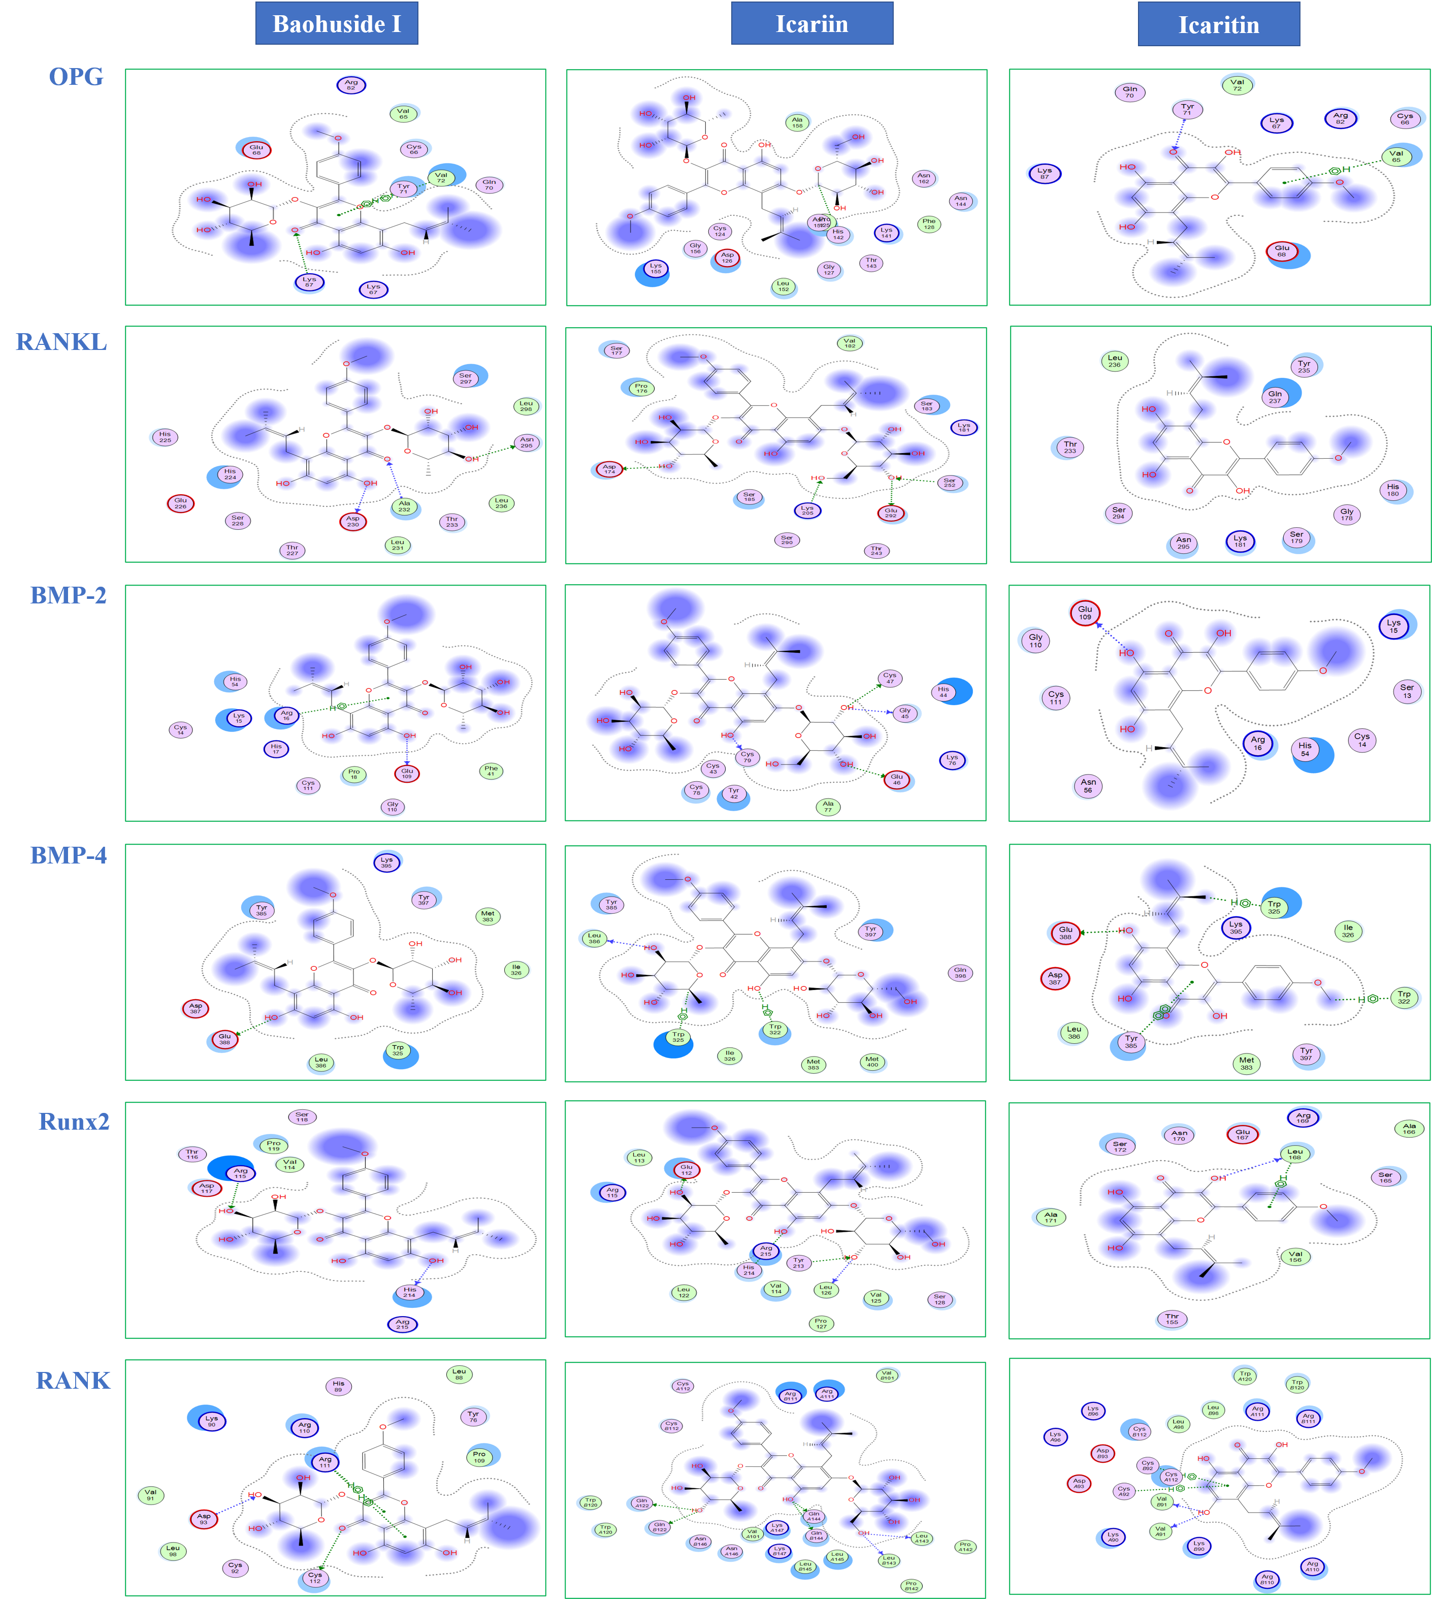

**Fig. s2**

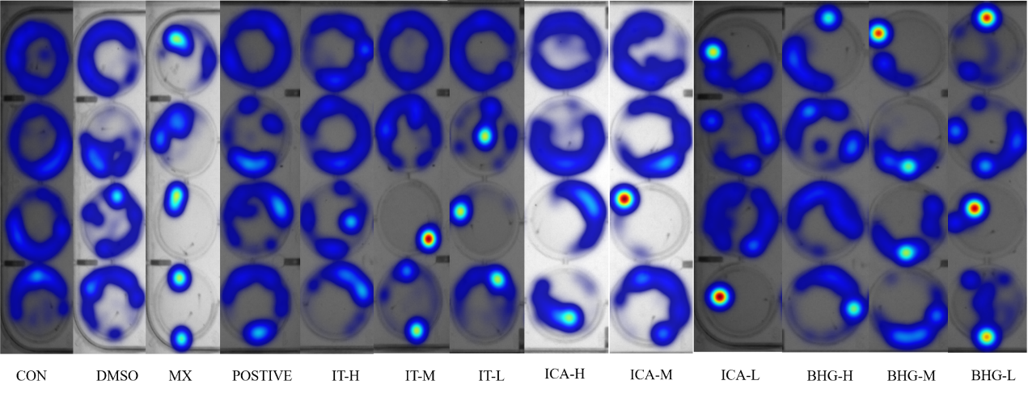

**Fig. s3**

