**Supporting Information for “Present-day tectonic deformation partitioning across south Tianshan from satellite geodetic imaging”**

**Contents of this file**

**1. Interferogram network：For the two tracks we define interferometric network connecting by PS InSAR. Dates of images and interferograms we used for each track are shown in (Table S1 and S2) and (Fig. S1 and S2).**

**2. Tropospheric delay of the descending and ascending track calculated based on GACOS model and TRAIN (Fig. S3 and S4) .**

**3. Combined GPS and InSAR 3-D velocities , with default InSAR data uncertainties (2 mm/yr).（Fig. S5：the vertical components(a) and solution uncertainties(b)；Fig. S6：data postfit residuals and solution uncertainties）**

**4. Inversion model and results for the profile perpendicular across folds and faults in southern Tianshan((Fig. S7 and S8).**

**1. Interferogram network:** For the two tracks we define interferometric network connecting by PS InSAR. Dates of images and interferograms we used for each track are shown in (Table S1 and S2) and (Fig. S1 and S2).

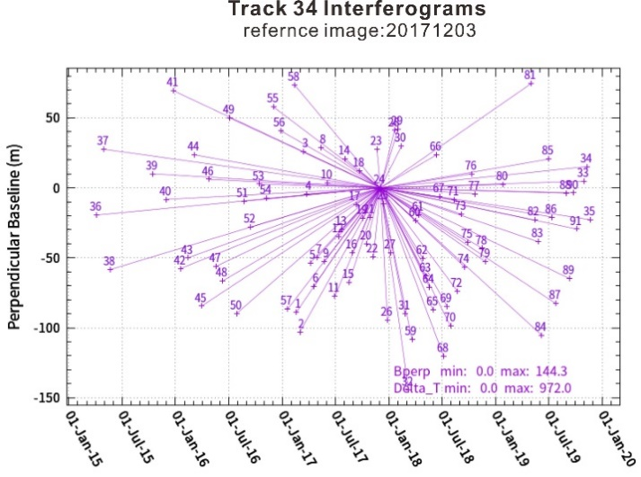

**Figure S1. Computed interferograms for the** **descending track 34**

Table S1. the dates of images of the descending track 34.

|  |  |  |  |  |  |  |  |
| --- | --- | --- | --- | --- | --- | --- | --- |
| Number | Date | Number | Date | Number | Date | Number | Date |
| 1 | 20170218 | 25 | 20171215 | 49 | 20160705 | 73 | 20180905 |
| 2 | 20170302 | 26 | 20171227 | 50 | 20160729 | 74 | 20180917 |
| 3 | 20170314 | 27 | 20180108 | 51 | 20160822 | 75 | 20180929 |
| 4 | 20170326 | 28 | 20180120 | 52 | 20160915 | 76 | 20181011 |
| 5 | 20170407 | 29 | 20180201 | 53 | 20161015 | 77 | 20181023 |
| 6 | 20170419 | 30 | 20180213 | 54 | 20161108 | 78 | 20181116 |
| 7 | 20170501 | 31 | 20180225 | 55 | 20161202 | 79 | 20181128 |
| 8 | 20170513 | 32 | 20180309 | 56 | 20161226 | 80 | 20190127 |
| 9 | 20170525 | 33 | 20191030 | 57 | 20170119 | 81 | 20190503 |
| 10 | 20170606 | 34 | 20191111 | 58 | 20170212 | 82 | 20190515 |
| 11 | 20170630 | 35 | 20191123 | 59 | 20180321 | 83 | 20190527 |
| 12 | 20170712 | 36 | 20150406 | 60 | 20180402 | 84 | 20190608 |
| 13 | 20170724 | 37 | 20150430 | 61 | 20180414 | 85 | 20190702 |
| 14 | 20170805 | 38 | 20150524 | 62 | 20180426 | 86 | 20190714 |
| 15 | 20170817 | 39 | 20151015 | 63 | 20180508 | 87 | 20190726 |
| 16 | 20170829 | 40 | 20151202 | 64 | 20180520 | 88 | 20190831 |
| 17 | 20170910 | 41 | 20151226 | 65 | 20180601 | 89 | 20190912 |
| 18 | 20170922 | 42 | 20160119 | 66 | 20180613 | 90 | 20190924 |
| 19 | 20171004 | 43 | 20160212 | 67 | 20180625 | 91 | 20191006 |
| 20 | 20171016 | 44 | 20160307 | 68 | 20180707 |  |  |
| 21 | 20171028 | 45 | 20160331 | 69 | 20180719 |  |  |
| 22 | 20171109 | 46 | 20160424 | 70 | 20180731 |  |  |
| 23 | 20171121 | 47 | 20160518 | 71 | 20180812 |  |  |
| 24 | 20171203 | 48 | 20160611 | 72 | 20180824 |  |  |

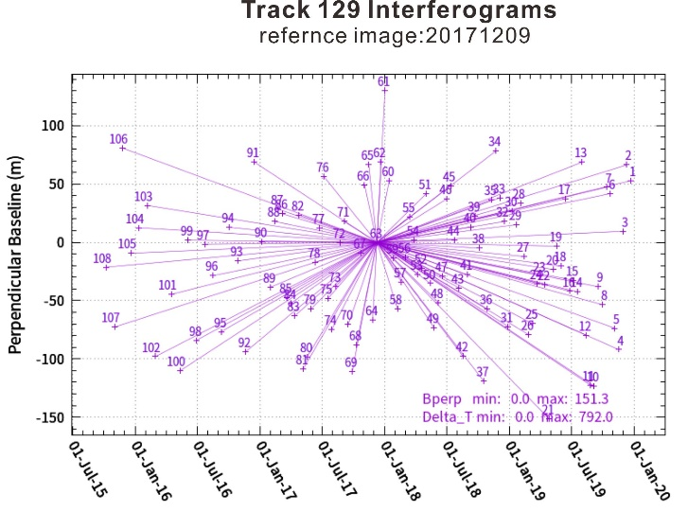

**Figure S2. Computed interferograms for the** **ascending track 129**

Table S2. the dates of images of the ascending track 129.

|  |  |  |  |  |  |  |  |
| --- | --- | --- | --- | --- | --- | --- | --- |
| Number | Date | Number | Date | Number | Date | Number | Date |
| 1 | 20191223 | 28 | 20190202 | 55 | 20180315 | 82 | 20170425 |
| 2 | 20191211 | 29 | 20190121 | 56 | 20180303 | 83 | 20170413 |
| 3 | 20191129 | 30 | 20190109 | 57 | 20180219 | 84 | 20170401 |
| 4 | 20191117 | 31 | 20181228 | 58 | 20180207 | 85 | 20170320 |
| 5 | 20191105 | 32 | 20181216 | 59 | 20180126 | 86 | 20170308 |
| 6 | 20191024 | 33 | 20181204 | 60 | 20180114 | 87 | 20170224 |
| 7 | 20191012 | 34 | 20181122 | 61 | 20180102 | 88 | 20170212 |
| 8 | 20190930 | 35 | 20181110 | 62 | 20171221 | 89 | 20170131 |
| 9 | 20190918 | 36 | 20181029 | 63 | 20171209 | 90 | 20170107 |
| 10 | 20190906 | 37 | 20181017 | 64 | 20171127 | 91 | 20161214 |
| 11 | 20190825 | 38 | 20181005 | 65 | 20171115 | 92 | 20161120 |
| 12 | 20190813 | 39 | 20180923 | 66 | 20171103 | 93 | 20161027 |
| 13 | 20190801 | 40 | 20180911 | 67 | 20171022 | 94 | 20161003 |
| 14 | 20190720 | 41 | 20180830 | 68 | 20171010 | 95 | 20160909 |
| 15 | 20190708 | 42 | 20180818 | 69 | 20170928 | 96 | 20160816 |
| 16 | 20190626 | 43 | 20180806 | 70 | 20170916 | 97 | 20160723 |
| 17 | 20190614 | 44 | 20180725 | 71 | 20170904 | 98 | 20160629 |
| 18 | 20190602 | 45 | 20180713 | 72 | 20170823 | 99 | 20160605 |
| 19 | 20190521 | 46 | 20180701 | 73 | 20170811 | 100 | 20160512 |
| 20 | 20190509 | 47 | 20180619 | 74 | 20170730 | 101 | 20160418 |
| 21 | 20190427 | 48 | 20180607 | 75 | 20170718 | 102 | 20160301 |
| 22 | 20190415 | 49 | 20180526 | 76 | 20170706 | 103 | 20160206 |
| 23 | 20190403 | 50 | 20180514 | 77 | 20170624 | 104 | 20160113 |
| 24 | 20190322 | 51 | 20180502 | 78 | 20170612 | 105 | 20151220 |
| 25 | 20190310 | 52 | 20180420 | 79 | 20170531 | 106 | 20151126 |
| 26 | 20190226 | 53 | 20180408 | 80 | 20170519 | 107 | 20151102 |
| 27 | 20190214 | 54 | 20180327 | 81 | 20170507 | 108 | 20151009 |

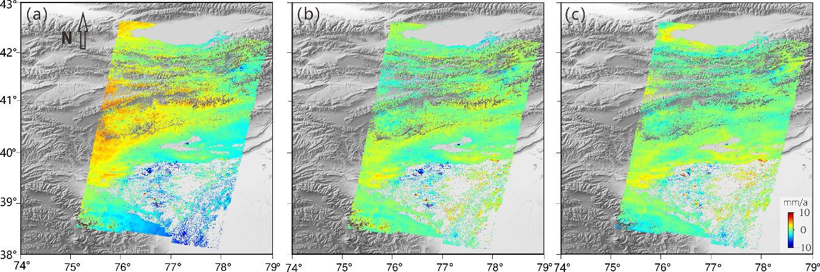**2. Tropospheric delay of the descending and ascending track calculated based on GACOS model and TRAIN**

**Figure S3：(a) observation InSAR deformation in the descending track 34; (b) orbit corrected InSAR deformation (c) APS corrected InSAR deformation**

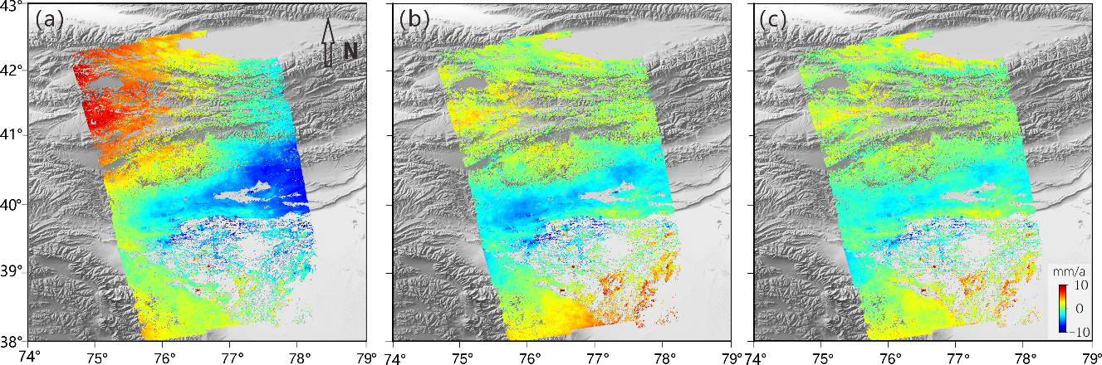

**Figure S4：(a) observation InSAR deformation in the descending track 129; (b) orbit corrected InSAR deformation (c) APS corrected InSAR deformation**

**3. Combined GPS and InSAR 3-D velocities , with default InSAR data uncertainties (2 mm/yr).**

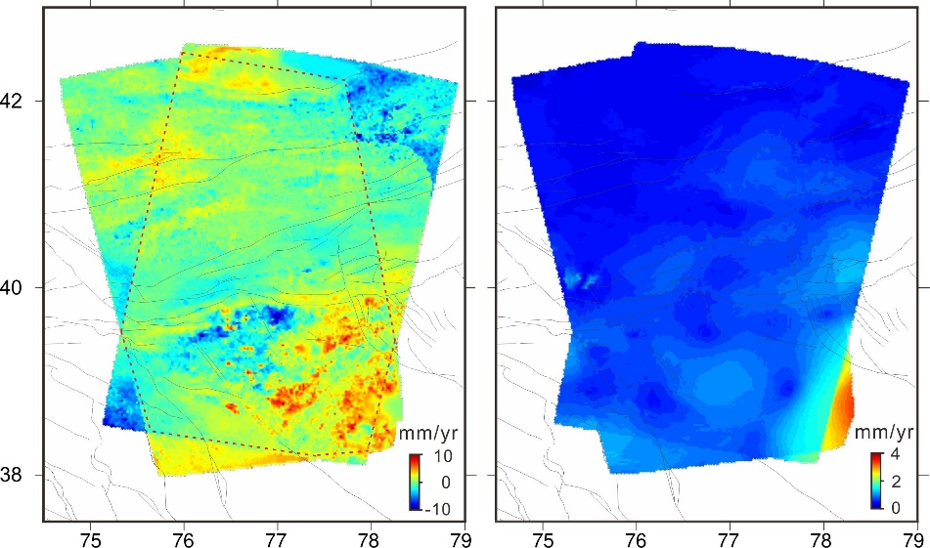

**Figure S5. the vertical components(a) and solution uncertainties(b).**

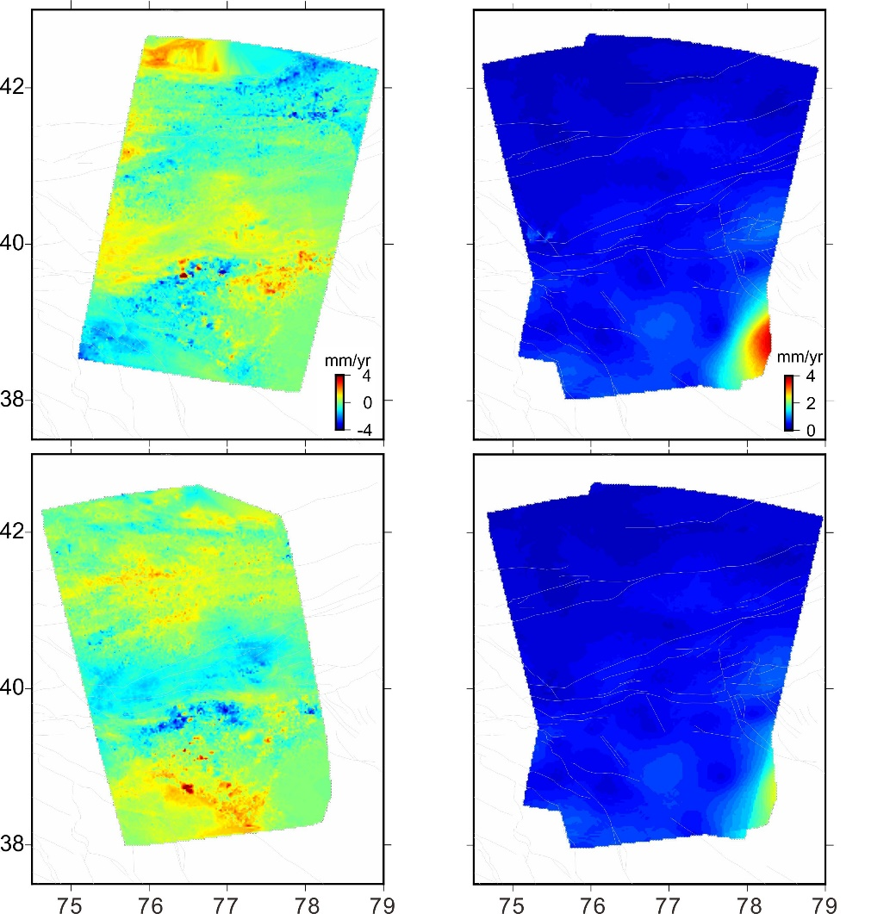

**Figure S6. Data postfit residuals and solution uncertainties. (a) and (b) are InSAR LOS postfit residuals for tracks D34 A129, respectively. (c) and (d) are solution uncertainties for the east and north components respectively.**

**4. Inversion model and results for the profile perpendicular across folds and faults in southern Tianshan.**

The south Tianshan foreland in our study area is geologically considered to be a typical thin-skin structure, involving thrust-folds and decollement. To understand the tectonic kinematics and the partitioning of the deep-secular motion in this area, we established two fault- decollement slip-partitioning models(Daout et al., 2016) on the LOS and horizontal velocity data projected on two independent profiles (P3 and P4 in Figures 2 and 3). For both profiles, the model consists of 2-D dislocations, infinite in the along-strike dimension, embedded in a homogeneous elastic half-space. the Bayesian approach is used to quantitatively explore the geometry of the fault system at depth and associated slip rates. To improve the computational efficiency, the LOS and horizontal velocity fields were uniformly downsampled by one out of ten. Bayes’ rule writes the posterior probability density function (PDF) of a model：

$p(m|d)∝p(m)exp\left[-\frac{1}{2}{\left(d-g\left(m\right)\right)}^{T}C_{d}^{-1}(d-g\left(m\right))\right]$, (1)

where **d** is the data vector, **m** is the vector of model parameters, **C**d is the covariance matrix of the data, and **g**(**m**) is the surface displacements predicted from model **m**. The data vector, **d**, is made of the LOS displacement rates and the horizontal velocities projected into profile-perpendicular and profile-parallel components. The data covariance matrix, **C**d, includes the variance of the horizontal measurements on its diagonal and InSAR data spatial correlation in the off-diagonal components.

Following our interpretation of geological, seismological, and surface deformation data, for the western profile P3, we model the flat decollement by a horizontal semi-infinite dislocation, limited to the north by the Maidan fault, with oblique motion (both strike-slip and dip-slip) . We extend the decollement with a ramp, connecting the northern tip of the decollement to the down-dip end of locked Atushi and Toth Goubaz faults. For eastern profile P4, we divide the region into two triple junctions and one frontal ramp. The first triple junction consists of Maidan fault, Toshgan fault and Kalatieke fault adjacent to both sides of it, and the second triple junction simulates Keping nappe structure, which consists of Kalatieke fault and a decollement, with a ramp pointing towards Keping Tag fault. For each model, We evaluate the posterior probability density functions (PDFs) using the Metropolis algorithm, implemented in the PYmC library(Dault et al.2016).

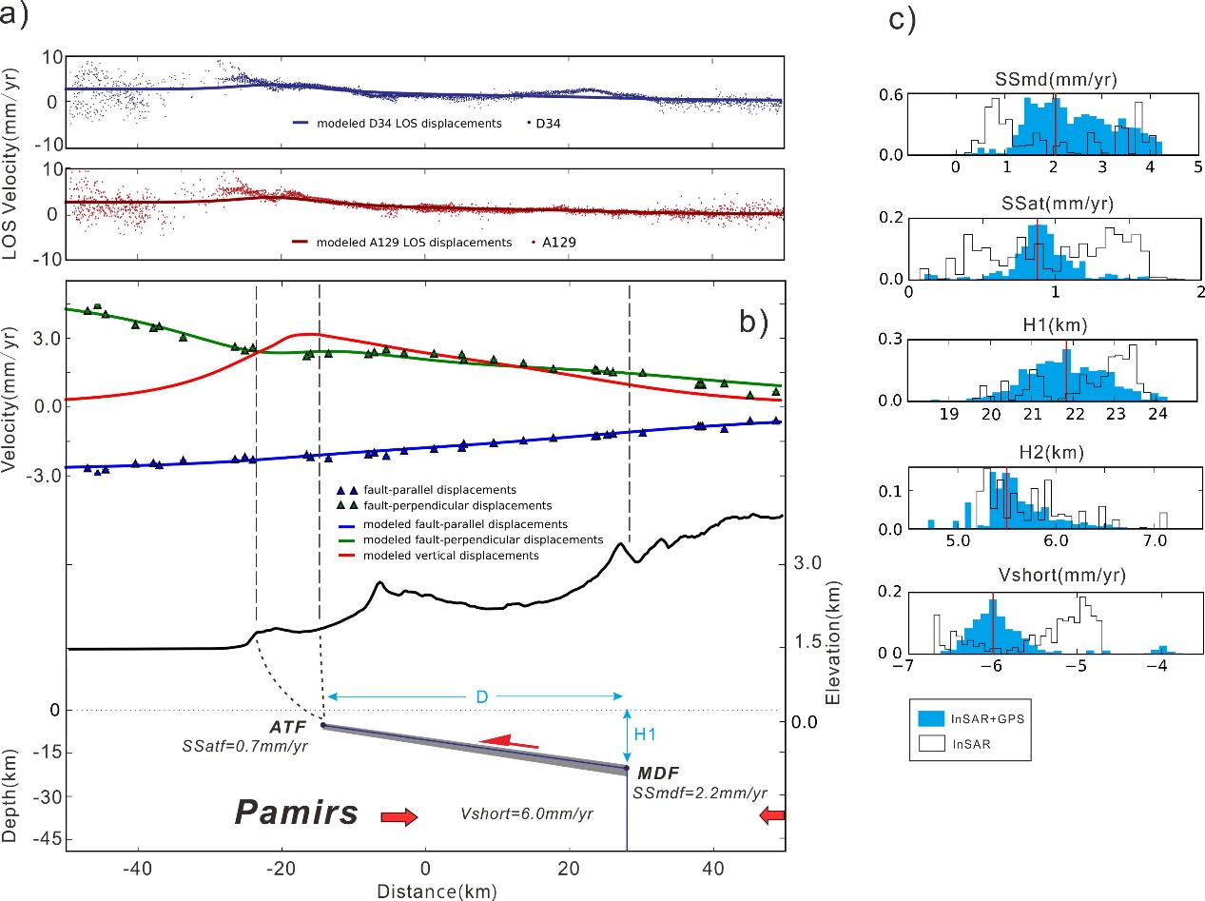**Figure S7: Inversion model and results for the P3 profile perpendicular to the Atushi anticline**

**(a) InSAR LOS velocities and average model obtained (D34 is blue and A129 is red). (b) (top) Profile-perpendicular (blue markers), profile-parallel (green markers), and vertical (red markers) horizontal velocities. Average model obtained (blue, green, and red lines) along profiles.(middle) average topography along the swath profile (back lines).(bottom) Two-dimensional model in agreement with the data (grey lines) and average geometry (blue lines) with associated slip rates. (c)** **Posterior marginal Probability Density Functions (PDFs) using InSAR data only (black unfilled histograms, respectively) or GPS+InSAR data (blue filled histograms).The boundaries of the histograms correspond to the uniform prior distributions. H1: depth of the décollement; H2:depth of the tip of the shallow ramp; D: width between H1 and H2; SSatf: the strike-slip rate of the Atushi fault (ATF); SSmdf: strike-slip rate of the Maidan Fault (MDF); Vshort:** **the mean shortening rate across the entire system.**

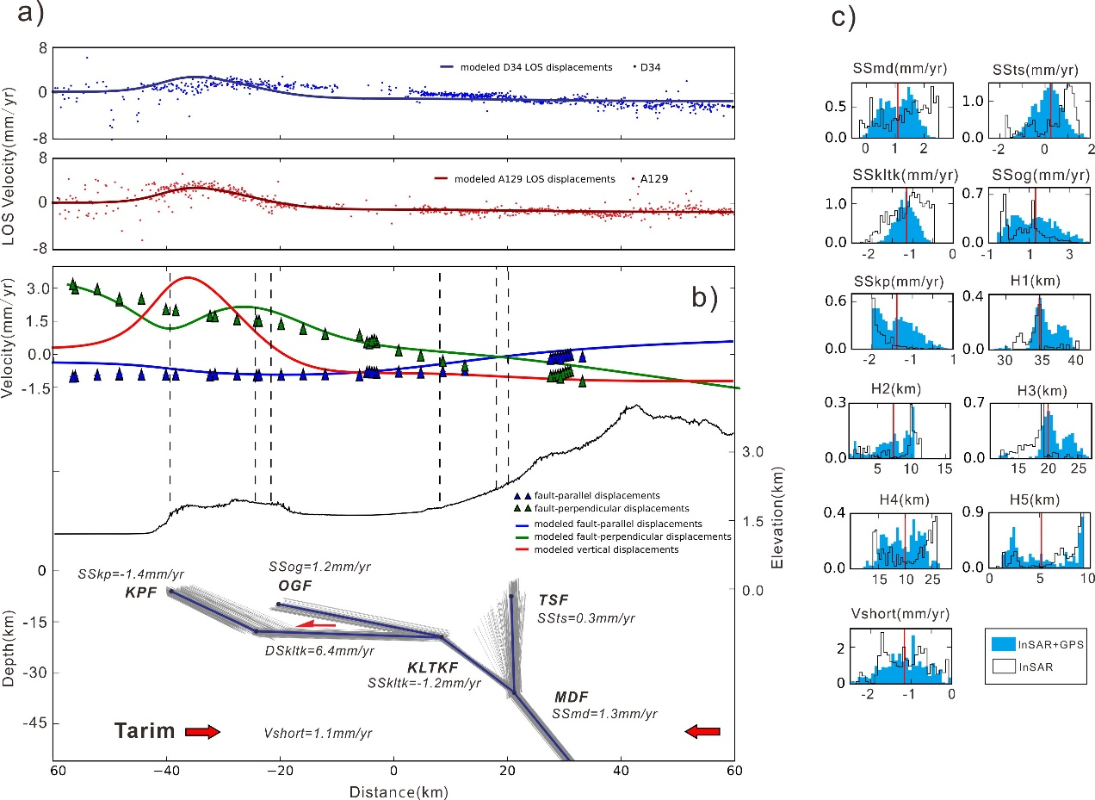**Figure S8: Inversion model and results for the P4 profile perpendicular to the** **Keping nappe**

**(a) InSAR LOS velocities and average model obtained (D34 is blue and A129 is red). (b) (top) Profile-perpendicular (blue markers), profile-parallel (green markers), and vertical (red markers) horizontal velocities. Average model obtained (blue, green, and red lines) along profiles.(middle) average topography along the swath profile (back lines).(bottom) Two-dimensional model in agreement with the data (grey lines) and average geometry (blue lines) with associated slip rates.(c)** **Posterior marginal Probability Density Functions (PDFs) using InSAR data only (black unfilled histograms, respectively) or GPS+InSAR data (blue filled histograms).The boundaries of the histograms correspond to the uniform prior distributions. SSkp: the strike-slip rate of the keping fault (KPF); SSts: strike-slip rate of the Toshigan Fault (TSF); SSkltk: strike-slip rate of the Kalatieke Fault (KLTKF); SSog: strike-slip rate of the Ozgeltawu Fault (OGF);SSmd: strike-slip rate of the Maidan Fault (MDF);** **Vshort: the mean shortening rate across the entire system.**