Supplementary Material

Supplementary Figures
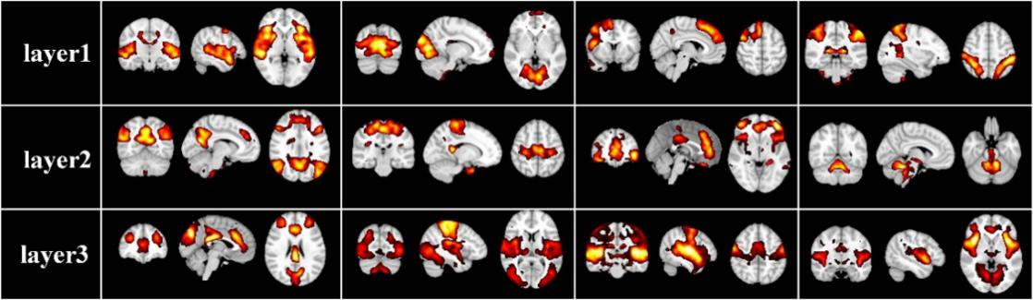
SFigure. 1 Representative group-level functional brain networks from three layers identified by first-stage DBN model based on session B.
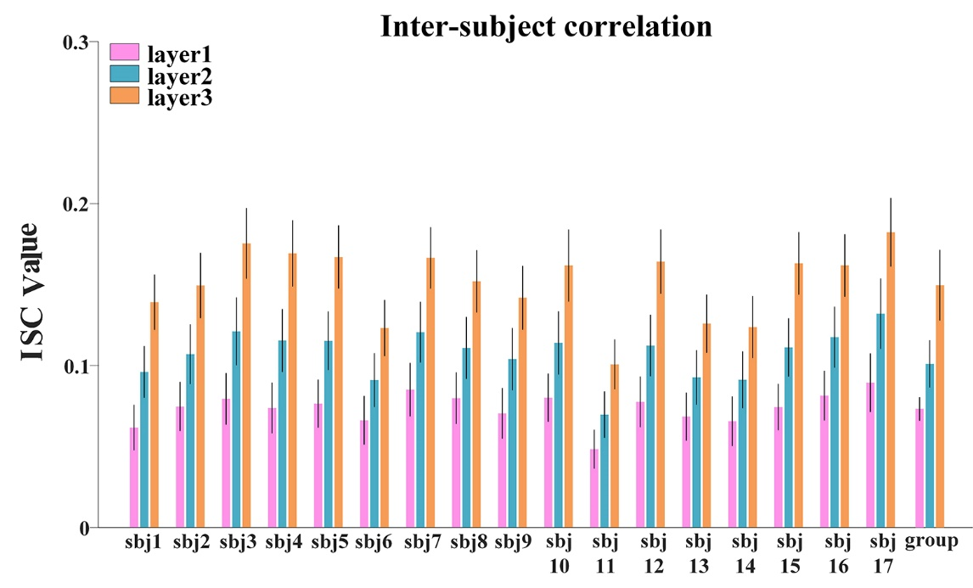
SFigure. 2 The ISC metric in each layer at individual-level and group-level for session B. Error bar indicates standard error of mean (s.e.m).
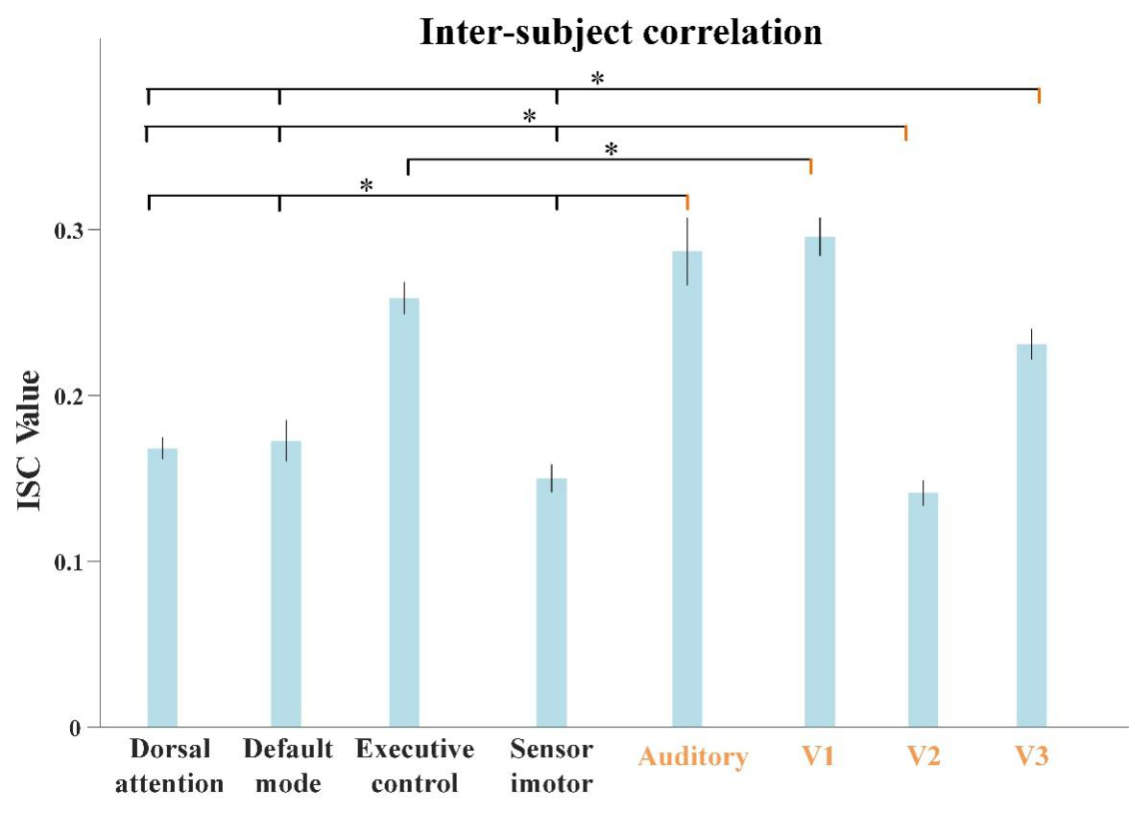
SFigure. 3 The average ISC values from individual temporal features corresponding to each FBN for session B, including dorsal attention network, default-mode network, executive control network, sensorimotor network, auditory network, medial-visual network (V1), occipital pole-visual network (V2) and lateral visual network (V3). The error bar refers to standard error of mean (s.e.m). The statistical test was conducted by ANOVA, where * represents FDR-corrected p<0.001.
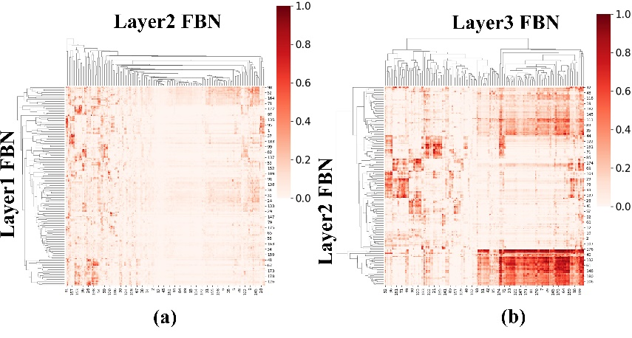
SFigure. 4 The group-level ISR maps of spatial maps across layers for session B. (a) is the ISR between layer 1 and layer 2. (b) is the ISR between layer 2 and layer 3.
SFigure. 5 The group-level ISR maps of temporal responses across hidden layers for session B. (A) The ISR map between layer 2 and layer 1, and (B) the ISR map between layer 3 and layer 2.
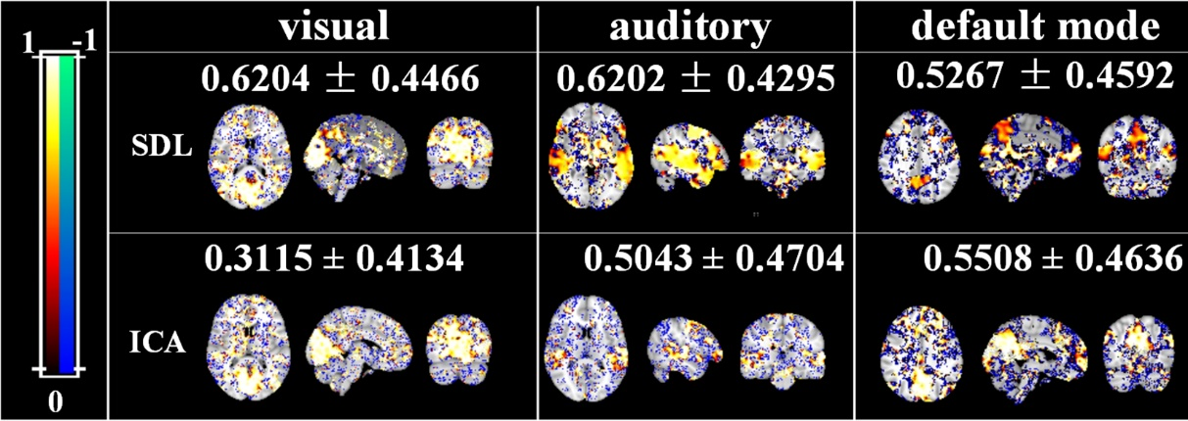
SFigure. 6. Brain maps of the voxel-wise ICCs of manually matching brain network using SDL and ICA methods.

