Oxidative damage is influenced by diet but unaffected by selection for early age of oviposition in the marula fly, Ceratitis cosyra (Diptera: Tephritidae)
Kevin Malod^{a†}, Esther E. du Randª, C. Ruth Archer^{b}, Susan W. Nicolsonª, Christopher W. Weldon^{a*}
ªDepartment of Zoology and Entomology, University of Pretoria, Private Bag X20, Hatfield 0028, South Africa.
^{b}Institute for Evolutionary Ecology and Conservation Genomics, University of Ulm, Ulm, Germany.
†Current address: Department of Conservation Ecology and Entomology, Faculty of AgriSciences, Stellenboch University, Stellenbosch, South Africa
*Corresponding author: E-mail: cwweldon@zoology.up.ac.za

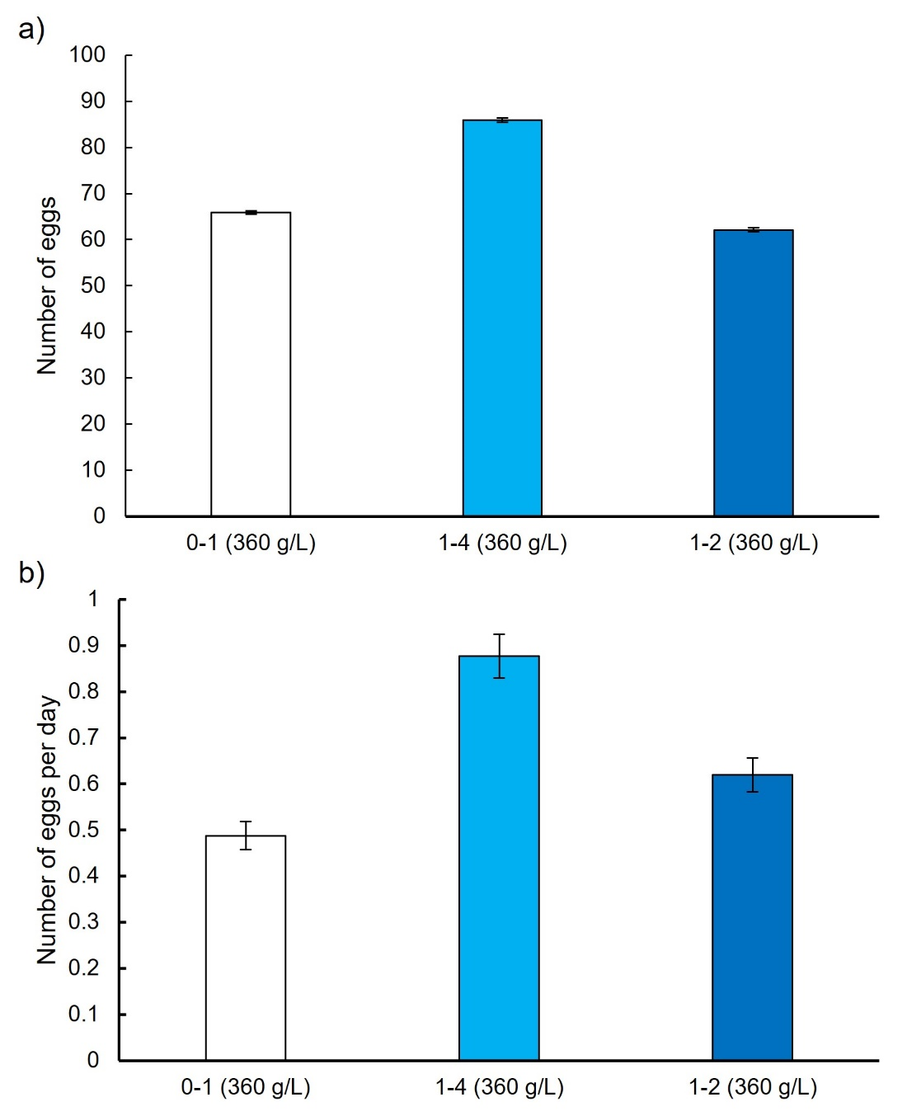

Figure S1. Average lifetime egg production (a) and daily egg production (b) in control females fed one of following diets that vary in their protein to carbohydrate (P:C) ratio: 0:1 P:C, 1:4 P:C and 1:2 P:C. Error bars represent the standard error to the mean.

Table S1. Experimental diets fed to female and male C. cosyra in either no-choice or choice experiment.
P:C | Concentration (g/L) | Sucrose (g/L) | Amino Acids (g/L) | Vitamin (g/L) | Cholesterol (g/L) | RNA (g/L) | Wesson salt (g/L)
0:1 | 360 | 360.00 | 0.00 | 3.6 | 4.0 | 10.0 | 10.0
1:4 | 360 | 288.00 | 72.00 | 3.6 | 4.0 | 10.0 | 10.0
1:2 | 360 | 240.00 | 120.00 | 3.6 | 4.0 | 10.0 | 10.0

