

**Fig.S1. Transcript level of *CsGSTU8* and *CsWRKY48* in our unpublished transcriptome data.** Data are presented as the means ± SDs of three independent experiments. Significant differences were determined using Student’s t-test (\*, P < 0.05).

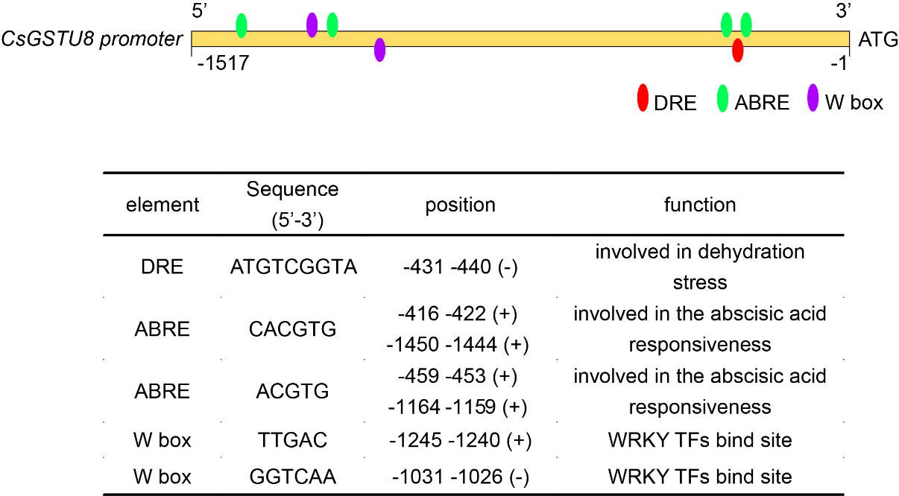

**Fig.S2. *Cis*-elements identification of *CsGSTU8* promoter in PlantCARE** (<http://bioinformatics.psb.ugent.be/webtools/plantcare/html/>).

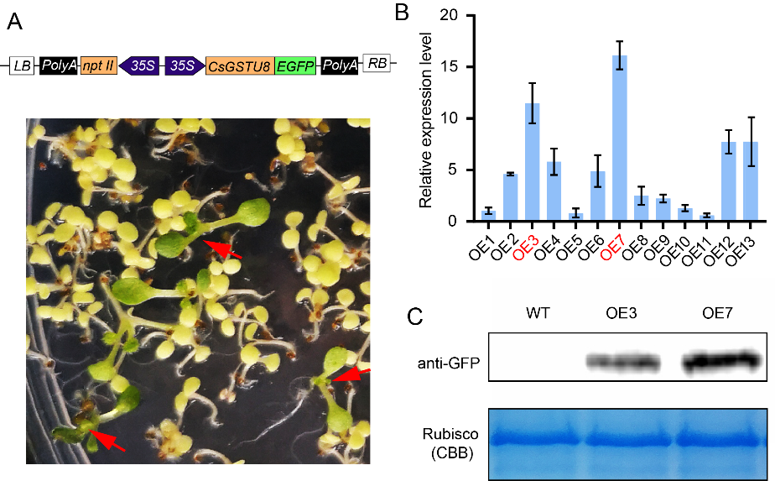

**Fig.S3. Identification of *CsGSTU8* transgenic *Arabidopsis*.** (A) Screening of transgenic plants with kanamycin resistance. (B) Expression level analysis of *CsGSTU8* in transgenic lines by using qRT-PCR, red marked lines were used in this study. (C) Western blot analysis of CsGTU8-GFP fusion protein in transgenic *Arabidopsis* using GFP antibody.