**Supplementary information**

***A. Model setup further details***

The hydrodynamic model was run from 1 July 2017 to 30 June 2020, i.e., a period of three years; this window was chosen as it began after the high flow event in 2016 which “reset” salinity levels in the Coorong. The simulation included gauged Salt Creek inputs (discharge and salinity) and measured ocean water levels based on the Barker Knoll telemetered site. Weather data were also used as a boundary condition, in order to predict the effect of wind and evapo-concentration effects. The model mesh contains 26250 cells in total and the mean cell size is 10,000 m2. The model is able to dynamically adjust the time step to maintain a Courant–Friedrichs–Lewy value below 0.9 based on the current speeds and cell sizes, with a minimum time step of 0.1 second and a maximum of 15 seconds. A summary of the boundary condition inputs is provided in Table A1.

**Table A1. Summary of boundary conditions applied to the Coorong model. The data sources for tide and flows include South Australian Department of Environment and Water (SA DEW) and Environmental Protection Authority (EPA); these data are curated by SA DEW and available from the online data portal water.data.sa.gov.au. The data source for weather is Bureau of meteorology (BoM).**

|  |  |  |  |
| --- | --- | --- | --- |
| **Location** | **Type** | **Data source** | **Time step** |
| Ocean | Water level | Barker Knoll (A4261039) | 10 min |
| Salinity | 35 PSU | 10 min |
| Temperature | Barker Knoll (A4261039) | 60 min |
| Salt Creek | Discharge | Salt Creek Gauge Station (A2390568) | daily |
| Salinity | Salt Creek Gauge Station (A2390568) | daily |
| Temperature | Salt Creek Gauge Station (A2390568) | daily |
| Barrages | Discharge | **All water discharge:** SA DEW  **Environmental water discharge:** Commonwealth environmental water accounting factored with DEW daily barrage flow for each barrage | daily |
| Salinity | **Goolwa:** Goolwa channel at Signal Point Beacon 23 (A4261123)  **Ewe:** Lake Alexandrina at Ewe Island barrage (A4261206)  **Mundoo:** EPA site at Mundoo Barrage (EPA Clayton 1)  **Boundary:** EPA site at Boundary Ck barrage (EPA Rat Island)  **Tauwitchere:** Lake Alexandrina at Tauwitchere barrage (A4261207) | daily |
| Temperature | **Goolwa:** Goolwa channel at Beacon 12 (A4261036)  **Ewe:** Lake Alexandrina at Ewe Island barrage (A4261206)  **Mundoo:** Lake Alexandrina at Mundoo Barrage (A4261204)  **Boundary:** Lake Alexandrina at Boundary Ck barrage (A4261205)  **Tauwitchere:** Lake Alexandrina at Tauwitchere barrage (A4261207) | daily |
| Global | Wind | BoM Narrung Weather Station | 15 min |
| Rainfall | BoM Narrung Weather Station | daily |
| Air Temperature | BoM Narrung Weather Station | 15 min |
| Solar Radiation | BoM Narrung Weather Station | 15 min |
| Humidity | BoM Narrung Weather Station | 15 min |

The flow over the barrages, for the total barrage flow and the estimate of barrage flow that was environmental water (as calculated by the water holder) is shown in Figure3, including the high flows over the 18 months preceding the start of the model simulation, demonstrating the low flow period considered in this work. Which barrage the total flow occurred through is shown in Figure A1. As the data provided for the environmental water accounting (Figure 3) only include the total flow and does not resolve details of specific barrages, we estimate the distribute the environmental water through the different barrage reaches by comparing the environmental flows to the actual estimates of daily barrage flow from each barrage from SA Water and DEW (Figure A1). The results show the dominance of flows through Goolwa and Tauwitchere over the period of interest, with some minor pulse through Mundoo (Figure A1). The analysis also highlights that Commonwealth environmental water dominated the barrage flows for this period, in many cases making up 100% of the specified flux into the Murray estuary and Coorong. For the final model simulations of the Coorong, we used the actual SA Government flow data over each of the barrages (called the “Base-case” simulation), and then undertook the following: Scenario 1: No environmental water across the barrages (essentially equating to no barrage flow); and Scenario 2: Observed conditions for 2017-18 and 2018-19 (as the Base-case), and no environmental water for the 2019-20 water year.

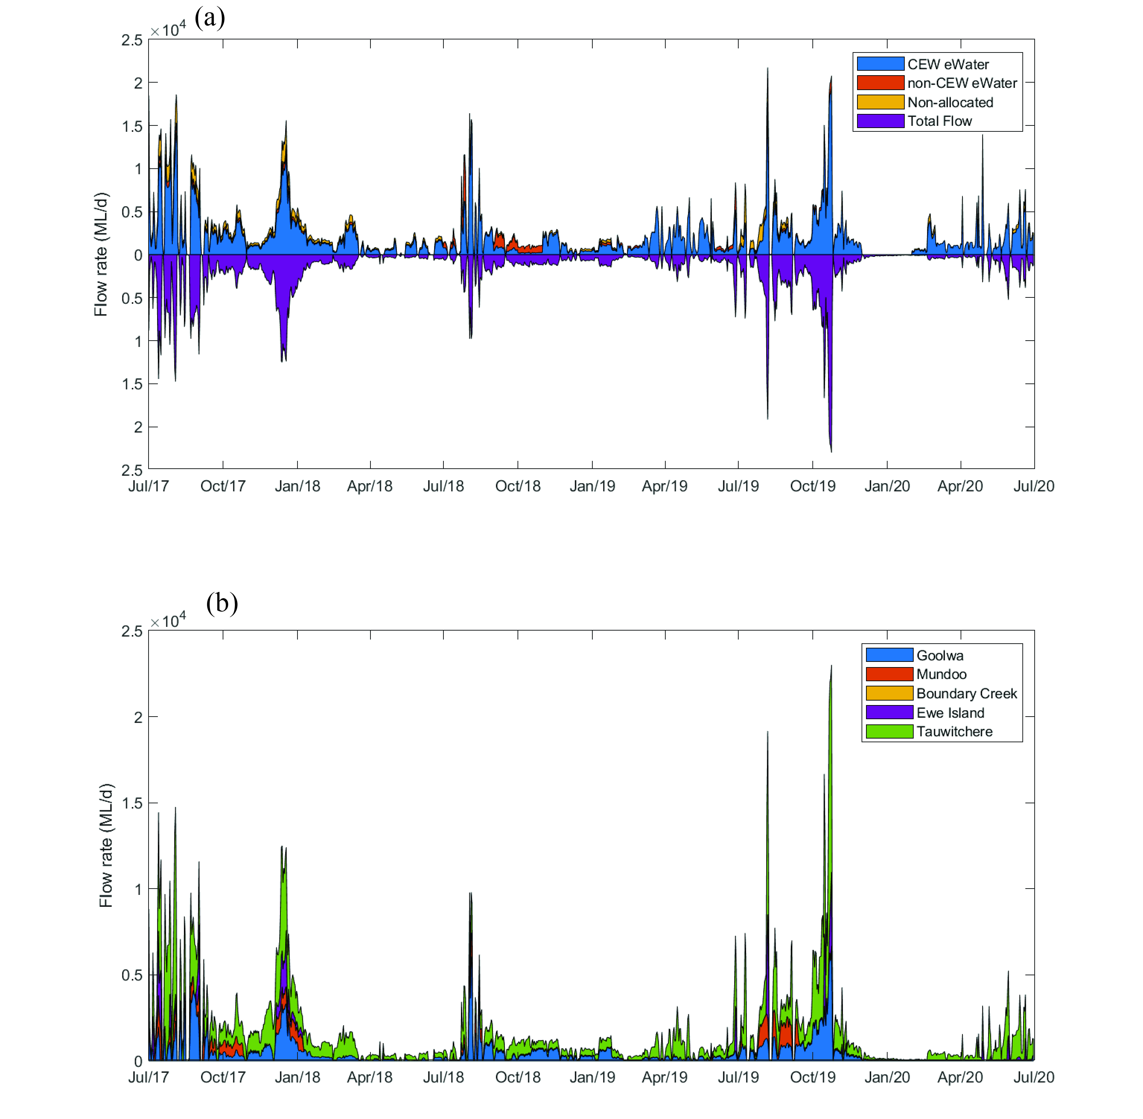

Figure A1. (a) Total flow over the barrages, categorized based on water source. The top axis of Figure A1a shows the flow from the water balance analysis provided by CEW water allocation modelling, categorized based on the source of Commonwealth environmental water (CEW eWater), environmental water from sources other than Commonwealth environmental water (non-CEW eWater), and flows that were not counted as environmental water (non-allocated); the bottom part of the axis of Figure A1a shows the sum of all source flow over all barrages from actual measures of daily barrage flow by SA Water and DEW; (b) Final daily flow volume over barrages, categorized based on flow per barrage gate.

***B. Salt flux assessment***

Transects were implemented at key points within the model numerical domain to quantify the salt flux; these are compared for each simulation (Figure B1-B3).

Figure B1. Detailed salt flux analysis at five locations in the Coorong (a-d) in the base-case scenario, which has environmental water flow over the barrages each year (see Figure D2). Panel (e) shows the cumulative salt flux into the North Lagoon (past Long Point) and into the South Lagoon (past Parnka Point); the shaded blue area shows salt export from the Coorong towards the river mouth.

Figure B2. Detailed salt flux analysis at five locations in the Coorong (a-d) for Scenario 1, which has no environmental water flow over the barrages each year. Panel (e) shows the cumulative salt flux into the North Lagoon (past Long Point) and into the South Lagoon (past Parnka Point); the minimal shaded blue area shows salt is always moving into the Coorong towards the South Lagoon, and is much larger than in the base-case (Figures D3 and D4).

Figure B3. Detailed salt flux analysis at five locations in the Coorong (a-d) for Scenario 2, which has environmental water flow for 2 years, and then no flow over the barrages in 2019-20. Panel (e) shows the cumulative salt flux into the North Lagoon (past Long Point) and into the South Lagoon (past Parnka Point); the minimal shaded blue area in 2019-20 shows salt begins to move towards the South Lagoon.

Figure B4. Monthly salt exports with and without environmental water delivery for July 2017–July 2020. Scenarios include with all water (Base-caseScenario), without Commonwealth environmental water for 3 years (Scenario 2) and hydrbid (Scenario 2, with eWater in first two years and no eWater in the last year). eWater delivery maintained this flux to be close to zero over the period of interest; even one year of no ewater over the barrages contributes to salt accumulation in the North and South Lagoon.

***C. Fish habitat change maps***

Environmental flows lead to an expansion of suitable fish habitat area for all species in most months. Figures show changes in habitat suitability index (ΔHSI) for bream (Figure C1), Tarmar goby (Figure C2), greenback flounder (Figure C3), yelloweye mullet (Figure C4), congolli (Figure C5) and smallmouth hardyhead (Figure C6) due to environmental water delivery.

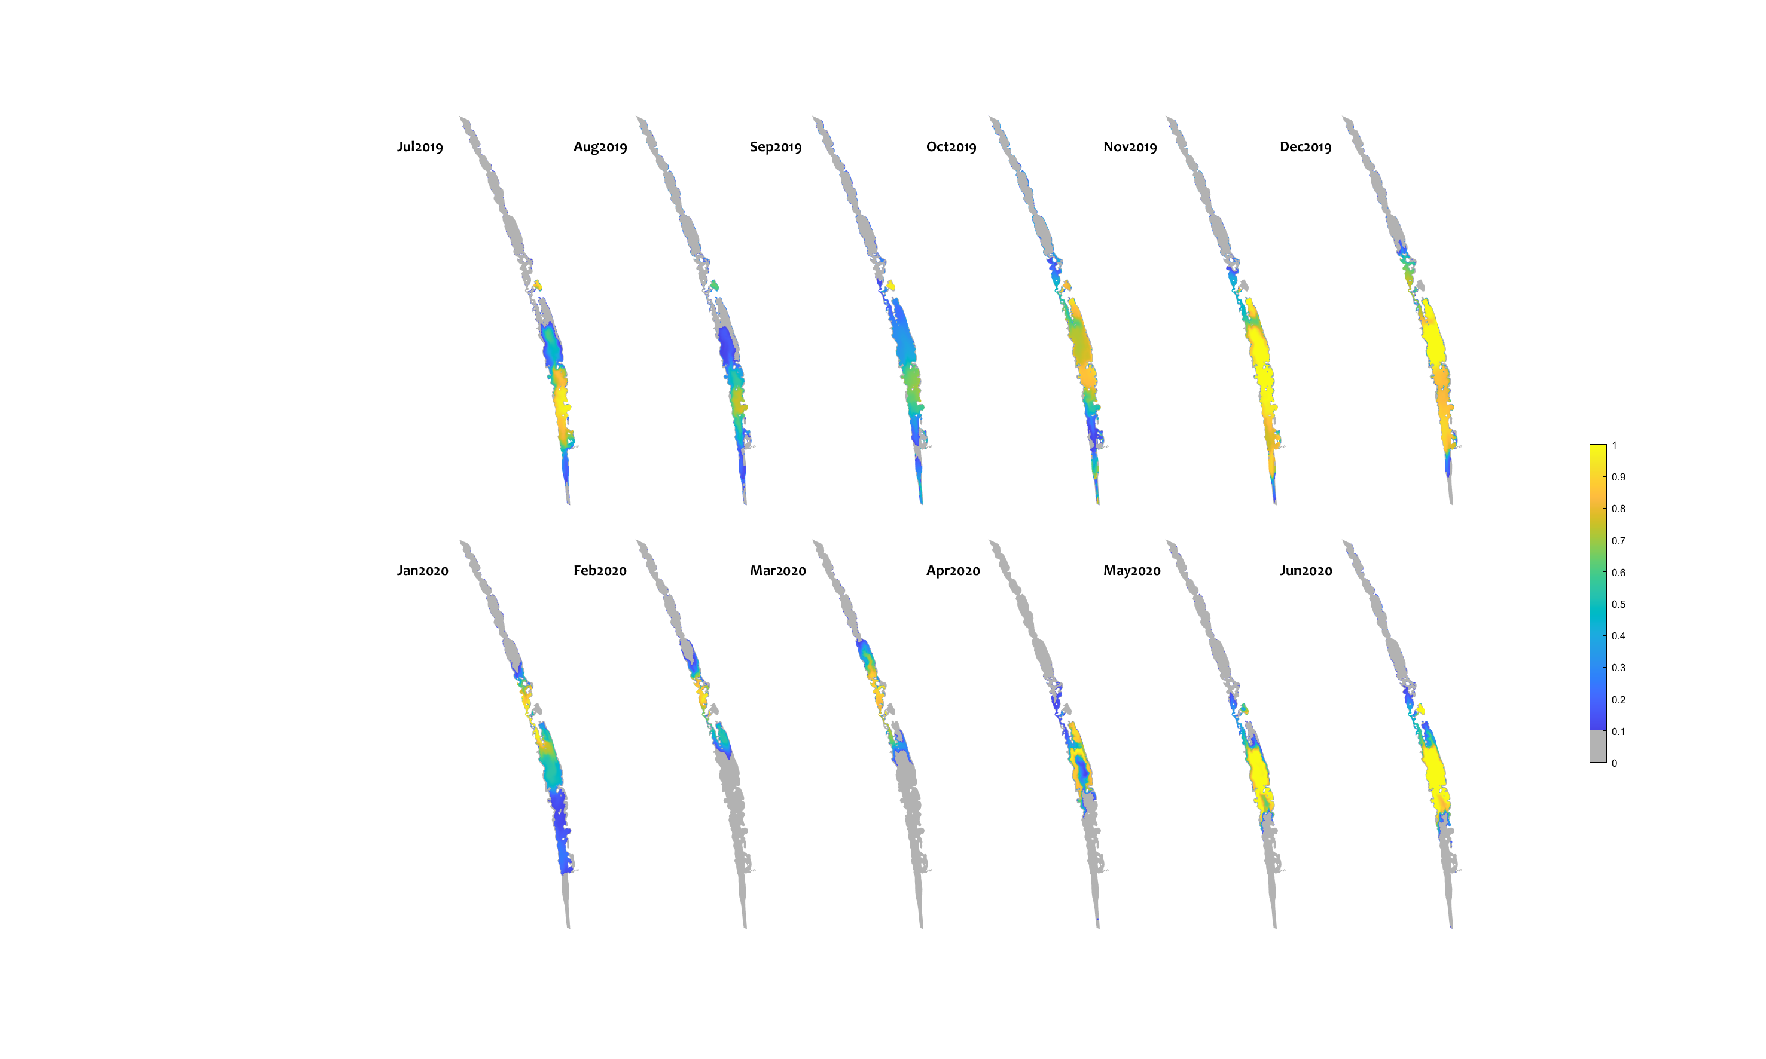

Figure C1. Monthly habitat area “gained” for black bream due to environmental water delivery (calculated as the difference between habitat suitability index (HSI) in the “All water” (base-case) and “no eWater 3yrs” scenario. Areas in bright yellow have an increase in habitat quality of 1, highlighting areas that would not be viable without environmental water, but became suitable due to the ongoing water delivery since 2017-18.

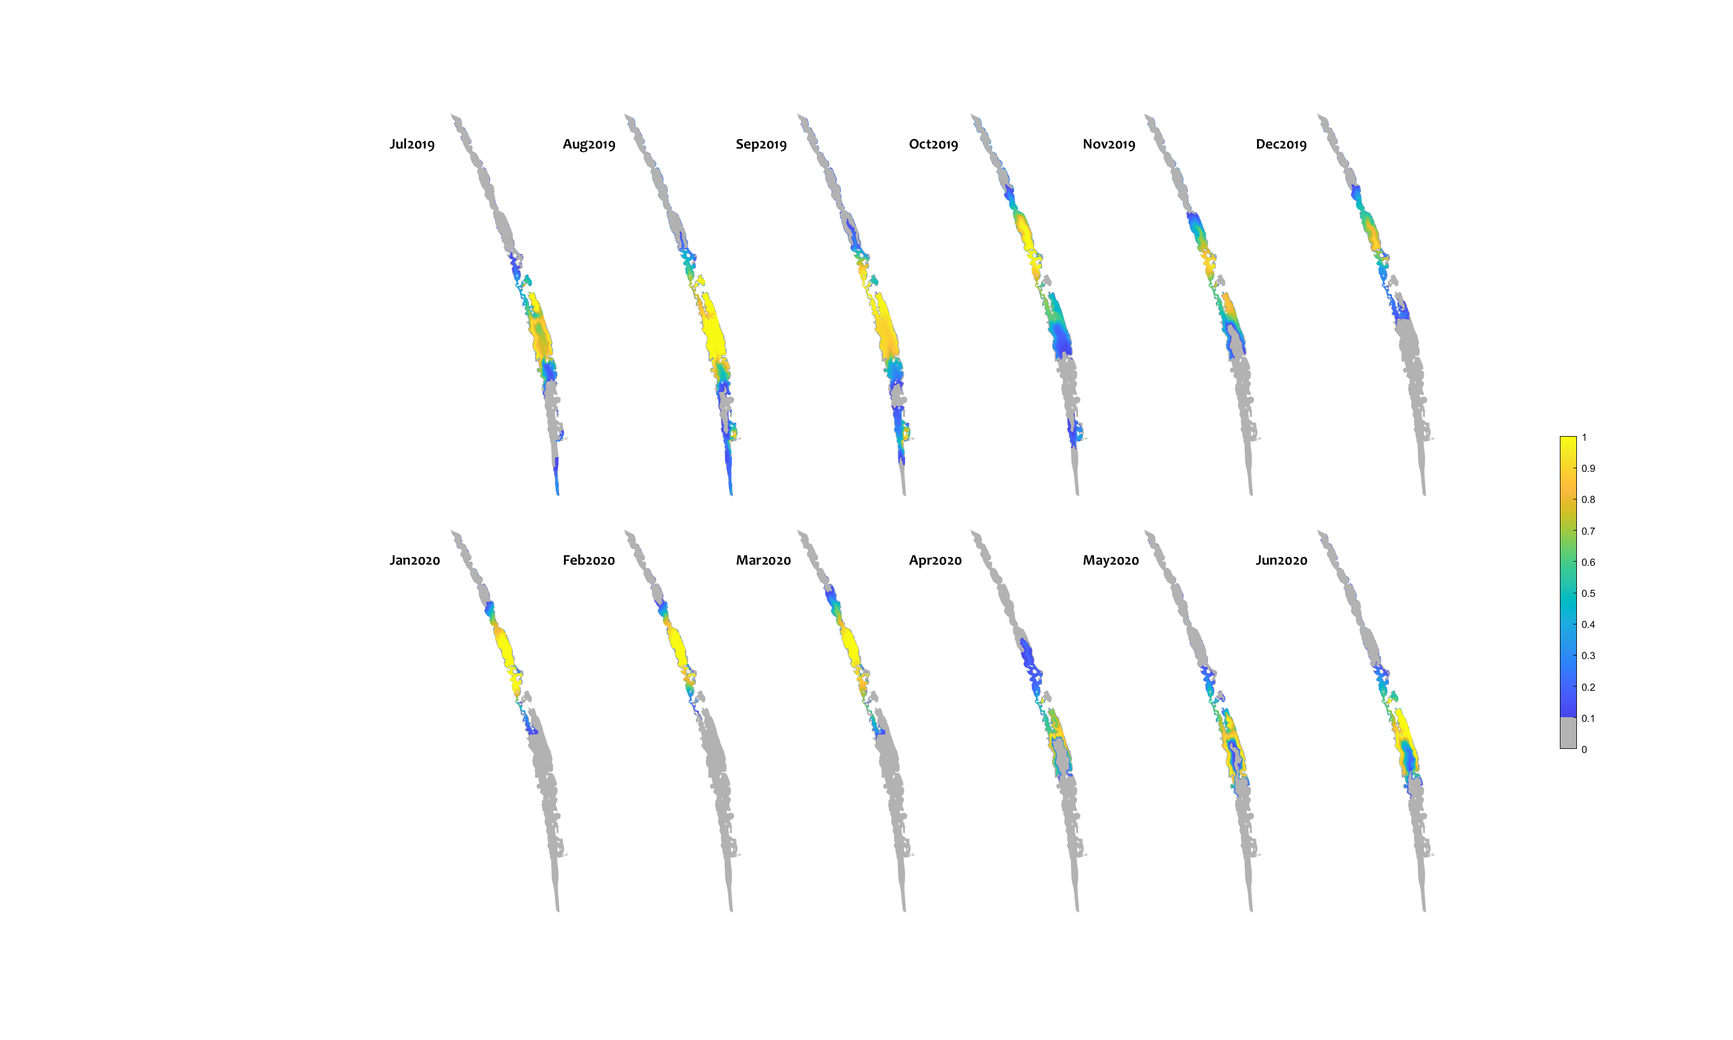

Figure C2. Monthly habitat area “gained” for Tamar goby due to environmental water delivery (calculated as the difference between habitat suitability index (HSI) in the “All water” (base-case) and “no eWater 3yrs” scenario. Areas in bright yellow have an increase in habitat quality of 1, highlighting areas that would not be viable without environmental water, but became suitable due to the ongoing water delivery since 2017-18.

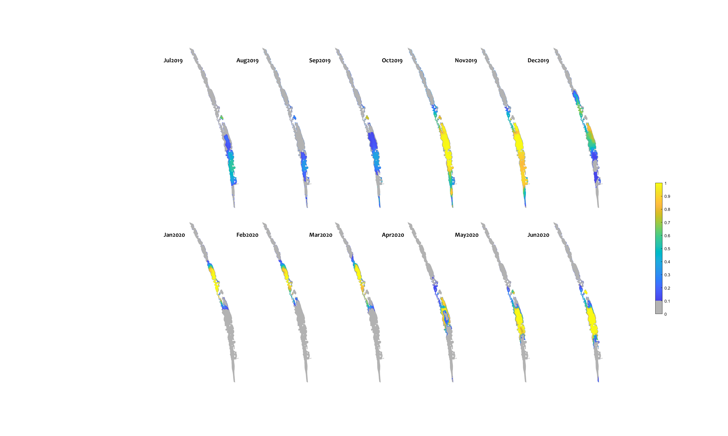

Figure C3. Monthly habitat area “gained” for greenback flounder due to environmental water delivery (calculated as the difference between habitat suitability index (HSI) in the “All water” (base-case) and “no eWater 3yrs” scenario. Areas in bright yellow have an increase in habitat quality of 1, highlighting areas that would not be viable without environmental water, but became suitable due to the ongoing water delivery since 2017-18.

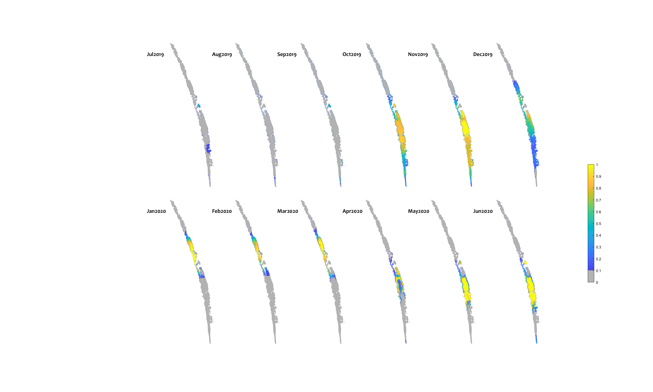

Figure C4. Monthly habitat area “gained” for yelloweye mullet to environmental water delivery (calculated as the difference between habitat suitability index (HSI) in the “All water” (base-case) and “no eWater 3yrs” scenario. Areas in bright yellow have an increase in habitat quality of 1, highlighting areas that would not be viable without environmental water, but became suitable due to the ongoing water delivery since 2017-18.

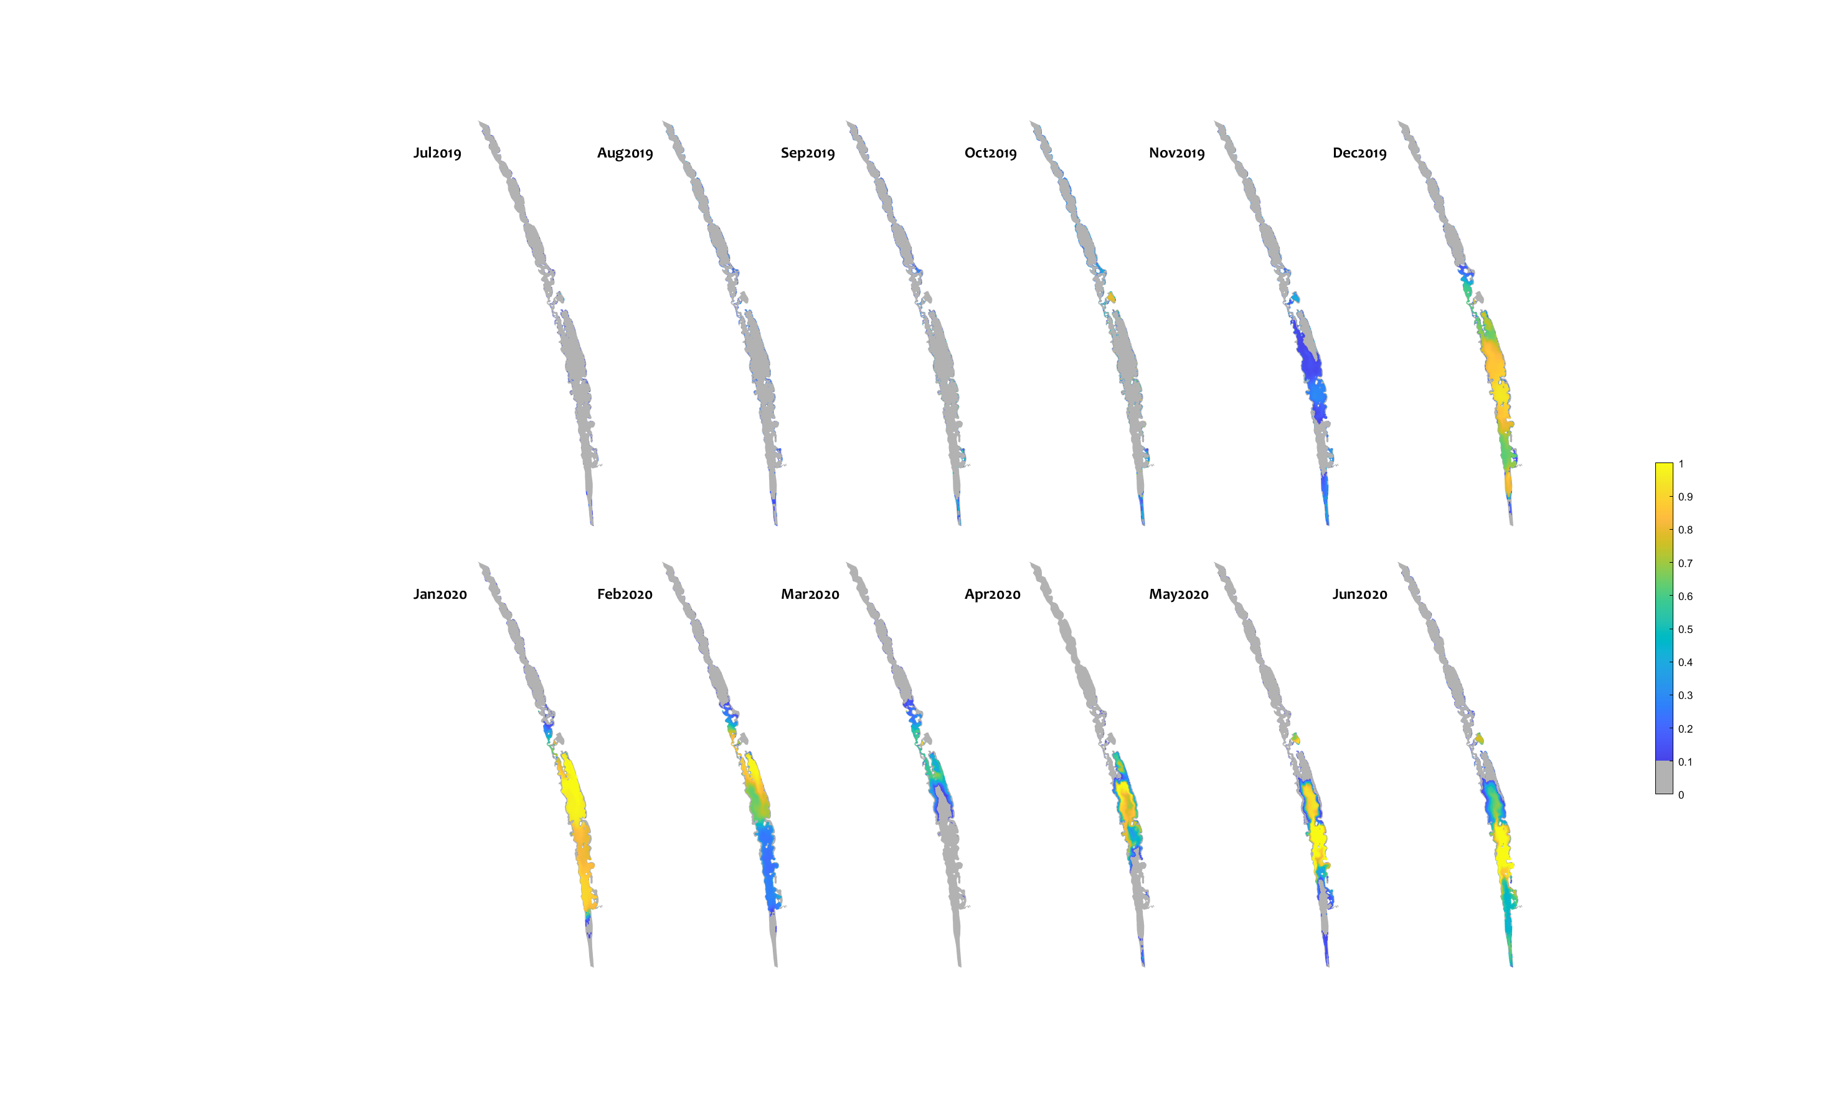

Figure C5. Monthly habitat area “gained” for congolli due to environmental water delivery (calculated as the difference between habitat suitability index (HSI) in the “All water” (Base-case) and “no eWater 3yrs” scenario (Scenario 1). Areas in bright yellow have an increase in habitat quality of 1, highlighting areas that would not be viable without environmental water, but became suitable due to the ongoing water delivery since 2017-18.

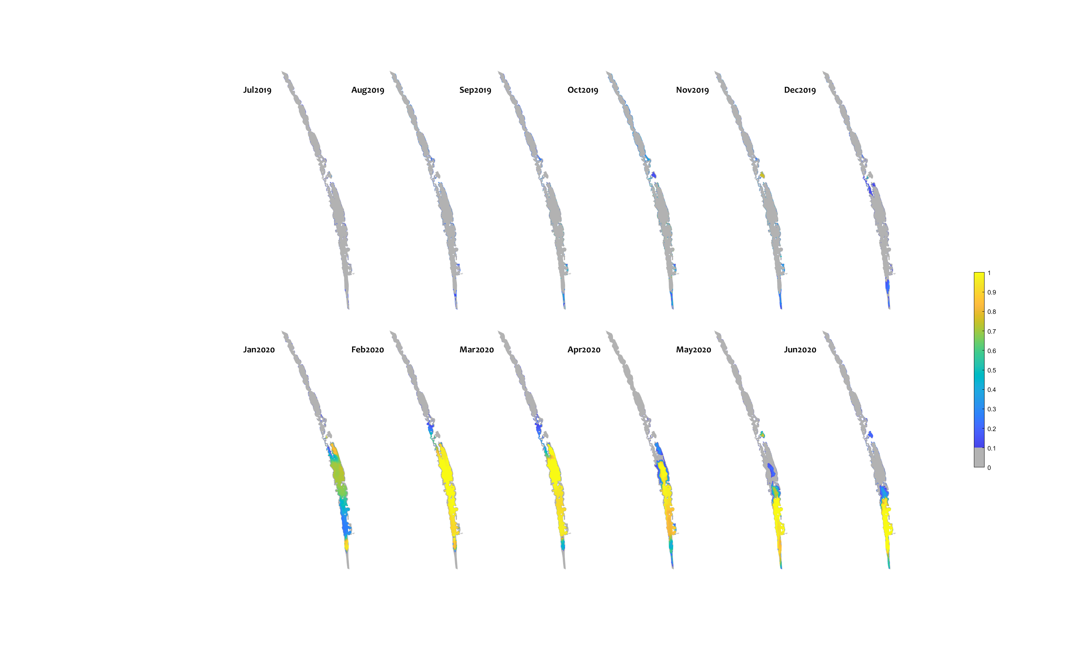

Figure C6. Monthly habitat area “gained” for smallmouth hardyhead due to environmental water delivery (calculated as the difference between habitat suitability index (HSI) in the “All water” (Base-case) and “no eWater 3yrs” scenario (Scenario 1). Areas in bright yellow have an increase in habitat quality of 1, highlighting areas that would not be viable without environmental water, but became suitable due to the ongoing water delivery since 2017-18.