Appendix B. Macrostructure rubric for English
Based on Westerveld and Gillon (2008)
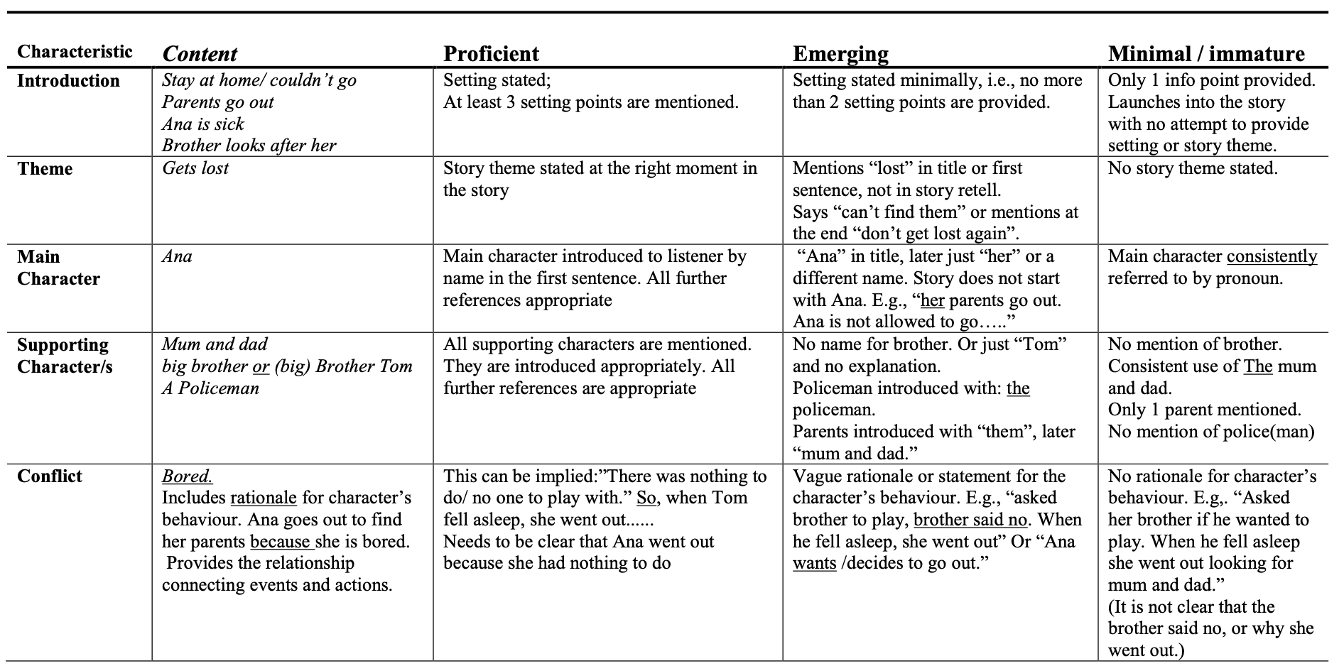
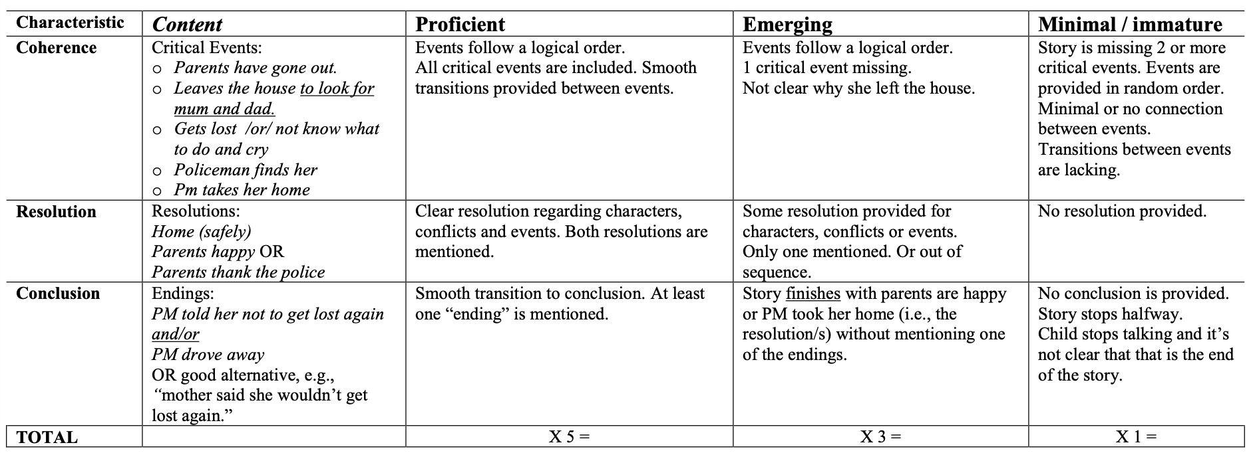
Note: The child was awarded points for each characteristic: 5 points if the child proficiently included the characteristic, 3 points if the skill was emerging, and 1 point if the child provided minimal or no information. The rubric includes specific scoring examples to promote easy and reliable scoring by other examiners. The scores were totalled to yield a total macrostructure score of English. As a result, the minimum score was 8 and the maximum score was 40.

