**SUPPLEMENTAL FIGURE LEGENDS**

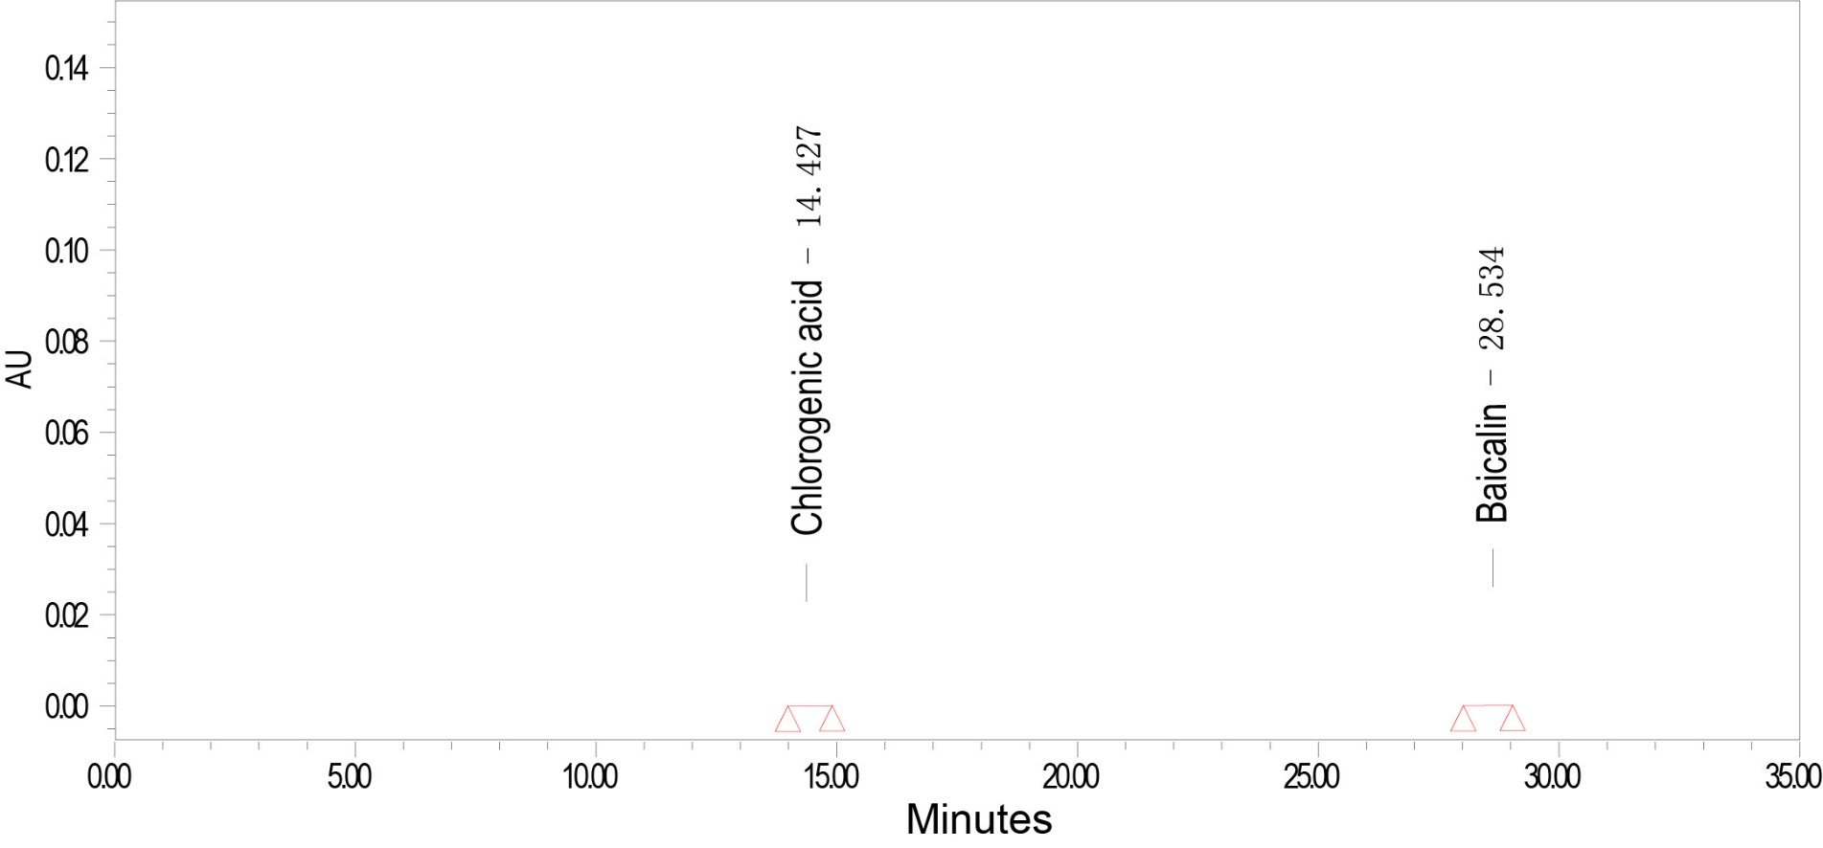**Figure S1 |** Total ion chromatography (TIC) of LSE.

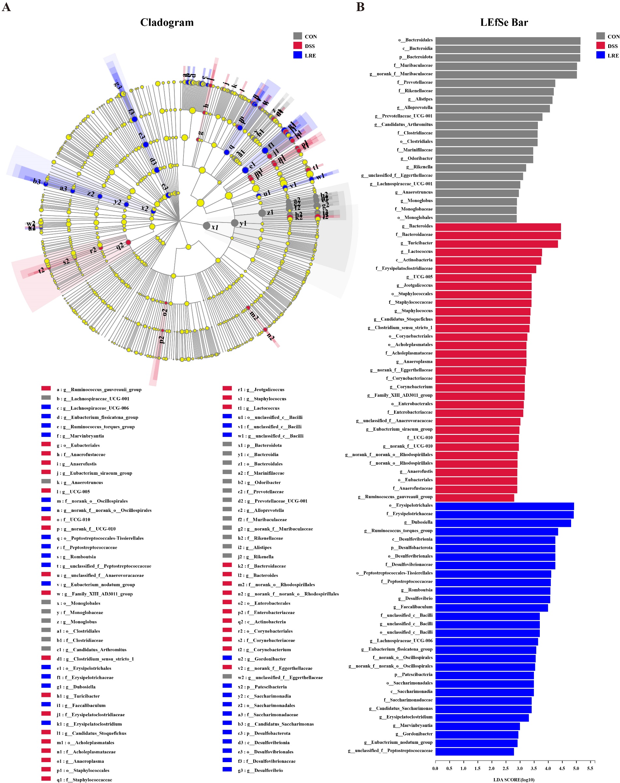**Figure S2 |** Effect of LRE administration on the colonic microbial composition in DSS-induced colitis mice. (A, B) LEfSe analysis.