Supplementary Material

Supplementary Figures
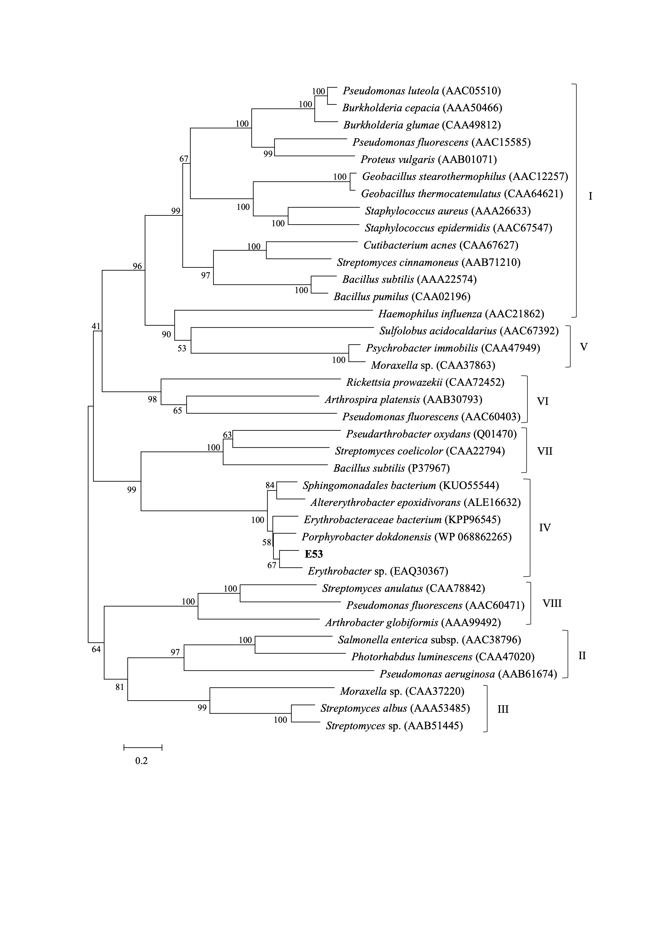
Figure S1. Phylogenetic tree based on amino acid sequences of E53 and its homologous proteins. Sequence alignment was performed using ClustalX software. The phylogenetic tree was constructed by the MEGA software. Bootstrap values were based on 1000 replicates and the values higher than 50 % were shown in the tree. The scale bar measured the number of amino acid substitutions per site.

Figure S2. The catalytic activity of wild type (WT) E53 under different NaCl concentrations. The reaction without NaCl was used as a control.

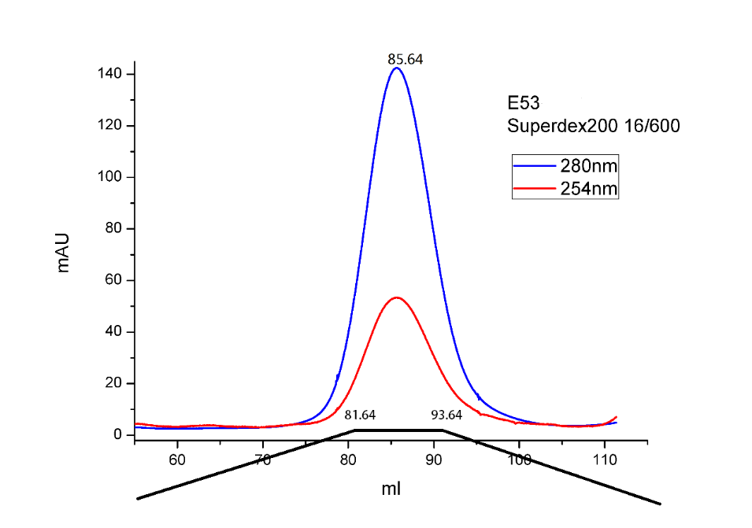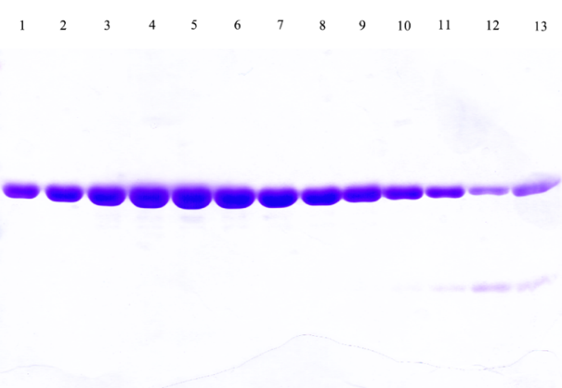

Figure S3. Molecular sieve UV absorption peak of WT E53. The sample was run on a Superdex 200 16/600 GL column and was eluted at 85.64 ml.

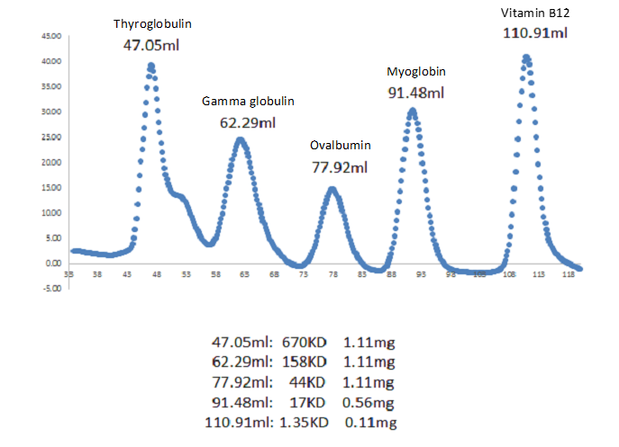
B
A
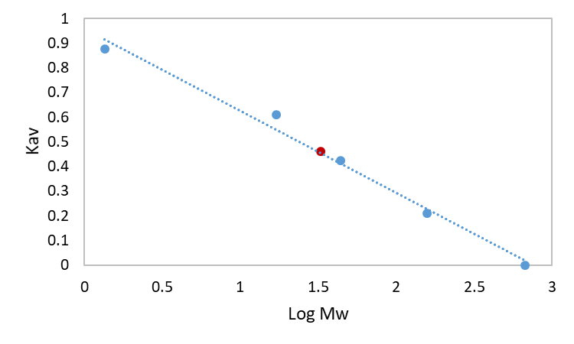
E53
32.4 kDa
Thyroglobulin
670 kDa
Gamma globulin
158 kDa
Ovalbumin
44 kDa
Myoglobin
17 kDa
Vitamin B12
1.35 kDa

Figure S4. Determination of Mw of E53. (A). The Superdex 200 16/600 GL standard elution curve. Protein size markers and corresponding elution volume are indicated in the figure. (B). Calibration curve of the The Superdex 200 16/600 GL column. Protein markers are labelled in blue dots, E53 is in red dot. Protein name and corresponding molecular weight is labelled beside the dot. The fitting has an R² of 0.987.

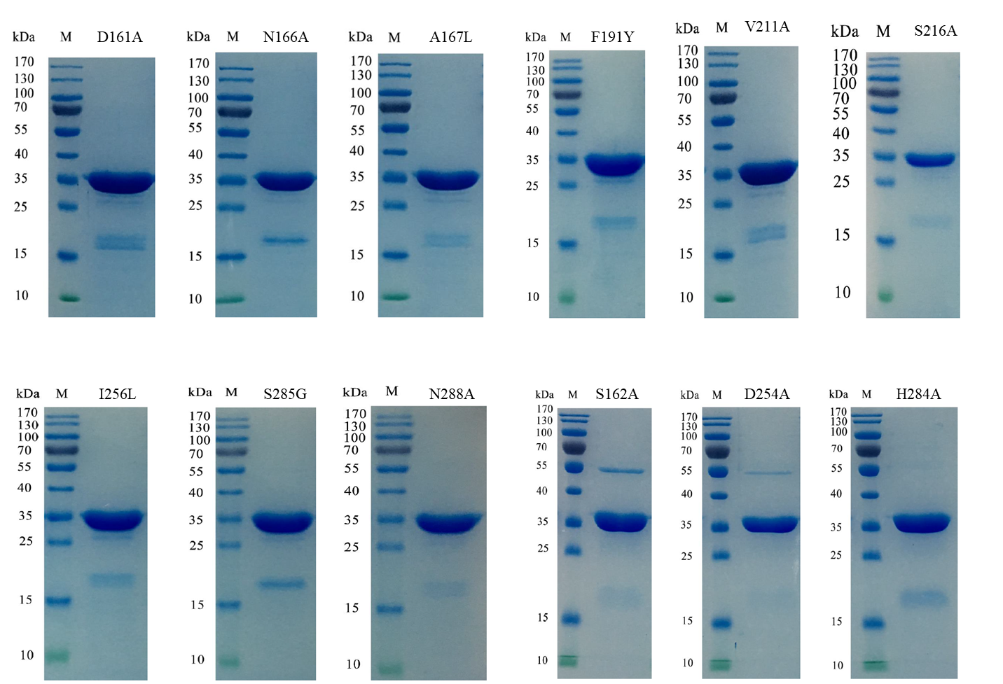
Figure S5. SDS-PAGE of all variants used in this study. The marker and variant are labelled in the figures.

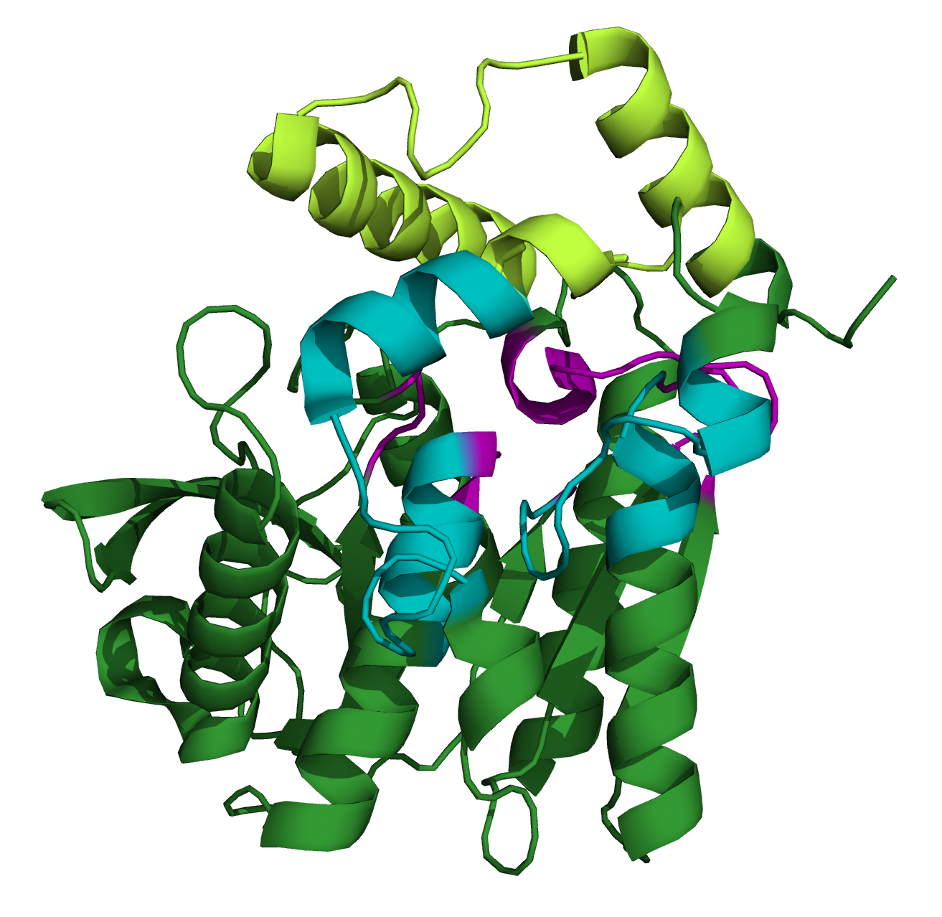

Figure S6. Visualization of R1, R2 and R3 region. The backbone of E53 is shown in green. R1 region is in magenta, R2 region is in yellow and R3 region is in cyan. The amino acid residues involved in each region are as following: R1: HGGG (88-91), GDS (160-162), F191, ASLD (251-254) and MEGVTHSFTN (279-288); R2: KAFLEAIAAMAGPTLAEMTLEEARASYVALHGMAD (11-47), GFV (209-211) and TKAS (213-216); R3: AGGNATI (163-169), PLASDAVGSASL (192-203), IEFFDTAYKADRADPRGF (217-234) and PIRDS (255-259)

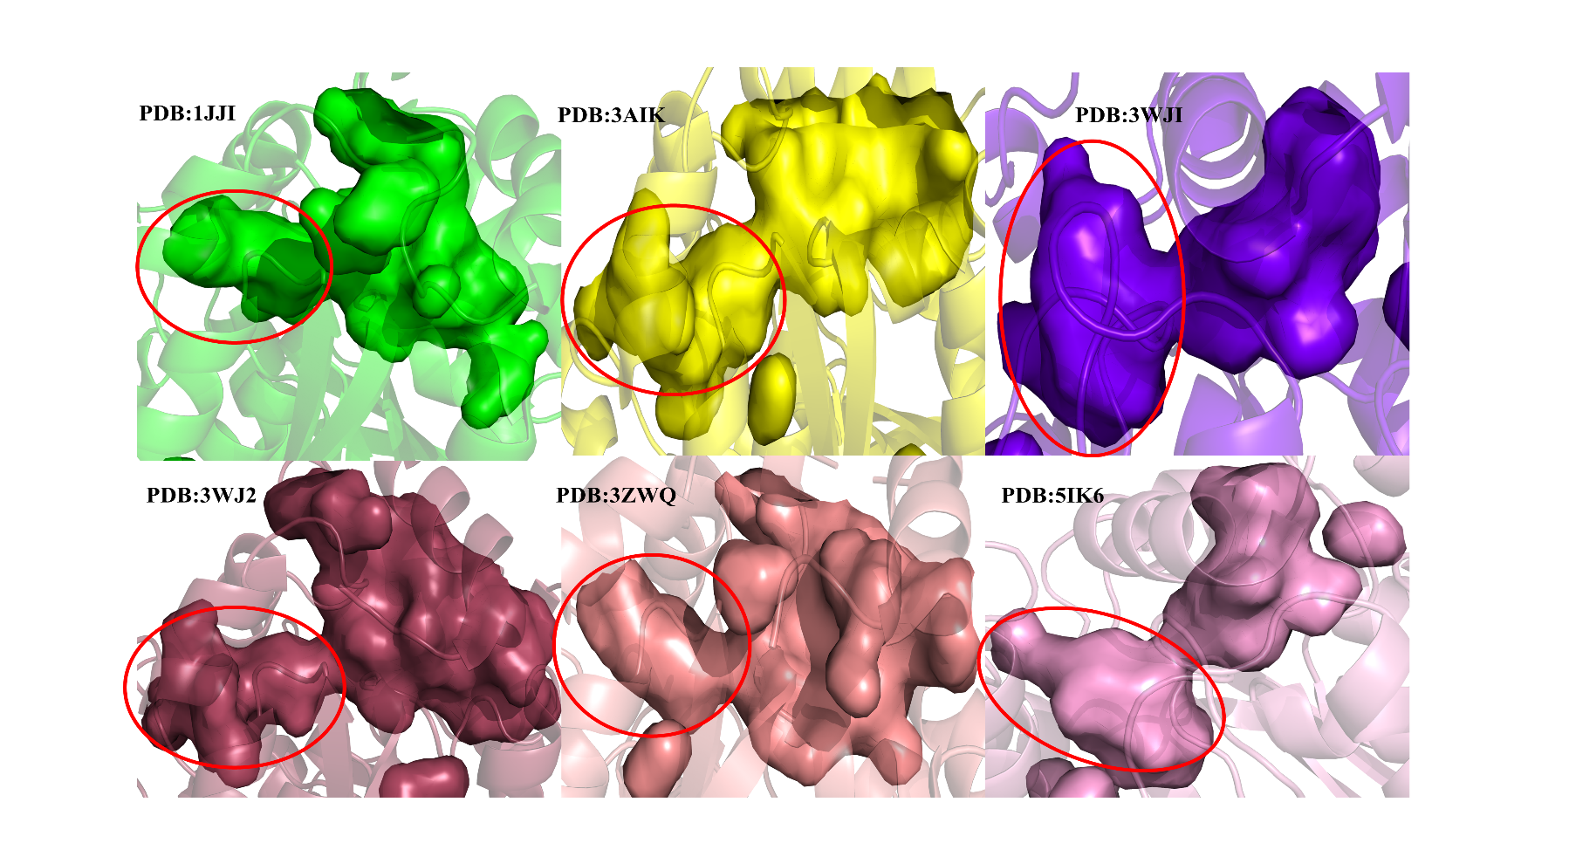
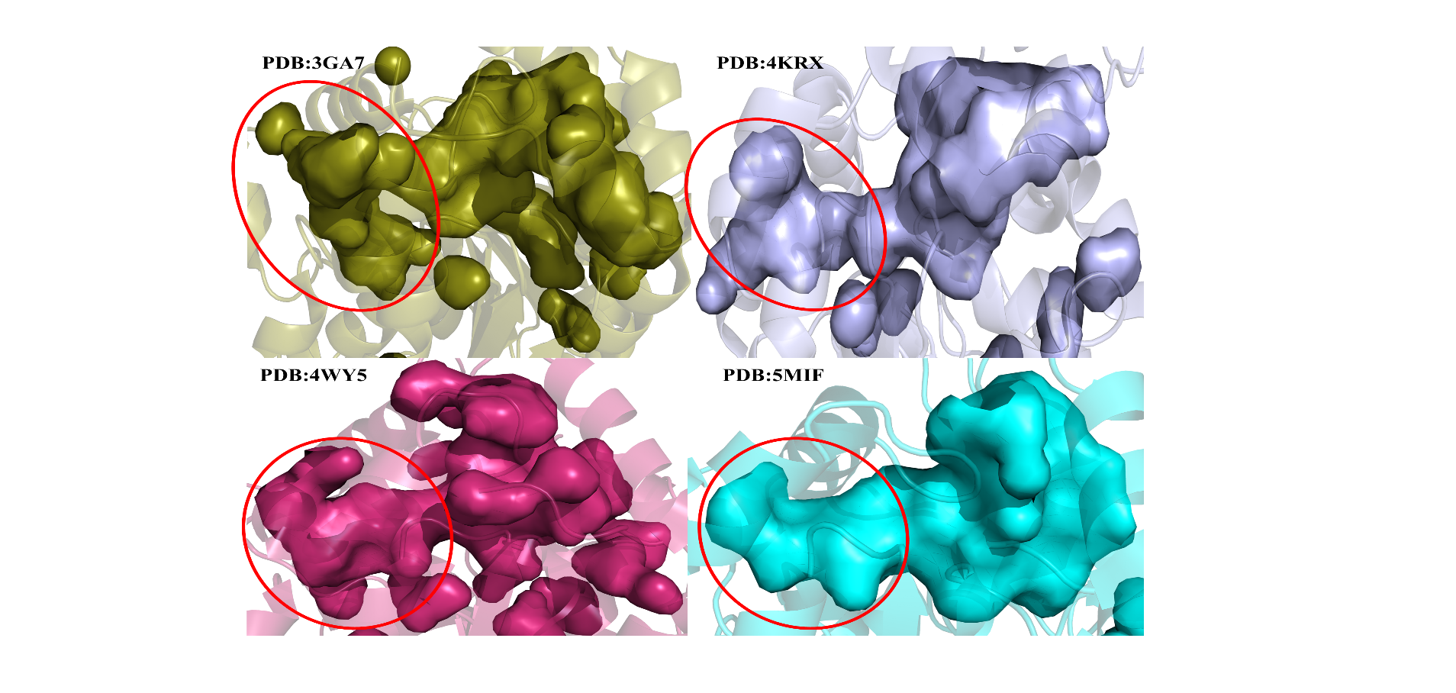

Figure S7. The microbial family IV esterases that contain the blind end area at the catalytic pocket were shown in cartoon. The blind end area was depicted by a red circle.

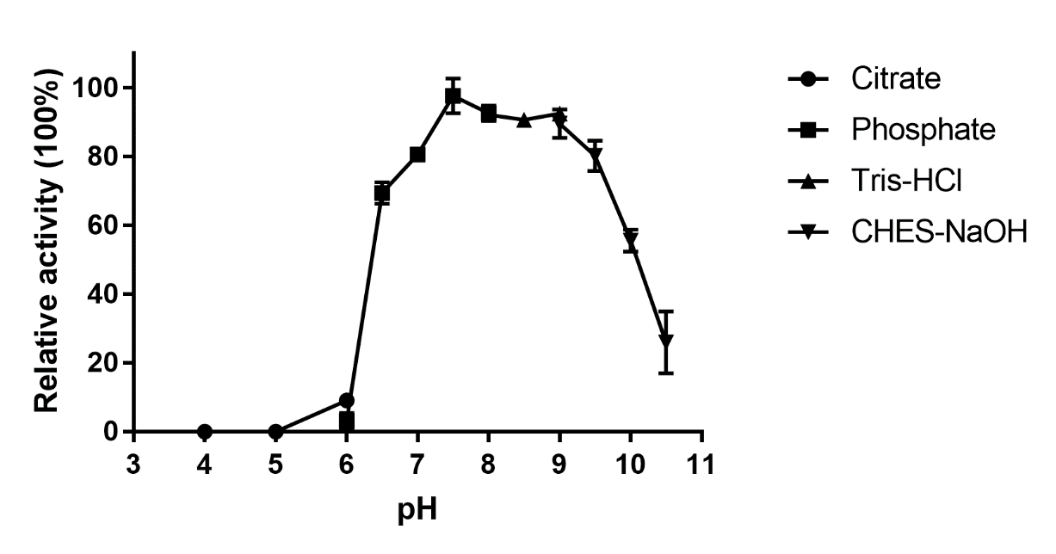
Figure S8. Effect of pH value on the activity of E53 N166A variant. The data are shown as mean ±SD (n=3). For some points, the error bars would be shorter than the height of the symbol.
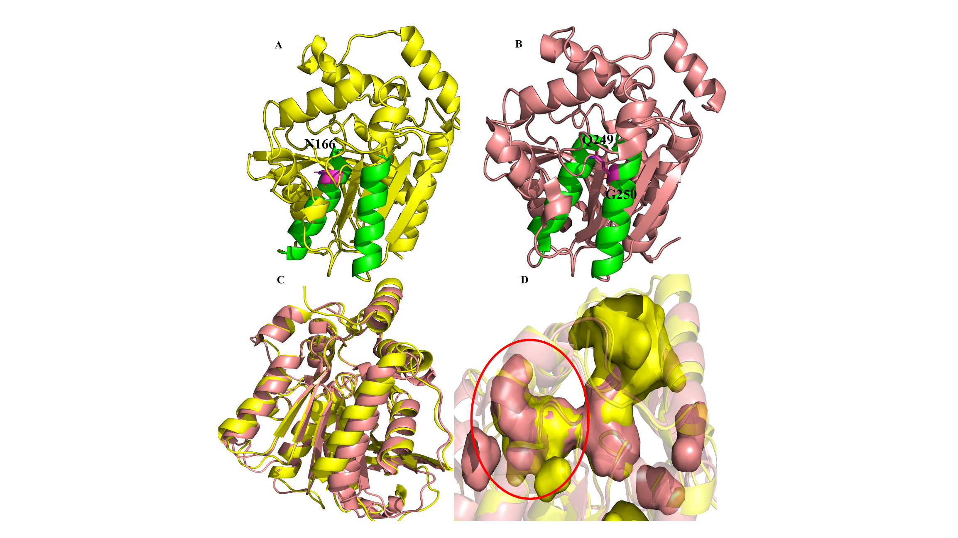
Figure S9. Structural comparison between E53 and SshEst. A, E53 was shown in cartoon with two α helices (α5 and α8) labelled with green color. The N166 located at the α5 helix was depicted with purple color. B, SshEst was shown in cartoon with two α helices (α5 and α8) labelled with green color. The Q249 and G250 resides located at the α8 helix were depicted with purple color. C, Structure superimposition of E53 (yellow) and SshEst (salmon). D, The catalytic pocket surfaces of E53 (yellow) and SshEst (salmon) were shown. Both enzymes contain the blind end area.

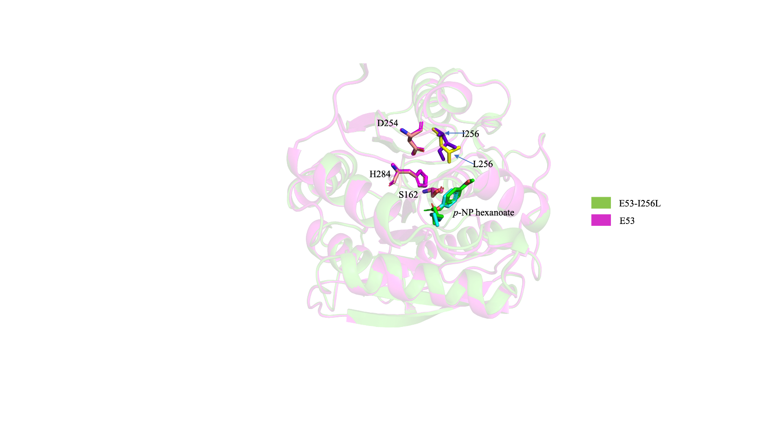

Figure S10. Structural comparison for E53 and its mutant I256L. The catalytic traid S162, D254 and H284 was shown in stick models

Figure S11. Kinetic curves of E53 WT and its variants in neutral and alkaline environments

Supplementary Tables

Table S1. The amino acid sequence alignment and the homology analysis of E53.
Name | PDB accession number | Identity | Origin | Microorganism
Est8 | 4YPV | 125/291 (43%) | Metagenome | -
Sto-Est | 3AIK | 99/286 (35%) | Sulfolobus tokodaii | Archaeon
AFEST | 1JJI | 94/279 (34%) | Archaeoglobus fulgidus | Archaeon
PestE | 2YH2 | 107/314 (34%) | Pyrobaculum calidifontis | Archaeon
Esta | 5LK6 | 97/267 (36%) | Sulfolobus islandicus REY15A | Archaeon
SshEstI | 3WJ1 | 98/286 (34%) | Sulfolobus shibatae DSM5389 | Archaeon
Lae6 | 5JD4 | 104/254 (41%) | Metagenome | -
ThaEst2349 | 4V2I | 99/303 (33%) | Thalassospira sp. GB04J01 | Bacterium
Este1 | 2C7B | 105/292 (36%) | Metagenome | -
Est2 | 1EVQ | 96/308 (31%) | Alicyclobacillus acidocaldarius | Bacterium
rPPE | 4OB8 | 96/319 (30%) | Pseudomonas putida ECU1011 | Bacterium
EstFa_R | 3WJ2 | 75/240 (31%) | Ferroplasma acidiphilum | Archaeon
Table S2. The microbial family IV esterases with crystal structures in the ESTHER database.
PDB ID | Resources | Organisms | R3-similiar region
1JJI | Archaeoglobus fulgidus | Archaeon | X
3AIK | Sulfolobus tokodaii | Archaeon | X
3WJ1 | Sulfolobus shibatae | Archaeon | X
3WJ2 | Ferroplasma acidiphilum | Archaeon | X
3ZWQ | Pyrobaculum calidifontis | Archaeon | X
5L2P | Saccharolobus solfataricus | Archaeon
5LK6 | Sulfolobus islandicus | Archaeon | X
1EVQ | Alicyclobacillus acidocaldarius | Bacterium
1JKM | Bacillus subtilis | Bacterium
1LZL | Rhodococcus sp. | Bacterium
2PBL | Silicibacter sp. | Bacterium
2QRU | Enterococcus faecalis | Bacterium
3D7R | Staphylococcus aureus | Bacterium
3GA7 | Salmonella typhimurium. | Bacterium | X
3H04 | Staphylococcus aureus | Bacterium
3HXK | Lactococcus lactis | Bacterium
3QH4 | Mycobacterium marinum | Bacterium
4C89 | Lactobacillus plantarum | Bacterium | X
4KRX | Escherichia coli | Bacterium | X
4N5H | Lactobacillus rhamnosis | Bacterium
4OB8 | Pseudomonas putida | Bacterium
4V2I | Thalassospira sp. | Bacterium
5AO9 | Thermogutta terrifontis | Bacterium
4WY5 | Rhizomucor miehei | Fungus | X
4WY8 | Rhizomucor miehei | Fungus
5MIF | Tuber melanosporum | Fungus | X
2C7B | Metagenomic Library | -
3DNM | Metagenome Library | -
3FAK | Metagenome Library | -
4J7A | Metagenome Library | -
4Q3K | Metagenome Library | -
4YPV | Metagenome Library | -
4ZRS | Metagenome Library | -
5GMS | Metagenome Library | -
5HC4 | Metagenome Library | -
5JD4 | Metagenome Library | - | X
5JD5 | Metagenome Library | -
6AAE | Metagenome Library | -

Table S3. Kinetic data of E53 and its mutants.
E53 and mutants | V_{max} (umol/min/mg) |  | K_{m} (mM)
 | pH7.0 | pH9.0 | pH7.0 | pH9.0
E53 | 1596±27 | 3347±88 | 0.35±0.03 | 0.33±0.03
E53-D161A | 37±1* | 47±2* | 0.24±0.01* | 0.88±0.11*
E53-N166A | 1540±46 | 1678±40* | 0.70±0.06* | 0.46±0.04*
E53-A167L | 4860±69* | 5238±73* | 0.24±0.01* | 0.15±0.01*
E53-F191Y | 3639±41* | 4381±103* | 0.23±0.01* | 0.21±0.02*
E53-V211A | 3359±93* | 4280±93* | 0.43±0.04 | 0.52±0.03*
E53-S216A | 3956±48* | 5832±162* | 0.40±0.02 | 0.42±0.03*
E53-I256L | 2285±44* | 2999±52* | 0.41±0.03 | 0.23±0.02*
E53-S285G | 531±8* | 613±20* | 0.58±0.03* | 0.44±0.05*
E53-N288A | 249±3* | 290±7* | 0.27±0.01* | 0.31±0.03
The data are shown as mean ±SD (n=3).
*: Representing a significant difference from the WT E53 (t test, p < 0.05).
Table S4. Primers for e53 gene amplification and mutants.
Primers | Sequences
E53-F | TCGCGGATCCATGACCGACACACCCTTC
E53-R | TCCGCTCGAGTCAGGCAGTCCCCAACATC
D161A-F | GGGCGTCATTCCCATCGGCGCCAGCGCAGGCG
D161A-R | GCGTGCCGCAGCCCGCAGTAAGGGTAGCCGCG
N166A-F | TCGGCGACAGCGCAGGCGGAGCTGCGACCATCG
N166A-R | GCAGTAAGGGTAGCCGCTGTCGCGTCCGCCTCG
A167L-F | AGCGCAGGCGGAAATCTGACCATCGTGGTGAGC
A167L-R | GCTCACCACGATGGTCAGATTTCCGCCTGCGCT
F191Y-F | CTGCAAGTCCCGATCTACCCGCTCGCAAGCGAT
F191Y-R | ATCGCTTGCGAGCGGGTAGATCGGGACTTGCAG
V211A-F | AGCCTTTGCCGAAGGCTTTGCCCTTACCAAAGC
V211A-R | CCGGTCAGAACTTCGGAAACGGCTTCCGAAACG
S216A-F | GCTTTGTCCTTACCAAAGCGGCGATCGAATTTTTTGA
S216A-R | TTCGGAAACGGCTTCCGAAACAGGAATGGTTTCGCC
D254A-F | GCCACCGCCAGCCTTGCTCCGATCCGCGATTCC
D254A-R | GGAATCGCGGATCGGAGCAAGGCTGGCGGTGGC
I256L-F | GCCAGCCTTGATCCGCTCCGCGATTCCGGGCGC
I256L-R | GCGCCCGGAATCGCGGAGCGGATCAAGGCTGGC
S285G-F | GAAGGGGTCACCCATGGTTTCACCAATATTCGC
S285G-R | GCGAATATTGGTGAAACCATGGGTGACCCCTTC
N288A-F | GGGTCACCCATTCTTTCACCGCTATTCGCGCCGC
N288A-R | AGCTTTACCTTCCCCAGTGGGTAAGAAAGTGGCG

