Supplementary Material/Appendix A1

1. **Methods, sample location, field work**

Raška is north from the big town of Novi Pazar (Serbia) and is also the place where the core-shed is located. A team of geologists from Euromax Resources Ltd. in Raska provided all selected drill-cores for our study. During the stay the drill site in the copper canyon ore zone was visited to get an idea of the various lithologies and then the main focus was put on the examination of the drill-cores from the core-shed. Two major types of porphyritic intrusions have been outlined and further on labeled as crowded porphyry (CP) and proper porphyry (PP). In total 50 samples have been taken, where 15 have been collected for the study of the intrusive events and the remaining 35 for the story of the fluid-fluid interaction and ore paragenesis. One important sample have been sent by Euromax Resources Ltd. to ETH Zurich to analyze the overlying volcanics and some other porphyritic intrusive events labeled as “syenite”, “granite” and “granodiorite”.

# 2 Petrographic microscope

For the study and determination of the rock type, minerals, texture, alteration and crystallinity 14 thin sections have been produced through cooperation with Bulgaria. Microscope was done on an Olympus BX60 polarizing microscope. Whole thin section photographs have been taken on a Canon EOSM 18 Mpxl with polarizer.

# Whole rock analysis

To get whole rock major and trace element data rock powder from ten samples was used to produce glass beads, which were later on analyzed by an Axios XRF spectrometer from PAN-analytical (2.4 Kw sequential) at the laboratories of the Swiss Federal Institute of Technology Zurich (ETH).

## U/Pb dating, zircon trace and Hf isotope measurements

Two CP (0727, 0723, 1361A), two PP (0831, 1361B, 1681), one “granite” (1677, 1259) and one sample of the overlying “volcanics” (17103, 1687) have been selected for U/Pb zircon dating. The drill-cores were cut and crushed with SelFrag technique with a 700 µm sieve. The < 700 µm fraction was further processed with a hand magnet and by gravimetric separation in methylene iodide to extract the zircons. Individual zircons were randomly handpicked under a binocular to obtain a large variety of zircon grain types, mounted on an epoxy pellet and polished to the middle of the grain to expose their interior. About 50 zircons per sample were used. Cathodoluminescence (CL) pictures were acquired at the Swiss Federal Institute of Technology of Zurich with a JEOL JSM-6390LA SEM working at 15 kV see Fig. 5.

All six samples display zircons with similar texture and size between 100 µm and 400 µm. Most of them show oscillatory zoning typical for magmatic type zircons and furthermore the core is often homogeneously zoned. Sector zoning is prominent in all samples. Inherited old cores are rare, however some of the zircons in all samples show zones of dark color between core and rim indicating change in growth rate, chemical or thermal conditions thus xenocrysts may be present. Melt inclusions are common and are mostly present as apatite.

Eu and Ce anomaly calculation:

Europium anomalies (Eu/Eu* = EuN /(Sm N × GdN )½ ) in zircons have been used as a redox indicator of the crystallizing magma and were inferred to be related to fertility regarding hydrothermal ore formation (e.g., Chelle-Michou et al., 2014; Dilles et al., 2015; Lee et al., 2017) and the Ce* anomaly yields an expression for Ce*: Ce∗ = [NdN)2/(SmN)] (Zhong et al., 2019).

In situ dating by Laser-Ablation Inductively Coupled Plasma-Mass Spectrometry (LA-ICP-MS) was done at ETH Zurich and performed on an Element XR ICP sector field MS connected to a 193 nm Resonetics ArF excimer laser system, whereas Hf isotopes were measured on a 193 nm GeoLas laser coupled to a Nu-500 instruments MC-IC-ICP-MS. The time resolved spectra of 206Pb/238U and 207Pb/235U were used to monitor the homogeneity of the ablated material. Changing ratios or fluctuations are interpreted as mixing of different age domains or isotopic disturbances (common lead, lead loss, partial dissolution or recrystallization) and were discarded. The same ablated material from the laser-spots for LA-ICP-MS dating was also used to measure the trace element budget.

Based on CL images to minimize the incorporation of xenocrystic cores 31 zircons from six samples were plucked out with a stainless-steel scalpel from the epoxy mount. To conduct high- precision U- Pb ages the zircons were annealed and chemically abraded (CA) following the modified procedure after Mattison (2005). Isotope Dilution-Thermal Ionization Mass Spectrometry (ID-TIMS) was performed at the Institute of Geochemistry and Petrology of ETH Zurich using procedures outlined in von Quadt et al. (2015).

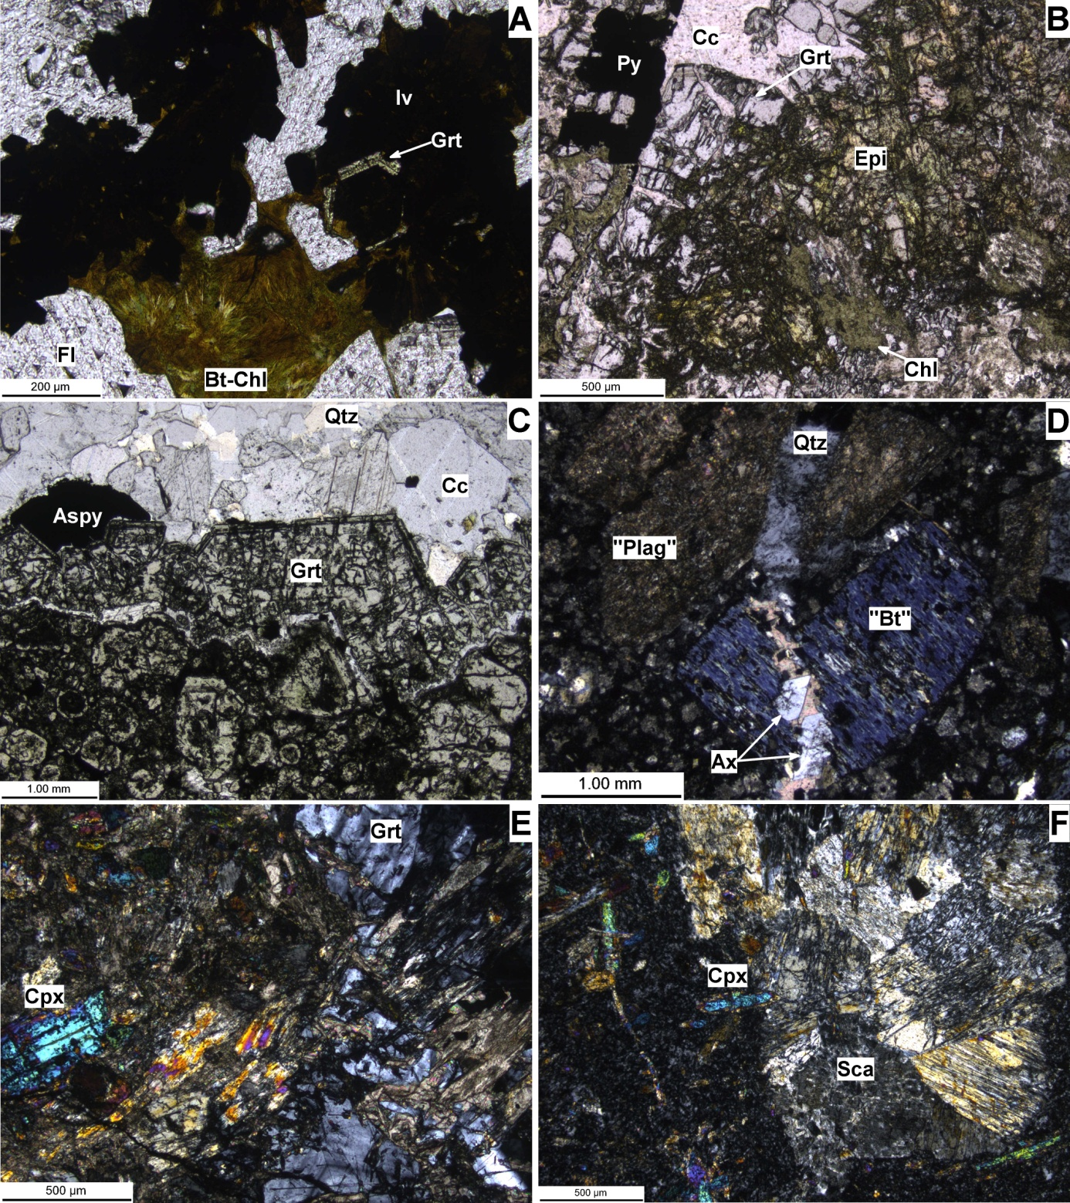

Supplementary Figure 1. A selection of hydrothermal alteration minerals in different rock types. A-E from EOKSC 1361A, F is from EOKSC 1673; A-C in plane polarised light, D-F under crossed polarisers. A: opaque ilvaite replacing the core of, and growing over, garnet. Fluorite and biotite-chlorite seem to be later phases (182m). B: garnet is fractured and appears to be partly replaced by grains of high-relief epidote and aggregates of chlorite. Later calcite brings little mineralisation of pyrite (167m). C: garnet mass that shows "atoll" textures in the bottom area was cut by a vein that lead to precipitation of euhedral garnet, arsenopyrite, quartz, calcite and a second generation of quartz, which is not well visible in this image (369m). D: relicts of magmatic biotite and plagioclase that have been altered to chlorite, and an assemblage of calcite, epidote and little sericite, respectively (51m). E: vein of fractured anisotropic garnet with calcite, that cuts through a bleached porphyry which contains clinopyroxene (435m). F: large scapolithe grains associated with clinopyroxene, precipitated in a bleaching vein through a porphyry (908m). Compare E and F also to Figure 5 E and F.

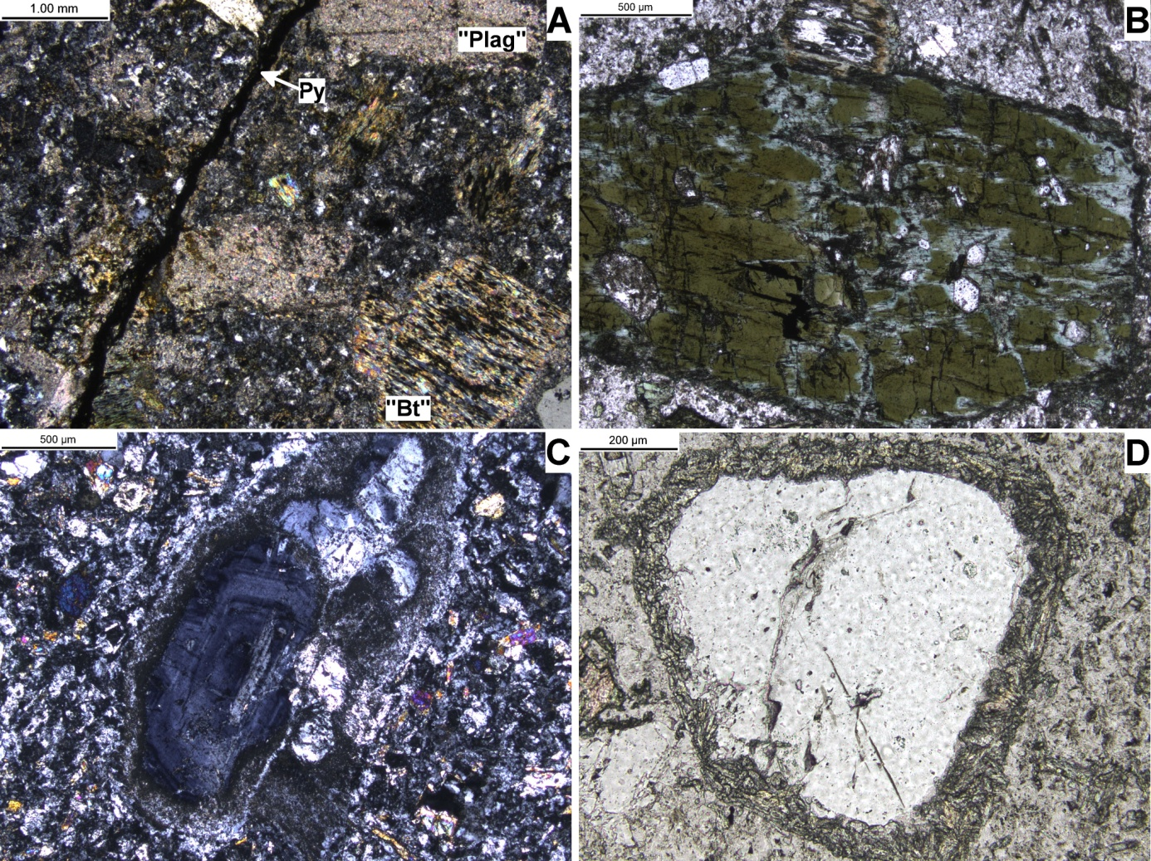

Appendix Figure 2: Further characteristics of hydrothermal overprint. B and D in plane polarised light, A and C under crossed polarisers. A: a thin vein of pyrite cuts a porphyry, leading to complete alteration of plagioclase to sericite and minor calcite near the vein. Biotite was originally altered to chlorite and later incompletely overprinted to sericite as well. (EOKSC 1673, 50m,). B: amphibole with loss of colour along fractures. Smaller grains in this sample (EOKSC 1680, 397m) are fully recrystallised to secondary, less intensely coloured amphiboles. C: bleached porphyry; magmatic feldspar shows zoning and complex twinning as well as a reaction/growth rim. Small, intermediate-birefringent grains in the matrix are clinopyroxenes (EOKSC 1673, 479m). D: magmatic quartz that exhibits a rim of clinopyroxene (same sample as C).