Figure S1. Pathways map associated with up-regulated circRNAs. Pathway analysis showed “Tight Junction" was the most affected pathway related to up-regulated circRNAs. Orange marked nodes were associated with up-regulated or only whole dataset genes.

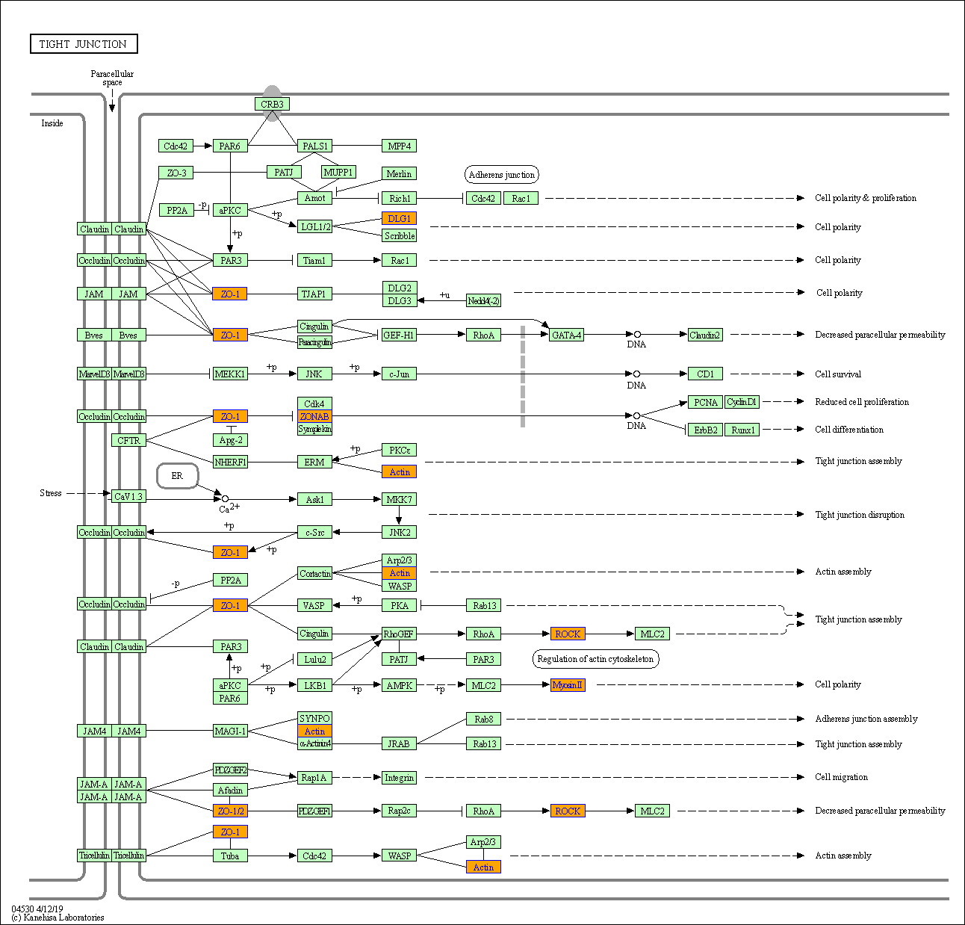

Figure S2. Pathways map associated with down-regulated circRNAs. Pathway analysis showed “Axon Guidance" was the most affected pathway related to down-regulated circRNAs. Yellow marked nodes were associated with down-regulated genes, green nodes have no significance.

