Supplementary Material

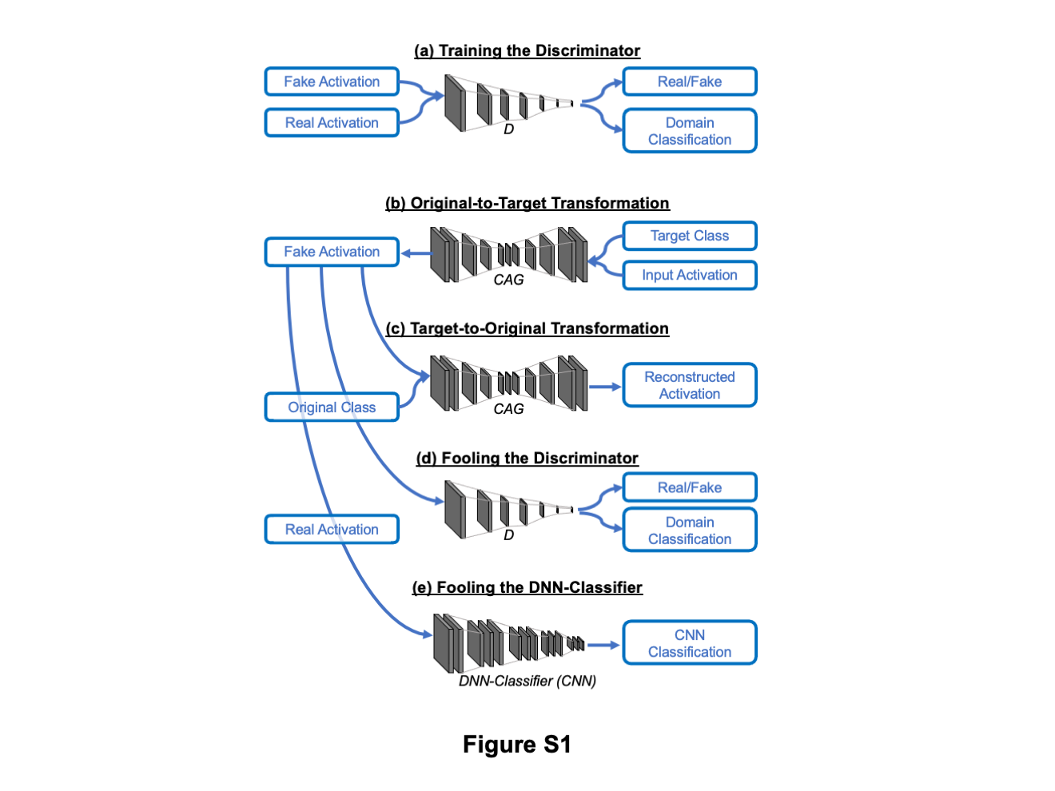
Supplementary Figures

Figure S1. Overall architecture of Discriminator/CAG training. We adapted the overall design of the StarGAN(Choi et al., 2018). The architecture includes two trainable modules, Discriminator (D) and CAG. Note that DNN-classifier is not trainable. (a) D learns to discriminate between real and fake activations and to classify the real activation to its corresponding domain. (b) CAG takes a real activation and a target domain label (i.e. target class) to generate a fake activation. (c) CAG tries to reconstruct the original activation from the fake activation and the domain label of the original activation. (d) CAG tries to generate a fake activation that is indistinguishable from real activations and classifiable as target domain by D. We also added a process “Fooling the DNN-Classifier” (e) to force CAG to generate a fake activation that is classifiable as target domain by the DNN-classifier.

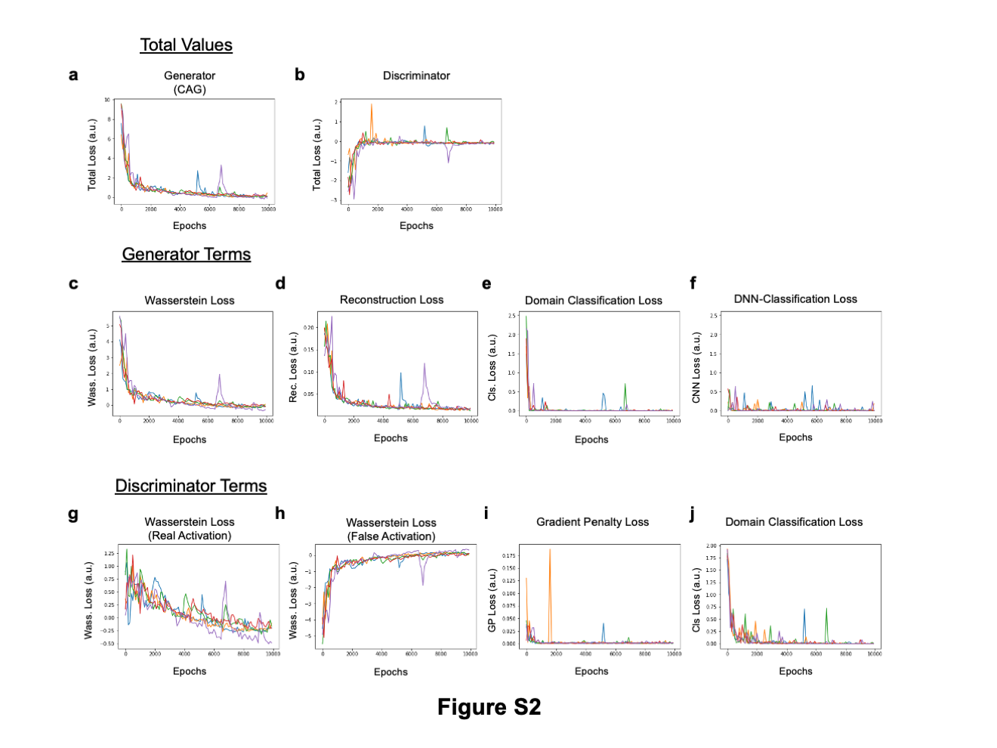

Figure S2 Time courses of key terms related to the Discriminator/CAG training. a) Total Generator Loss for CAG (same as Fig.3b). b) Total Discriminator Loss for Discriminator. c-f) Decomposed Generator Loss. g-j) Decomposed Discriminator Loss. Five independent replicates are shown in different colors.

Figure S3 Representative counterfactual activations generated by CAG (related to Fig. 3c). All counterfactual activations were generated from the source activation.

Figure S4. Additional example of counterfactual explanation of correct classification. Same convention as in Fig.4(b)-(e). In this case, we asked why brain activations were (correctly) classified as WM but not LANGUAGE.

Figure S5. Additional example of counterfactual explanation of incorrect classification. Same convention as in Fig.5(b)-(e). In this case, we asked why brain activations were (incorrectly) classified as GAMBLING but not WM.

Figure S6. Another example of texture-like feature extracted by counterfactual exaggeration (related to Fig. 6f). Top, texture-like feature extracted by counterfactual exaggeration. Middle, randomly chosen raw brain activations. Bottom, texture-like patterns added to the raw brain activation shown in the middle.

Supplementary Table

 |  | Output Class
 |  | EMOTION | GAMBLING | LANGUAGE | MOTOR | RELATIONAL | SOCIAL | WM
Input Class | EMOTION | 0.986 | 0 | 0 | 0 | 0 | 0.014 | 0
 | GAMBLING | 0 | 0.877 | 0 | 0 | 0.068 | 0.055 | 0
 | LANGUAGE | 0 | 0 | 0.986 | 0 | 0 | 0.014 | 0
 | MOTOR | 0 | 0 | 0 | 1 | 0 | 0 | 0
 | RELATIONAL | 0 | 0.095 | 0 | 0.027 | 0.851 | 0.014 | 0.014
 | SOCIAL | 0.014 | 0.027 | 0 | 0 | 0.027 | 0.932 | 0
 | WM | 0 | 0.107 | 0 | 0.027 | 0.04 | 0 | 0.827
Table S1. Profile of the DNN classifier (Confusion Matrix) Same as Fig.2d but exact numbers for proportion correct are shown)

