Supplementary Material for **Water and Rock Chemistry Inform our Understanding of the Deep Biosphere: Case Study in an Archaean Banded Iron Formation**

Christopher J. Schuler, Lindsey J. Briscoe, Scott C. Alexander, E. Calvin Alexander Jr., Jeffrey A. Gralnick, Cara M. Santelli, Brandy M. Toner

Corresponding author: Brandy M. Toner

Email: [toner@umn.edu](mailto:toner@umn.edu)

# Supplementary Figures

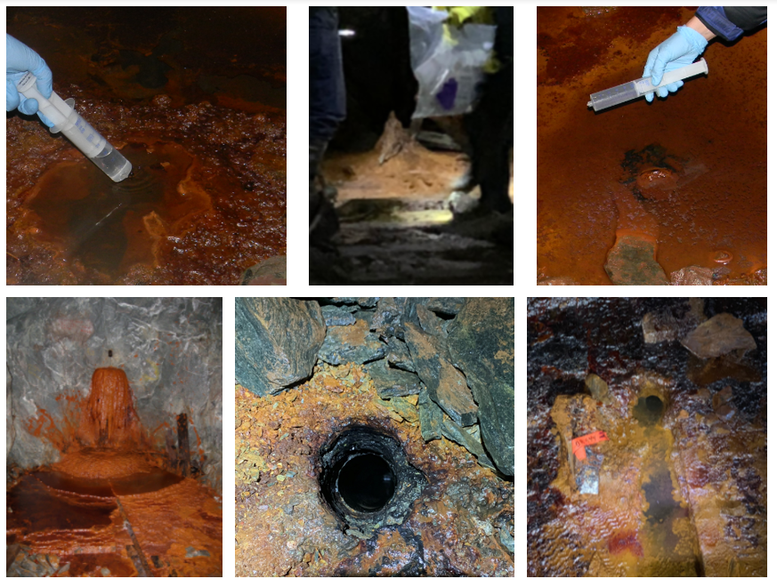**Supplementary Figure 1.** Photos of boreholes. Clockwise from upper left: DDH 932 (West drift, downward), DDH 933 (East drift, downward), DDH 942 (West drift, downward), DDH 944 (West drift, downward), DDH 951 (West drift, downward), and DDH 962 (East drift, horizontal).

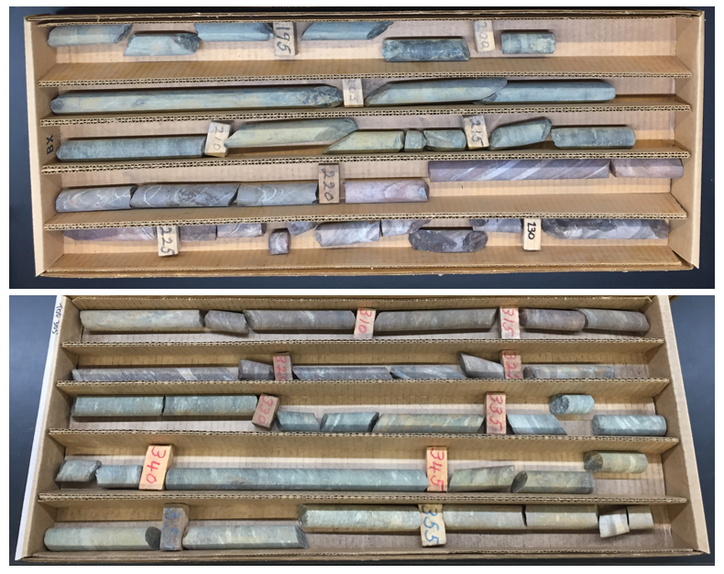

**Supplementary Figure 2.** Photos of skeletonized & archived Soudan core. Core pictured is from DDH 942 (top) and DDH 951 (bottom).

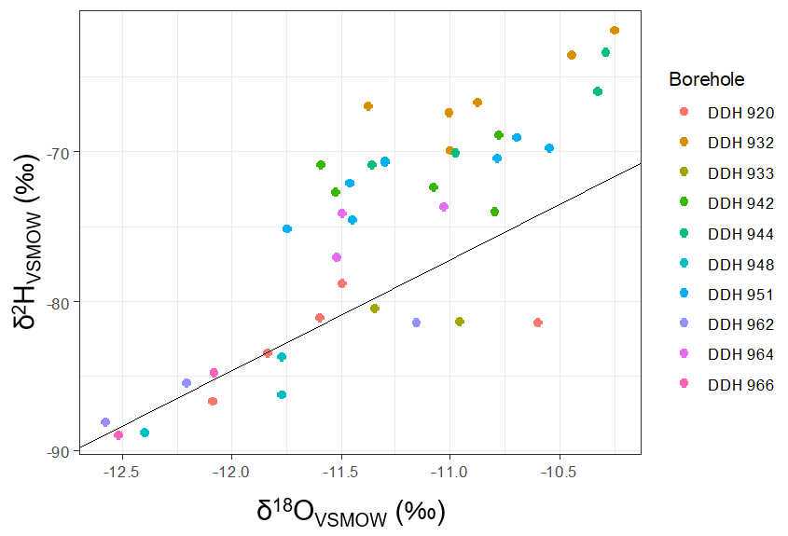

**Supplementary Figure 3.** Deviation of Hydrogen and Oxygen isotopes of Soudan borehole water samples relative to VSMOW. The black line shows local meteoric water regression calculated from Ely, MN, USA precipitation sampled between April - November, 1996.

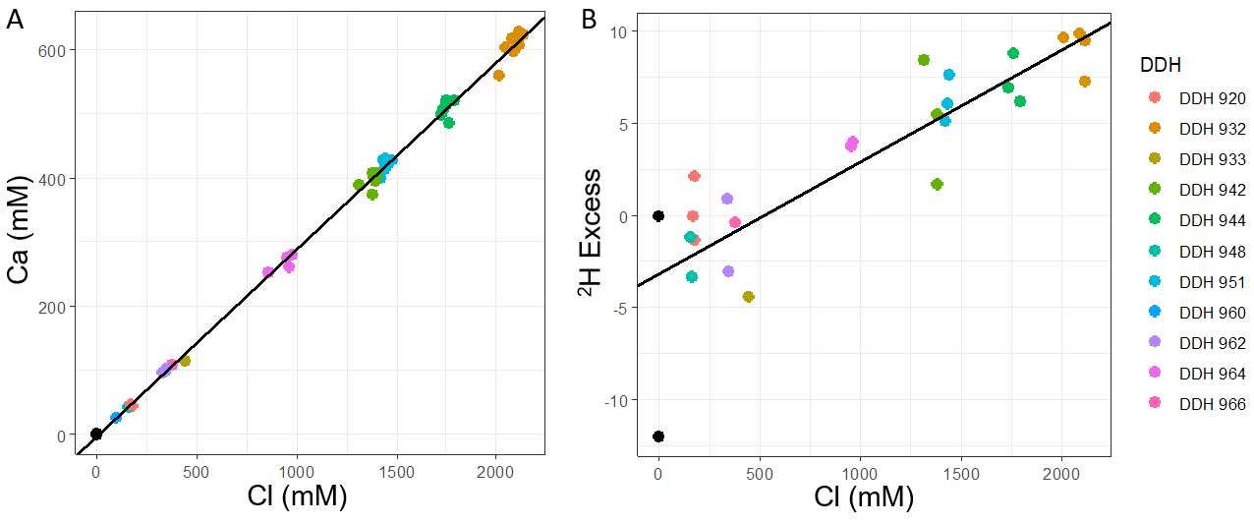

**Supplementary Figure 4.** Diagrams showing mixing in Soudan aquifers. (a) Ca2+ concentrations versus Cl- concentrations in Soudan borehole water, with the black line indicating a regression based on these values (R2 = 0.9979). Black points are surface water samples taken from a spring in the town of Soudan, MN and from the nearby Lake Vermillion. (b) Deuterium excess, as compared to Ely, MN precipitation, versus Cl- concentrations in Soudan borehole water, with the black line indicating a regression based on these values (R2 = 0.7473). Black points indicate deuterium excess of Lake Vermillion surface water sample (below the regression line) and an average of Ely, MN precipitation deuterium excess.

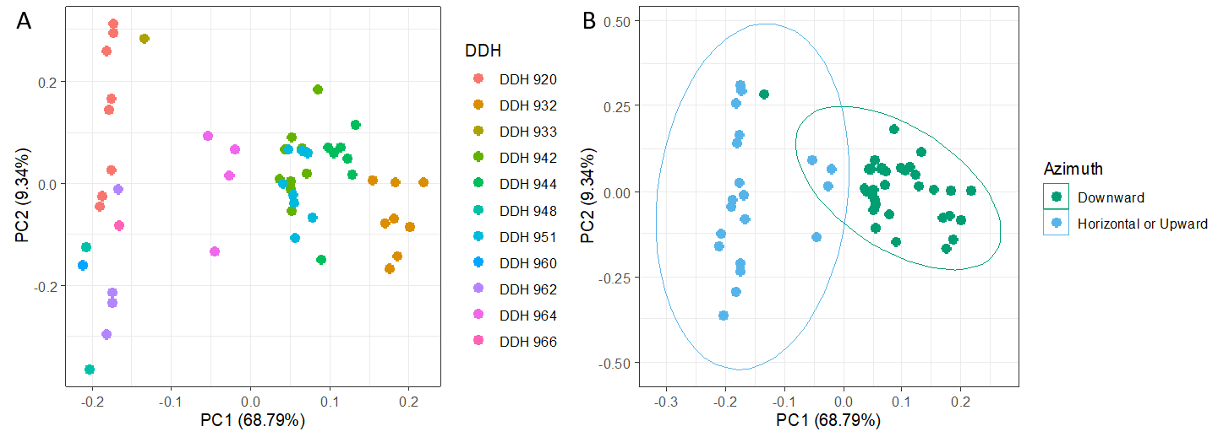

**Supplementary Figure 5.** Principal Component Analysis (PCA) of Soudan borehole waters based on geochemistry data. PCA was conducted in R using the prcomp() command and plotted using the ggfortify package. (a) PCA of Soudan data with points grouped by borehole. (b) PCA of Soudan data with points grouped by azimuth of borehole in relation to mine floor.

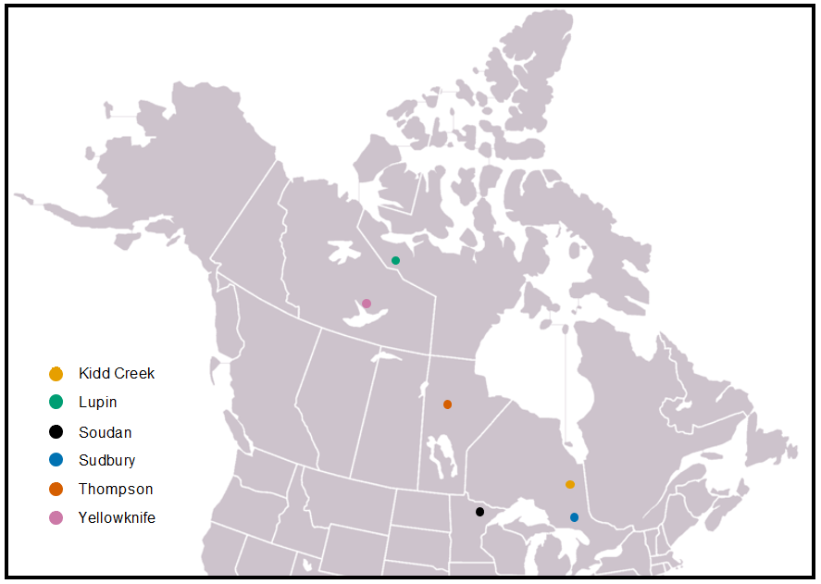

**Supplementary Figure 6.** Location of the Soudan Underground Mine State Park and the other Canadian Shield sites used as comparison points.

# Supplementary Tables

**Supplementary Table 1.** Full geochemical dataset. Included as separate file.

|  |  |  |  |  |
| --- | --- | --- | --- | --- |
| **ID** | **Borehole** | **Date** | **3H Concentration (TU)** | **Standard Deviation (TU)** |
| 13758 | DDH 920 | 1/20/2011 | < 0.8 | 0.8 |
| 13759 | DDH 932 | 1/20/2011 | Unable to measure | Unable to measure |
| 13760 | DDH 942 | 11/30/2011 | < 0.8 | 0.76 |

**Supplementary Table 2.** Tritium data. Concentrations are given in Tritium Units. Due to the high salinity of the DDH 932 fluids, the conductivity of sample 13759 could not be brought low enough for measurement.