# Supplementary information

## Supplementary methods

### Calculation CH4 oxidation rates

To determine CH4 percentages in the headspace, measurements on the GC were converted using a standard curve. During every sampling, 1 ml of headspace and 1 ml of medium were removed, which affected later samplings and GC measurements, which we accounted for as follows.

First, we calculated the pressure in the incubation bottle after every measurement, based on the amount of air removed and the total headspace volume. For example, after the first sampling, 1 ml of air was removed, leading to a total amount of 59 ml air in the bottle. Furthermore, 1 ml of water was removed, leading to a headspace volume of 61 ml. The pressure therefore became 59 ml air /61 ml headspace = 0.967 atm.

Second, later samplings of the headspace would sample a lower volume of the original headspace because of the lower pressure. In the second measurement, the amount of air sampled would be 0.967 atm * 1 ml sampled = 0.967 ml of the original headspace. We accounted for that both in the GC measurements and in the calculations of pressure in the incubations in later samplings. Using these modifications, we determined CH4 percentages at every time point, as shown in figure S4. After quality control, nine measurements (of total 300) were removed because of suspected blockage of the GC (i.e., they were much lower than the measurement the day before and the day after).

Because the growth became very fast in day 4 of microcosms from the eutrophic lakes and day 5 of the microcosms of the oligotrophic lake, we did not have enough measurements to fit linear models to estimate the slope of decrease of CH4. Instead, we fitted nonlinear least-squares (NLS) regressions using the *nls* function to determine CH4 oxidation rates during exponential growth. All of these regressions had a pseudo-R2 >0.87, as calculated by the *modelR* function (table S6). We used the NLS models to determine the CH4 oxidation rate between the third and the fourth day (day 3.5) for the eutrophic lakes (Manacás and Funil) and between the fourth and the fifth day (day 4.5) of the oligotrophic lake (CDU), when exponential growth occurred. This yielded a decrease in CH4 percentage per hour. CH4 percentage was converted into mols CH4 according to Henry’s law.

Last, we divided the decrease in CH4 per day by the amount of medium still left in the bottle. Therefore, in day four (eutrophic lakes) we divided by 57 ml and in day five (oligtrophic lake) we divided by 56 ml, yielding a CH4 oxidation rate per day per ml medium. We assumed that the medium was homogeneous, and therefore removing 1 ml of medium, if there was 60 ml left, would remove 1/60th of the MOB community and thus 1/60th of all the MOB cells present in the medium.

As a cross-check to our calculation, we also determined CH4 oxidation rates based on the total decrease in CH4 during the day with the highest growth rates (figure S5A). Here, the total decrease in mols CH4 was divided by the amount of ml left in the medium and by the time in days, also yielding a rate in mols CH4 day-1 L-1, which showed similar patterns to the rates as calculated by the NLS models (figure 2). Finally, we determined the amount of CH4 left after the day with the highest growth rates (figure S5B) in relation to PO43- concentrations, which showed a similar pattern to the CH4 oxidation rates.

## Supplementary tables

**Table S1: Lake Characteristics**

|  |  |  |  |  |  |  |  |
| --- | --- | --- | --- | --- | --- | --- | --- |
| Lake | Location (dd) | Area (ha) | Max. depth (m) | Altitude (m) | trophic state | Locality | Reference |
| Manacás | -21.778991,  -43.368984 | 2 | 5 | 841 | Eutrophic | Busy road, small stand of trees | Lawall, Sarah;, Fillipe; Tamiozzo Pereira Torres, and Geraldo César Rocha. (2005) |
| Funil | -22.525431,  -44.550312 | 4000 | 70 | 466 | Eutrophic | Urban areas, Paraíba do Sul river coming from industrial area Sao Paulo - Rio de Janeiro | Pacheco, F. S. et al. (2015) |
| UFJF botanical garden | -21.732067,  -43.370562 | 1.5 | 2 | 702 | Mesotrophic | Forest, close to city | Nunes et al., 2021 |
| Chapeu D'Uvas | -21.587142,  -43.552231 | 7000-10600 | 41 | 734 | Oligotrophic | Grassland (66%), natural forest (30%), and Eucalyptus plantation (4%) | Almeida, Rafael M. Et al. (2019) |

**Table S2: qPCR programs**

|  |  |  |  |  |  |
| --- | --- | --- | --- | --- | --- |
| MOB type | Forward primer | Reverse primer | PCR protocol | Data acquisition | Most common genera |
| Ia | A189F | 601R | 95°C 10s, 54°C 10s, 72°C 25s, 40 cycles | 82°C | *Methylobacter*, *Methylomonas* |
| Ib | A189F | 468R | 95°C 10s, 64°C 10s, 72°C 25s, 40 cycles | 82°C | *Methylocaldum*, *Methylococcus* |
| II | II223F | II646R | 95°C 10s, 64°C 10s, 72°C 25s, 40 cycles | 82°C | *Methylosinus*, *Methylocella*, *Methylocystis* |

**Table S3: Model selection for methane oxidation during exponential growth sorted by AIC value in increasing order**

|  |  |  |  |  |  |
| --- | --- | --- | --- | --- | --- |
| **Model** | **AIC** | **Terms** | **Estimate** | | **Test statistic** |
| **Nonlinear least square regression** | 72.46 | Asym | 3.476 | *** | 9.96 |
|  | Xmid | 5.104 | * | 2.60 |
| **Segmented linear regression** | 75.15 | y0 | 0.307 |  | 0.77 |
|  |  | β1 | 0.255 | * | 2.23 |
|  |  | β2 | 0.018 |  | 0.17 |
| **Linear regression** | 83.57 | y0 | 1.295 | *** | 5.37 |
|  |  | β | 0.044 | *** | 4.84 |

**Table S4: Model selection for log-transformed bacterial P content sorted by AIC value in increasing order**

|  |  |  |  |  |  |
| --- | --- | --- | --- | --- | --- |
| **Model** | **AIC** | **Terms** | **Estimate** | | **Test statistic** |
| **Linear regression** | 49.89 | y0  β | -11.821  0.021 | ***  *** | -85.94  3.96 |
| **Segmented linear regression** | 49.89 | y0  β1 | -11.821  0.021 | ***  *** | -85.94  3.96 |
| * **No breakpoint calculated** |  | β2 | NA |  | NA |
| **Nonlinear least square regression** | 57.07 | Asym | -11.234 | *** | -85.67 |
|  |  | Xmid | -0.060 | * | -2.63 |

**Table S5: Relative abundances of different types of MOB and relationship to other variables, including posthoc groups for lakes based on Emmeans function**

|  |  |  |  |  |  |  |  |  |
| --- | --- | --- | --- | --- | --- | --- | --- | --- |
|  |  | Linear Model | | | | Posthoc groups per lake | | |
| MOB type | Trans | Variables | t-value | p-value | | Manacás | Funil | CDU |
| Ia | Logit | Intercept | 1.94 | 0.066 | ns | A  95%CI:  66%  -  95% | AB  95%CI:  25%  -  78% | B  95%CI:  8.9%  -  59% |
| NO3- | 0.76 | 0.455 | ns |
| PO43- | 0.14 | 0.888 | ns |
| Lake-CDU | -3.25 | 0.004 | ** |
| Lake-Funil | -2.16 | 0.043 | * |
| Ib | Log | Intercept | -7.05 | 5.82E-07 | *** | A  95%CI:  0.60%  -  3.02% | B  95%CI:  0.11%  -  0.60% | A  95%CI:  0.56%  -  3.92% |
| NO3- | -2.08 | 0.050 | * |
| PO43- | 0.19 | 0.854 | ns |
| Lake-CDU | 0.16 | 0.874 | ns |
| Lake-Funil | -2.93 | 0.008 | ** |
| II | Logit | Intercept | -2.29 | 0.032 | * | B  95%CI:  4.1%  -  28% | AB  95%CI:  22%  -  74% | A  95%CI:  34%  -  88% |
| NO3- | -0.76 | 0.455 | ns |
| PO43- | -0.34 | 0.736 | ns |
| Lake-CDU | 3.26 | 0.004 | ** |
| Lake-Funil | 2.52 | 0.020 | * |

**Table S6: Statistics of non-linear regressions used to calculate CH4 oxidation rates, pseudo-R2 as calculated by the *modelr* package.**

|  |  |  |  |  |  |  |
| --- | --- | --- | --- | --- | --- | --- |
| Lake | [NO3-] | [PO43-] | CH4 oxidation rate (CH4 d-1 L-1) | Asymptote | Xmid | pseudo-R2 |
| Manacás | 150 | 1 | 0.407913 | 10.46 | 150.94 | 0.94 |
| 150 | 5 | 2.250179 | 9.03 | 88.33 | 0.98 |
| 150 | 10 | 2.587952 | 10.25 | 91.39 | 0.97 |
| 150 | 30 | 2.107212 | 10.22 | 86.49 | 0.99 |
| 150 | 50 | 3.306331 | 9.91 | 89.73 | 1 |
| 600 | 1 | 0.947486 | 10.19 | 111.22 | 0.98 |
| 600 | 5 | 2.238282 | 9.92 | 95.88 | 1 |
| 600 | 10 | 3.787353 | 9.7 | 90.83 | 1 |
| 600 | 30 | 3.392644 | 9.83 | 92.03 | 1 |
| 600 | 50 | 4.757363 | 9.75 | 83.37 | 1 |
| CDU | 150 | 1 | 0.436408 | 11.54 | 170.1 | 0.94 |
| 150 | 5 | 1.270943 | 10.75 | 119.34 | 0.89 |
| 150 | 10 | 1.098257 | 11.32 | 121.25 | 0.97 |
| 150 | 30 | 2.108897 | 10.98 | 109.38 | 1 |
| 150 | 50 | 3.410855 | 10.85 | 114.06 | 0.99 |
| 600 | 1 | 0.405889 | 11.37 | 183.14 | 0.87 |
| 600 | 5 | 1.395775 | 8.88 | 118.56 | 0.94 |
| 600 | 10 | 4.128394 | 10.66 | 108.2 | 1 |
| 600 | 30 | 3.52838 | 10.91 | 102.79 | 1 |
| 600 | 50 | 2.31567 | 10.75 | 119.65 | 1 |
| Funil | 150 | 1 | 0.976776 | 11.76 | 88.61 | 0.96 |
| 150 | 5 | 1.042282 | 10.5 | 109.23 | 0.98 |
| 150 | 10 | 2.0395 | 10.25 | 94.47 | 1 |
| 150 | 30 | 2.472669 | 10.6 | 91.63 | 0.99 |
| 150 | 50 | 2.291388 | 10.94 | 85.61 | 0.99 |
| 600 | 1 | 0.198831 | 9.02 | 160.77 | 0.87 |
| 600 | 5 | 1.306392 | 10.29 | 104.82 | 0.99 |
| 600 | 10 | 1.569513 | 9.72 | 100.59 | 1 |
| 600 | 30 | 2.974609 | 9.78 | 84.64 | 0.99 |
| 600 | 50 | 3.439083 | 10.66 | 90.67 | 1 |

## Supplementary figures

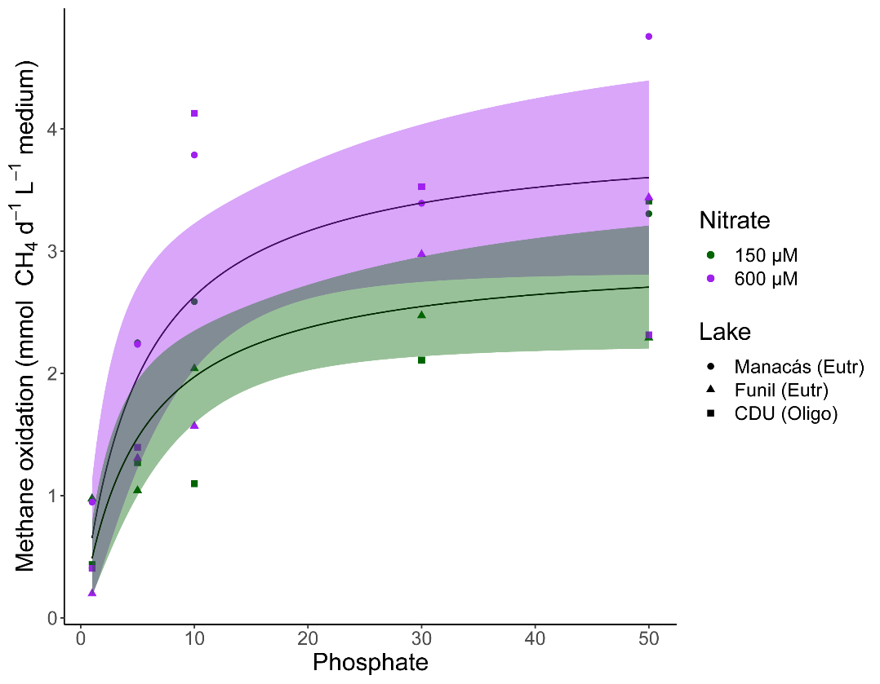

**Figure S1**: CH4 oxidation per day per ml of medium at different [PO43-] and [NO3-] during exponential growth phase of MOB from Manacás lake, Funil lake, and CDU lake. Fitted line according to non-linear least-squares regression, shading shows 95% confidence interval at 150 µM and 600 µM NO3-. Individual measurements shown, colours show [NO3-] treatments, shapes correspond to the lake of origin, n=30.

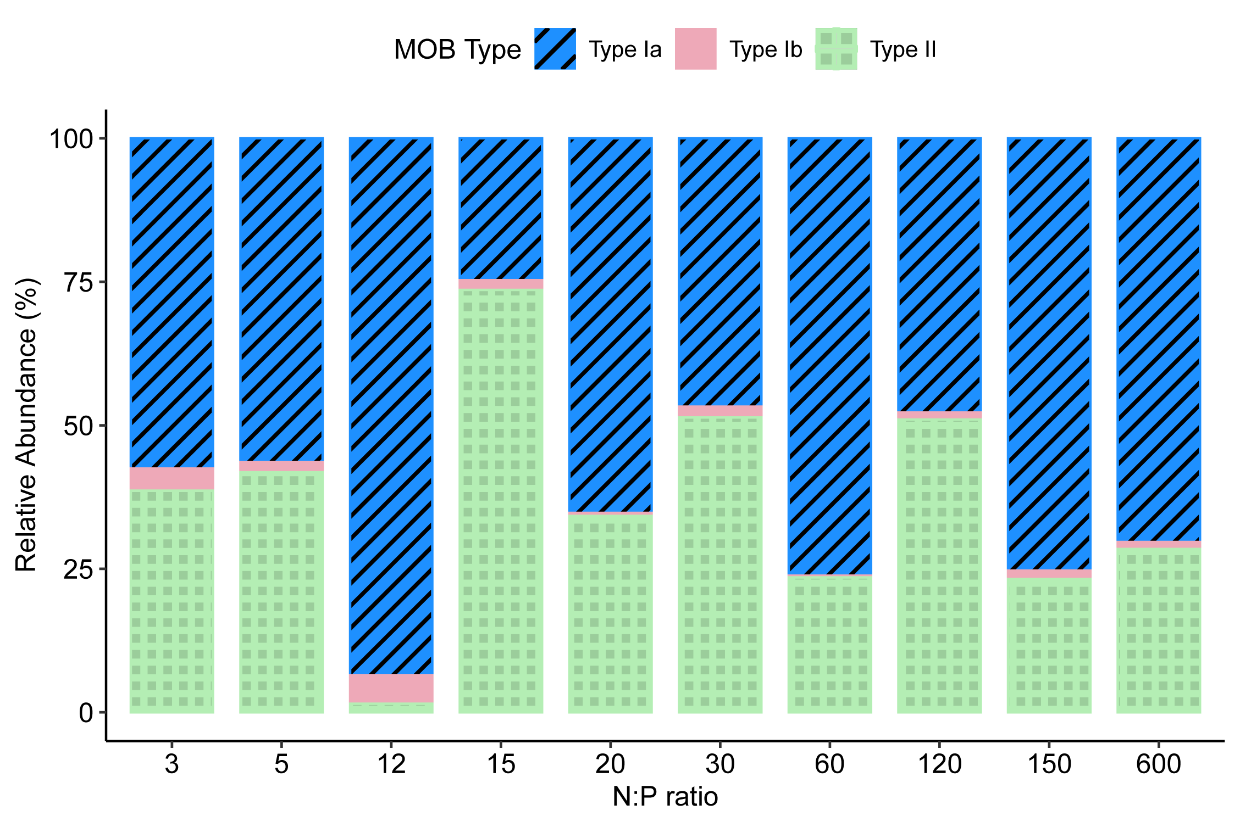

**Figure S2**: proportional abundance of different types of MOB per N:P ratio based on qPCR copy number of the *pmoA* gene at the end of microcosm incubations. Different colours represent different types of MOB, n=26.

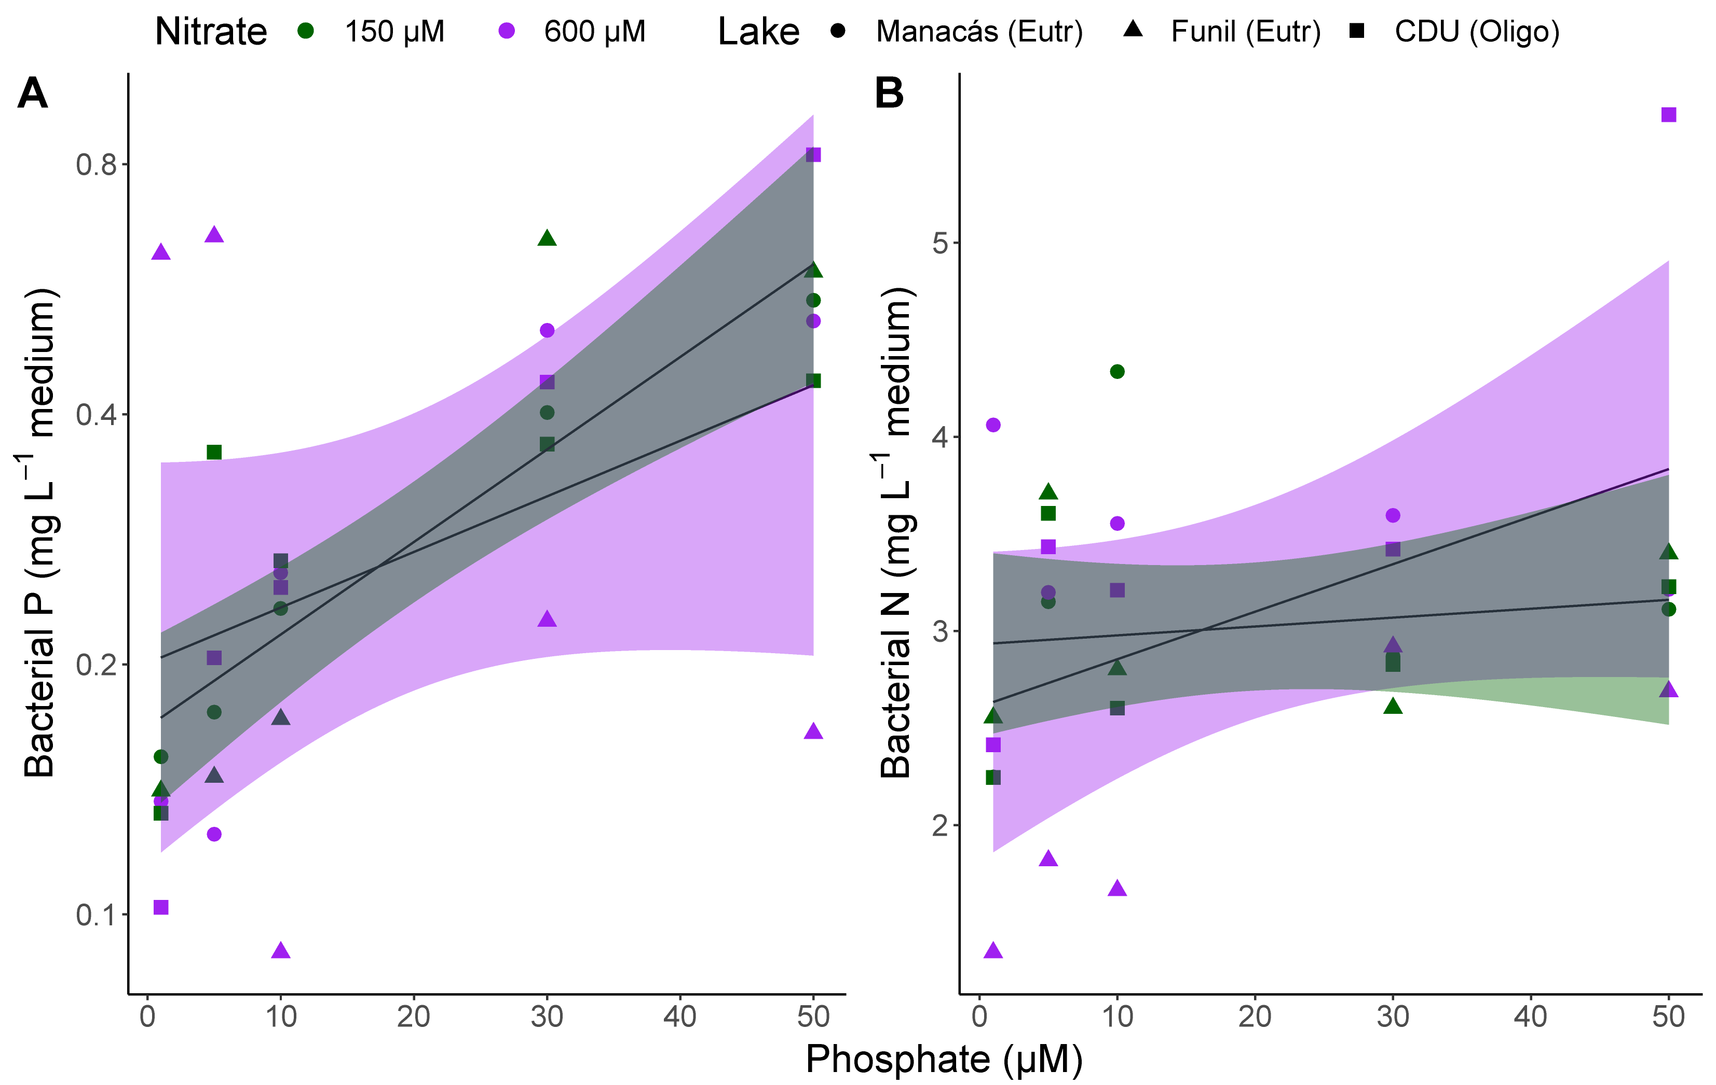

**Figure S3**: Bacterial P (log-transformed, A) and bacterial N (B) content per litre of medium at the end of the microcosm incubations. Fitted line according to linear regression, shading shows 95% confidence interval at 150 µM and 600 µM NO3-. Individual measurements are shown, colours represent [NO3-] treatments, shapes represent lake of origin, n=30.

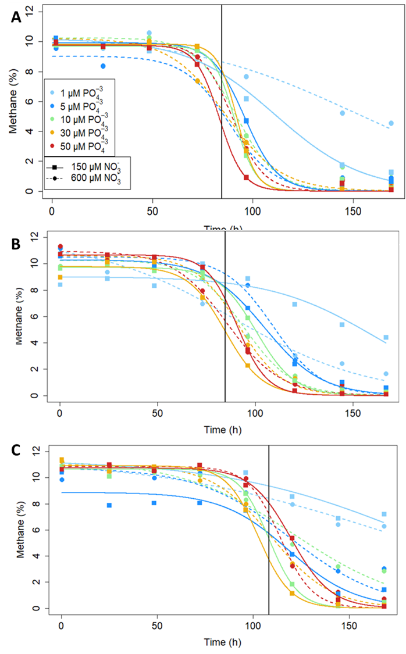

**Figure S4**: Decrease in CH4 concentration in the microcosm incubations in Manacás Lake (**A**), CDU Lake (**B**) and Funil Lake (**C**)during 7 days of incubating at 20°C. Colors represent PO43- concentrations, solid lines and squared represent 150 µM NO3-, dotted lines and circles 600 µM NO3-. The black line represents 3.5 days for the Manacás and Funil Lakes, and 4.5 days for the CDU Lake, during which time CH4 oxidation rates were determined according the non-linear least squares regressions.

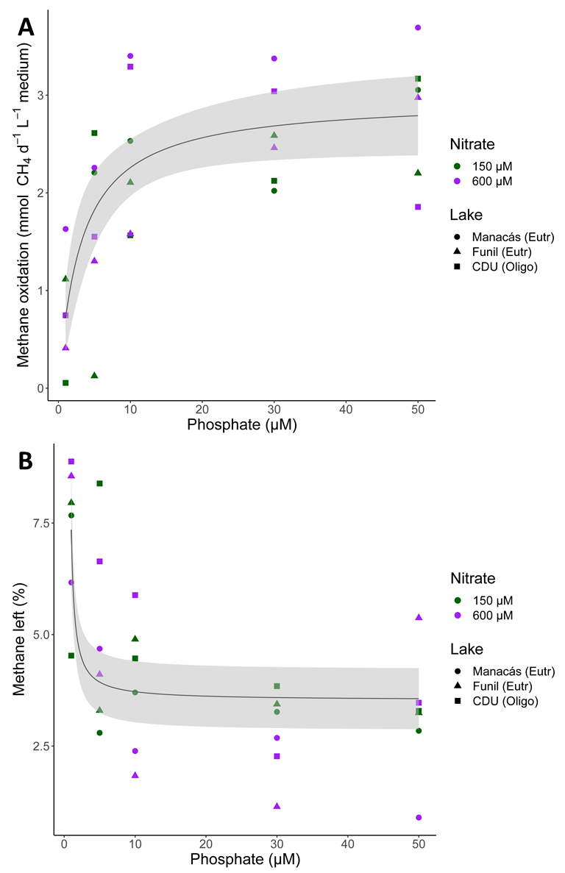

**Figure S5**: CH4 oxidation rates (**A**) as calculated from the total decrease in CH4 in day 4 for the eutrophic lakes and day 5 for the oligotrophic lake, and CH4 percentage (**B**) after the day with the highest growth rates. Fitted lines according to nonlinear least-squares regression, shading represents 95% confidence interval. Individual measurements are shown, colours represent [NO3-] treatments, shapes represent lake of origin, n=30.