Supplementary Material

Supplementary Data
A. The I-NK questionnaire: Italian Nutrition Knowledge questionnaire
List of the questionnaire items measuring i) Nutrition knowledge related to experts recommendations; ii) Food's composition; iii) Food choices and nutrition labels; iv) Diet-disease associations.
Experts recommendations
C1. What do you think the experts recommend that people should be eating for the following foods? (eating more; eating less; no recommendation; I don’t know)
vegetables; water; fruit; high fibre foods; salty foods, sugary foods; processed and preserved meat; fatty foods.
C2. How many servings of fruit and vegetables a day do you think experts are advising people to eat? (1; 2, 4; 5 or more; I don’t know)
C3. What do you think the experts recommend that people should be consume among the following fats? (eating more; eating less; I don’t know)
saturated fats; trans fats; unsaturated fats.
C4. Which type of milk do experts advice people to eat (skimmed or semi-skimmed milk; whole milk; I don’t know; both; no one, not should be consume)
C5. How many times a week do you think experts are advising people to eat fish? (3-4 times a week; 1-2 times a week; everyday; I don’t know)
C6. What is the tolerated limit of alcohol intake (alcoholic beverages) per day? (1 drink for male and female; 2 drinks for male and female; 2 drinks for male and 1 drink for female; 3 drinks for male and 2 drinks for female; I don’t know)
C7. How many times a week do you think experts are advising people to do breakfast? (everyday; 4 times a week; I don’t know; 3 times a week)
C8. Two glasses of fruit juice a day how many servings of fruits and vegetables correspond to? (0; 1; 2, 3; I don’t know)
C9. According to the Guidelines for a healthy Italian diet, how many carbohydrates should be taken daily compared to the total caloric intake? (1/3; ¼; ½; I don’t know)

Food's composition
D1. Do you think these food products are high or low in added sugar? (high; low; I don’t know)
cola drinks with sweeteners; ice cream; tomato ketchup; melon; natural yoghurt.
D2. Do you think these food products are high or low in salt? (high; low; I don’t know)
soup, canned beans; bread; red meat; frozen vegetables; breakfast cereals.
D3. Do you think these food products are high or low in fiber? (high; low; I don’t know)
oat flakes; potatoes with peel; bananas; white rice; pasta; eggs.
D4. Do you think these food products are high or low in protein? (high; low; I don’t know)
beans; nuts; cheese; chicken meat; butter; fruits.
D5. Do you think these food products are high or low in starch? (high; low; I don’t know)
potatoes; pasta; bread; nuts; cheese.
D6. What is the main fat contained in the following foods? (polyunsaturated; saturated; monounsaturated, cholesterol; I don’t know)
butter; eggs; olive oil; sunflower oil.
D7. Which of these food products mainly contain hydrogenated fats? (biscuits, cakes and sweets; sunflower oil; fish; eggs; I don’t know)
D8. The amount of calcium in a glass of whole milk compared to a glass of skimmed milk is? (the same; higher; lower; I don’t know)
D9. In your opinion, which one of the following has the most calories for the same weight? (sugar; fats; carbohydrates/starch; fiber; I don’t know)
D10. In your opinion, processed foods compared to those poorly processed contain: (more calories; more fiber; low salt, I don’t know)

Food choices and nutrition labels
E1. If a person wants to buy a low sugar yogurt, which would choose? (natural yogurt; yogurt fruit 0% fat; fruit yogurt dessert; I don’t know)
E2. If a person wants to eat a dish in a restaurant, which is the option with the lowest fat content? (pumpkin cream; spelt and bean soup, risotto with mushroom; I don’t know)
E3. What is the healthiest and most balanced choice for a meal in a restaurant? (grilled chicken breast, with raw oil, vegetables and potatoes; burger with sauces and fries; fried fish and salad; I don’t know)
E4. Which of these is the healthiest and most balanced picnic lunch? (sandwich with tuna and tomatoes + fruit + skimmed yogurt + water; sandwich with omelette (2 eggs) + juice fruit + skimmed yogurt + water; sandwich with cooked ham and cheese + fruit snack + fruit juice + water; I don’t know)
E5. Which of these desserts is the healthiest alternative? (apple pie; ice cream; tart with jam of plum; cheesecake; I don’t know)
E6. Which of these vegetable combinations in a salad would count a better variety of vitamins and antioxidants? (broccoli, carrots, tomatoes; red peppers, tomatoes, lettuce; lettuce, green peppers, cabbage; I don’t know)
E7. If a person wants to reduce the fat content in the diet, but does not want to avoid French fries, which of the following types is the best choice? (thicker chips; less thick chips; wrinkled chips; I don’t know)
E8. In your opinion, what would be added to flavor food without adding additional fat or salt? (aromatic herbs; soy sauce; ketchup; I don’t know)
E9. In your opinion, which of the following cooking methods requires the addition of fat? (frying, steaming; grill; I don’t know)
E10. On the product’s label, in what order are the ingredients placed? (descending order; there is no rule; ascending order; I don’t know)
E11. In your opinion, light foods are always good option because they are low in calories? (I disagree; I agree; I don’t know)
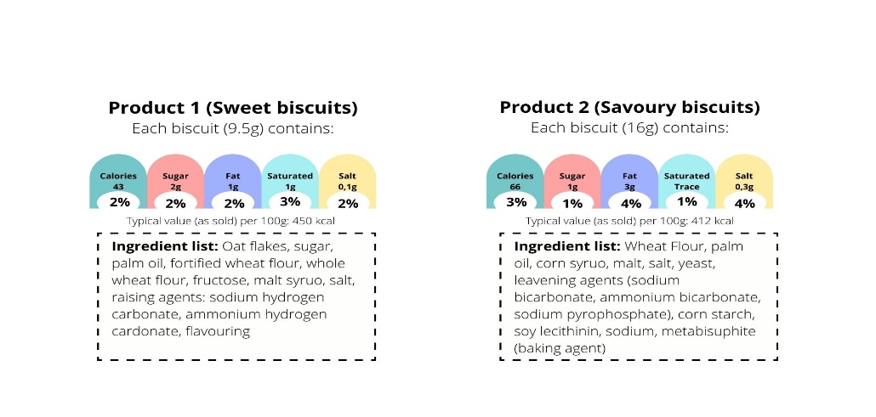
Figure 1: Nutrition labels used in the administration of questions.
E12. Considering the images of Product 1 and Product 2, which of the two has more calories (kcal) per 100 grams? (product 1; product 2; they have same quantity; I don’t know)
E13. What are the sources of sugar in the Product 1 ingredient list? (sugar, fructose and malt syrup; sugar and malt syrup; sugar, fructose and lecithin; I don’t know)
Diet-disease associations
F1. In your opinion, which of these diseases is related to low fiber content? (intestinal disorder; anaemia; decay; I don’t know)
F2. In your opinion, which of these diseases is related to sugar content in the diet? (decay; hypertension; anaemia; I don’t know)
F3. In your opinion, which of these diseases is related to salt content in the diet? (hypertension; hypothyroidism; diabetes; I don’t know)
F4. What do you think experts recommend to prevent cancer? (eat less red meat; avoid additives in food; drink alcohol regularly; I don’t know)
F5. What do you think experts recommend to people to prevent cardiovascular diseases? (eat less trans fats; eat less fat fish; take supplements; I don’t know)
F6. What do you think experts recommend to prevent diabetes? (eat less refined foods; drink more fruit juices; eat more processed meat; I don’t know)
F7. In your opinion, which of these foods is responsible for increasing blood cholesterol? (animal fat; eggs; vegetable oils; I don’t know)
F8. In your opinion, which of these foods has a high glycemic index? (white bread, refined cereals; fruit and vegetables; I don’t know)
F9. In your opinion, to maintain an optimal weight, people need to completely eliminate fat from the diet. (I disagree; I agree; I don’t know)
F10. In your opinion, to maintain an optimal weight, people need to follow a high-protein diet. (I disagree; I agree; I don’t know)
F11. In your opinion, eating bread always causes weight increase. (I disagree; I agree; I don’t know)
F12. In your opinion, eating fiber may decrease the risk of weight increase. (I disagree; I agree; I don’t know)
F13. In your opinion, which of these options can help people maintain an optimal weight? (yes; no; I don’t know)
pay attention when eating; read nutritional labels; check the weight; no eat while watching tv; snack during the day; take supplements.
F14. In your opinion, if a person has a Body Mass Index (BMI) of 23kg/m2, what is their nutritional status? (normal weight; overweight; underweight; obese; I don’t know)
F15. In your opinion, if a person has a Body Mass Index (BMI) of 31kg/m2, what will their nutritional status? (normal weight; overweight; underweight; obese; I don’t know)
F16. In your opinion, which of these body shape corresponds to an increase of cardiovascular risk? (apple shape; pear shape; I don’t know)
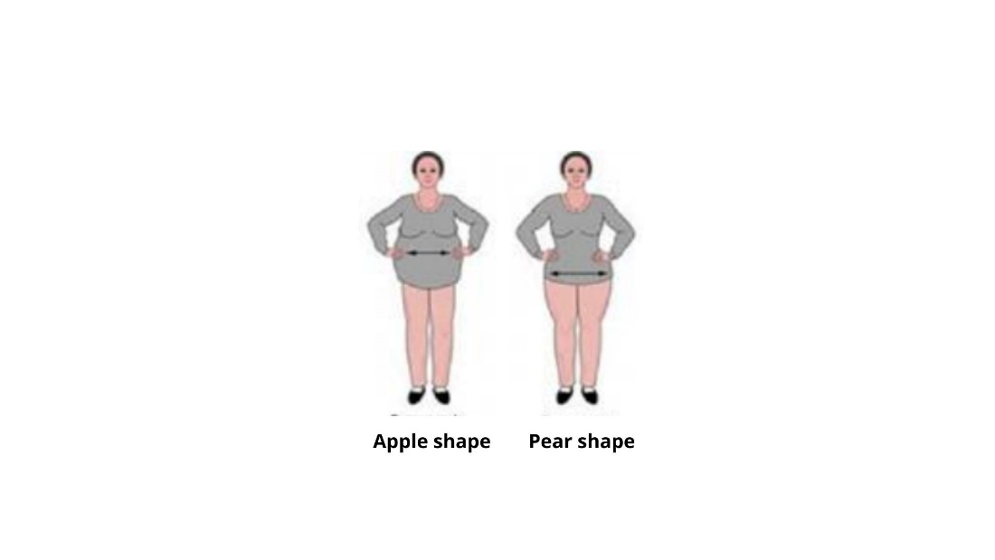
Figure 2: Body shapes.

2.1 Supplementary Tables
B. Table 3-Nutrition knowledge scores and sociodemographic characteristics
Table 3- Nutrition knowledge and sociodemographics
NK-General Nutrition Knowledge | Total | Gender |  | Age (years) |  |  |  |  |  | Education
 |  | Male | Fenale | 18-24 | 25-34 | 35-44 | 45-54 | 55-64 | > 64 | Low | Medium | High
Low (0-42) | 25.4% | 29.1%_{a} | 22.0%_{b} | 28.3%_{a,c} | 36.3%_{a,b} | 42.7%_{b} | 19.7%_{c,d} | 17.5%_{d} | 17.8%_{d,e} | 31.2%_{a} | 22.6%_{b} | 13.3%_{c}
Low-Medium (43-52) | 26.5% | 28.4%_{a} | 24.7%_{b} | 29.0%_{a,b} | 19.7%_{a} | 19.7%_{a} | 25.5%_{a} | 26.9%_{a,b} | 33.5%_{b} | 31.5%_{a} | 21.7%_{b} | 21.7%_{b}
Medium-High (53-60) | 26.0% | 23.6%_{a} | 28.2%_{b} | 26.3%_{a,b} | 24.2%_{a,b} | 19.1%_{a} | 26.0%_{a,b} | 30.3%_{b} | 28.2%_{b,c} | 21.9%_{a} | 29.3%_{b} | 31.0%_{b}
High (>60) | 22.1% | 18.9%_{a} | 25.1%_{b} | 16.4%_{a} | 19.9%_{a} | 18.5%_{a} | 28.8%_{b} | 25.2%_{a,b} | 20.6%_{a} | 15.4%_{a} | 26.4%_{b} | 34.0%_{c}
Table 3 (continued)
NK-General Nutrition Knowledge | Total | Region |  |  |  |  |  |  |  |  |  |  |  | Degree of urbanisation
 |  | Alpin Regions (Piemonte, Liguria, Valle d'Aosta) | Lombardia | North east regions (Trentino Alto Adige, Friuli Venezia Giulia ) | Veneto | Emilia Romagna | Appennine regions (Tuscany, Umbria) | Adriatic regions (Marche, Abruzzo) | Lazio | Puglia and Molise | Campania | Calabria and Basilicata | Islands (Sardegna, Sicilia) | High | Medium | Low
Low (0-42) | 25.4% | 22.2%_{a,d,f,h} | 30.3%_{a,b,c} | 39.5%_{c} | 26.8%_{a,c,d} | 16.1%_{d} | 17.5%_{d,e,f} | 32.0%_{b,c,f,g} | 17.6%_{d,g} | 23.7%_{a,c,d} | 31.6%_{b,c,h} | 22.1%_{a,c,d} | 27.9%_{a,c,d} | 20.2%_{a} | 27.1%_{b} | 39.2%_{c}
Low-Medium (43-52) | 26.5% | 24.9%_{a} | 31.2%_{a} | 18.9%_{a} | 23.9%_{a} | 24.5%_{a} | 21.6%_{a} | 28.4%_{a} | 25.2%_{a} | 36.0%_{a} | 26.9%_{a} | 23.9%_{a} | 24.9%_{a} | 28.3%_{a} | 27.6%_{a} | 15.7%_{b}
Medium-High (53-60) | 26.0% | 27.5%_{a,d,e,f,g,i} | 17.9%_{a,b} | 18.4%_{a,c,d} | 28.0%_{a,d,e,f,g,i} | 32.1%_{d,e,f,g,i} | 39.6%_{e} | 18.8%_{b,c,f,h} | 27.8%_{a,d,e,f,g,i} | 27.0%_{a,d,e,f,g,i} | 23.9%_{b,c,g,h} | 36.3%_{d,e,h,i} | 22.9%_{b,c,i} | 28.4%_{a} | 24.9%_{a,b} | 20.5%_{b}
High (>60) | 22.1% | 25.4%_{a,b} | 20.6%_{a,b} | 23.2%_{a,b} | 21.3%_{a,b} | 27.3%_{a} | 21.3%_{a,b} | 20.8%_{a,b} | 29.5%_{a} | 13.3%_{b} | 17.6%_{a,b} | 17.7%_{a,b} | 24.3%_{a,b} | 23.1%_{a} | 20.4%_{a} | 24.6%_{a}
Table 3 (continued)
NK-General Nutrition Knowledge | Total | Household size (member number) |  |  |  |  | Household annual income
 |  | 1 | 2 | 3 | 4 | >=5 | <=18,000 € | 18,001- 27,000 € | 27,001- 36,000€ | 36,001 - 54,000€ | 54,001 -72,000 € | >=72,001 € | I prefer not to answer
Low (0-42) | 25.4% | 24.8%_{a} | 17.7%_{b} | 30.3%_{a,c} | 27.5%_{a} | 39.7%_{c} | 28.1%_{a} | 25.0%_{a} | 26.0%_{a} | 24.7%_{a} | 24.1%_{a} | 24.1%_{a} | 29.9%_{a}
Low-Medium (43-52) | 26.5% | 25.9%_{a,c,d} | 30.9%_{a,b} | 20.8%_{c} | 27.5%_{b,d} | 23.7%_{a,c,d} | 32.1%_{a} | 25.4%_{a} | 27.2%_{a} | 22.8%_{a} | 18.6%_{a} | 16.5%_{a} | 30.5%_{a}
Medium-High (53-60) | 26.0% | 26.9%_{a} | 26.9%_{a} | 27.1%_{a} | 23.5%_{a} | 23.1%_{a} | 21.0%_{a} | 29.6%_{b} | 24.8%_{a,b} | 26.5%_{a,b} | 20.6%_{a,b} | 24.7%_{a,b} | 19.9%_{a}
High (>60) | 22.1% | 22.4%_{a,b} | 24.5%_{a} | 21.9%_{a,b} | 21.4%_{a,b} | 13.5%_{b} | 18.8%_{a} | 19.9%_{a,c} | 22.0%_{a,c} | 25.9%_{a,b} | 36.7%_{b} | 34.8%_{b,c,d} | 19.7%_{a,d}
Values in the same row and sub-table that do not share the same index are significantly different at p< ,05 in the bilateral equality test for column proportions.

C. Table 4 - Adherence to Mediterranean Diet and sociodemographic characteristics
Table 4- Predimed Plus and sociodemographics
Predimed Plus | Total | Gender |  | Age (years) |  |  |  |  |  | Education
 |  | Male | Fenale | 18-24 | 25-34 | 35-44 | 45-54 | 55-64 | > 64 | Low | Medium | High
Low (0<6) | 31.4% | 36.6%_{a} | 26.6%_{b} | 39.9%_{a} | 36.6%_{a,b} | 35.2%_{a,b} | 31.4%_{a,b,c} | 27.6%_{b,c} | 26.4%_{c} | 35.0%_{a} | 29.5%_{b} | 24.6%_{b}
Low-medium (6-7) | 31.3% | 31.7%_{a} | 30.9%_{a} | 34.8%_{a} | 26.9%_{a} | 35.9%_{a} | 31.8%_{a} | 32.4%_{a} | 28.6%_{a} | 31.6%_{a} | 30.5%_{a} | 32.3%_{a}
Medium-high (8-9) | 24.0% | 22.0%_{a} | 26.0%_{b} | 18.0%_{a} | 23.9%_{a} | 20.7%_{a} | 26.3%_{a} | 25.8%_{a} | 25.3%_{a} | 22.1%_{a} | 26.0%_{a} | 25.7%_{a}
High (10-17) | 13.3% | 9.7%_{a} | 16.6%_{b} | 7.3%_{a} | 12.6%_{a} | 8.2%_{a} | 10.6%_{a} | 14.2%_{a,b} | 19.8%_{b} | 11.4%_{a} | 14.1%_{a,b} | 17.4%_{b}
Table 4 (continued)
Predimed Plus | Total | Region |  |  |  |  |  |  |  |  |  |  |  | Degree of urbanisation
 |  | Alpin Regions (Piemonte, Liguria, Valle d'Aosta) | Lombardia | North east regions (Trentino Alto Adige, Friuli Venezia Giulia ) | Veneto | Emilia Romagna | Appennine regions (Tuscany, Umbria) | Adriatic regions (Marche, Abruzzo) | Lazio | Puglia and Molise | Campania | Calabria and Basilicata | Islands (Sardegna, Sicilia) | High | Medium | Low
Low (0<6) | 31.4% | 30.1%_{a,b} | 32.8%_{a,b,d} | 45.4%_{a,d} | 34.4%_{a,b,d} | 27.0%_{a,b} | 26.3%_{b} | 30.7%_{a,b,d} | 34.0%_{a,b,d} | 23.6%_{b,c} | 44.2%_{d} | 24.2%_{b,e} | 25.0%_{b,f} | 31.4%_{a} | 30.6%_{a} | 34.3%_{a}
Low-medium (6-7) | 31.3% | 32.6%_{a,d,e} | 33.0%_{a,b,d,g} | 18.6%_{a,c,e,f} | 27.8%_{a,d,e} | 33.3%_{a,d,e} | 40.6%_{d} | 29.8%_{a,d,e} | 20.8%_{e} | 36.4%_{b,d,f,g} | 23.2%_{c,e,g,h} | 39.1%_{d,h} | 37.0%_{d,i} | 27.7%_{a} | 34.0%_{b} | 35.5%_{b}
Medium-high (8-9) | 24.0% | 22.4%_{a} | 24.0%_{a} | 24.6%_{a} | 26.0%_{a} | 22.4%_{a} | 19.5%_{a} | 27.8%_{a} | 29.0%_{a} | 30.3%_{a} | 22.7%_{a} | 21.7%_{a} | 20.2%_{a} | 26.2%_{a} | 22.3%_{a} | 21.9%_{a}
High (10-17) | 13.3% | 14.9%_{a} | 10.2%_{a} | 11.4%_{a} | 11.7%_{a} | 17.2%_{a} | 13.6%_{a} | 11.7%_{a} | 16.2%_{a} | 9.8%_{a} | 9.9%_{a} | 15.0%_{a} | 17.7%_{a} | 14.7%_{a} | 13.1%_{a} | 8.3%_{b}
Table 4 (continued)
Predimed Plus | Total | Household size (member number) |  |  |  |  | Household annual income
 |  | 1 | 2 | 3 | 4 | >=5 | <=18,000 € | 18,001- 27,000 € | 27,001- 36,000€ | 36,001 - 54,000€ | 54,001 -72,000 € | >=72,001 € | I prefer not to answer
Low (0<6) | 31.4% | 22.5%_{a} | 28.2%_{a,b} | 32.2%_{b,c} | 37.4%_{c} | 42.2%_{c,d} | 29.8%_{a} | 29.7%_{a} | 28.0%_{a} | 32.1%_{a} | 37.2%_{a} | 34.3%_{a} | 33.1%_{a}
Low-medium (6-7) | 31.3% | 30.6%_{a} | 29.9%_{a} | 33.8%_{a} | 31.6%_{a} | 29.6%_{a} | 32.9%_{a} | 35.5%_{a} | 28.6%_{a} | 27.7%_{a} | 22.5%_{a} | 34.6%_{a} | 29.9%_{a}
Medium-high (8-9) | 24.0% | 33.1%_{a} | 24.7%_{b} | 21.5%_{b} | 21.9%_{b} | 19.9%_{b} | 26.9%_{a} | 23.7%_{a} | 28.4%_{a} | 22.7%_{a} | 23.3%_{a} | 18.6%_{a} | 20.5%_{a}
High (10-17) | 13.3% | 13.8%_{a,b} | 17.2%_{a} | 12.5%_{a,b} | 9.1%_{b} | 8.3%_{b,c} | 10.3%_{a} | 11.1%_{a} | 15.0%_{a} | 17.4%_{a} | 16.9%_{a} | 12.5%_{a} | 16.4%_{a}
Values in the same row and sub-table that do not share the same index are significantly different at p< ,05 in the bilateral equality test for column proportions.

