**Supplementary Data S9: Hap1K4R mutant protein has similar expression levels and distribution as the wild-type protein**

a. Total protein extract from SH-SYS5 cells expressing HAP1wt-, HAP1K4R-FLAG tagged or the corresponding empty construct, 48h post transfection. b. Subcellular fractionation of SH-SYS5 cells expressing HAP1wt-, HAP1K4R-FLAG tagged or the corresponding empty construct. CEB: Cytosolic fraction, MEB: Membrane fraction, PEB – Cytoskeletal (or pellet) fraction. Figure panels were cropped for clarity, the corresponding full length gels are presented on the next page.



Full sized images:

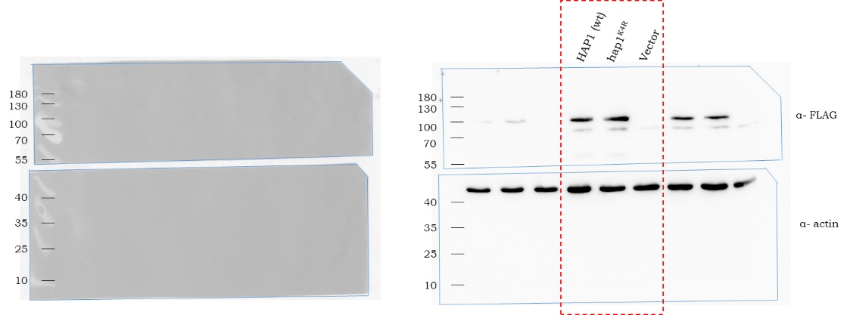

a.

b.

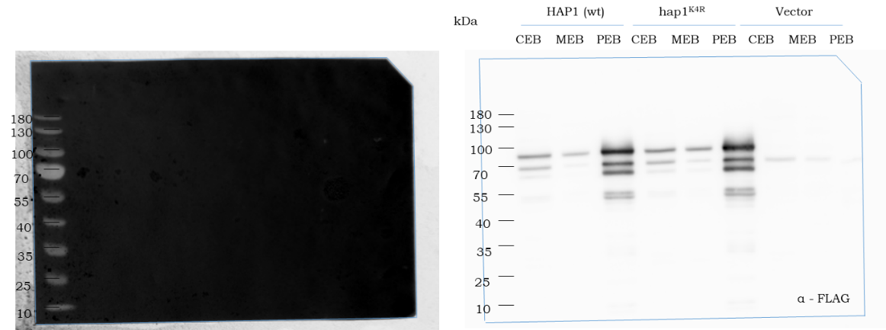

Stripped

membrane

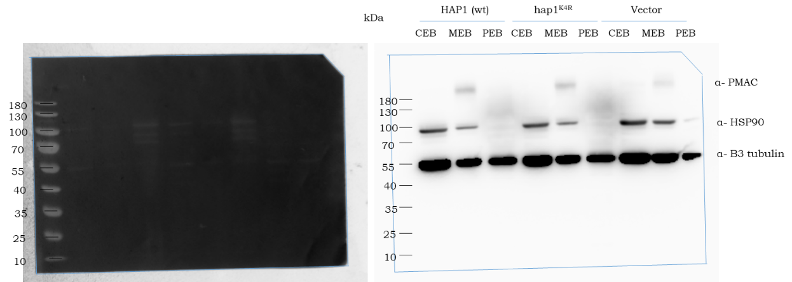

Stripped

membrane

