**SUPPLEMENTARY MATERIAL**

**Normalized Difference Vegetation Index - NDVI**

**The index is calculated from the following equation:**

**NDVI = (Near Infrared – Red) / (Near Infrared + Red)**

In essence, it is a measure of the reflectance of the vegetation, ranging from -1 to 1, where values approaching 1 mean the presence of dense green leaves.

NDVI was calculated from Copernicos Sentinel -2 images, taken in 18/07/2019 (scenes: RT_T18NVJ_2019 07 18 T152649). Source: https://earthexplorer.usgs.gov/

**Discharge Calculation:**

The discharge was calculated from the flow direction and flow accumulation algorithms from Topotoolbox 2 (Schwanghart and Scherler, 2014), using TanDEM-X (12 m) images. Discharge was weighted with mean annual precipitation (MAP) image corrected by potential evapotranspiration index (PET), both from Chelsea database (Karger et al., 2017, 2018). Thus, MAPcorrected = MAP – PET, being that negative values are converted to 0.

This offers a relative proxy for discharge; however, the limitation is that it does not account for infiltration.

Figure S1. NDVI map and Upper Magdalena discharge. The negative NDVI values at southeastern (Eastern Cordillera) are cloud effects.

Copernicus Sentinel data, 2021, processed by ESA.

German Aerospace Center-TanDEM-X, (2019). https://tandemx-science.dlr.de.

Karger, D.N., Conrad, O., Böhner, J., Kawohl, T., Kreft, H., Soria-Auza, R.W., Zimmermann, N.E., Linder, P., Kessler, M. (2017). Climatologies at high resolution for the Earth land surface areas. Scientific Data. 4 170122. https://doi.org/10.1038/sdata.2017.122.

Karger D.N., Conrad, O., Böhner, J., Kawohl, T., Kreft, H., Soria-Auza, R.W., Zimmermann, N.E., Linder, H.P., Kessler, M. Data from: Climatologies at high resolution for the earth’s land surface areas. Dryad Digital Repository.http://dx.doi.org/doi:10.5061/dryad.kd1d4.

Schwanghart, W., Scherler, D. (2014). TopoToolbox 2 – MATLAB-based software for topographic analysis and modeling in Earth surface sciences. Earth Surface Dynamics, 2, 1-7.

Figure S2. Stratigraphic column of the Upper Magdalena Valley. Simplified from Terraza-Melo et al. (2019). Note that the conglomerate upper layer of the La Victoria Formation is the Cerbatana Conglomerate Bed showed in Figure 2.

Terraza-Melo, R., Martin, C.L., Martínez, G.A., Rojas, S.T., Rojas, N.R. (2019). Exploración geológica de fosfatos en el departamento del Huila, costado Occidental del río Magdalena, Plan 302, 323, 344, 345 y 366. Bogotá: 547 pp. Internal report. Servicio Geologico Colombiano.

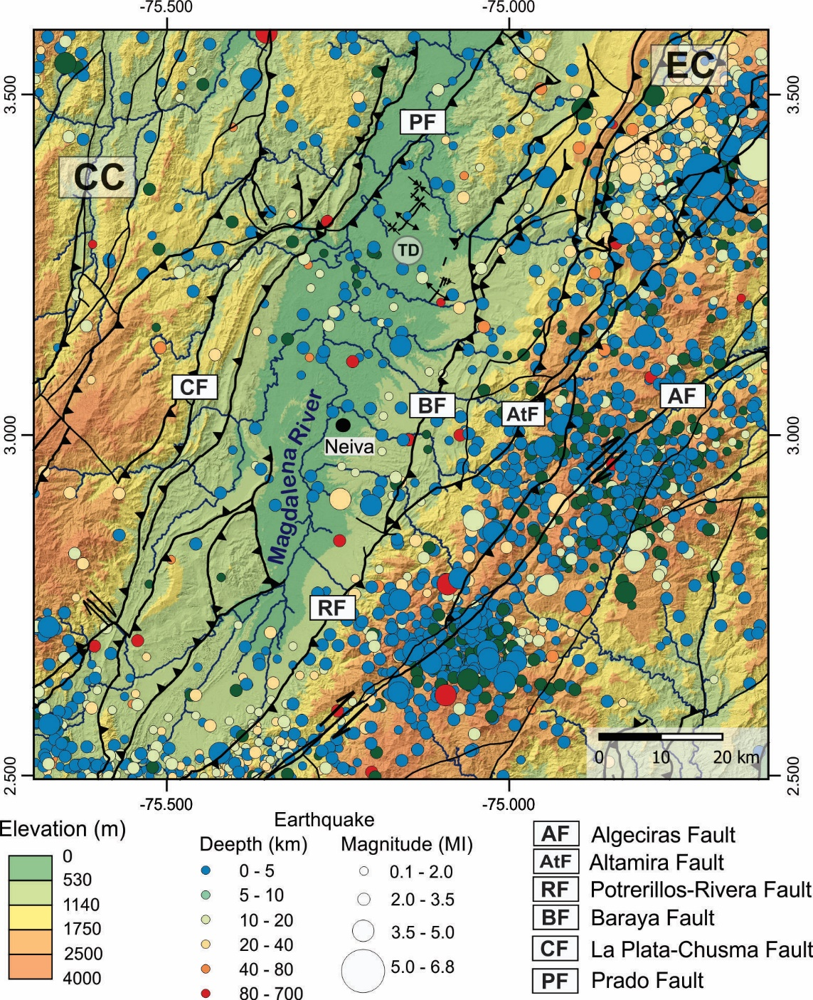

Figure S3. Earthquakes distribution along the Upper Magdalena Valley. Events were compilated from the catalog of the Colombian Geological Survey and cover the period between 1993 and 2018 (INGEOMINAS, 1993). CC is the Central Cordillera, EC is the Eastern Cordillera and TD is the Tatacoa Desert.

INGEOMINAS - Servicio Geologico Colombiano (SGC Colombia) (1993): Red Sismologica Nacional de Colombia. International Federation of Digital Seismograph Networks. Dataset/Seismic Network. https://doi.org/10.7914/SN/CM

**Optically Stimulated Luminescence dating (OSL)**

Table S1. OSL dating protocol.

|  |  |  |
| --- | --- | --- |
| Step | Procedure | Observation |
| 1 | Dose |  |
| 2 | Preheat at 240°C for 10 s |  |
| 3 | OSL at 125 °C for 40 s | Lx |
| 4 | Test dose |  |
| 5 | Preheat at 160 °C for 0 s |  |
| 6 | OSL at 125 °C for 40 s | Tx |
| 7 | Blue illumination at 280 °C for 40 s |  |
| 8 | Back to step 1 |  |

Table S2. Dose recovery results for sample TAT 2A. Calculated doses represent the average of all accepted aliquots and one standard deviation.

|  |  |  |  |  |  |
| --- | --- | --- | --- | --- | --- |
| **Temperature (°C)** | **Experiment** | **Aliquots accepted/ Aliquots tested** | **Given Dose** | **Calculated dose (Gy)** | **Calculated dose/ Given Dose** |
| 200 | 1 | 6/6 | 45 Gy (386s) | 38.2 ± 1.4 | 0.85 ± 0.03 |
| 220 | 1 | 4/5 | 45 Gy (386s) | 39.2 ± 1.9 | 0.87 ± 0.04 |
| 220 | 2 | 5/6 | 45 Gy (386s) | 41.4 ± 4.1 | 0.92 ± 0.09 |
| 220 | 3 | 5/6 | 45 Gy (386s) | 42.0 ± 4.4 | 0.93 ± 0.10 |
| 220 | 4 | 9/11 | 45 Gy (386s) | 40.8 ± 2.4 | 0.91 ± 0.05 |
| 220 | 5 | 9/11 | 45 Gy (386s) | 42.9 ± 2.6 | 0.95 ± 0.06 |
| 240 | 1 | 4/6 | 45 Gy (386s) | 46.9 ± 2.5 | 1.04 ± 0.06 |
| 240 | 2 | 3/4 | 45 Gy (386s) | 47.6 ± 2.7 | 1.06 ± 0.06 |
| 240 | 3 | 3/4 | 45 Gy (386s) | 47.8 ± 2.0 | 1.06 ± 0.04 |

Table S3. Radionuclide activity and dose rates results.

|  |  |  |  |  |  |  |  |
| --- | --- | --- | --- | --- | --- | --- | --- |
| **Sample** | **238U**  **(ppm)** | **232Th**  **(ppm)** | **K**  **(%)** | | **Water content (%)** | **Cosmic dose rate (Gy/ka)** | **Dose rate**  **(Gy/ka)** |
| TAT-1A | 1.4 ± 0.1 | 7.8 ± 0,3 | 0.3 ± 1.3 | 5.1 | | 0.2 ± 0.02 | 2.3 ± 0.2 |
| TAT-1B | 1.9 ± 0.1 | 11.2 ± 0.4 | 0.4 ± 1.6 | 2.4 | | 0.17 ± 0.01 | 3.0 ± 0.3 |
| TAT-2A | 2.4 ± 0.1 | 11.6 ± 0.4 | 0.4 ± 0.8 | 6.8 | | 0.19 ± 0.02 | 2.3 ± 0.2 |
| TAT-2B | 2.3 ± 0.1 | 13.9 ± 0.5 | 0.5 ± 0.7 | 10.6 | | 0.18 ± 0.01 | 2.2 ± 0.2 |

Figure S4. Temperature versus Lx/Tx after pulse annealing tests: Average of 2 aliquots from the TAT 1A sample (A) and TAT 2B sample (B).

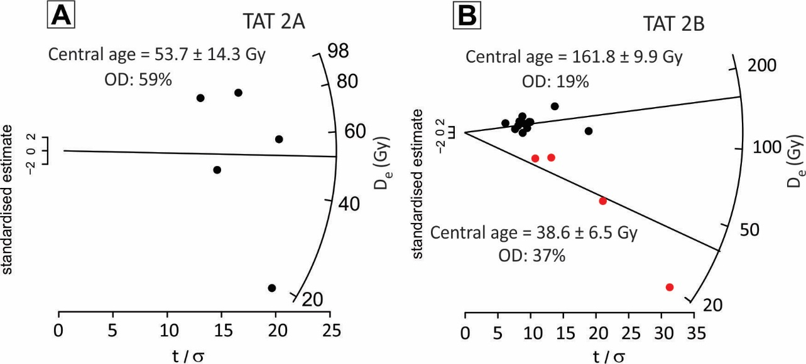

Figure S5. Radial plots for all non-saturated accepted aliquots of (A) TAT 2A and (B) TAT 2B samples. Note the split in 2 finites groups of the TAT 2B aliquots, the group represented by red circles were considered outliers.

Table S4. OSL-derived incision rates

|  |  |  |  |  |  |
| --- | --- | --- | --- | --- | --- |
| **Terrace /River** | **Terrace mean elevation (m)** | **Segment River mean elevation (m)** | **Total incision (m)** | **OSL deposition age (ka)** | **Incision rate (mm/y)** |
| TAT-1 / Magdalena River | 461.5 ± 3.3 | 383.1 2.3 | 78.4 ± 4 | 7.7 ± 1.5 | 10.8 ± 2.0 |
| TAT-2 / Cabrera River | 632.0 ± 4.2 | 425.6 ± 6.1 | 206.4 ± 7.4 | 74.1 ± 7.0 | 2.8 ± 0.2 |

Table S5. Paleocurrent measurements:

|  |  |  |  |  |
| --- | --- | --- | --- | --- |
| **Site** | **Clast** | **Azimuth face to paleocurrent (°)** | **Dip (°)** | **Paleocurrent (°)** |
| TAT-1 | 1 | 230 | 41 | 50 |
| 2 | 188 | 35 | 8 |
| 3 | 196 | 22 | 16 |
| 4 | 202 | 43 | 22 |
| 5 | 181 | 44 | 1 |
| 6 | 196 | 34 | 16 |
| 7 | 177 | 24 | 357 |
| 8 | 220 | 52 | 40 |
| 9 | 200 | 17 | 20 |
| TAT-2 | 1 | 171 | 40 | 351 |
| 2 | 151 | 9 | 331 |
| 3 | 164 | 18 | 344 |
| 4 | 145 | 25 | 325 |
| 5 | 50 | 22 | 230 |
| 6 | 138 | 34 | 318 |
| 7 | 125 | 4 | 305 |
| 8 | 95 | 32 | 275 |
| 9 | 25 | 6 | 205 |
| 10 | 4 | 20 | 184 |
| 11 | 130 | 22 | 310 |
| C-3 | 1 | 170 | 45 | 350 |
| 2 | 110 | 30 | 290 |
| 3 | 130 | 25 | 310 |
| 4 | 118 | 13 | 298 |
| 5 | 30 | 30 | 210 |
| 6 | 80 | 18 | 260 |
| 7 | 40 | 8 | 220 |
| 8 | 48 | 22 | 228 |
| 9 | 80 | 43 | 260 |
| 10 | 100 | 25 | 280 |
|  | 11 | 84 | 35 | 264 |

**Morphometric analysis**

Table S6. Best fit for the concavity index (θref)

|  |  |
| --- | --- |
| θref | **R²\*** |
| 0.0001 | 0.3795 |
| 0.1 | 0.464 |
| 0.2 | 0.5543 |
| 0.3 | 0.6355 |
| 0.35 | 0.6642 |
| 0.4 | 0.6789 |
| 0.4156 | 0.6798 |
| 0.45 | 0.6746 |
| 0.5 | 0.6471 |
| 0.55 | 0.5942 |
| 0.6 | 0.5164 |
| 0.7 | 0.3015 |
| 0.8 | 0.049 |
| 0.9 | -0.1962 |
| 1 | -0.4109 |

* The determination coefficient R² refers to the correlation between Elevation and χ values calculated at variable θref values in the Upper Magdalena drainage network.

Figure S6. Determination of the concavity index (θref) and calculation of χ. (A) The Upper Magdalena drainage system. The arbitrary outlet is after the confluence of Magdalena with Cabrera River; (B) Best fit for the concavity index (θref), according to Table S6; (C) χ – values for the Upper Magdalena drainage system, calculated with the optimal θref= 0.4156.

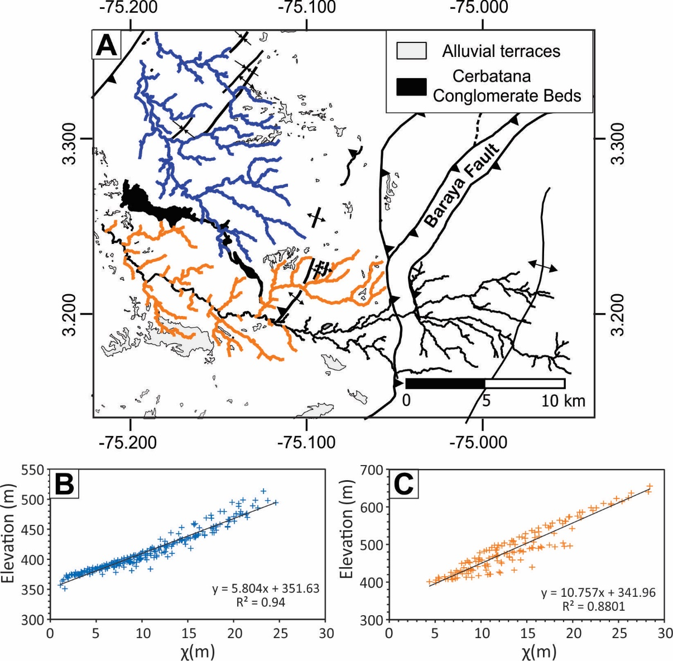

Figure S7. Definition for the mean normalized steepness index (ksn) for the Tatacoa Catchments. (A) Location of the catchments, the blue channels are the internal Tatacoa catchments, and the orange channels are the Las Hajas River tributaries catchments. (B) and (C) are the correlation between elevation and χ – values respectively for the internal Tatacoa and Las Hajas catchments. The ksn index is the slope coefficient.

Table S7. Calculation of coefficient K

|  |  |  |  |
| --- | --- | --- | --- |
| **Catchments** | **Incision rate (m/y)(1)** | **Ksn(2)** | **K (x10-4)** |
| Tatacoa | 10.8 ± 2.0 | 5.80 ± 0.09 | 17.55 ± 3.54 |
| Las Hajas | 10.8 ± 2.0 | 10.76 ± 0.32 | 9.46 ± 1.92 |

1. Incision rate according to table S4
2. ksn according to figure S6.

Figure S8. Effect of a reduced downstream area in χ-profiles of the (A) Tatacoa 1 main river; and (B) Tatacoa 2 main river (see location in figure 5). The thick line is the measured χ-profile, and the dotted line is the χ-profile recalculated subtracting the downstream area of the catchments. The subtracted area corresponds to the modern alluvial plain in the confluence of these channels with the Magdalena River (see figure 2).