RAI14,As an Reciprocal Protein of Carboxypeptidase N1,
Is a Prognostic Biomarker Associated With Immune Inﬁltration
in Triple Negative Breast Cancer

A table of contents
Contents
Supplementary Materials & Methods
Supplementary Table
Supplementary Figure

Supplementary Materials & Methods
Clinical Baseline Information Form，ROC curve and Forest charts of RAI14
Based on TCGA database, software R (version 3.6) for statistical analysis and visualization, human species.

Invasive tumor immune cell analysis
Timer2.0(https://cistrome.shinyapps.io/timer/), A Web Server for comprehensive analysis of tumor-infiltrating immune cells .It is an enhanced version that integrates a variety of state-of-the-art algorithms for immune infiltration estimation. These algorithms are applied to the expression profiles of the Cancer Genome Atlas(TCGA), enabling users to explore various associations between immune infiltration and genetic features in TCGA cohorts.1In Correlation module , we have detected the correlation of RAI14 expression in different breast cancer molecular statues (Luminal,Her2,Basal) with immune cell markers to determine the presence of any corresponding immune cell infiltration. That also provides options for partial correlation conditional on tumor purity or age

Breast Cancer Gene-Expression Miner v4.7
Breast Cancer Gene-Expression Miner v4.7(http://bcgenex.centregauducheau.fr/)，is a statistical mining tool of published annotated breast cancer transcriptomic data (DNA microarrays [n = 11 359] and RNA-seq [n = 4 712]). It offers the possibility to explore gene-expression of genes of interest in breast cancer.The statistical analyses are grouped in three modules: "correlation", "expression" and "prognostic" (see flowchart). Results are presented in tables, maps and various kinds of plots (pairwise correlation, box and whisker, bee swarm, violin, raincloud, Kaplan-Meier curves). First we selected the sub-module EXPRESSION of ANALYSIS, then we entered RAI14 and selected the metrics we wanted to analyze.

Table S1 Clinical Baseline Information Form

Characteristic | Low expression of RAI14 | High expression of RAI14 | p
n | 532 | 533
T stage, n (%) |  |  | 0.009
T1 | 116 (10.9%) | 159 (15%)
T2 | 315 (29.7%) | 300 (28.2%)
T3 | 81 (7.6%) | 56 (5.3%)
T4 | 18 (1.7%) | 17 (1.6%)
N stage, n (%) |  |  | 0.003
N0 | 243 (23.2%) | 264 (25.2%)
N1 | 184 (17.6%) | 165 (15.8%)
N2 | 44 (4.2%) | 72 (6.9%)
N3 | 47 (4.5%) | 27 (2.6%)
M stage, n (%) |  |  | 1.000
M0 | 422 (46.4%) | 467 (51.4%)
M1 | 10 (1.1%) | 10 (1.1%)
Pathologic stage, n (%) |  |  | 0.176
Stage I | 79 (7.6%) | 101 (9.7%)
Stage II | 305 (29.3%) | 301 (28.9%)
Stage III | 130 (12.5%) | 108 (10.4%)
Stage IV | 10 (1%) | 8 (0.8%)
Age, n (%) |  |  | < 0.001
<=60 | 260 (24.4%) | 328 (30.8%)
>60 | 272 (25.5%) | 205 (19.2%)
Histological type, n (%) |  |  | < 0.001
Infiltrating Ductal Carcinoma | 345 (36%) | 412 (43%)
Infiltrating Lobular Carcinoma | 127 (13.2%) | 75 (7.8%)
PR status, n (%) |  |  | 0.799
Negative | 163 (16%) | 175 (17.2%)
Indeterminate | 2 (0.2%) | 2 (0.2%)
Positive | 342 (33.7%) | 332 (32.7%)
ER status, n (%) |  |  | < 0.001
Negative | 96 (9.4%) | 141 (13.9%)
Indeterminate | 2 (0.2%) | 0 (0%)
Positive | 410 (40.3%) | 368 (36.2%)
HER2 status, n (%) |  |  | 0.178
Negative | 245 (34.2%) | 303 (42.3%)
Indeterminate | 7 (1%) | 5 (0.7%)
Positive | 82 (11.4%) | 75 (10.5%)
PAM50, n (%) |  |  | < 0.001
Normal | 17 (1.6%) | 23 (2.2%)
LumA | 291 (27.3%) | 260 (24.4%)
LumB | 109 (10.2%) | 93 (8.7%)
Her2 | 54 (5.1%) | 28 (2.6%)
Basal | 61 (5.7%) | 129 (12.1%)
Menopause status, n (%) |  |  | 0.016
Pre | 94 (9.8%) | 130 (13.6%)
Peri | 16 (1.7%) | 23 (2.4%)
Post | 362 (37.9%) | 331 (34.6%)
radiation_therapy, n (%) |  |  | 0.242
No | 226 (23.3%) | 206 (21.2%)
Yes | 261 (26.9%) | 279 (28.7%)
Anatomic neoplasm subdivisions, n (%) |  |  | 0.022
Left | 257 (24.1%) | 296 (27.8%)
Right | 275 (25.8%) | 237 (22.3%)
Age, meidan (IQR) | 61 (50, 69) | 56 (48, 65) | < 0.001

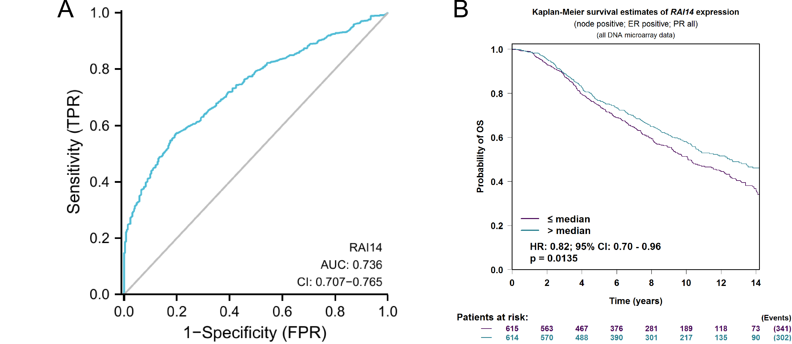

Figure S1 Diagnostic and prognostic relationship of RAI14 in breast cancer
(A) ROC curve of RAI14 (B) Association of RAI14 expression with OS(n) in ER-positive breast cancer patients in the GenExMinerv4.6 database

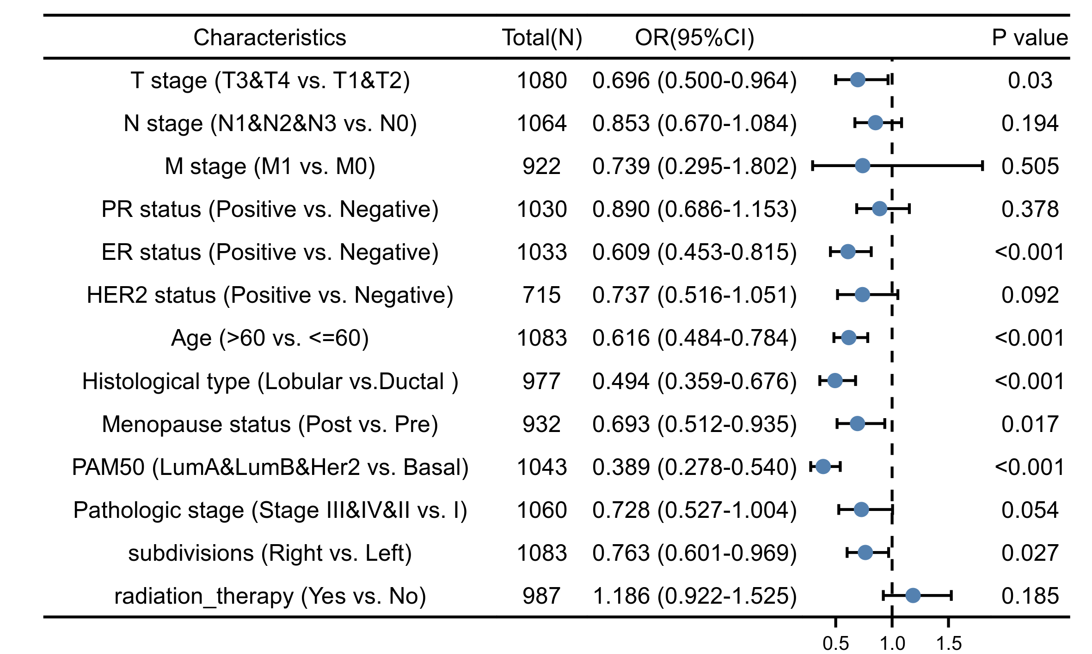

Figure S2 Forest charts of RAI14

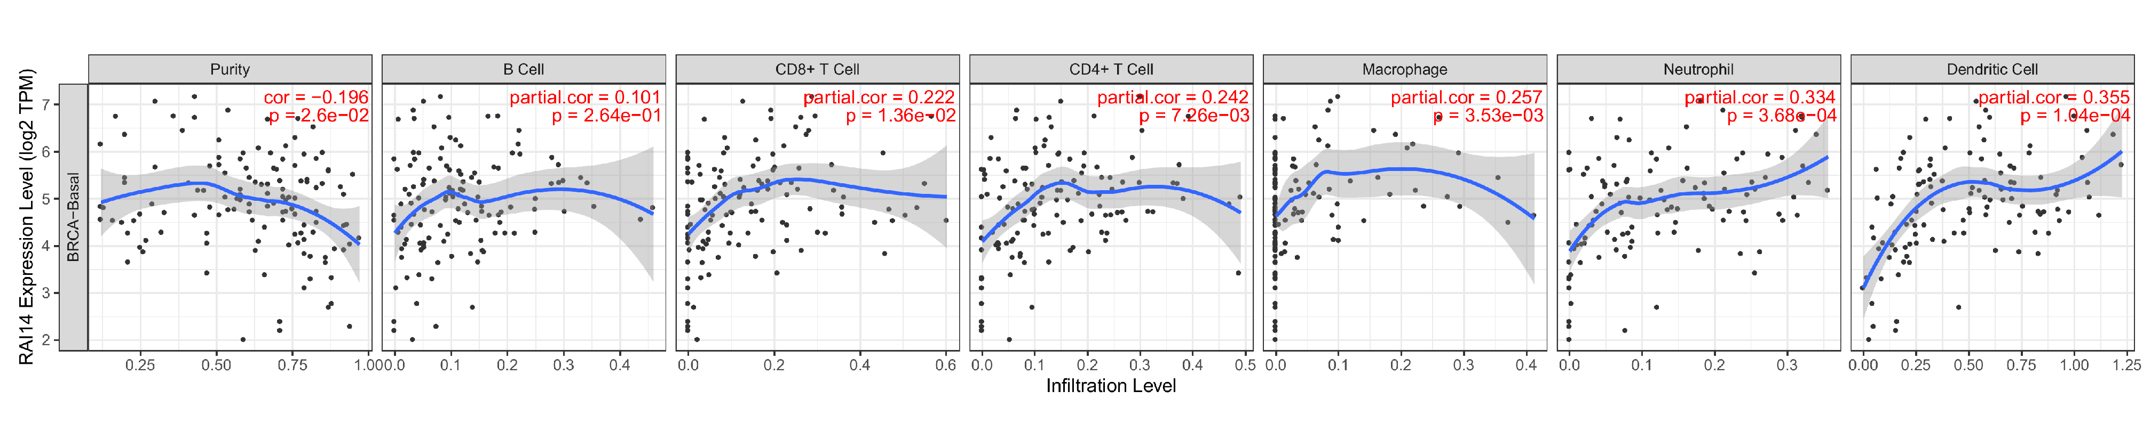

Figure S3 RAI14 Infiltration Level of BRCA-Basal

