**Supplementary material for**

**Temporal evolution of island arc magmatism and its influence on long-term climate: Insights from the Izu intra-oceanic arc**

Julia M. Ribeiro1, Osamu Ishizuka2,3, Philip A.E. Pogge von Strandmann4, Yoshihiko Tamura2, Yi-Gang Xu1,5

1 State Key Laboratory of Isotope Geochemistry, Guangzhou Institute of Geochemistry, the Chinese Academy of Science, China.

2 Japan Agency for Marine-Earth Science and Technology, Yokosuka, Japan.

3 Geological Survey of Japan, AIST, Ibaraki, Japan.

4 Institute of Geosciences, Johannes Gutenberg University Mainz, Germany.

5 Southern Marine Science and Engineering Guangdong Laboratory (Guangzhou), Guangzhou, 511458, China.

**Ensuring reliable contents in the glass shards and plagioclase-hosted melt inclusions**

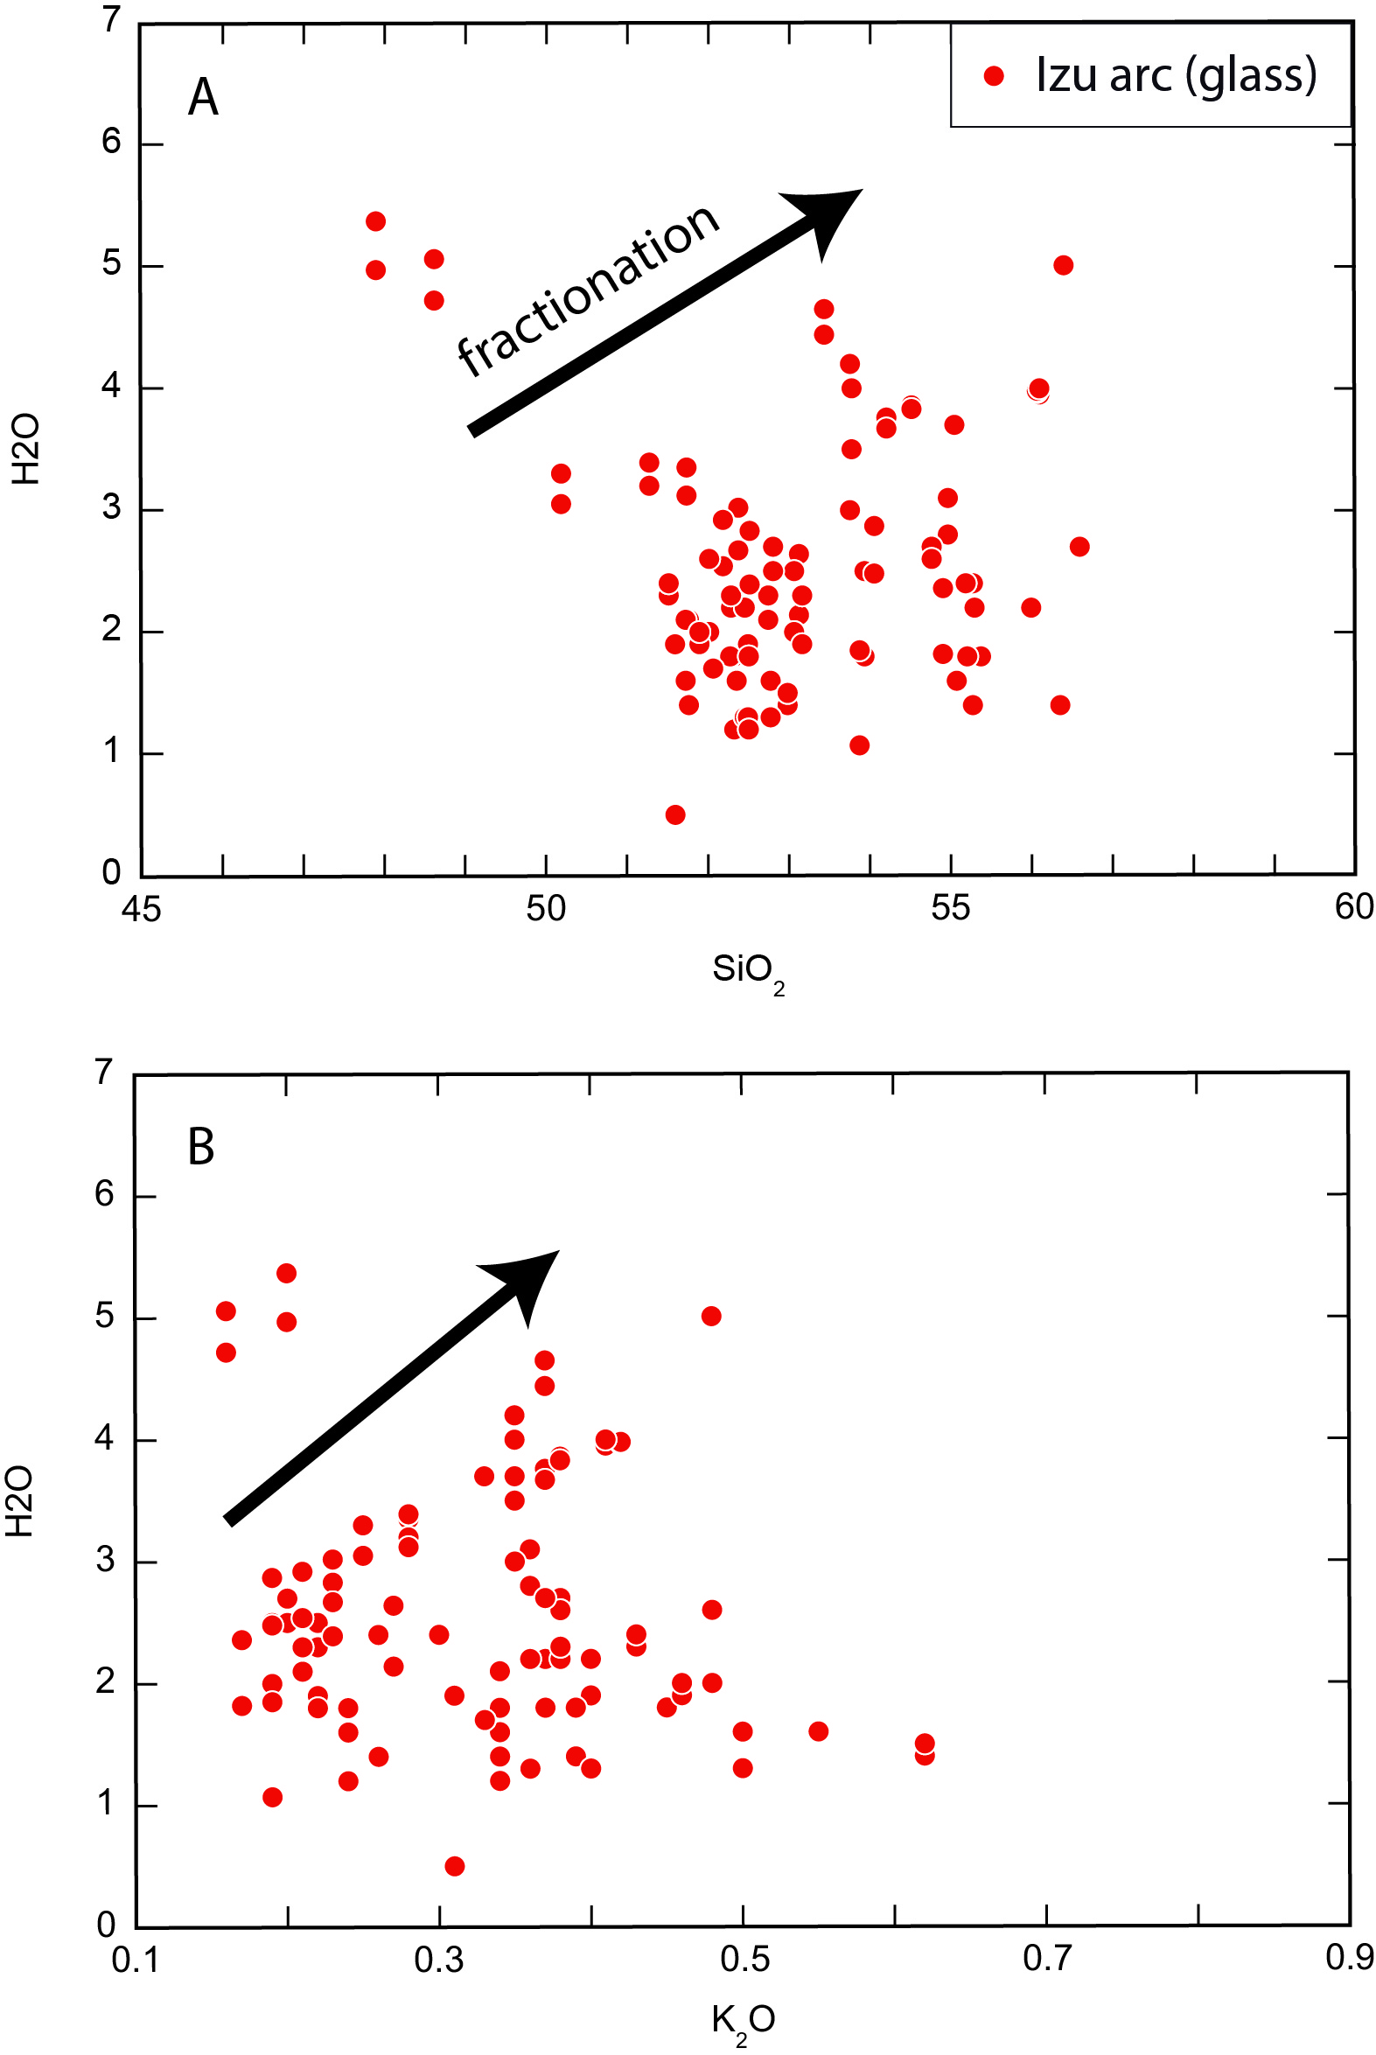

*Fig. S1: A) H2O (wt%) vs. SiO2 (wt%), and B) H2O (wt%) vs. K2O (wt%) diagrams. The positive co-variations between H2O, K2O and SiO2 demonstrate that fractionation trends remained preserved in the samples, indicating that alteration processes, diffusion between the crystal host and the inclusion (Gaetani and Watson, 2000), and volcanic degassing play a minor role in the water content of our filtered glasses.*

Despite their freshness, basaltic glass shards and mineral-hosted melt inclusions may still be prone to volcanic degassing or alteration processes upon magma ascent or after their emplacement. Degassing and alteration can affect the water content of the magmas. Alteration processes can also modify the composition of the magmas in fluid-mobile elements, such as K2O, Ba, Cs, Rb, Na2O which can be easily mobilized by hydrothermal fluids or seawater brines (Kent et al., 2002). The fact that fractionation trends are preserved between H2O, SiO2, K2O and Na2O (Fig. S1-S2) in most samples demonstrates that they generally retained their original composition.

To further ensure that the markers of slab fluids have retained their original composition, we also plotted Rb/Th, Ba/Th, Th/Nb, Cs/Ba, Ba/Nb ratios along with their silica content. Most of these ratios are roughly constant with increasing SiO2, suggesting that they are minimally affected by fractionation and alteration processes. However, a few basaltic glasses display higher ratios as compared to the general trend, especially in Rb/Th, Cs/Ba and Ba/Th. Because Rb, Cs and Ba are highly sensitive to alteration processes, these samples might be affected by alteration to some extent. Because here we are only concerned by the global trend in fluid–mobile elements, outliers will not be considered in our interpretations. Despite the scattering observed in Th/Nb in the basaltic glasses, Th and Nb are much less sensitive to alteration processes. We can thus consider concentrations in fluid-mobile elements can be reliably used to infer subduction processes in our filtered database.

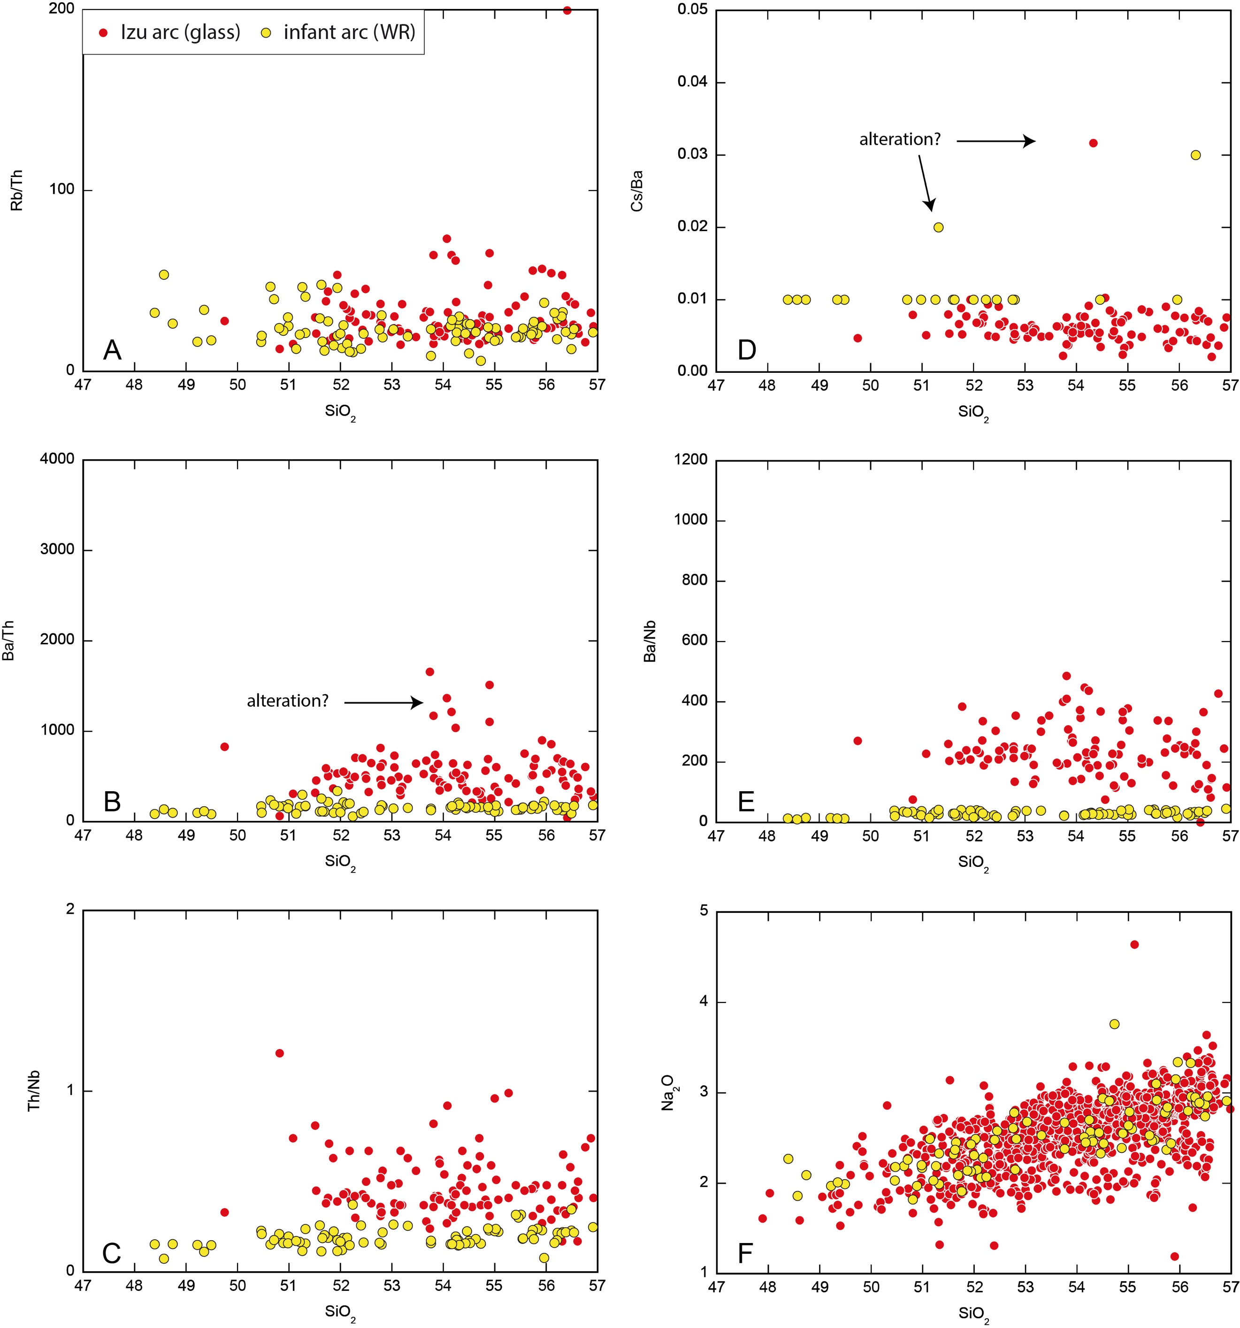

*Fig. S2: A) Rb/Th, B) Ba/Th, C) Th/Nb, D) Cs/Ba, E) Ba/Nb, F) Na2O (wt%) vs. SiO2 (wt%) diagrams. The roughly constant Ba/Th, Rb/Th, Th/Nb, Cs/Ba and Ba/Nb demonstrates that these ratios are generally little affected by alteration and fractionation processes. However, there are some outliers in the basaltic glasses, with much higher ratios, suggesting that glasses, despite their freshness, might be affected by alteration to some extent. The positive correlation between SiO2 and Na2O is consistent with fractionation, demonstrating that Na2O is little affected by alteration processes.*

**REE patterns of the samples**



*Fig. S3: Rare Earth element patterns of the mature Izu arc basalts (A) and the infant arc basalts (whole rock, WR). The orange compositional field depicts the bulk rock samples of De Bari et al. (2020).*

In the main text, we show a representative rare Earth element (REE) patterns of the bulk samples from the Izu infant arc and of the volcanoclastic glasses from the Izu mature arc examined in this study for simplification. Here, we show the complete set of REE patterns that are described in the main text.

**References**

Gaetani, G.A., Watson, E.B., 2000. Open system behavior of olivine-hosted melt inclusions. Earth and Planetary Science Letters 183, 27-41.

Kent, A.J.R., Peate, D.W., Newman, S., Stolper, E.M., Pearce, J.A., 2002. Chlorine in submarine glasses from the Lau Basin: seawater contamination and constraints on the composition of slab-derived fluids. Earth and Planetary Science Letters 202, 361-377.