**Supplementary Figure S1**

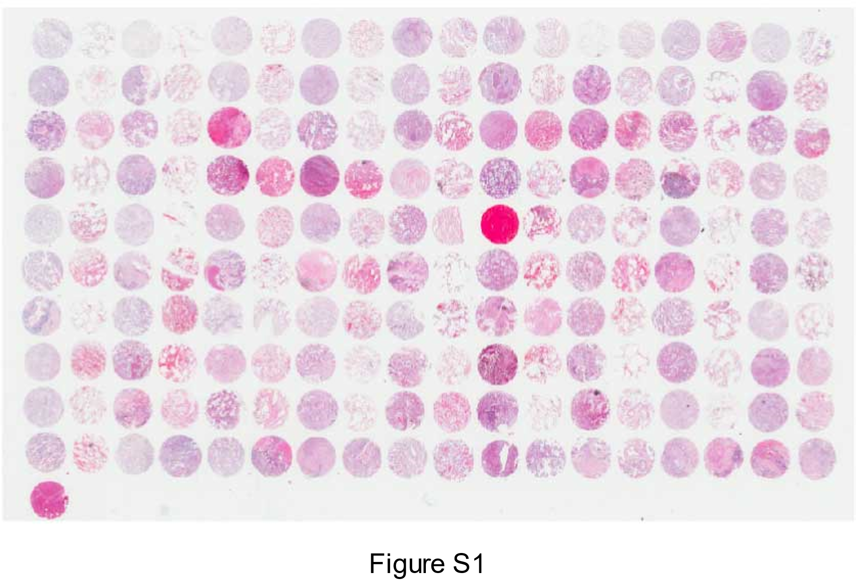

**Figure S1. H&E results of the 180-core TMA.**