**Supplementary Figure S2**

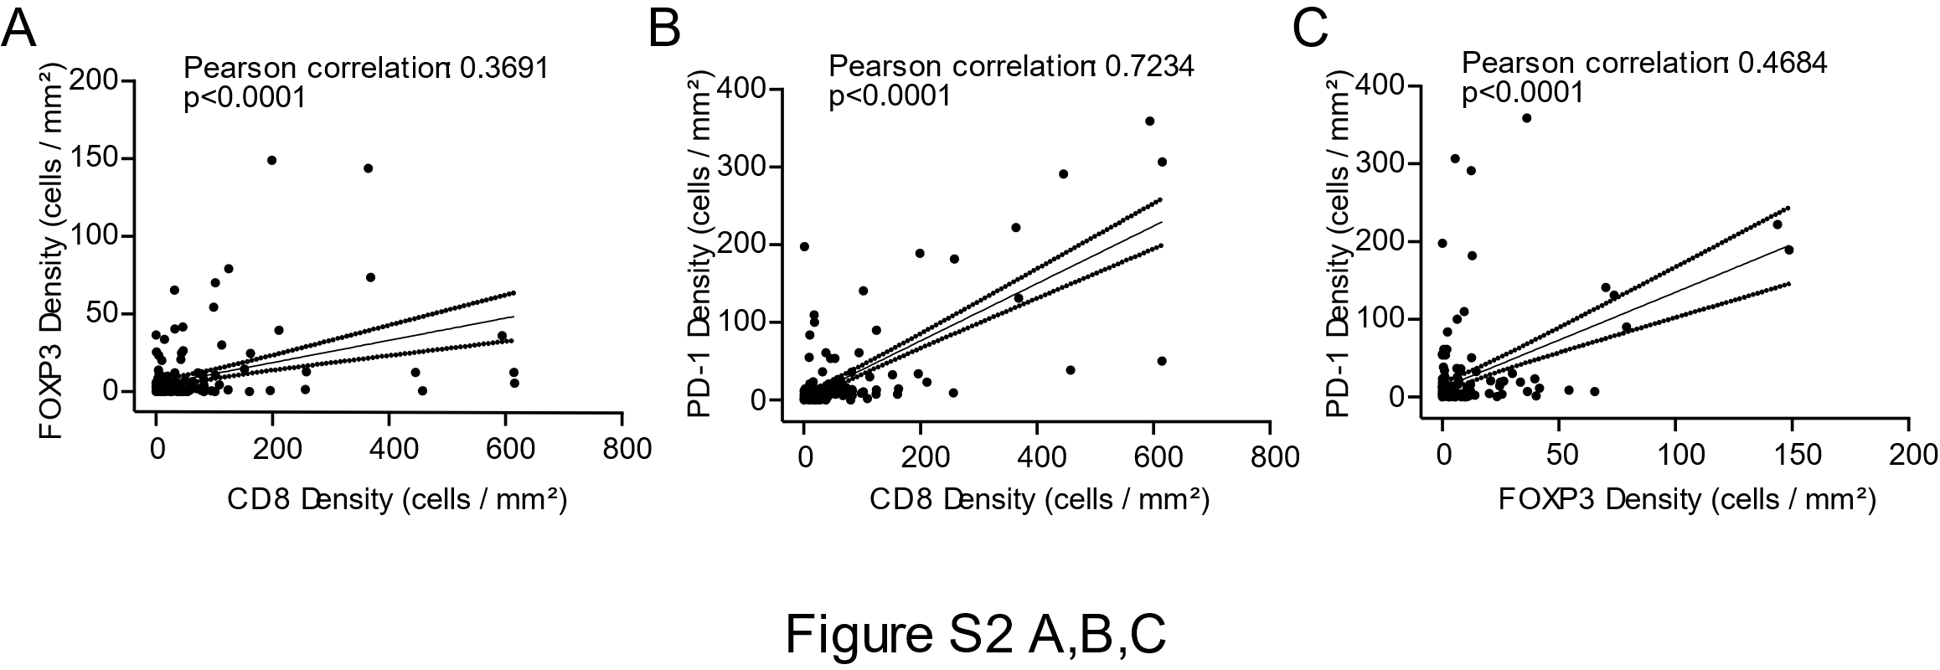

**Figure S2.** Pearson correlation between densities of **(A)** CD8 and FOXP3, **(B)** CD8 and PD-1, **(C)** FOXP3 and PD-1 (n=97 for tumor tissue samples).