**Supplementary Figure S3**

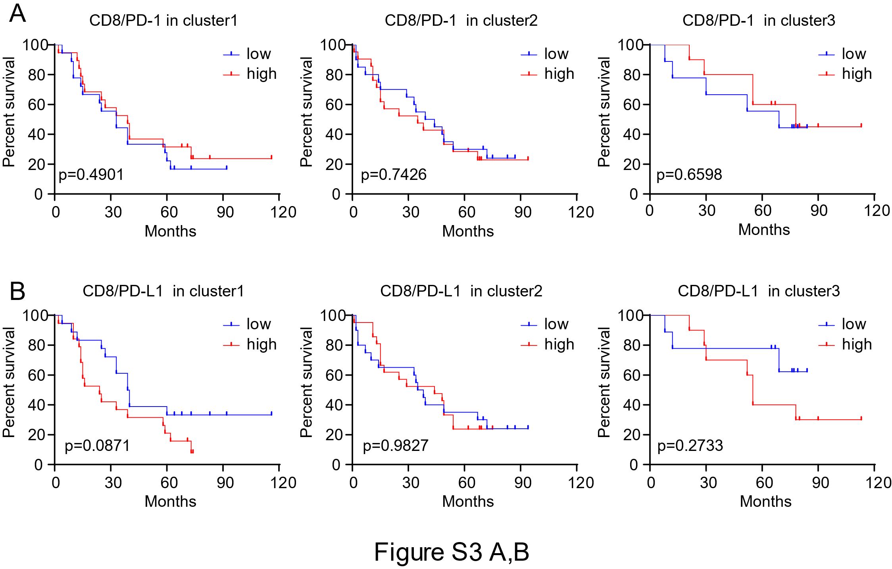

**Figure S3.** Kaplan-Meier analyses of overall survival (OS) for **(A)** CD8/PD-1 and **(B)** CD8/PD-L1 in 3 clusters generated according to their CD8/FOXP3 ratio, PD-1 and PD-L1 densities. A median cutoff was used to separate high and low populations. Log rank test was used to determine significance.