Supplementary material

Table S1 Detailed input information for deep learning models
Inputs of Model
Baseline demographic and clinical variables
Age
Gender
Education (year)
Height (cm)
Weight (kg)
Course (year)
Interventions
HIS at baseline
Anxiety at baseline
CDR at baseline
DSST at baseline
TMT A time at baseline
TMT B time at baseline
ALT at baseline
Medical history (Hypertension)
Medical history (Diabetes mellitus)
Medical history (Thyropathy)
Medical history (Cardiovascular disorder)
Medical history (Asthma)
Medical history (Cerebrovascular disorder)
Medical history (Hyperlithuria)
Medical history (Hyperlipemia)
Family history (Alzheimer's disease)
Time-dependent variables
MMSE at baseline
MMSE at 3-month
MMSE at 6-month
ADAS-cog at baseline
ADAS-cog at 3-month
ADAS-cog at 6-month
IADL at baseline
IADL at 3-month
IADL at 6-month
NPI at baseline
NPI at 3-month
NPI at 6-month
QOL-AD at baseline
QOL-AD at 3-month
QOL-AD at 6-month
GDS at baseline
GDS at 3-month
GDS at 6-month
TC at baseline
TC at 3-month
TC at 6-month
TG at baseline
TG at 3-month
TG at 6-month
LDL at baseline
LDL at 3-month
LDL at 6-month
Urea at baseline
Urea at 3-month
Urea at 6-month
ERP (N1 latency) at baseline
ERP (N1 latency) at 3-month
ERP (N1 latency) at 6-month
ERP (N1 base-to-peak) at baseline
ERP (N1 base-to-peak) at 3-month
ERP (N1 base-to-peak) at 6-month
ERP (N1 peak-to-peak) at baseline
ERP (N1 peak-to-peak) at 3-month
ERP (N1 peak-to-peak) at 6-month
ERP (P2 latency) at baseline
ERP (P2 latency) at 3-month
ERP (P2 latency) at 6-month
ERP (P2 base-to-peak) at baseline
ERP (P2 base-to-peak) at 3-month
ERP (P2 base-to-peak) at 6-month
ERP (P2 peak-to-peak) at baseline
ERP (P2 peak-to-peak) at 3-month
ERP (P2 peak-to-peak) at 6-month
ERP (N2 latency) at baseline
ERP (N2 latency) at 3-month
ERP (N2 latency) at 6-month
ERP (N2 base-to-peak) at baseline
ERP (N2 base-to-peak) at 3-month
ERP (N2 base-to-peak) at 6-month
ERP (N1 peak-to-peak) at baseline
ERP (N2 peak-to-peak) at 3-month
ERP (N2 peak-to-peak) at 6-month
ERP (P3 latency) at baseline
ERP (P3 latency) at 3-month
ERP (P3 latency) at 6-month
ERP (P3 base-to-peak) at baseline
ERP (P3 base-to-peak) at 3-month
ERP (P3 base-to-peak) at 6-month
ERP (P3 peak-to-peak) at baseline
ERP (P3 peak-to-peak) at 3-month
ERP (P3 peak-to-peak) at 6-month
MMSE: mini-mental state examination; ADAS-Cog: Alzheimer’s disease assessment scale-cognitive section; IADL: instrumental activity of daily living; NPI: neuropsychiatric inventory; QOL-AD: quality of life-Alzheimer’s disease; GDS: geriatric depression scale; HIS: hachiski ischemic score; CDR: clinical dementia rating; DSST: digit symbol substitute test; TMT A: trail making test A; TMT B: trail making test B; ALT: alanine aminotransferase; TC: total cholesterol; TG: triglyceride; LDL: low density lipoprotein; ERP: event related potentials.
*TMT is a tool widely used to assess the ability of flexibly switch attention between competing task-set representation. The standardized version of TMT compromises two task components, TMT A and TMT B. TMT performance is typically indexed by total time to completion.
*DSST is extensively used to assess the cognitive domains including visual motor speed and coordination, capacity for learning, attention, concentration, and short-term memory. The score of DSST is the number of consecutive digit-symbol pairs correctly completed within 2 minutes, and the total score is up to 135.
*ERPs are the most commonly used tools to assess cognitive processing with high temporal resolution, mainly include N100, P200, N200 and P300. Among which, N200 and P300 are related to mental state and attention of people. Prolonged latency and decreased amplitudes (including base-to-peak value and peak-to-peak value) reflect cognition decline.

Table S2 Predictive accuracy estimation stratified by age, gender, symptom severity and intervention subtypes
Subgroup | Total | 3-month |  |  | 6-month
 |  | Correct prediction | Incorrect prediction |  | Correct prediction | Incorrect prediction
Age, n (%)
50-59yrs | 30 | 24/30 (80.00) | 6/30 (20.00) |  | 28/30 (93.33) | 2/30 (6.67)
60-69yrs | 74 | 53/74 (71.62) | 21/74 (28.38) |  | 63/74 (85.14) | 11/74 (14.86)
70-79yrs | 87 | 63/87 (72.41) | 24/87 (27.59) |  | 66/87 (75.86) | 21/87 (24.14)
80-89yrs | 33 | 17/33 (51.52) | 16/33 (48.48) |  | 26/33 (78.79) | 7/33 (21.21)
Gender, n (%)
Male | 87 | 64/87 (73.56) | 23/87 (26.44) |  | 72/87 (82.76) | 15/87 (17.24)
Female | 137 | 93/137 (67.88) | 44/137 (32.12) |  | 111/137 (81.02) | 26/137 (19.98)
Symptom severity, n (%)
AD | 135 | 93/135 (68.89) | 42/135 (31.11) |  | 107/135 (79.26) | 28/135 (20.74)
MCI | 89 | 64/89 (71.91) | 25/89 (28.09) |  | 76/89 (85.39) | 13/89 (14.61)
Interventions, n (%)
Observation | 62 | 52/62 (83.87) | 10/62 (16.13) |  | 58/62 (93.55) | 4/62 (6.45)
Exercise | 22 | 15/22 (68.18) | 7/22 (31.82) |  | 19/22 (86.36) | 3/22 (13.64)
Monotherapy | 93 | 59/93 (63.44) | 34/93 (36.56) |  | 74/93 (79.57) | 19/93 (20.43)
Donepezil and GBEcombination | 47 | 31/47 (66.00) | 16/47 (34.00) |  | 32/47 (68.09) | 15/47 (31.91)
AD: Alzheimer’s disease; MCI: mild cognitive impairment; GBE: ginkgo biloba extract

Figure S1 Illustration of the feed forward neural network architecture of the proposed CNN network
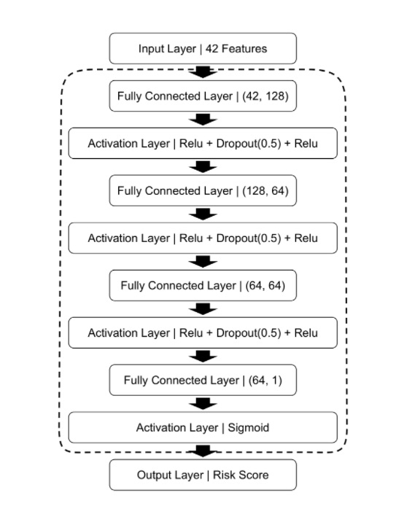
CNN: convolutional neural networks.

Figure S2 ROC comparisons of cognitive conversion at 6-month with CNN-LSTM based withdrawal modeling
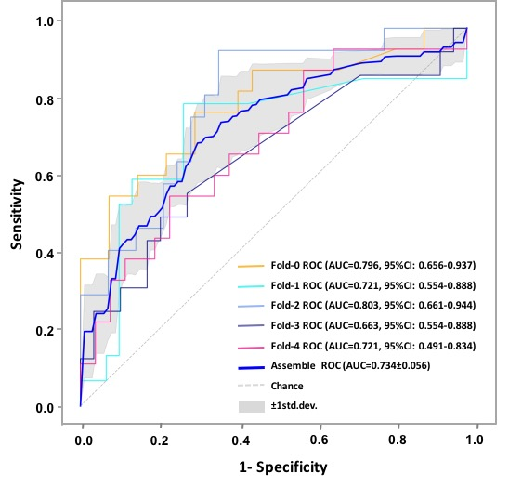
ROC: receiver operating curve; AUC: area under curve; CI: confidence interval.

Figure S3 Predictive performance evaluation of CNN-LSTM based withdrawal modeling with confusion matrix at 6-month
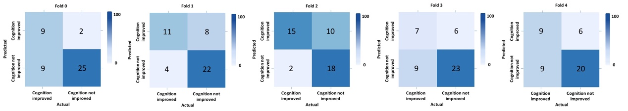
*Computed classification confusion matrix using our hybrid CNN-LSTM modelling in 5-fold cross-validation.

