Supplementary Material

# Supplementary Table S1 Overview of used RT-qPCR primer sequences.

|  |  |  |  |
| --- | --- | --- | --- |
| Gene | Species | Forward sequence (5’-3’) | Reverse sequence (5’-3’) |
| *Gapdh* | Mouse | TGGATTTGGACGCATTGGTC | TTTGCACTGGTACGTGTTGAT |
| *Il17a* | Mouse | TTTAACTCCCTTGGCGCAAAA | CTTTCCCTCCGCATTGACAC |
| *GAPDH* | Human | CAACAGCCTCAAGATCATCAG | GAGTCCTTCCACGATACCA |
| *PRTN3* | Human | CACTGCCTGCGGGACATAC | TTCAGAAACACCTGAGCCACC |
| *ZO1* | Human | GACTTAAAGCTGCCTCAACAGA | GGTTTGTTTCAGGCGAAAGG |
| *OCLN* | Human | TTAACTTCGCCTGTGGAT | AGTGATCTTGCTCTGTTCT |

**Supplementary Figure S1** IL-17A had no effect on the expression of MMPs in hBMECs.

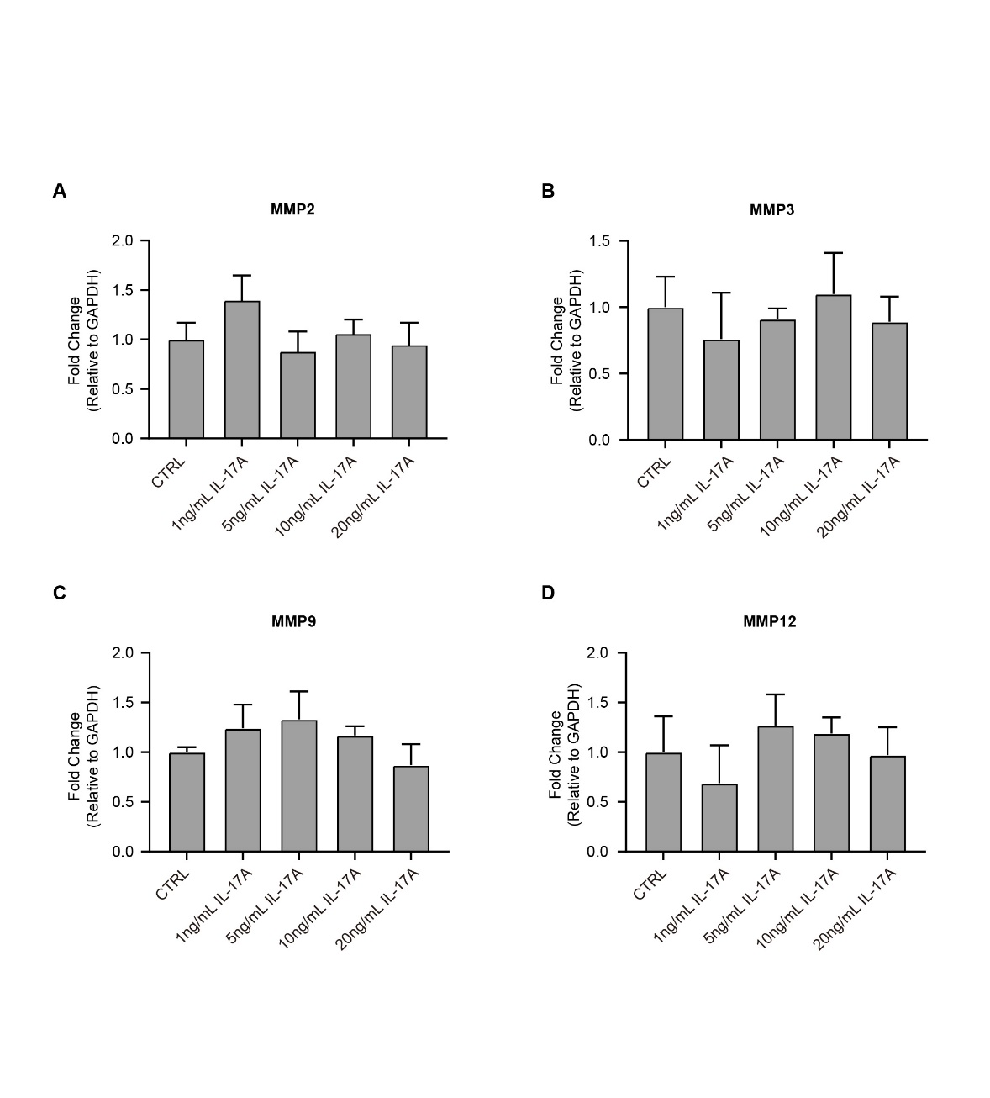

**Supplementary Figure S2** The time course of the effects of IL-17A on BBB permeability in vivo and in vitro.

