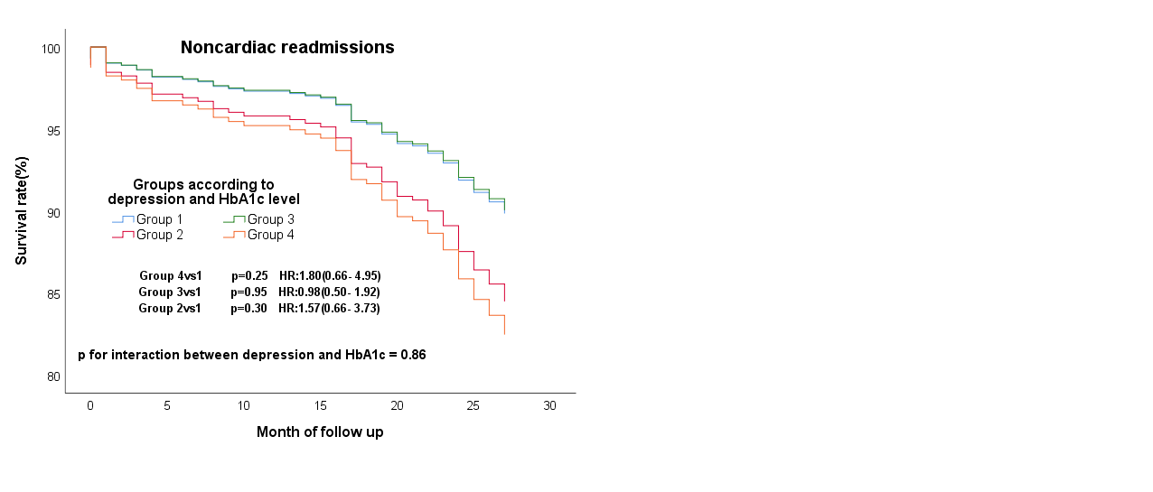

SUPPLEMENTARY FIGURE 1 | Cox regression curves for noncardiac readmissions by the four groups of all patients in the multi-variable adjusted model. (Group1: patients without clinical depression and low HbA1c; Group2: patients with clinical depression and low HbA1c; Group3: patients without clinical depression and high HbA1c; Group4: patients with clinical depression and high HbA1c). Noncardiac readmissions Model: Adjusted for sex, age, severity of coronary artery stenosis, diabetes, taking furosemide and CCR.



SUPPLEMENTARY FIGURE 2 | Cox regression curves for MACE (left) and composite endpoint (right) by the four groups of CAD patients with diabetes. (Group1’’ : patients without clinical depression and low HbA1c; Group2’’ : patients with clinical depression and low HbA1c, patients without clinical depression and high HbA1c; Group3’’ : patients with clinical depression and high HbA1c).