Supplementary Material
Higher photochemical quenching and better maintenance of CO₂ fixation are key traits for PUE in the wheat breeding line, RAC875.
Van Lam Nguyen¹, Lachlan Palmer¹ and James Stangoulis^{1*}

¹College of Science and Engineering, Flinders University, Sturt Rd, Bedford Park SA 5042, Australia.

*Correspondence:
James Stangoulis
Email: james.stangoulis@flinders.edu.au
Postal address: GPO Box 2100, Adelaide 5001, South Australia

Supplementary figures
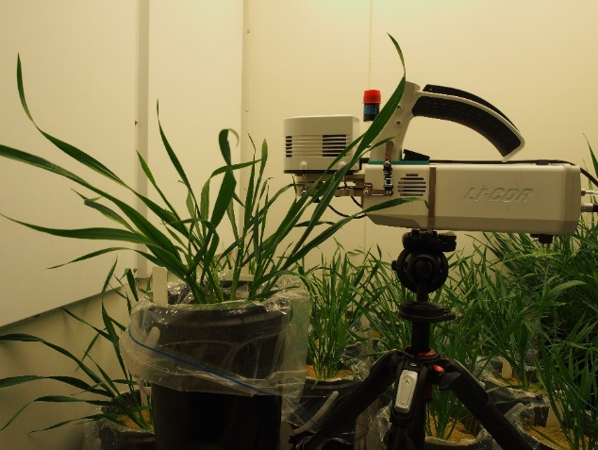

Figure 1 S. Gas exchange measurement by LI-6800 portable photosynthesis system

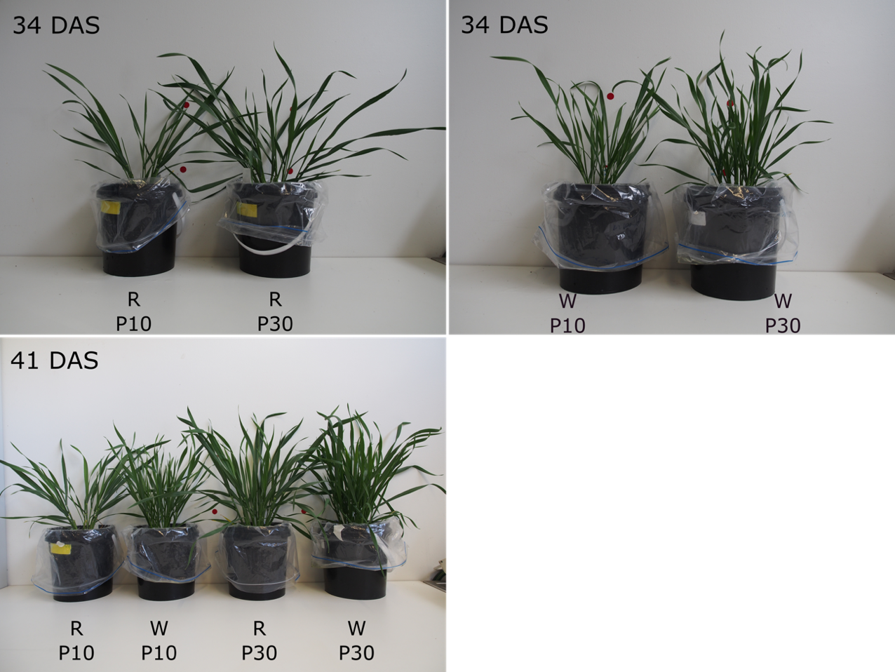

Figure 2 S. Plant growth at the vegetative stage (34 and 41 DAS). R: RAC875, W: Wyalkatchem, P10 and P30: P supply at 10 and 30 mg P/kgsoil.

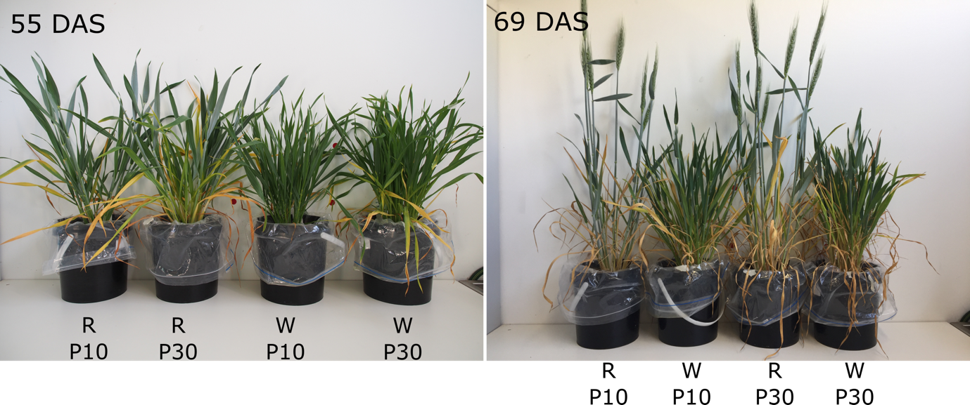
Figure 3 S. Plant growth at the booting stage (55 DAS for RAC875 and 69 DAS for Wyalkatchem). R: RAC875, W: Wyalkatchem, P10 and P30: P supply at 10 and 30 mg P/kgsoil.

Supplementary Tables
Table 1 S.Analysis of variance, simple interaction and simple effect for effects of genotype, P supply and growth stage on tiller number. P10 and P30: P supply at 10 mg and 30 mg P/kg soil; DAS: day after sowing.
Source | SS | df | MS | F | Sig
Genotype (G) | 1177 | 1 | 1177 | 524.976 | <0.001
P supply (P) | 383 | 1 | 383 | 170.713 | <0.001
Growth stage (GS) | 8712 | 6 | 1452 | 647.918 | <0.001
G x P | 21 | 1 | 21 | 9.566 | 0.0027
G x GS | 1406 | 6 | 234.3 | 104.558 | <0.001
P x GS | 433 | 6 | 72.2 | 32.228 | <0.001
G x P x GS | 32 | 6 | 5.3 | 2.361 | 0.0037
G x P at each GS
G x P at GS = 13 DAS | 0.25 | 1 | 0.25 | 0.11 | ns
G x P at GS = 23 DAS | 3.06 | 1 | 3.06 | 1.39 | ns
G x P at GS = 25 DAS | 1.563 | 1 | 1.563 | 0.71 | ns
G x P at GS = 27 DAS | 9 | 1 | 9 | 4.09 | ns
G x P at GS = 30 DAS | 0.25 | 1 | 0.25 | 0.11 | ns
G x P at GS = 34 DAS | 0.25 | 1 | 0.25 | 0.11 | ns
G x P at GS = 51 DAS | 36 | 1 | 36 | 16.36 | sig
G at each GS
G at GS = 13 DAS | 4 | 1 | 4 | 1.82 | ns
G at GS = 23 DAS | 33.06 | 1 | 33.06 | 15.03 | sig († ‡)
G at GS = 25 DAS | 27.562 | 1 | 27.562 | 12.53 | sig († ‡)
G at GS = 27 DAS | 36 | 1 | 36 | 16.36 | s sig († ‡)
G at GS = 30 DAS | 144 | 1 | 144 | 65.45 | sig († ‡)
G at GS = 34 DAS | 175.56 | 1 | 175.56 | 79.8 | sig († ‡)
G at GS = 51 DAS | 2162.2 | 1 | 2162.2 | 982.82 | sig († ‡)
P at each GS
P at GS = 13 DAS | 0.25 | 1 | 0.25 | 0.11 | ns
P at GS = 23 DAS | 14.06 | 1 | 14.06 | 6.39 | sig (‡)
P at GS = 25 DAS | 3.062 | 1 | 3.062 | 1.39 | ns
P at GS = 27 DAS | 6.25 | 1 | 6.25 | 2.84 | ns
P at GS = 30 DAS | 72.25 | 1 | 72.25 | 32.84 | sig († ‡)
P at GS = 34 DAS | 95.06 | 1 | 95.06 | 43.21 | sig († ‡)
P at GS = 51 DAS | 625 | 1 | 625 | 284.09 | sig († ‡)
G at P (GS=51 DAS)
G at P10 (GS=51 DAS) | 820.1 | 1 | 820.1 | 372.77 | sig († ‡)
G at P30 (GS=51 DAS) | 1378.1 | 1 | 1378.1 | 626.41 | sig († ‡)
Error | 188 | 84 | 2.2
†F_{(0.05/6, 1, 84)} = 7.30 (Family error rate critical value)
‡F_{(0.35/10, 1, 84)} = 4.59 (Dunn’s critical value)

Table 2 S. Two-way ANOVA and simple effect analysis for the effects of genotype, P supply on the productive tiller number and the ratio of productive tillers to the total tiller number, leaf number per main tiller at 69 DAS, and the grain yield. Simple effect was analysed using Phia package in r. P10 and P30: P supply at 10 mg and 30 mg P/kg soil.
Source | P value
 | Productive tiller number | Productive tiller/total tiller | Leaf number/mail tiller | Grain yield
G (Genotype) | P<0.001 | P<0.001 | P<0.001 | P<0.001
P (P supply) | P<0.001 | P<0.002 | P<0.001 | P<0.001
G x P | P=0.474 | P=0.244 | P=0.346 | P=0.346
G at each P supply
G at P10 | P<0.001 | P=0.002 | P<0.001 | P=0029
G at P30 | P<0.001 | P=0.021 | P<0.001 | P=0.276

Table 3 S.Analysis of variance, simple interaction and simple effect for effects of genotype, P supply and growth stage on intracellular CO₂concentration at the vegetative stage. P10 and P30: P supply at 10 mg and 30 mg P/kg soil; DAS: day after sowing.
Source | SS | df | MS | F | Sig
Genotype (G) | 608.2 | 1 | 608.2 | 7.116 | 0.014
P supply (P) | 44 | 1 | 44 | 0.515 | 0.48
Growth stage (GS) | 0 | 1 | 0 | 0 | 0.982
G x P | 253.7 | 1 | 253.7 | 2.968 | 0.092
G x GS | 471.2 | 1 | 471.2 | 5.513 | 0.028
P x GS | 3.7 | 1 | 3.7 | 0.043 | 0.836
G x P x GS | 2.4 | 1 | 2.4 | 0.028 | 0.87
G x P at each GS
G x P at GS=34 DAS | 108.1 | 1 | 108.1 | 1.26
G x P at GS=41 DAS | 157.9 | 1 | 157.9 | 1.85
G at each GS
G at GS=34 DAS | 4.4 | 1 | 4.4 | 0.05 | ns
G at GS=41 DAS | 1075.1 | 1 | 1075.1 | 12.58 | sig († ‡)
Residual | 2051.4 | 24 | 85.475
†F_{(0.05/2, 1, 24)} = 5.72 (Family error rate critical value)
‡F_{(0.35/6, 1, 24)} = 3.95 (Dunn’s critical value)

Table 4 S. The ratio of photosynthetic rate at low P to adequate P for each genotype at the vegetative and booting stage. P10 (low P) and P30 (adequate P): P supply at 10 mg and 30 mg P/kg soil.
Genotype | Pn
 | Vegetative | Booting
RAC875 | 0.83 | 0.90
Wyalkatchem | 0.89 | 0.83

Table 5 S. Two-way ANOVA and simple effect analysis for the effects of genotype, P supply on F_{o}, F_{m} and F_{v} at booting stage. Simple effect was analysed using Phia package in r.
Source | P value
 | F_{o} | F_{m} | F_{v}
Genotype (G) | P<0.001 | P<0.001 | P<0.001
P supply (P) | P=0.246 | P=0.058 | P<0.042
G x P | P=0.010 | P=0.003 | P=0.003
P at each genotype
P at RAC875 | P=0.021 | P=0.003 | P=0.002
P at Wyalkatchem | P=0.219 | P=0.294 | P=0.331

Table 6 S. Two-way ANOVA and simple effect analysis for the effects of genotype, P supply on NQP at booting stage. Simple effect was analysed using Phia package in r.
Source | P value
 | NPQ
Genotype (G) | P=0.287
P supply (P) | P=0.131
G x P | P=0.094
P at each genotype
P at RAC875 | P=0.890
P at Wyalkatchem | P=0.063

Table 7 S. The ratio of NPQ to adequate P for each genotype at vegetative and booting stage. P10 (low P) and P30 (adequate P): P supply at 10 mg and 30 mg P/kg soil.
Genotype | NPQ
RAC875 | 0.97
Wyalkatchem | 1.52

Table 8 S. Effect of P supply on harvest index (HI) in two wheat genotypes
P treatment (mg P kg⁻¹ soil) |  | Harvest index (%)
10 | RAC875 | 36.43 ± 0.62ª
 | Wyalkatchem | 28.79 ± 1.31^{b}
30 | RAC875 | 34.46 ± 0.09
 | Wyalkatchem | 31.76 ± 2.35
P value
Genotype (G) |  | P<0.001
P supply (P) |  | P=0.997
G × P |  | P=0.002
Different letters show significantly different between two genotypes within the same P supply (P<0.05).

