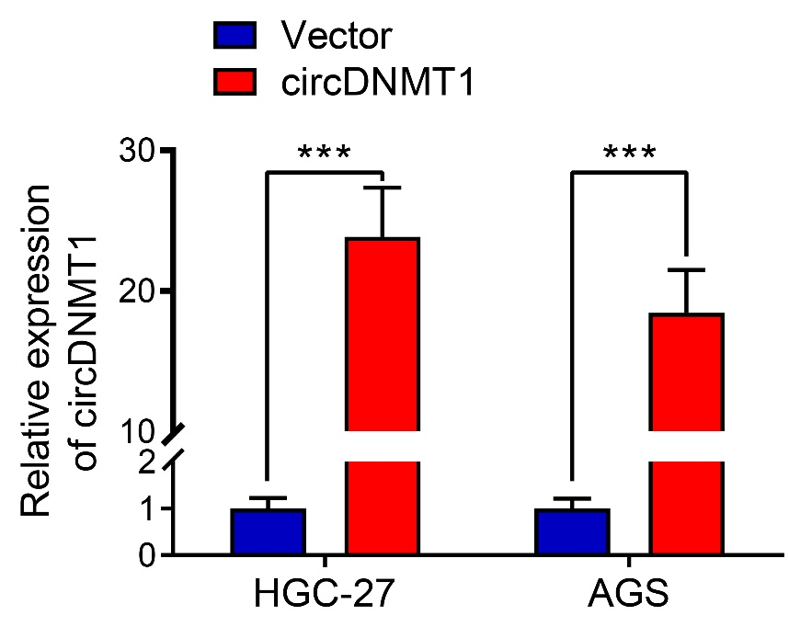

**Supplementary Figure 1.** Confirmation of efficiencies of circDNMT1 expression plasmids. qRT-PCR analysis to show circDNMT1 in HGC-27 and AGS cells stably carrying lentivirus with vectors or circDNMT1 overexpression plasmids. Data were presented as means±SD. ***P < 0.001.